**ASSIGNMENT-7**

**Problem Statement:** Upload a static website on EC2.

**Procedure:**

1. Login to your AWS account as root user. Then search “EC2” in the search box. Click on the first result that appears.

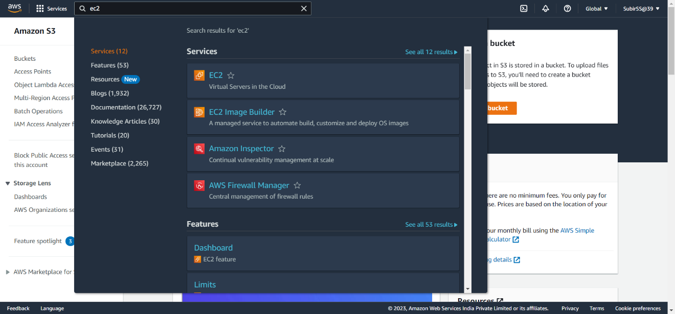

1. Click on Instances dropdown menu on the left sidebar. Then again click on instances.

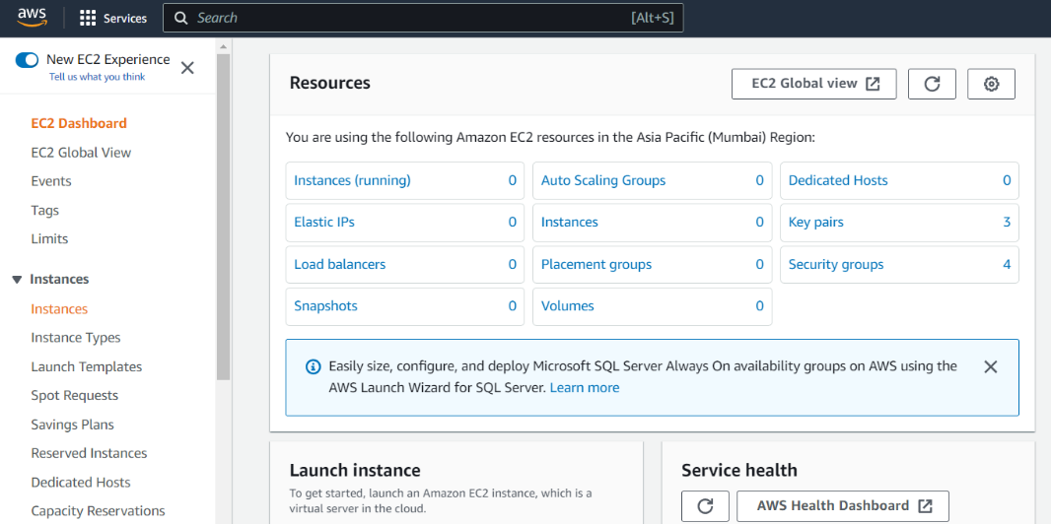

1. Next click on Launch instances button.

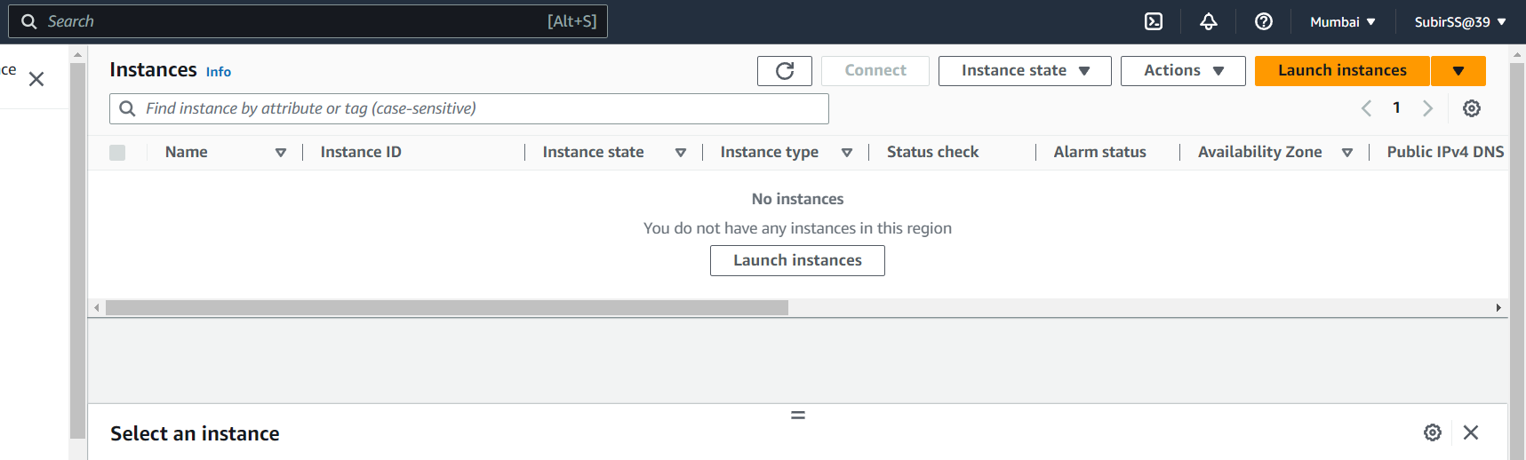

1. Now customize the instance you want to launch.
   1. Set the unique instance name.
   2. Select Ubuntu as OS.
   3. Next go to key pair(login) section.

**i.**Click on create new key pair

**ii.**Enter the name of key pair.

**iii.**Select RSA as Key pair type.

**iv.**Select “. pem” as file format.

**v.**Create the key pair.

**vi.**Save the automatically downloaded file. It will be required later.

* 1. Now select the newly created key pair from the dropdown selection.
  2. Go at the bottom of the network settings section and check the 
     1. Allow HTTP traffic box.
     2. Allow HTTPS traffic box.
  3. Next Click on Launch Instance button on the right side.

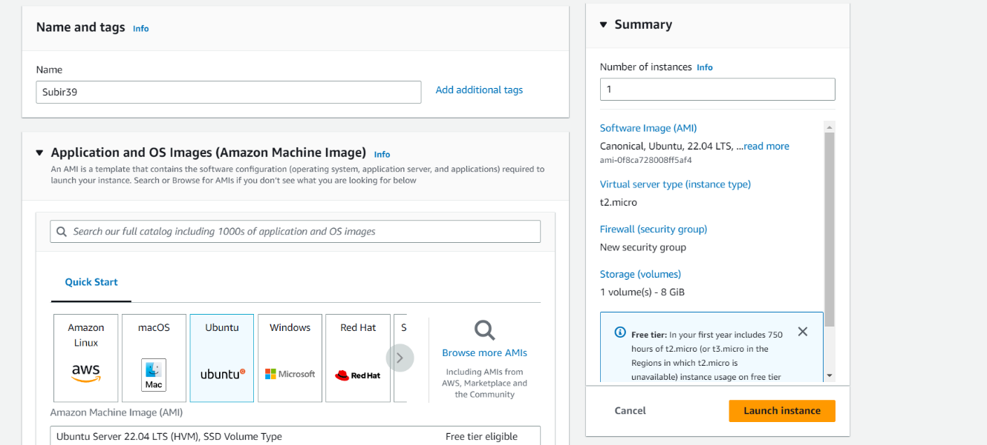

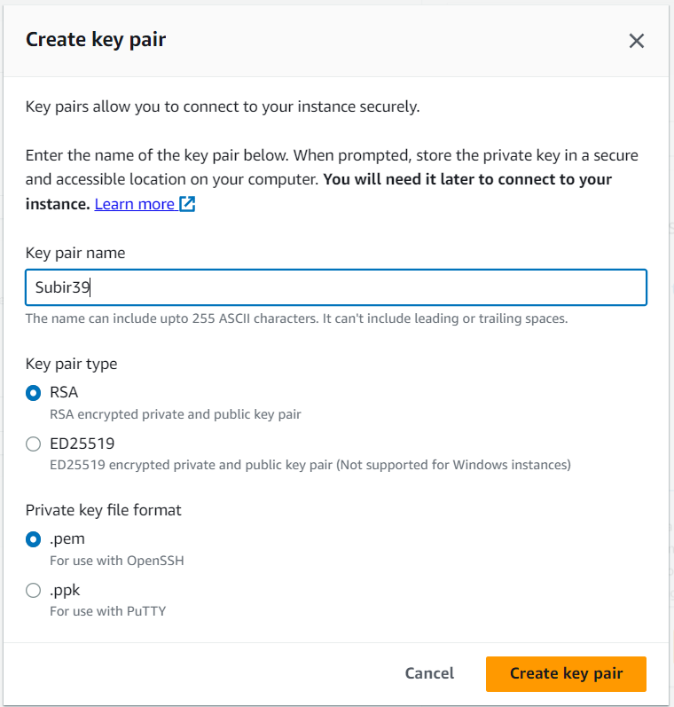

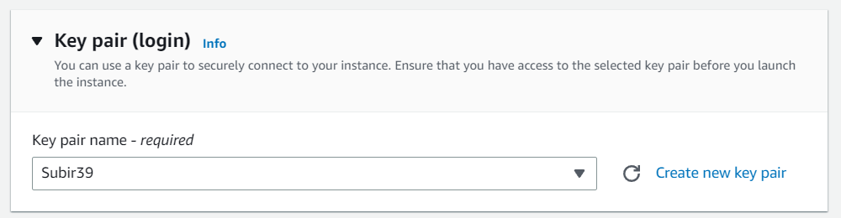

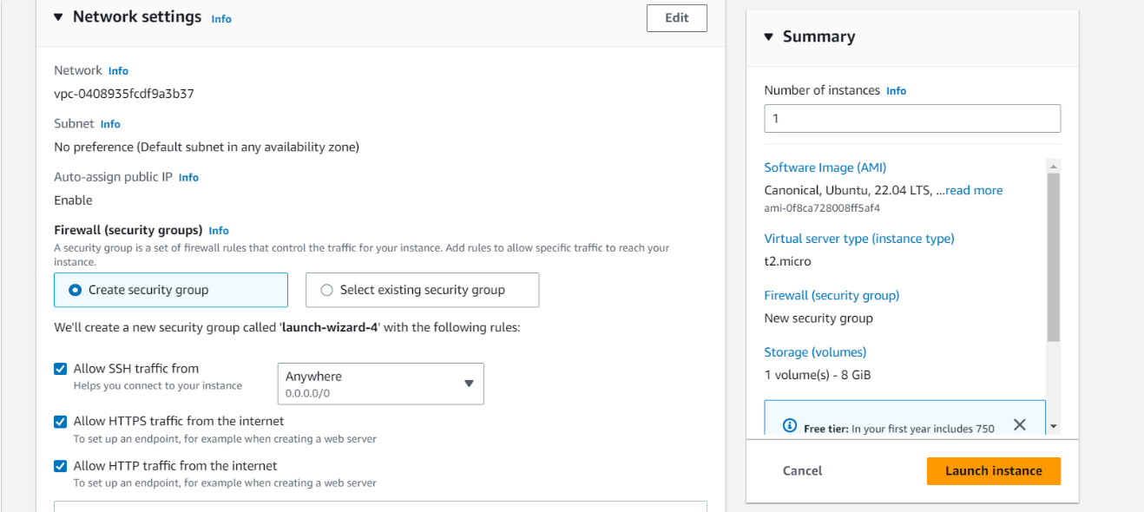

1. Now check whether your newly created instance is running or not in the instances page. Note it will take a few seconds to show the running status. (From Pending)

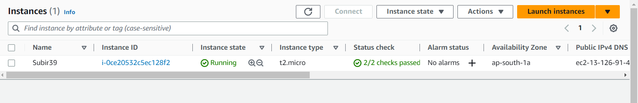

1. Now click on the Instance ID of the server.

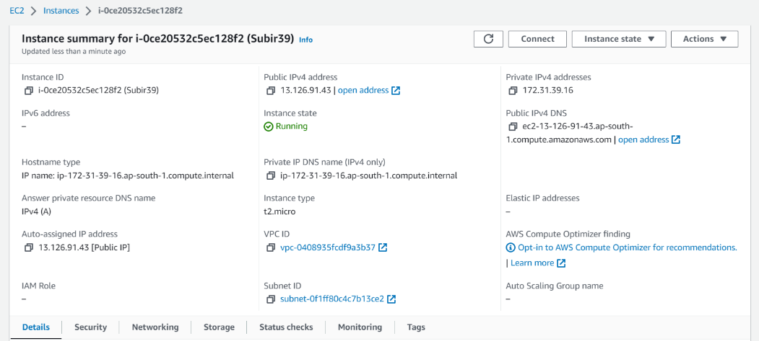

1. Copy the Public IPv4 address.
2. Now for the next steps we require **Bitvise SSH client**. Download it and install in your local pc.
3. Now open the Bitvise SSH Client.

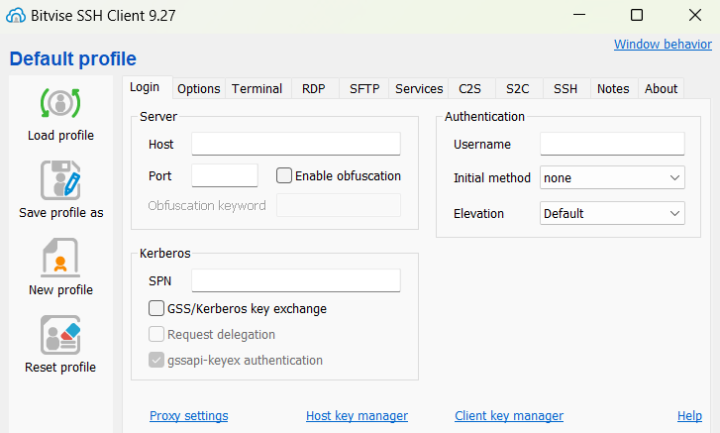

1. Paste the copied IPv4 address in the Host section.
2. Set user name to ubuntu.
3. Click on the client key manager link below the authentication section.It will open another pop-up window. There click on import button.

Select the previously downloaded .pem file. Click on import. Then close the Client key manager window.

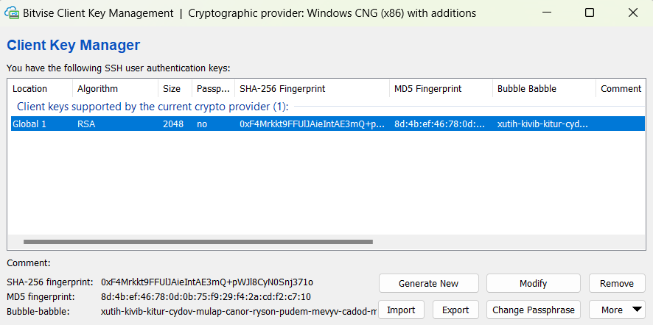

1. Now set initial method to public key.
2. Set Client Key to Global 1.

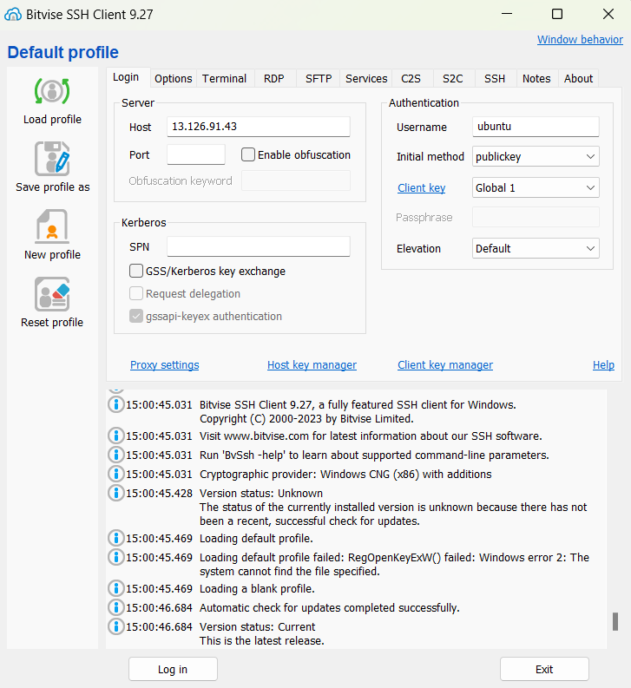

1. Now click on the Log In button at the bottom of the Window.

Click on Accept and Save button on the pop-up.

One of many ways in which you can know that whether you have successfully logged in is if your Log In button has changed to Log Out.

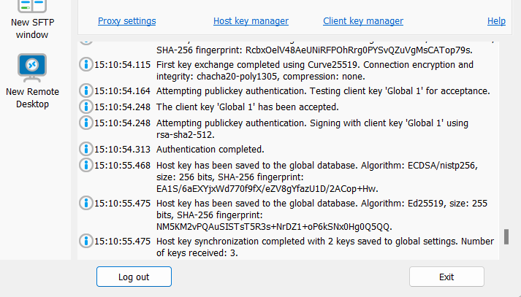

1. Now newly created options will arise on the left sidebar on successful login.

Click on the new terminal console to open terminal of our server.

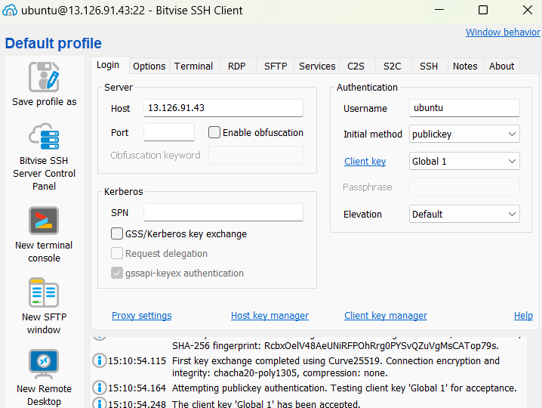

1. Enter the following commands in the terminal:
   1. **sudo apt-get update**
   2. **sudo apt-get upgrade**

(Remember to press Y and then Enter when prompted)

(After the process is completed a new box/window appears. But just press Enter to continue.)

* 1. **sudo apt-get install nginx**

(Remember to press Y and then Enter when prompted)

(After the process is completed a new box/window appears. But just press Enter to continue.)

1. Now minimize the console.
2. Click on the new SFTP window icon on the left sidebar.



1. Select the folder where you have kept HTML files of your website on the local files section. Just keep it open.

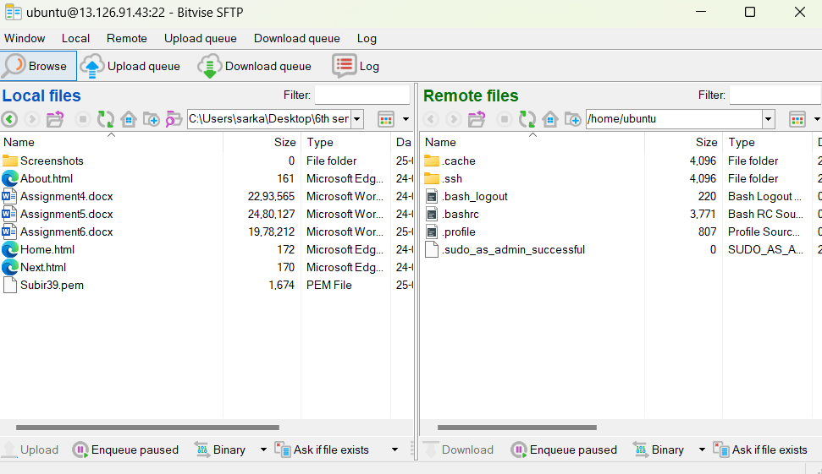

1. Now click the Up button (2 times) on the Remote Files section. You will be able to see a bunch of folders. Scroll down and open the last folder named “var”.

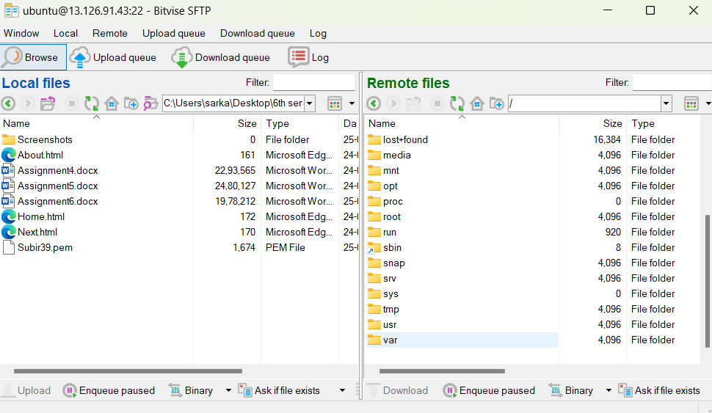

1. Now again open the last folder in it named “www”.

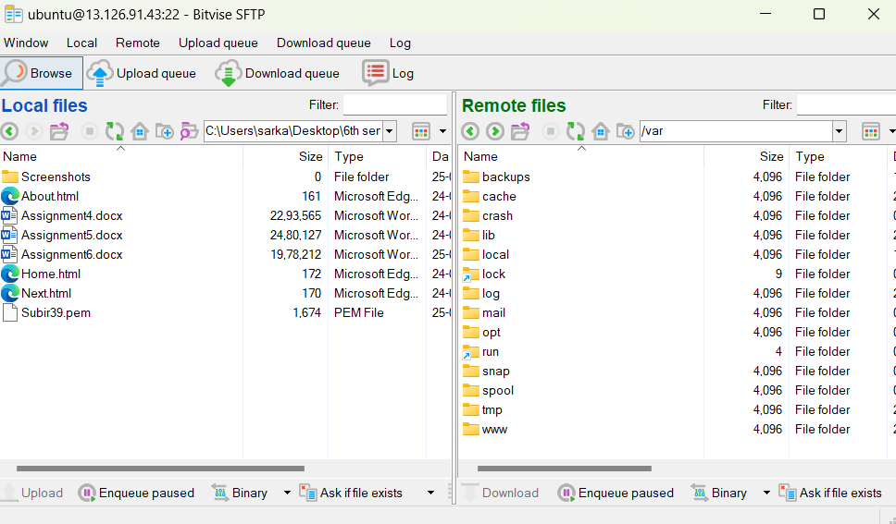

1. Open the only folder named “html” and keep it open. You will see a default html already present.

You can check whether nginx is working by pasting our previously copied IPv4 address of our server instance in a different browser. It will show something like this.

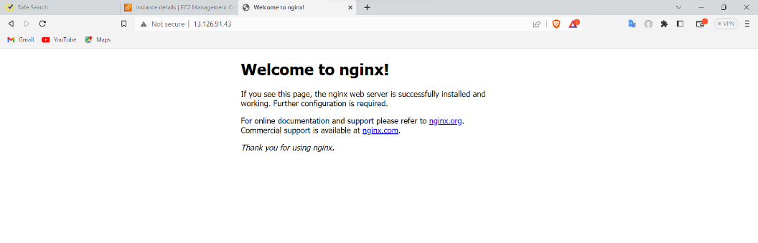

1. We actually need to transfer our local html file here in this open folder of the remote server. However, we do not have such permissions for this folder. To give such permission we need to go back to the terminal console and give the required permissions to the folder.
2. Now type the following commands in the terminal.
   1. **cd /**
   2. **cd var/www/**
   3. **sudo chmod 777 html**

Now the permission (Read, Write, Execute) of the folder is successfully granted.

1. Now drag and drop all the files from local to remote.

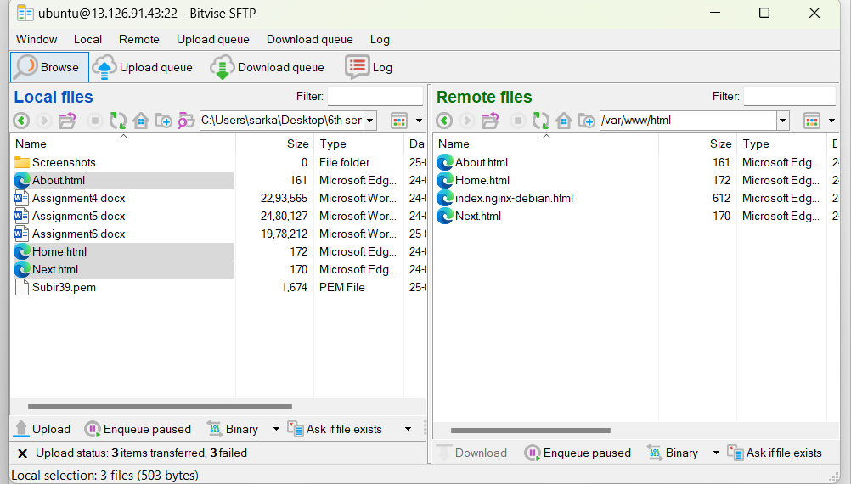

Remember you must have the opening html named “index.html” in order to show the opening html page by the web server.

1. Finally open the website from any browser or device by using the public IPv4 address that you copied.

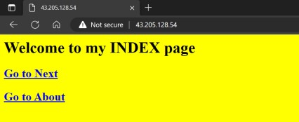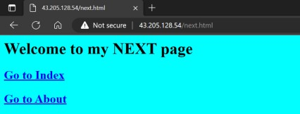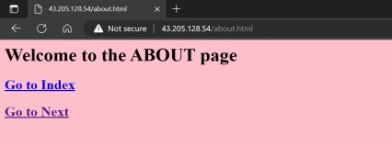

We now have successfully hosted a static website on an AWS EC2 sever.