Assignment 8:

Problem Statement: Deploy a project from local machine to github and vice versa.

**Procedure: (a) Create new repository in Github:**

1. At first log into your Github Account.

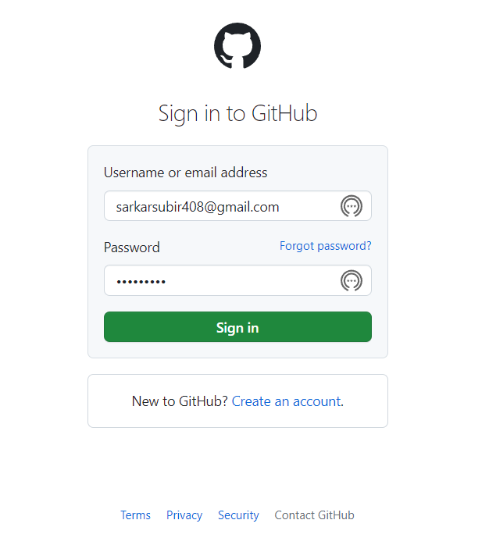

1. Then go to the ‘+’ sign on top right corner and click on ‘New repository’ to create a new repository.

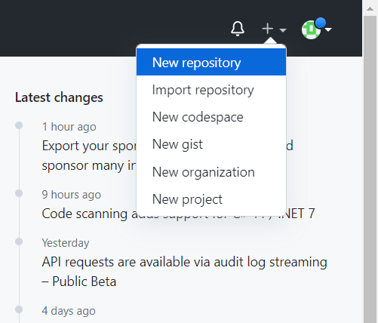

1. Give an unique repository name. Select Private and then click on ‘Create repository’.

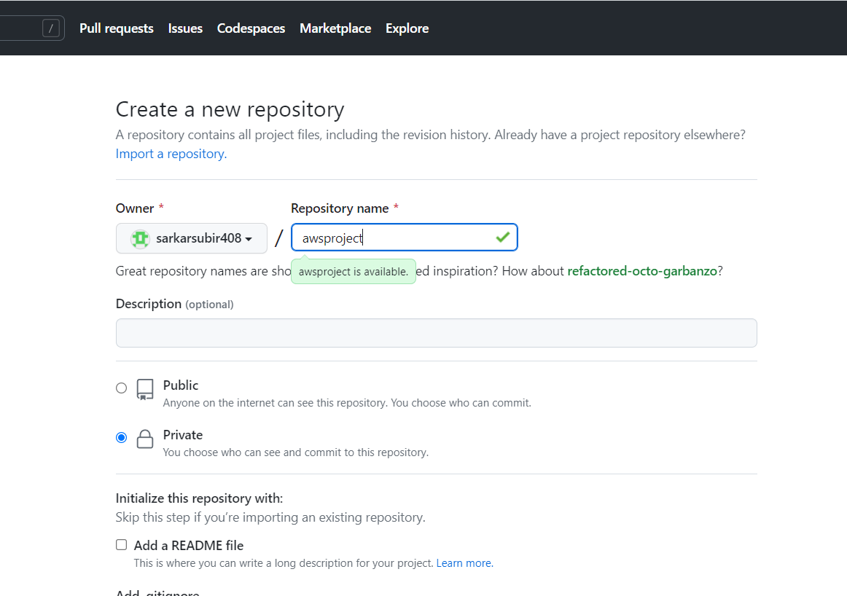

1. Now click on your account at the top right and go to Settings then go to Developer settings.

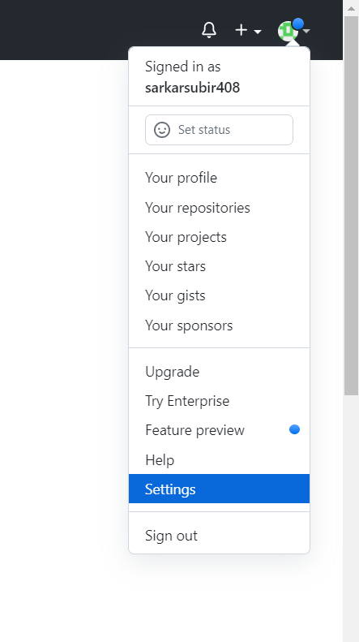

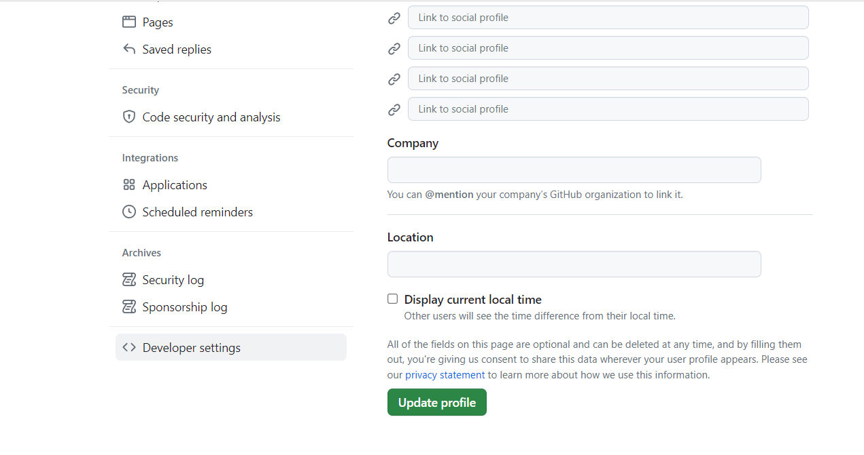

1. Select the drop-down menu of Personal access tokens and click Tokens (classic).

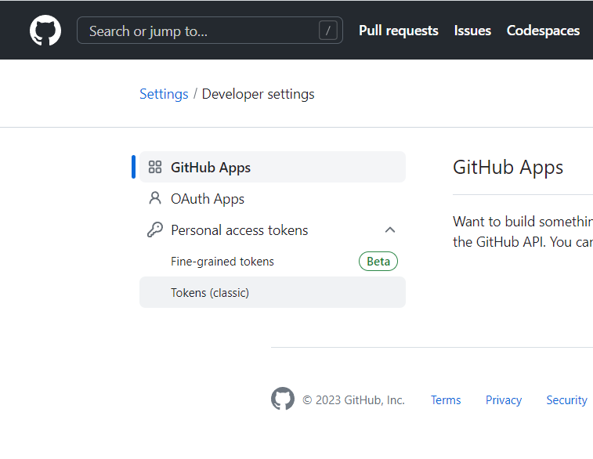

1. Click on ‘Generate new token’, then select ‘Generate new token (classic)’.

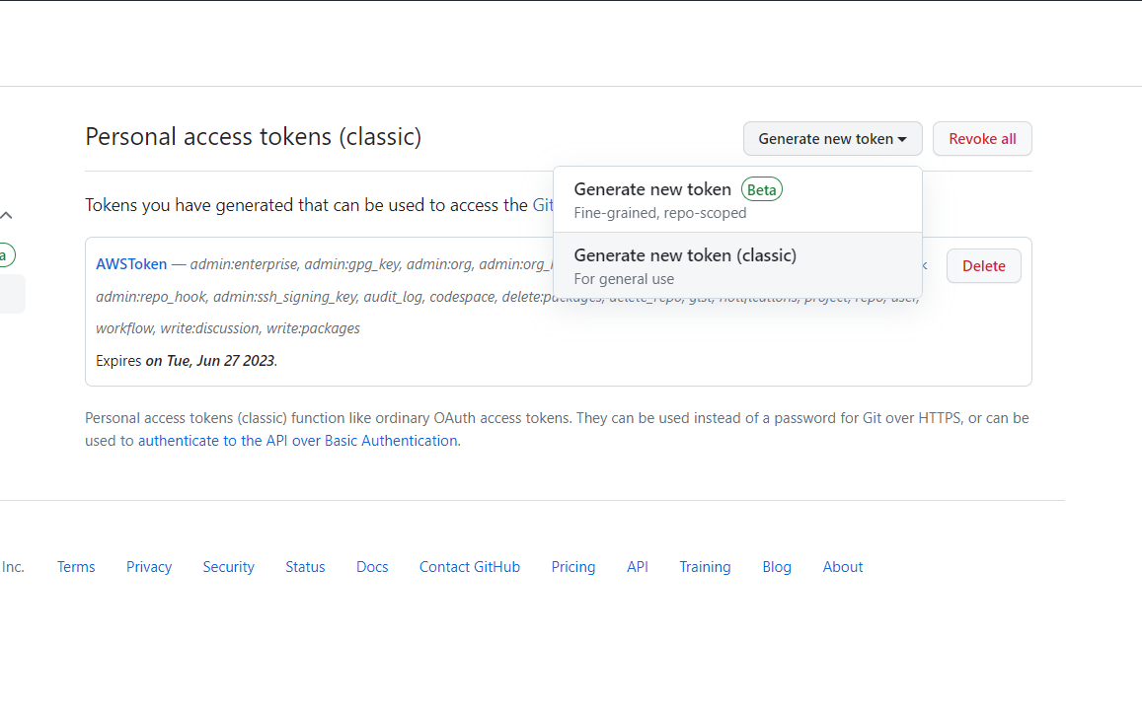

1. Give the token name, set expiration as 90 days and select all the checkboxes.Then click on ‘Generate token’.Save your token id to notepad for future reference.

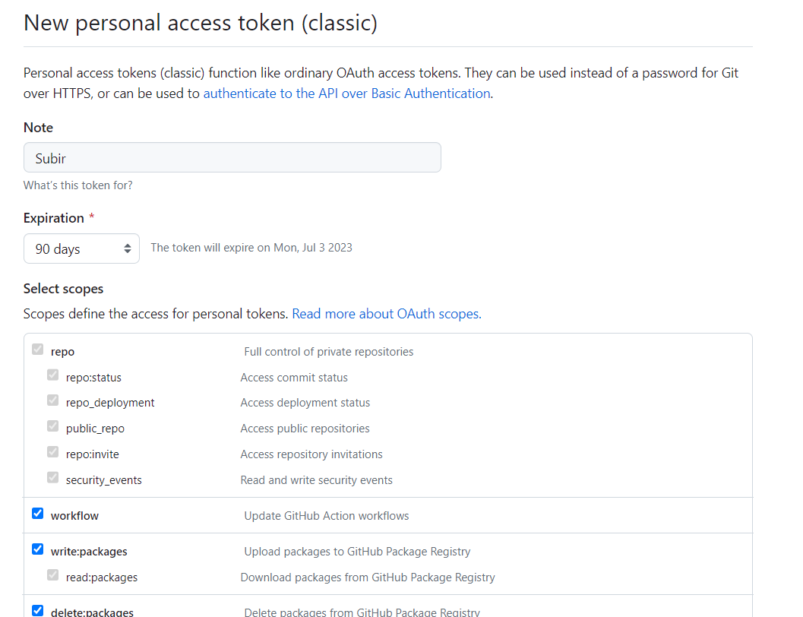

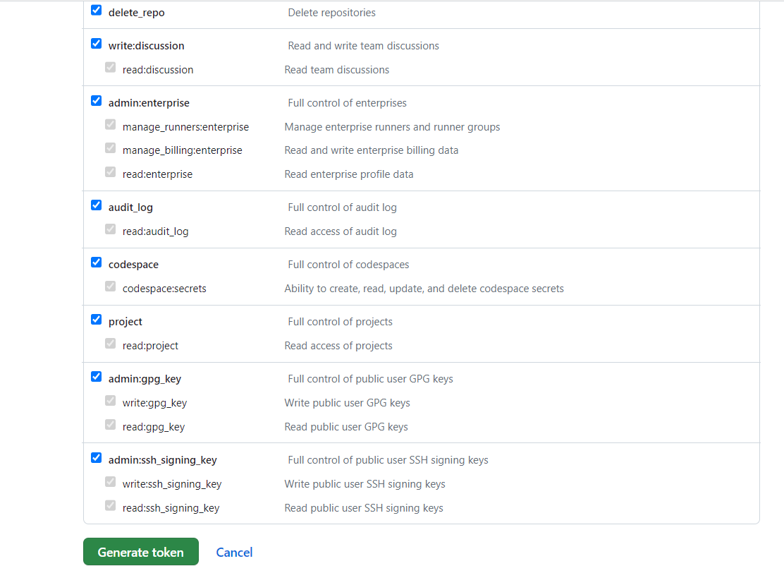

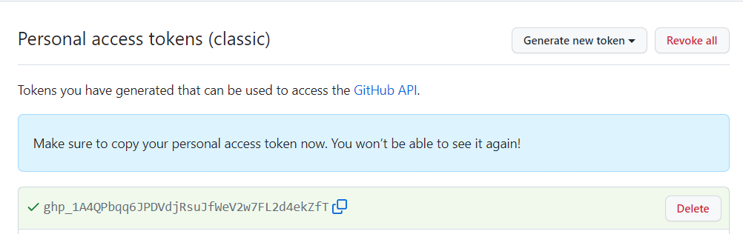

1. Now go to the newly created repository and then to repository settings. Click on ‘Collaborators’. Select Add people and invite people by searching.

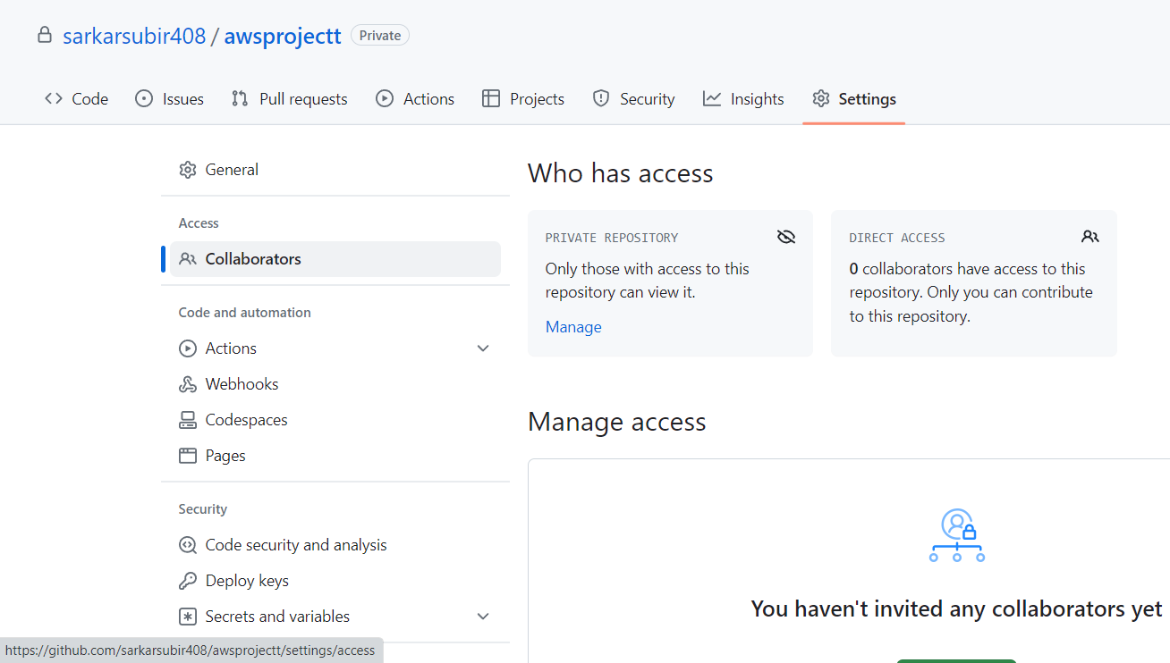

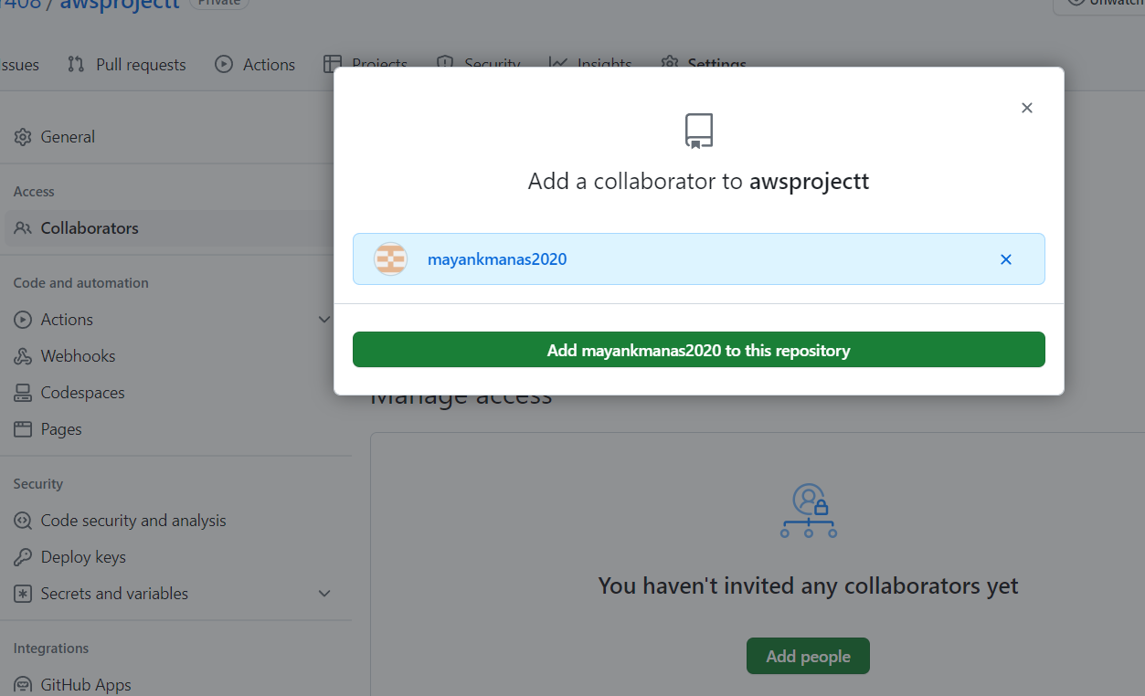

**(b)Deploying a project from local machine to github and vice versa:**

1. Go to the html files folder in your local machine then right click on it and select ‘Git Base Here’ option.

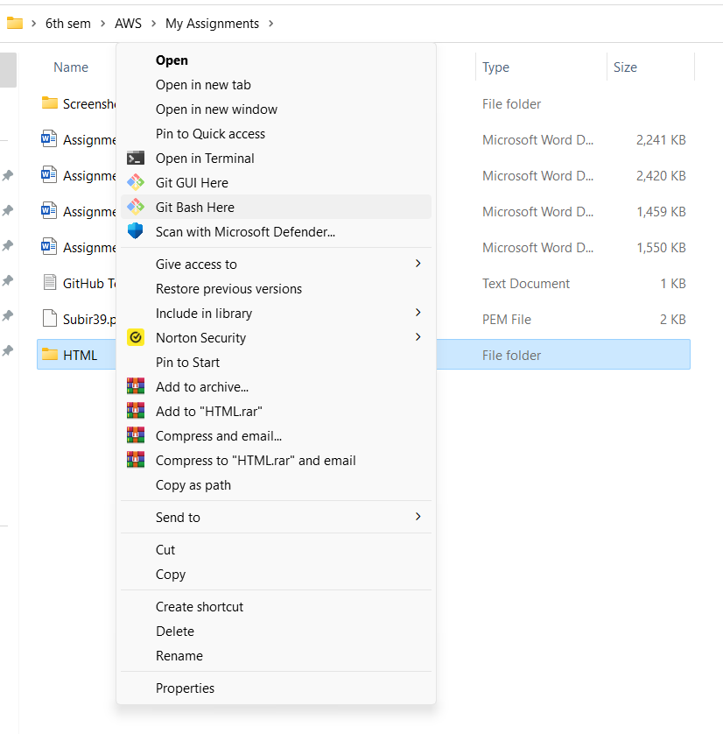

1. After opening Git Bash type and execute the following commands one by one:-
   * + 1. git init
       2. ls -l
       3. git status
       4. git add .
       5. git status
       6. git commit -m “Html files committed”

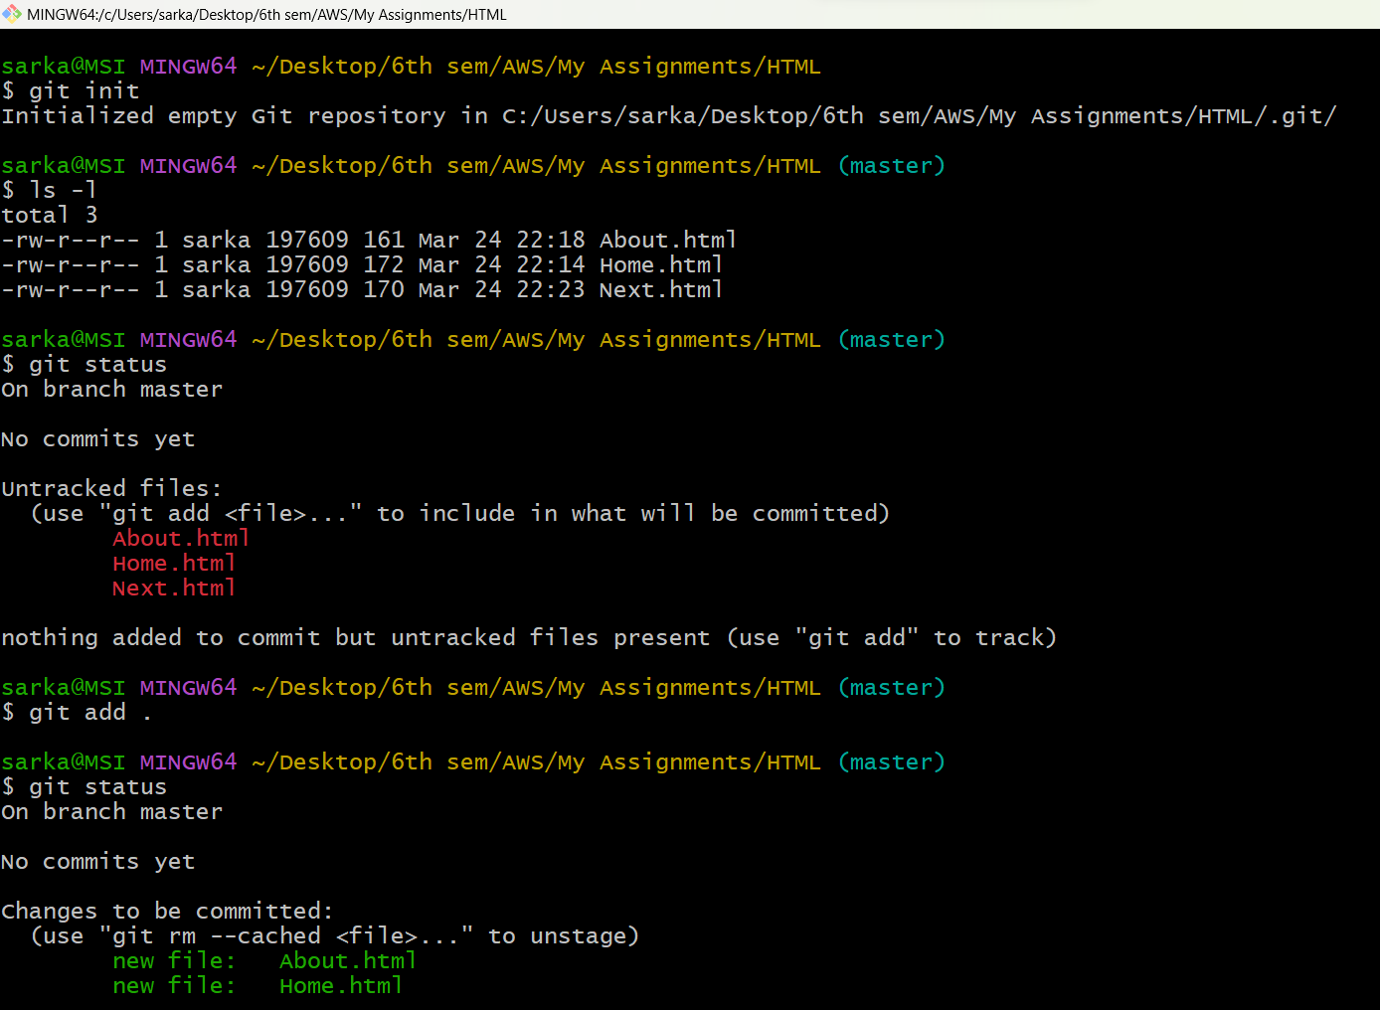

1. Copy the HTTPS Adress of your repository from GitHub.Then write on Git Bash terminal - > git remote add origin ‘‘paste repository ‘s origin’’.Then write ‘git remote origin master’ .

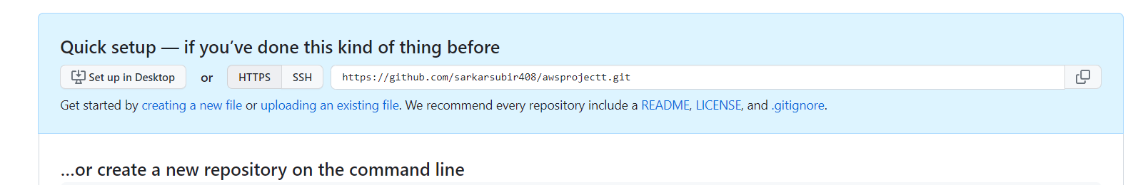

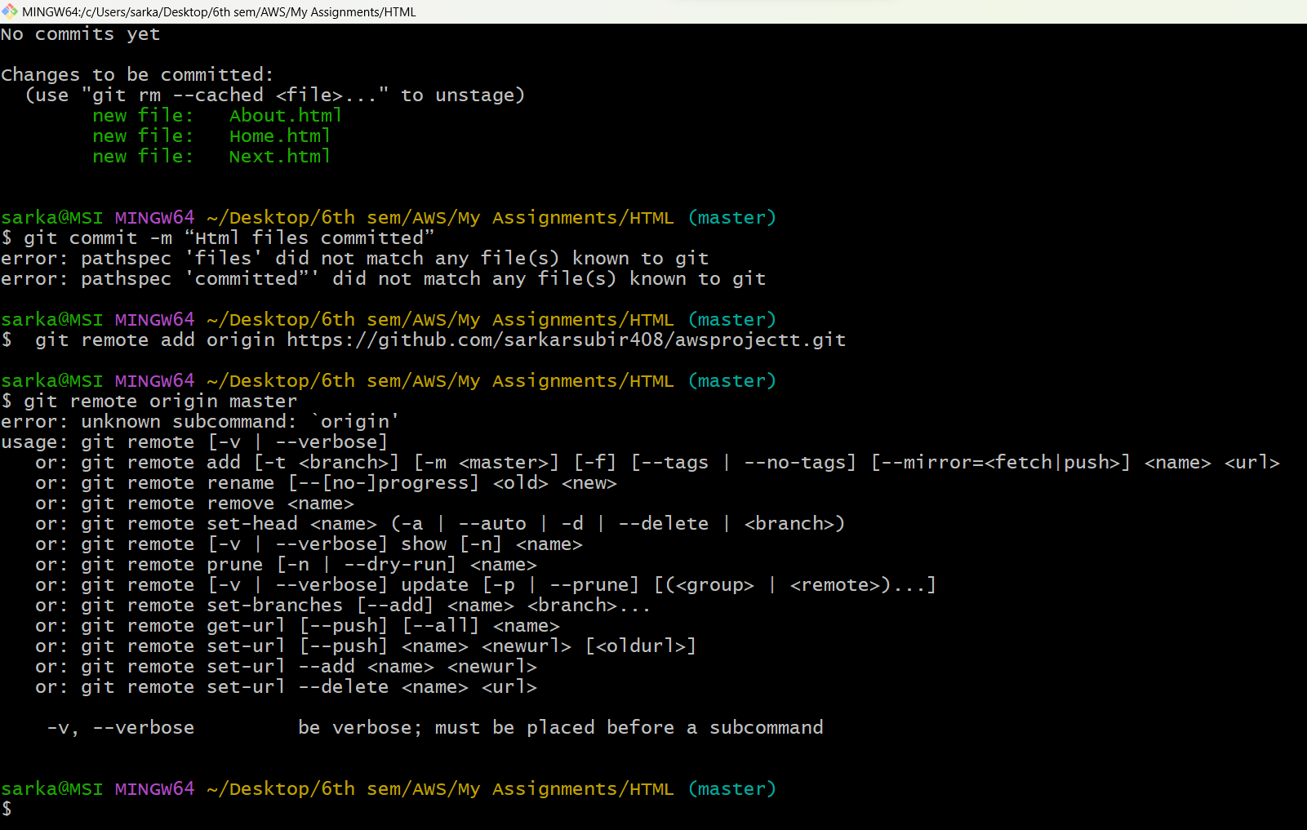

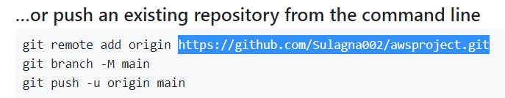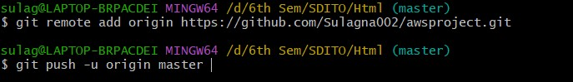

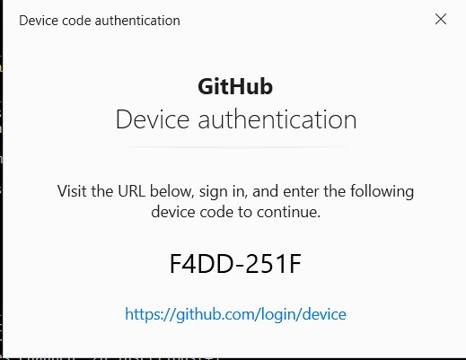

4.Now sign in to GitHub with this above code => Refresh the GitHub page in your browser.

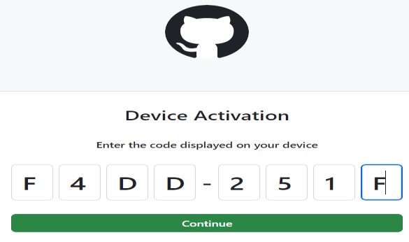

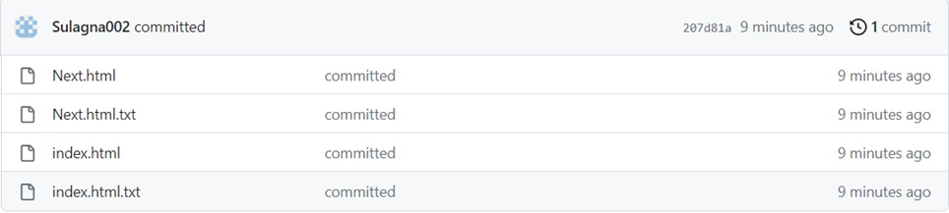

**(c)Deploying project in GitHub from local machine:**

1. Create a new folder => Right click on it => Git Bash Here => ‘git init’ => git clone 'https://github.com/sudip7407/New-repo1.git'

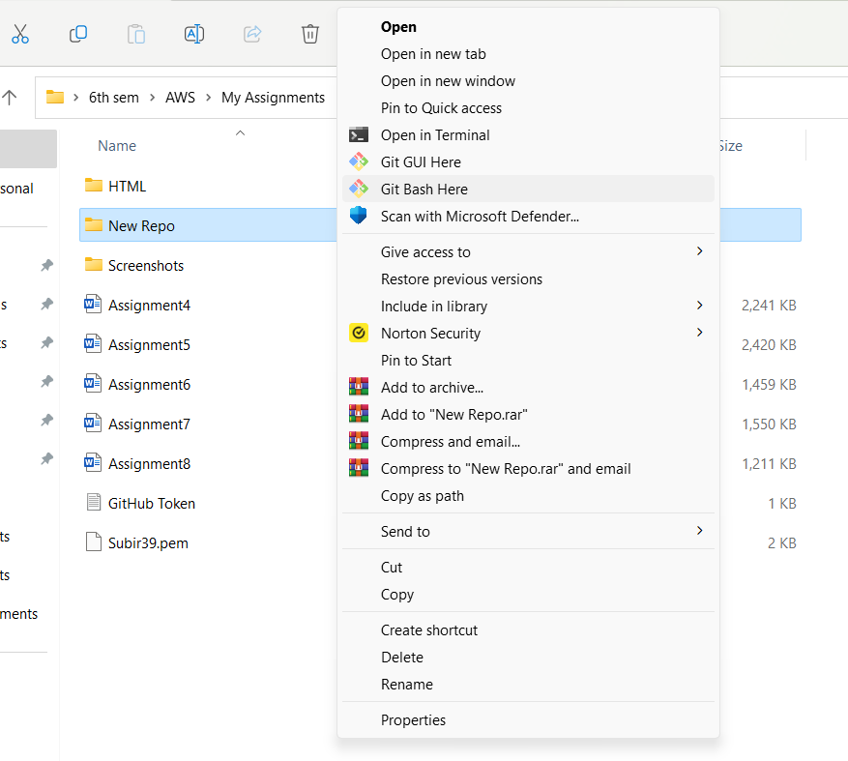

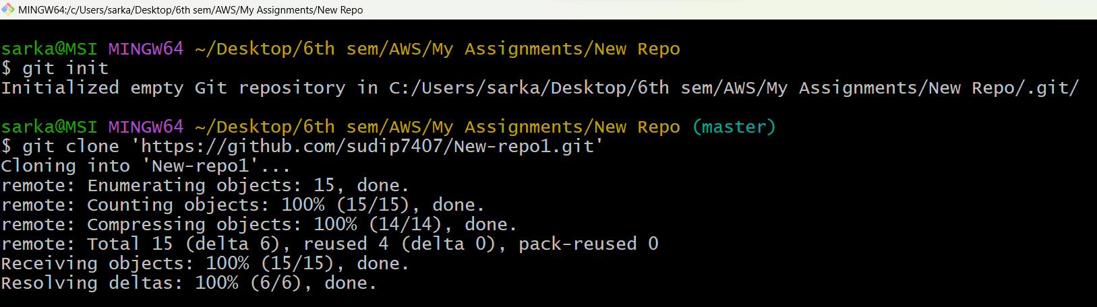

Click on New Repo folder => New-repo1 cloned successfully.

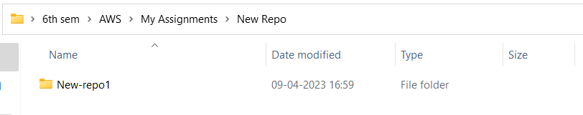

2.Type and execute the following commands

i)git init

ii)git clone https://github.com/sudip7407/New-Repo1.git

3.Create a new repository in github

4.Open gitbash in the cloned folder (remove the already existing .git hidden folder in the folder containing the cloned project.)

5.Type and execute the following commands

* + - 1. git init
      2. git add .
      3. git commit -m “Committed”
      4. git remote add origin *repository link*
      5. git push -u origin master

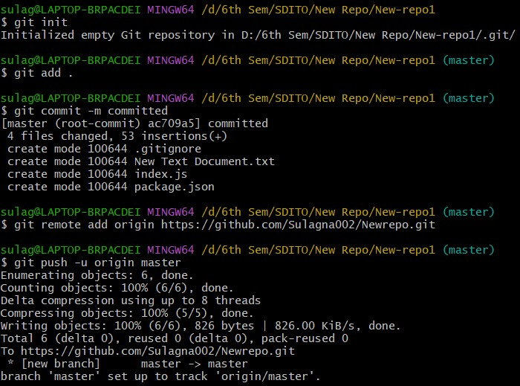

6.Refresh your repository.

