**ASSIGNMENT 9:**

**Problem Statement: Deploy a project from GitHub to EC2.**

**Procedure:**

1. Log in to AWS and create an EC2 Instance by the steps shown in the Assignment7.

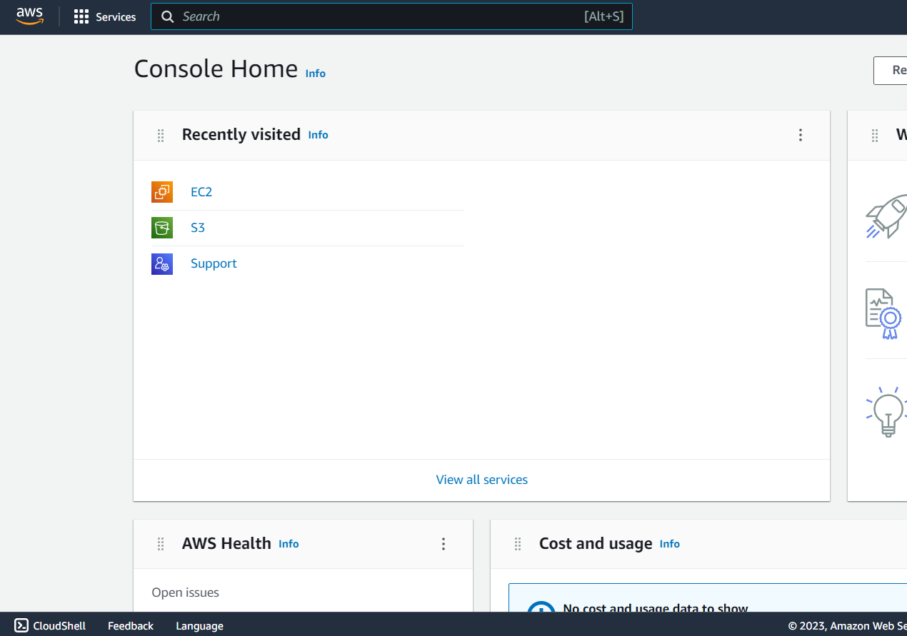

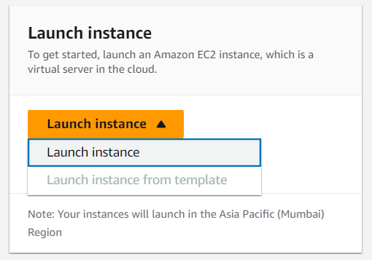

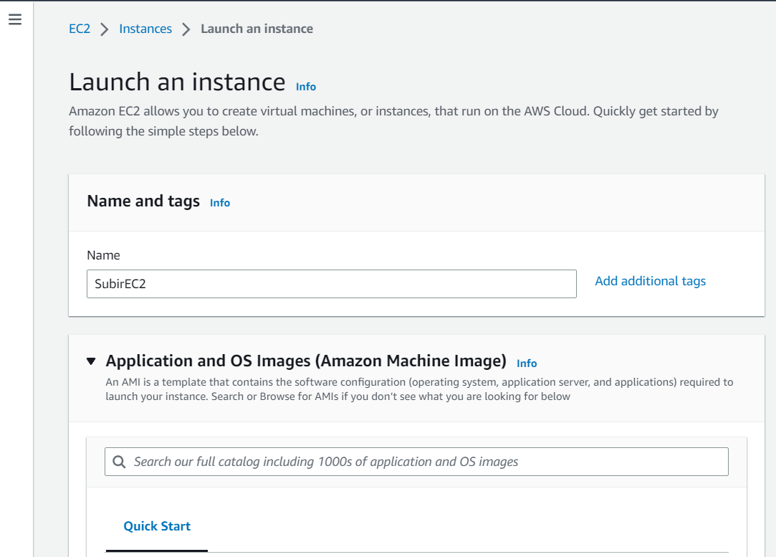

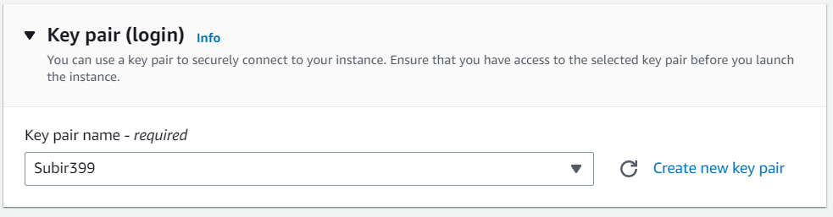

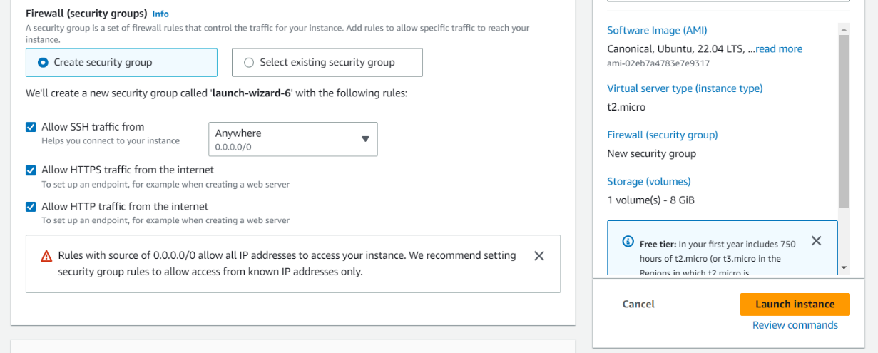

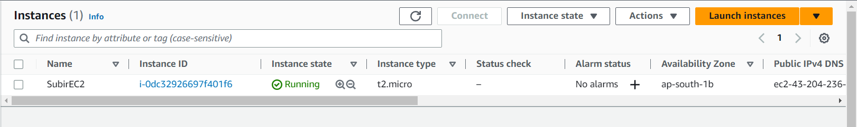

1. Copy the IPv4 address of the EC2 Instance.

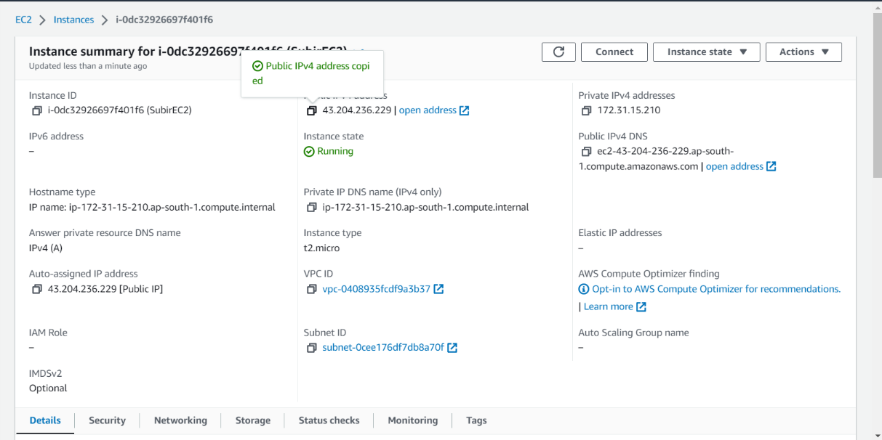

1. Open Bitvise SSH Client Application , paste the public IPv4 in the Host field. Give Username as ubuntu.

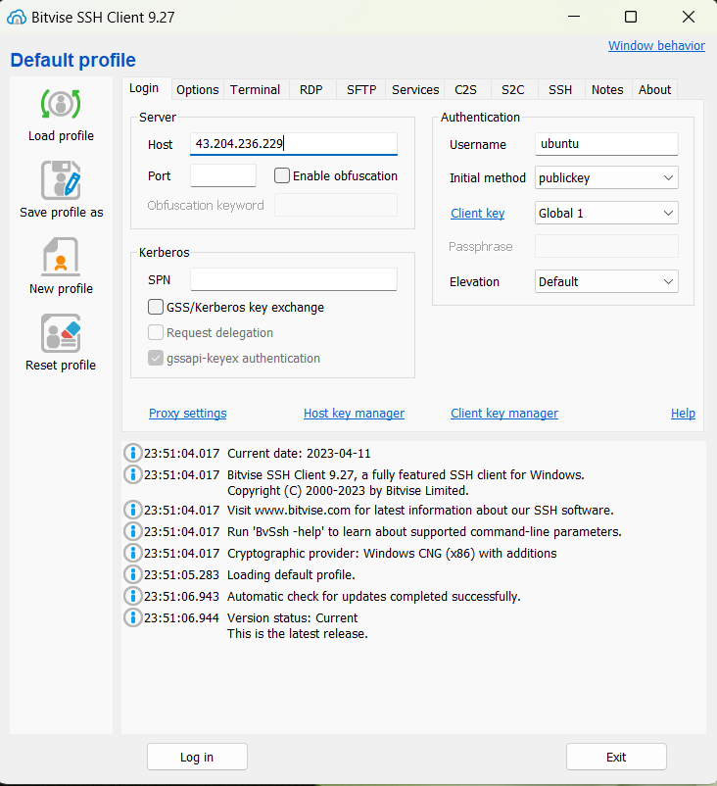

1. Go to Client Key Manager, remove existing keys and import the new key.

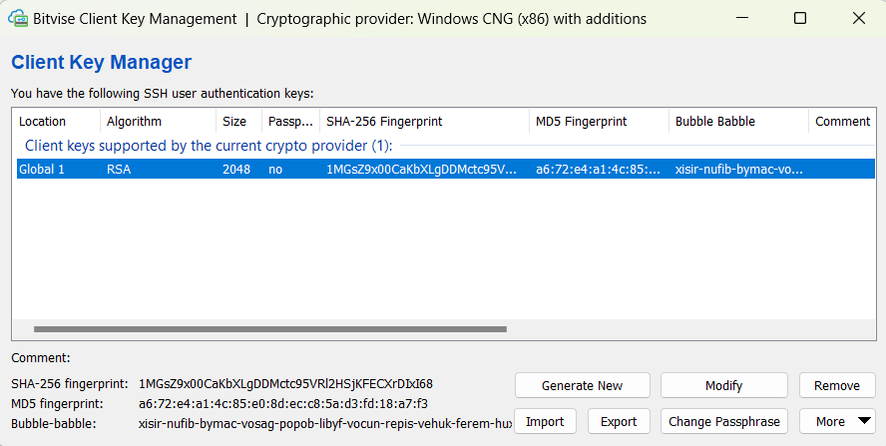

1. Log in. Set client key as Global1.Then you will get a ‘New Terminal Console’ option on the left hand side.Open it.

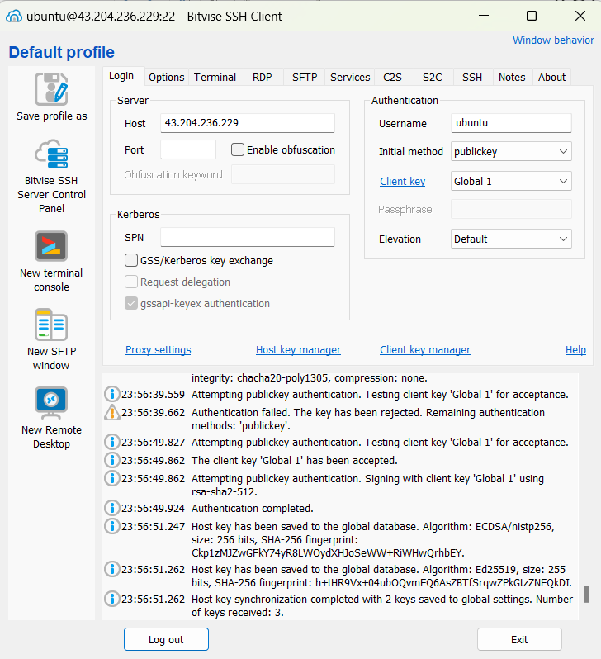

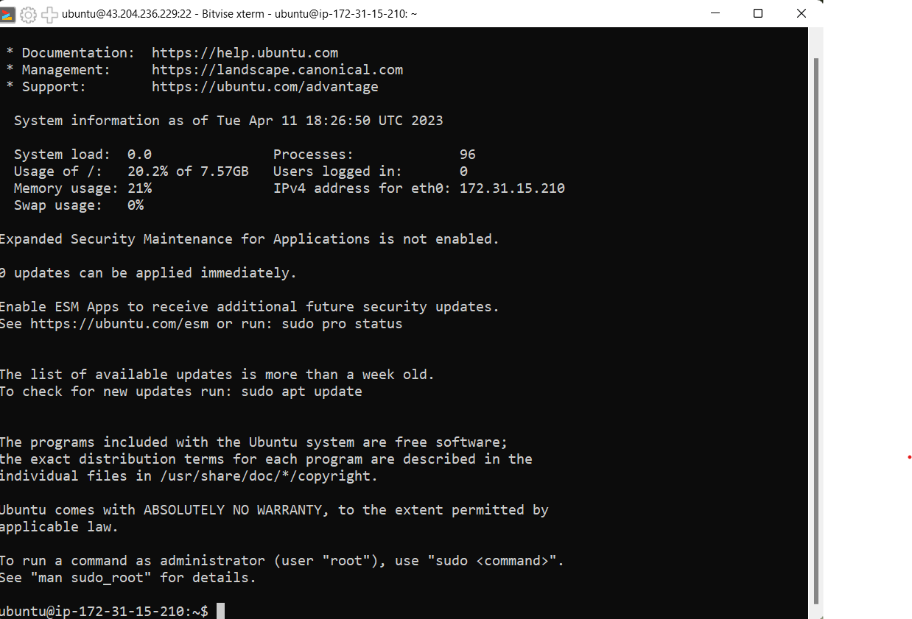

1. Enter the commands in the console:

i)pwd

ii)sudo apt-get update

iii)sudo apt-get upgrade

iv)sudo apt-get install nginx

v)curl -sL https://deb.nodesource.com/setup_18.x | sudo -E bash –

vi)sudo apt install nodejs

node -v

git clone [“repo](https://github.com/Sayan-K-Dutta/Assign8-Repo2.git) link”

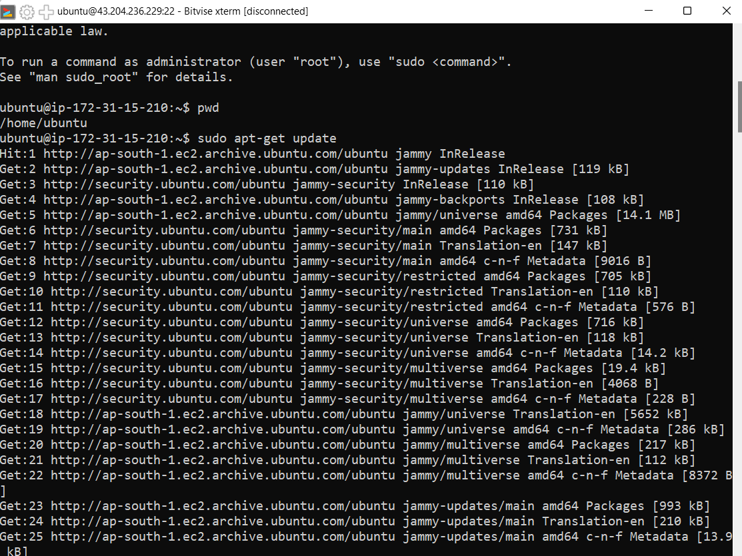

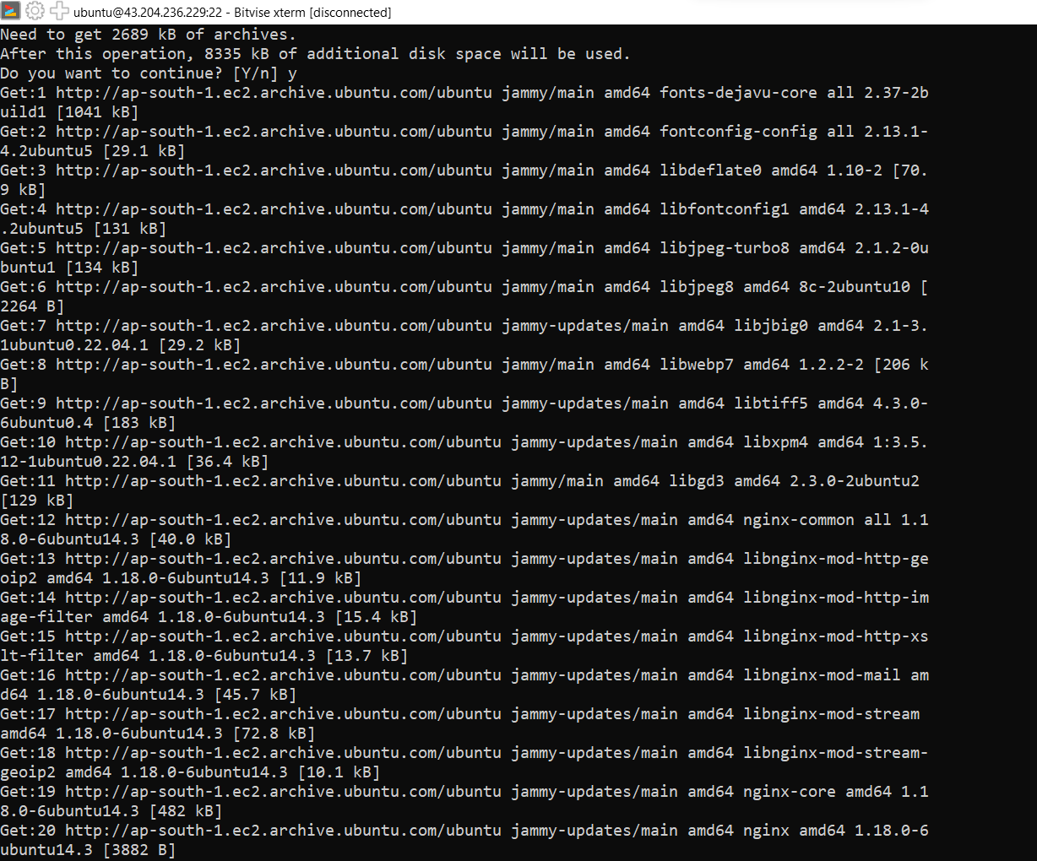

1. Give Username & token as the password.Then enter the commands in the Terminal Console:

i)dir

ii)cd Assign8-Repo2

iii)ls

iv)npm install

v)node index.js

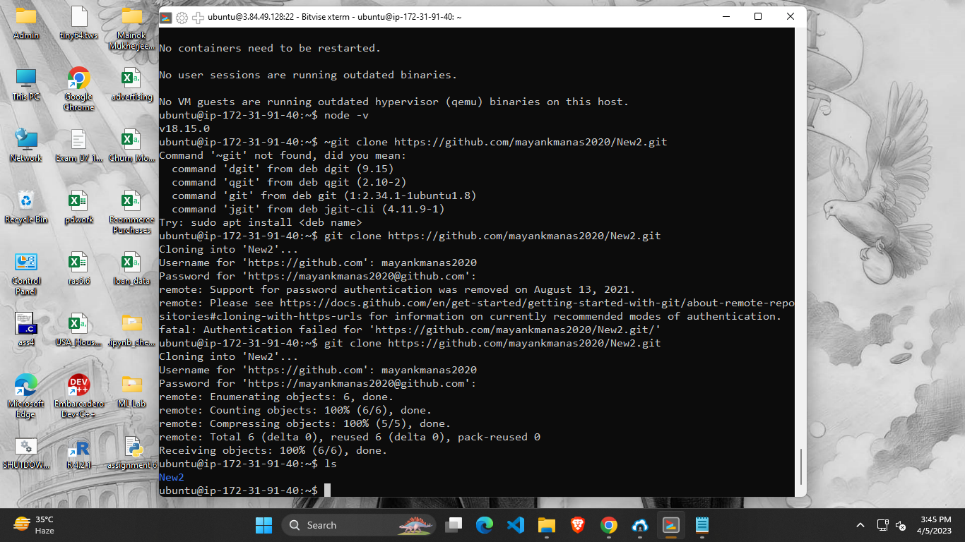

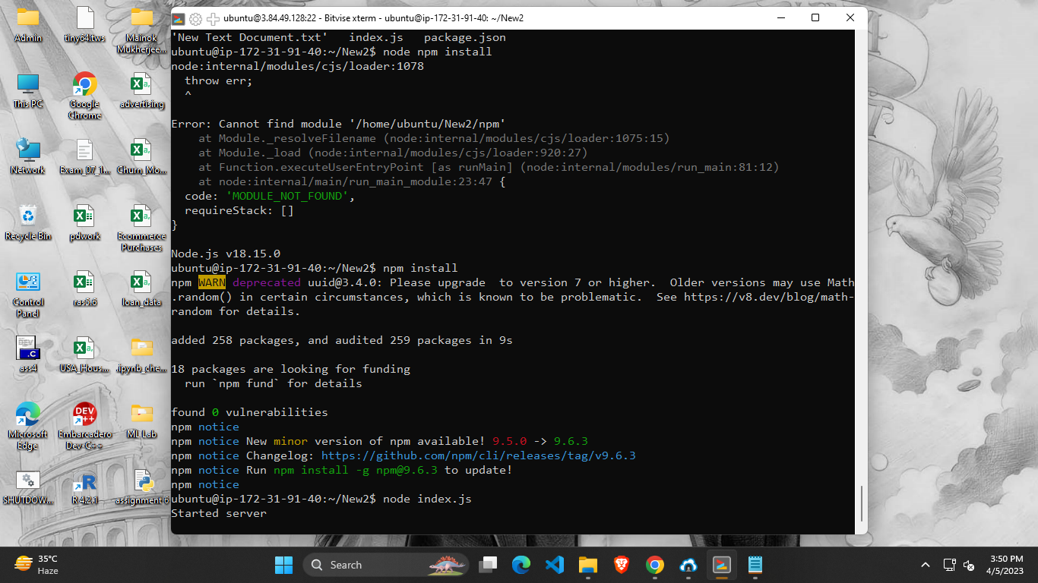

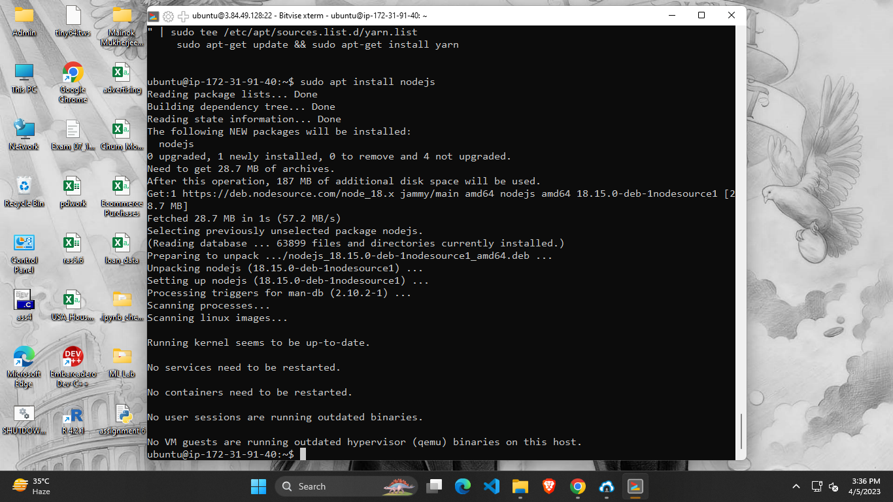

1. Go to web browser and paste public IPv4.

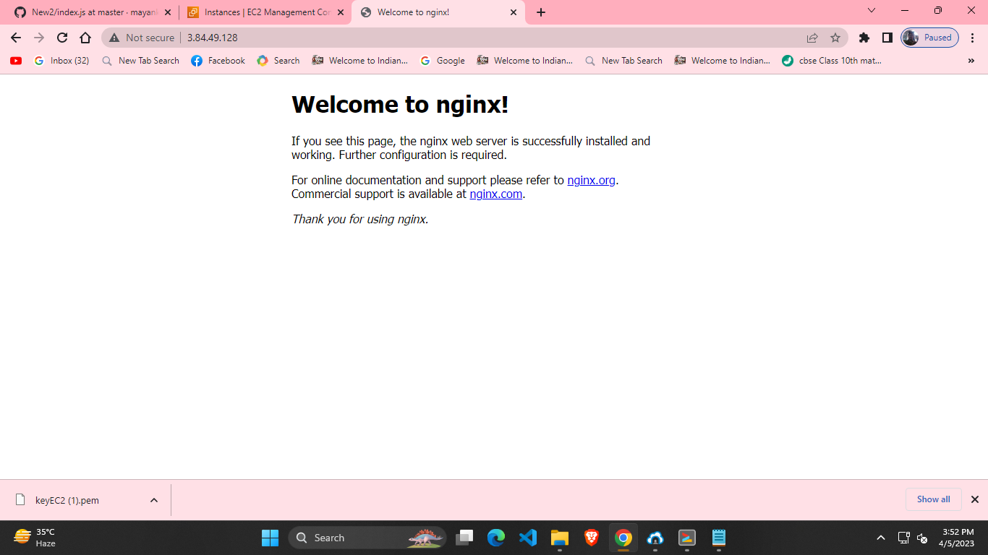

1. Now go to the ‘Security groups’ in the ‘Security’ section of the instance ID -🡪 Edit inbound rules. **Add rule**: Custom TCP --- Port range 4000 ---- 0.0.0.0/0 and then save the rule.

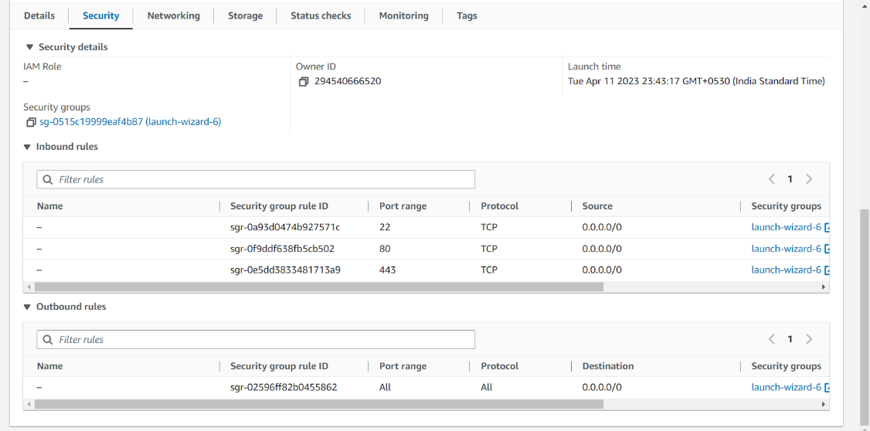

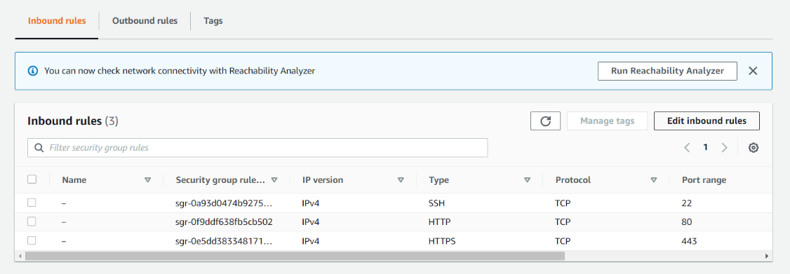

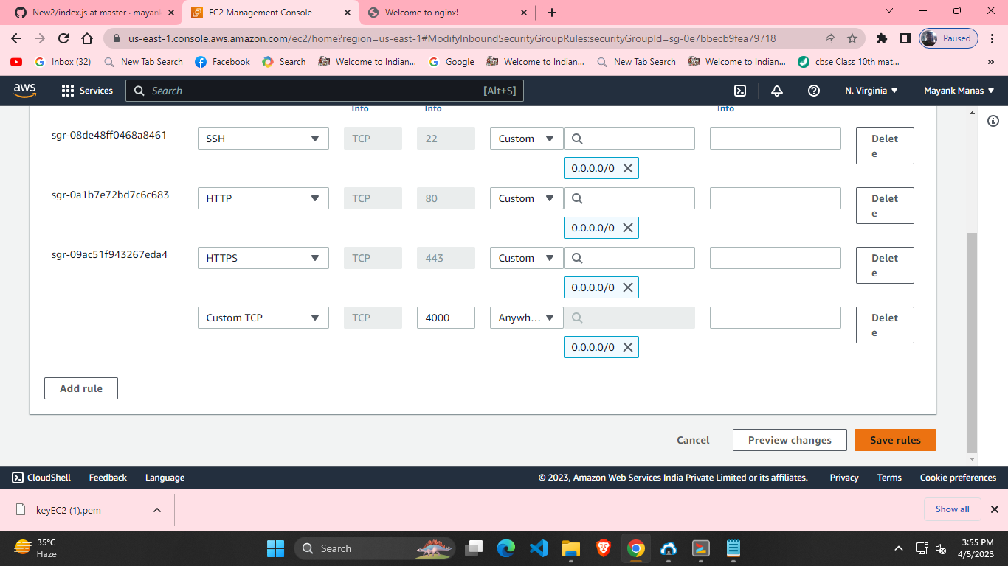

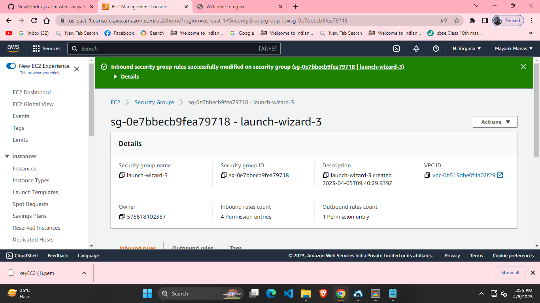

1. Now again go to the web browser and paste the public IPv4.

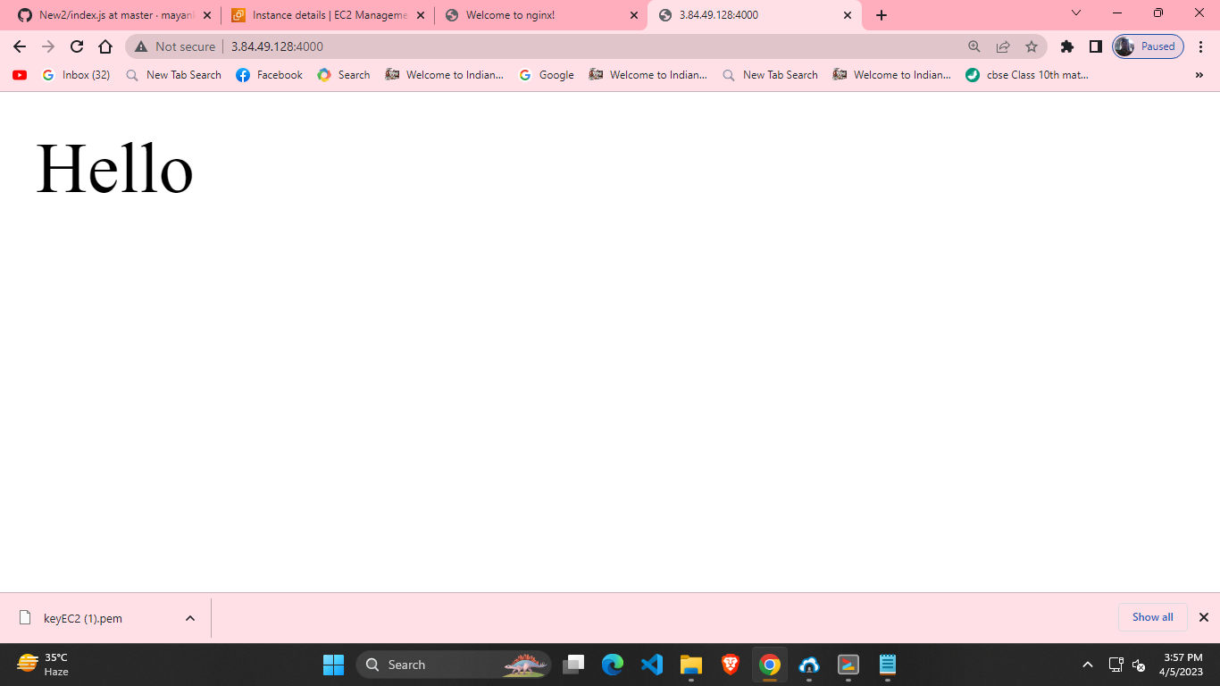

1. Go to the index.js file in GitHub and edit it.Then click on ‘Commit Changes’.

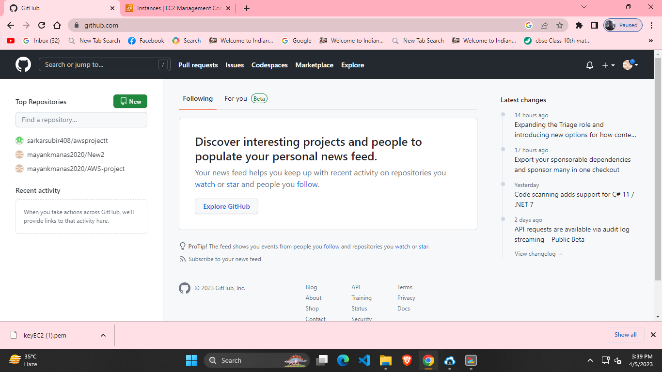

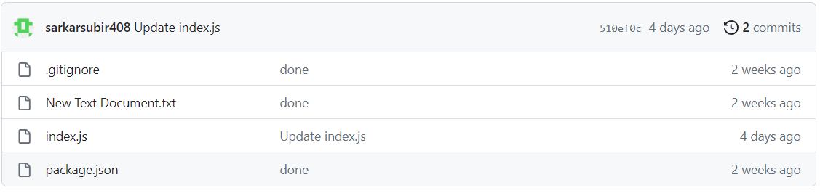

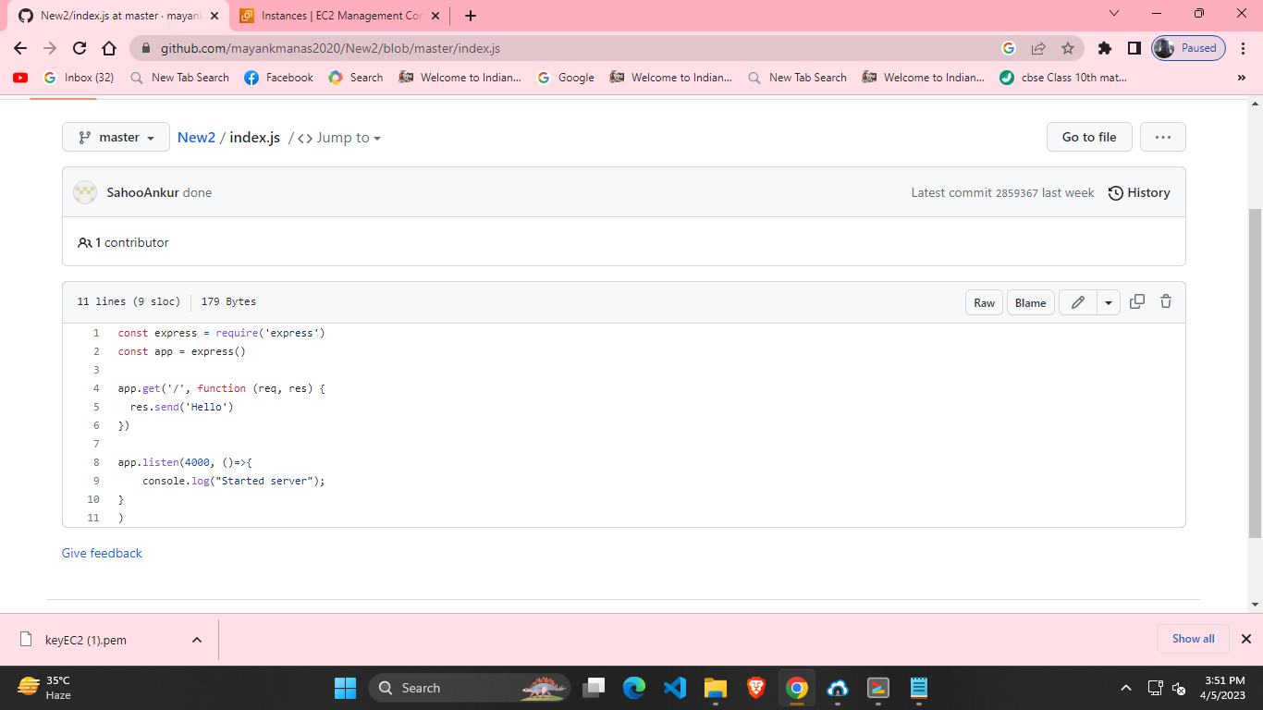

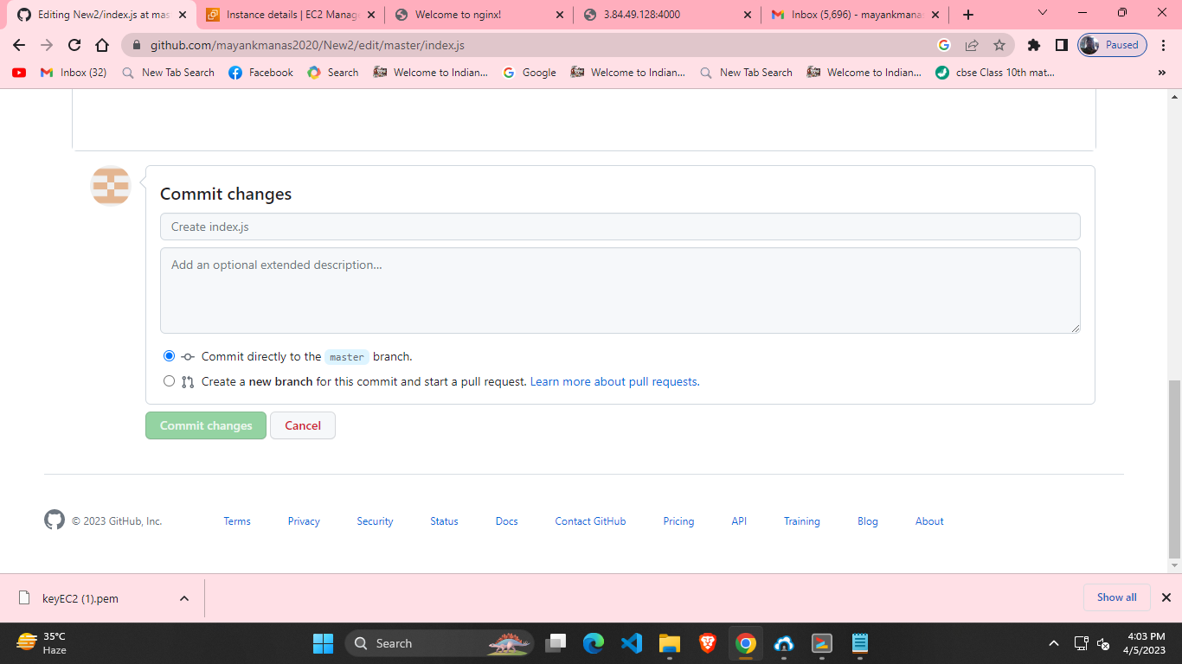

1. Stop the server by ctrl+c.
2. Enter command git pull. Enter Username and Password and type the command: node index.js.

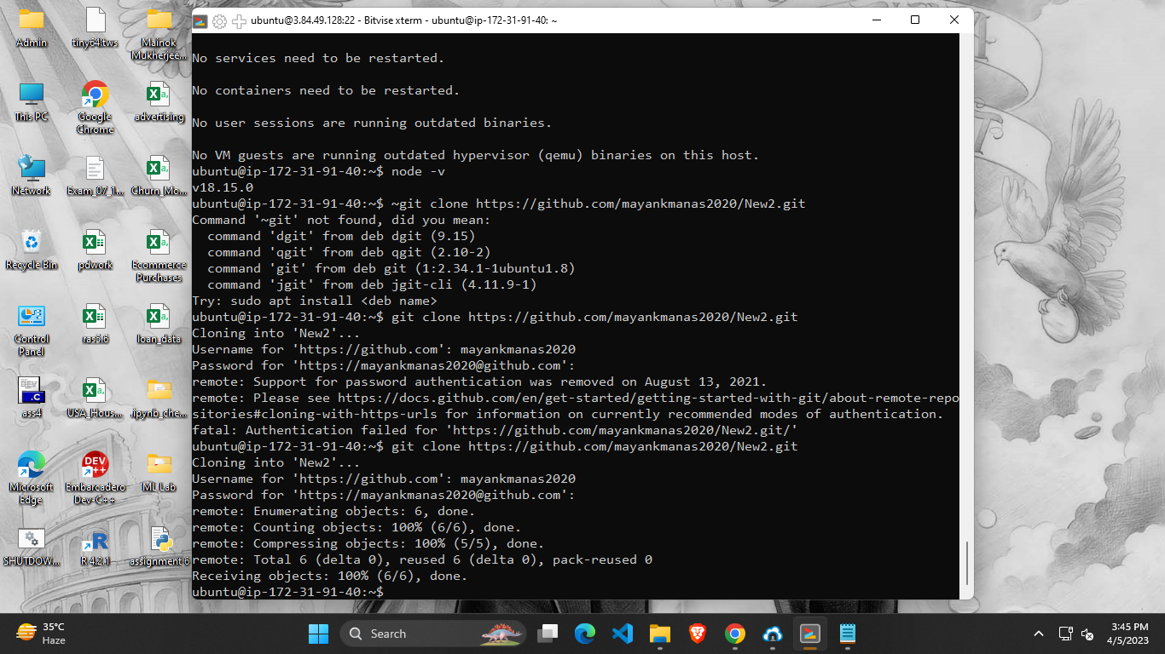



1. Now refresh the web browser.

