42) If K denotes the expectation, the variance of a random variable X is denoted as?

1. 2K(X)
2. K(X2) - (K(X)2)
3. K(X)2

**Answer:** Option c

**Explanation:**

According to the property of Expectation

**Variance V(X)** = K(X2) - (K(X))2

43) If K is a variance between 0 and 4. Find the value of K(X2)

1. 32
2. 64
3. 27
4. 9

Hide Answer Workspace

**Answer:** Option b

**Explanation:**

Integrating f(x) = X2 from 0 and 4 we get the value of K(X2) = 64

44) Find the median of the run made by a player in 5 T20 matches, 55,44, 21, 35, 45.

1. 55
2. 51
3. 45
4. 44

Hide Answer Workspace

**Answer:** Option d

**Explanation:**

Statistics MCQs

Where n = number of terms = 5

The median is the middle value of the data sets, so first, we need to arrange the number in ascending order 21,35,44,45,55

the middle one is 5+1/2 = 3rd number

so, the 3rd number is 44

45) Find the standard deviation of the given data sets 7,2,8,11,6,13,16

1. 4.64
2. 4.34
3. 2.34
4. 3.64

Hide Answer Workspace

**Answer:** Option b

**Explanation:**

If we want to calculate the standard deviation, first, we need to calculate the Mean of the given data sets

Therefore, **Mean** = 7+2+8+11+6+13+16/7 = 63/7 = 9

Now, we need to find the square root to calculate the variance = (Mean - each number of data sets)2

i.e.,

(9-7)2 +(9-2)2 +(9-8)2 +(9-11)2+(9-6)2 +( 13-9)2 +(16--9)2

=4 + 49 + 1 + 4 + 9 + 16 + 49

=132

So,

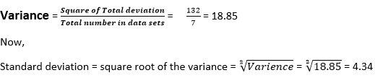

46) Find the coefficient of the given data sets 7,2,8,11,6,13,16

1. 48.64
2. 43.34
3. 42.34
4. 48.22

Hide Answer Workspace

**Answer:** Option d

**Explanation:**

If we want to calculate the standard deviation, first, we need to calculate the Mean of the given data sets

Therefore, **Mean** = 7+2+8+11+6+13+16/7 = 63/7 = 9

Now, we need to find the square root to calculate the variance = (Mean - each number of data sets)2

i.e.,

(9-7)2 +(9-2)2 +(9-8)2 +(9-11)2+(9-6)2 +( 13-9)2 +(16--9)2

=4 + 49 + 1 + 4 + 9 + 16 + 49

=132

So,

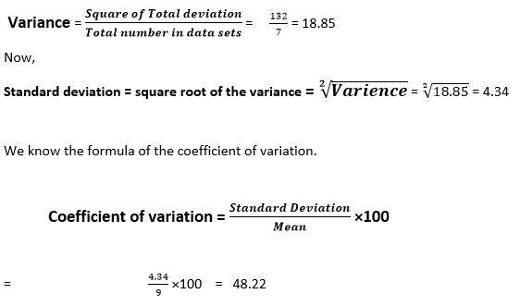

47) The random variables of A and B have variances 0.4 and 0.6, respectively, and K = 4A - 2B. Find the value of K

1. 2.2
2. 4.4
3. 6.6
4. 8.8

Hide Answer Workspace

**Answer:** Option d

**Explanation:**

Given

**Variance (A)** = 0.4 and Variance (B) = 0.6

And K = 4A - 2B

Therefore,

Var(K) = Var(4A - 2B)

= Var(4A) + Var(2B)

= 16 Var(A) + 4 Var(B)

Var(K) = 16*0.4 + 4*0.6

= 8.8

48) The mean value of the Hypergeometric distribution is given by the equation

1. E(X) = n*k/N2
2. E(X) = n*k/N-1
3. E(X) = n*k/N
4. E(X) = n*k/N3

Hide Answer Workspace

**Answer:** Option c

**Explanation:**

The equation gives the Mean of the Hypergeometric distribution

**E(X) = n*k/N**

Where,

N denotes the number of trails

K denotes the number of success

And, N denotes the sample size

49) The Variance of the Hypergeometric distribution is given by the equation

1. n* k (N-k)*(N-n)/[N2*(N-1)]
2. n* k (N-k)*(N-n)/[N3*(N-P)]
3. n* k (N-1)*(N2-n)/[N2*(N-1)]
4. n* k (N-k)*(N2-n)/[N3*(N-1)]

Hide Answer Workspace

**Answer:** Option a

**Explanation:**

The variance of the Hypergeometric distribution is given by n* k (N-k)*(N-n)/[N2*(N-1)].

Where,

n denotes the number of trails

K denotes the number of success

An, N denotes the sample size.

50) Find the range of the following data sets 61,22,34,17,81,99,42,94.

1. 81
2. 82
3. 83
4. 84

Hide Answer Workspace

**Answer:** Option b

**Explanation:**

We know that,

**Range = Maximum Value - Minimum Value**

Here, Maximum value in the data sets = 99, and Minimum value = 17

Therefore, Range = 99-17= 82