MA322 – Scientific Computing Lab

Lab – 03

Dipanshu Goyal 210123083

# I have used Error as |xn+1 – xn|. To run, open and run output_file.m file.

# For the loglog plot between Error and number of iterations, I have used the inbuilt loglog(.) function in MATLAB.

# For plotting function plot between specific intervals, I have used inbuilt fplot(.) function in MATLAB.

# Ques - 1

Function Taken => f(x) = x4 – x – 10 and g(x) = (x + 10)(1/4).

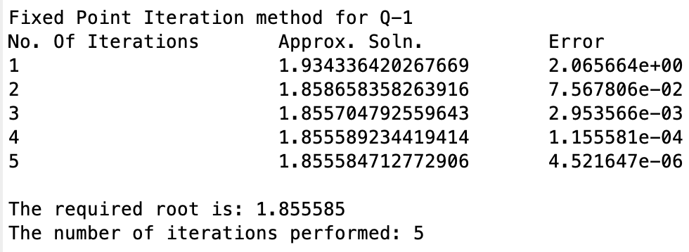

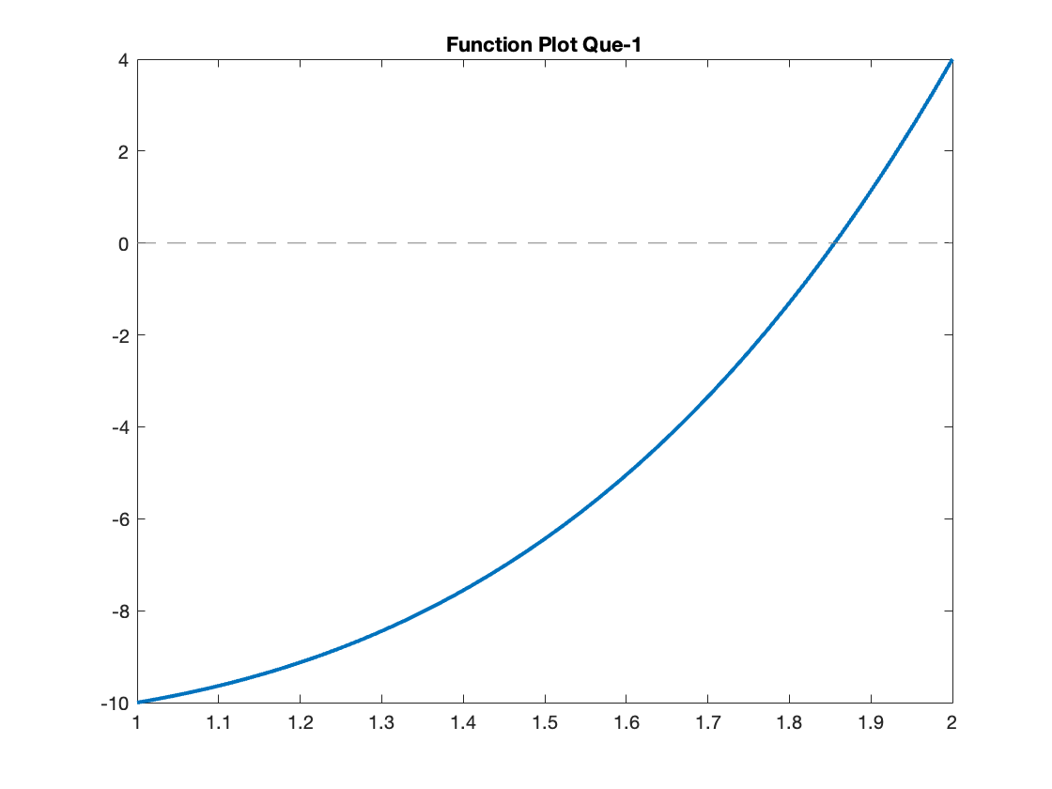

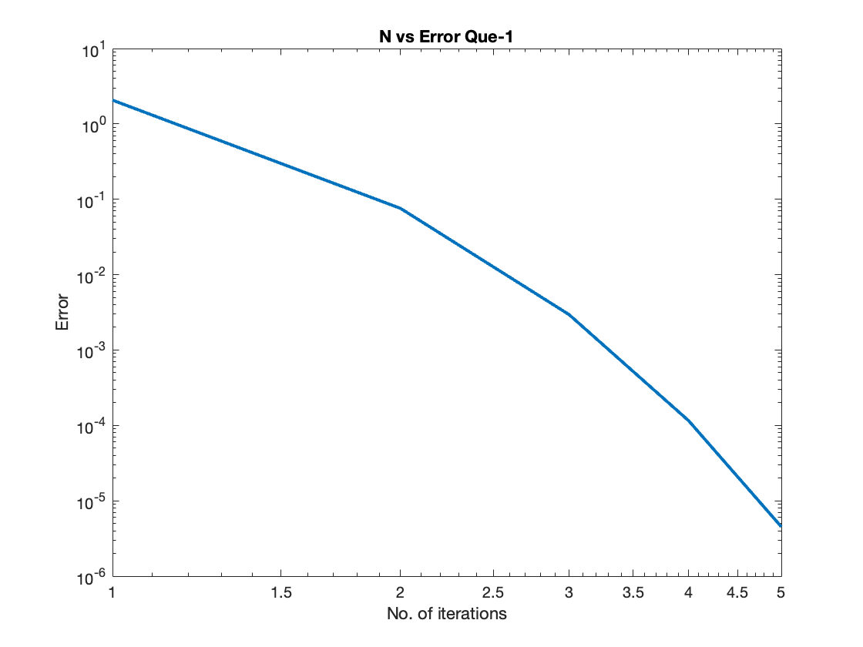

# Ques – 2

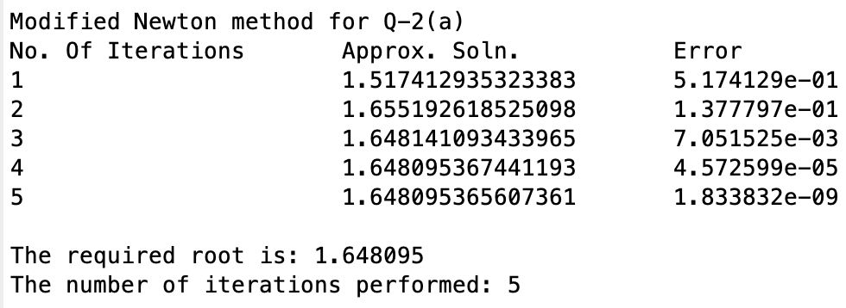

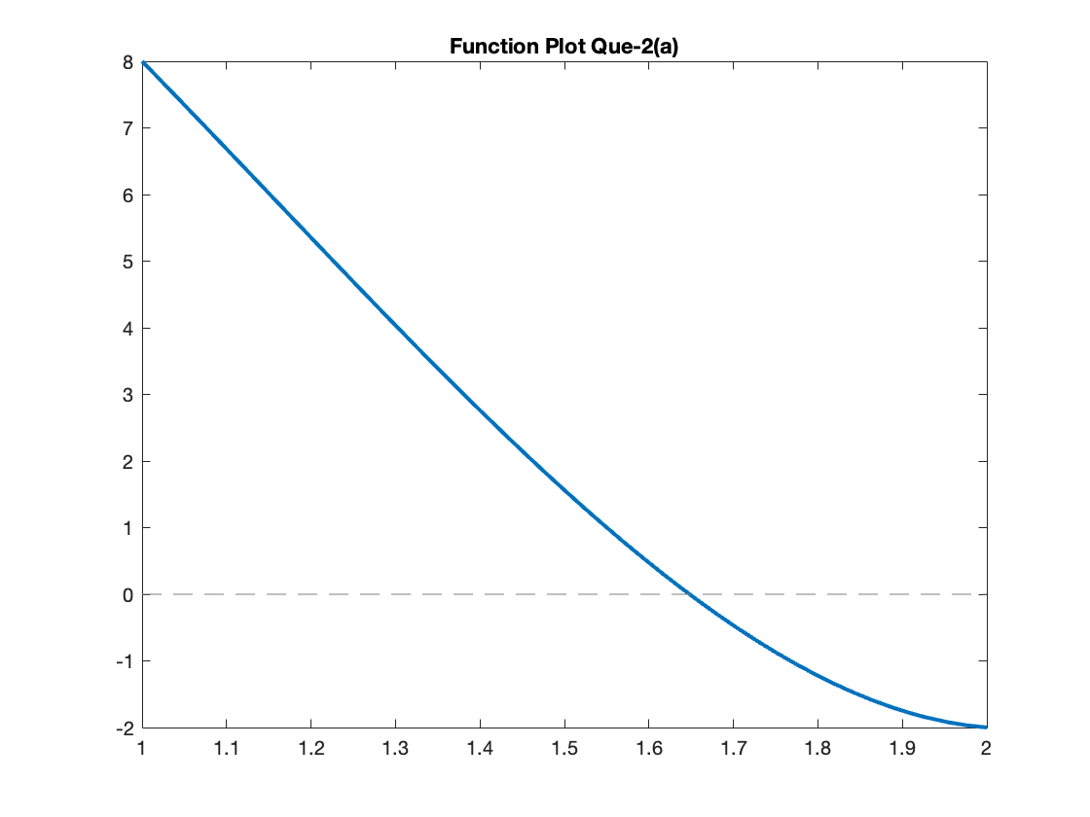

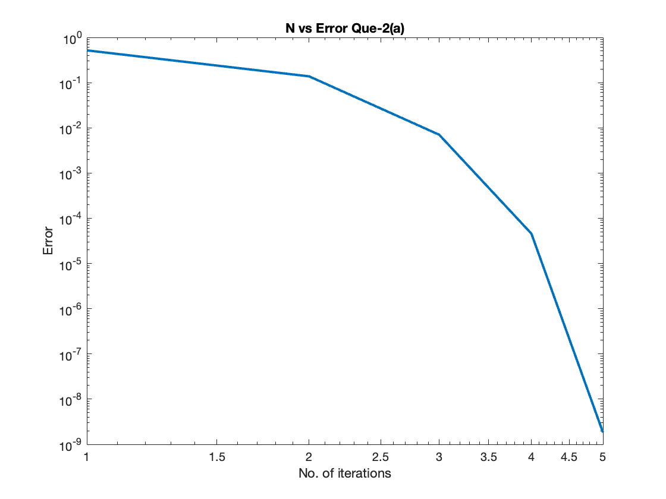

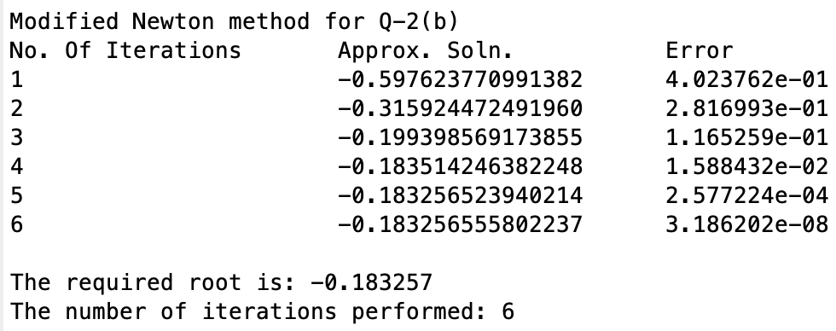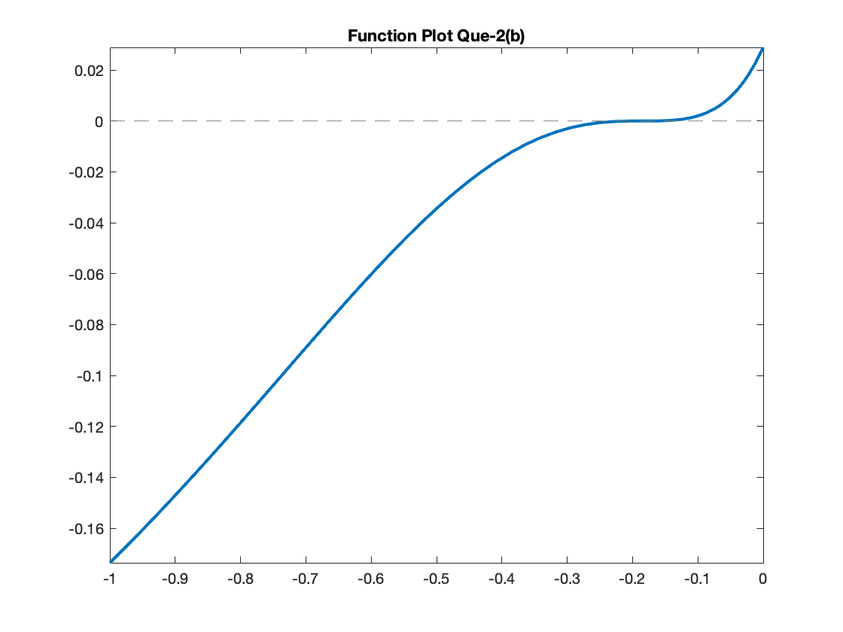

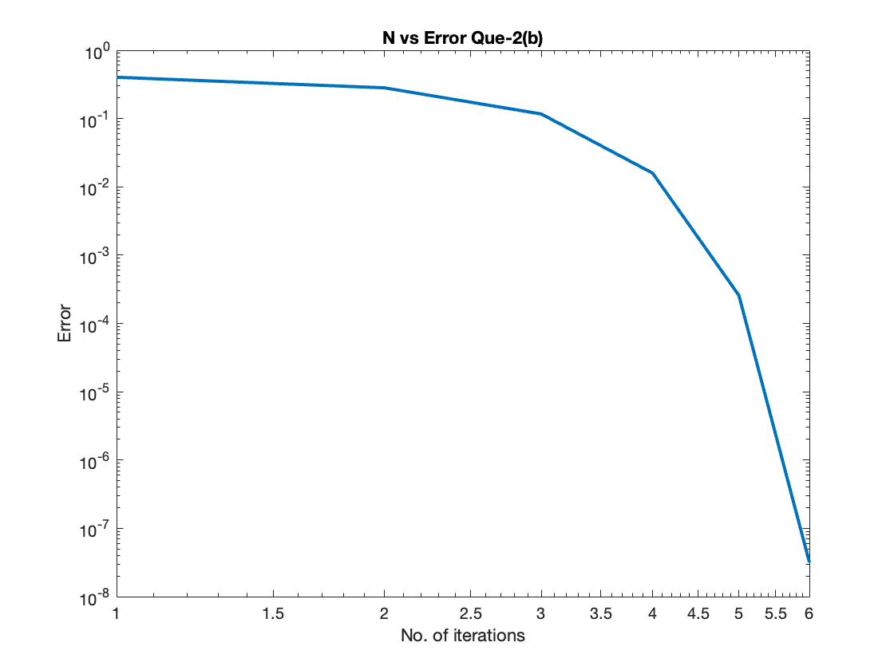

# Ques – 3

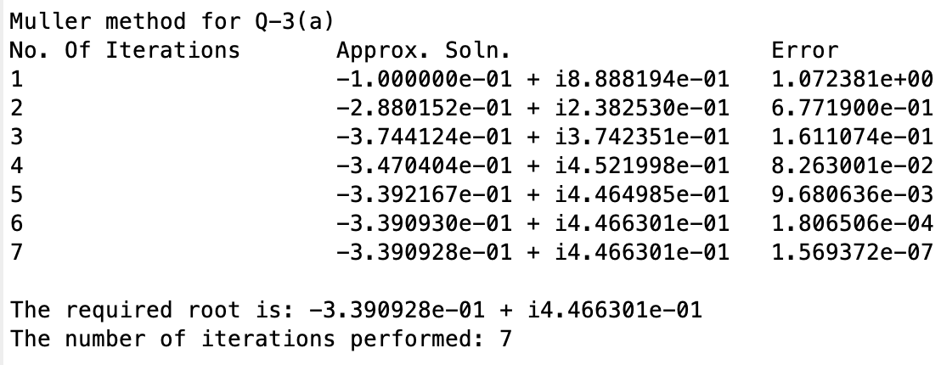

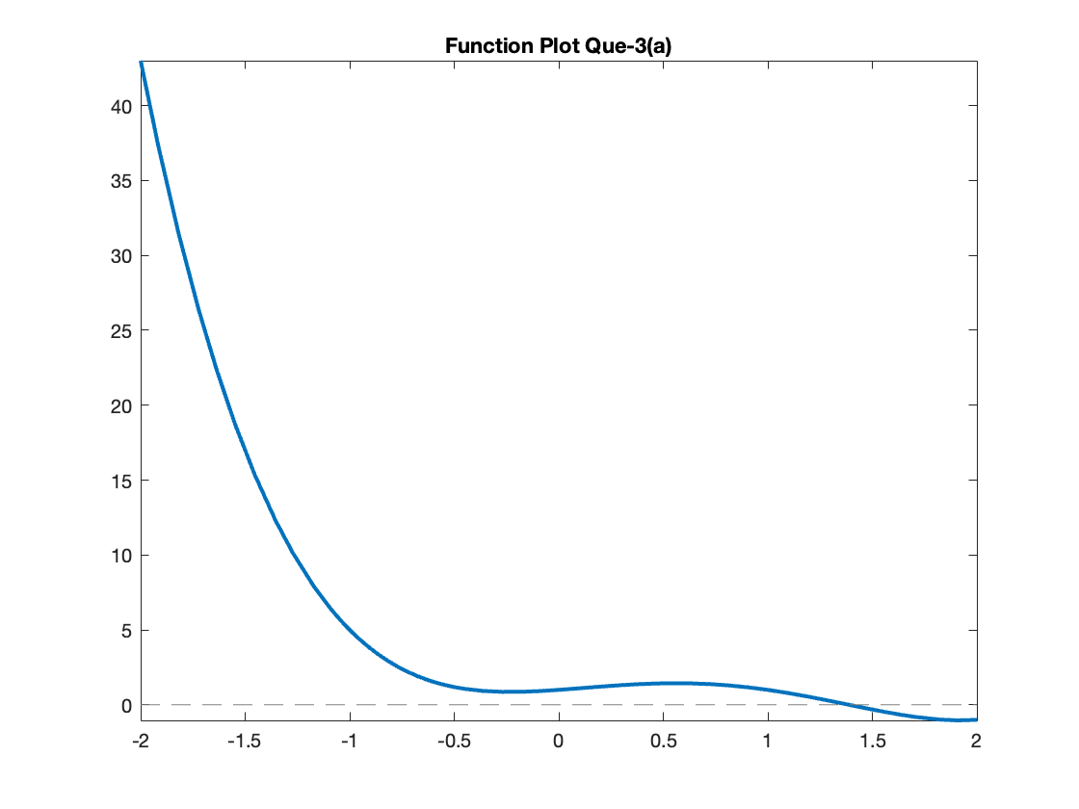

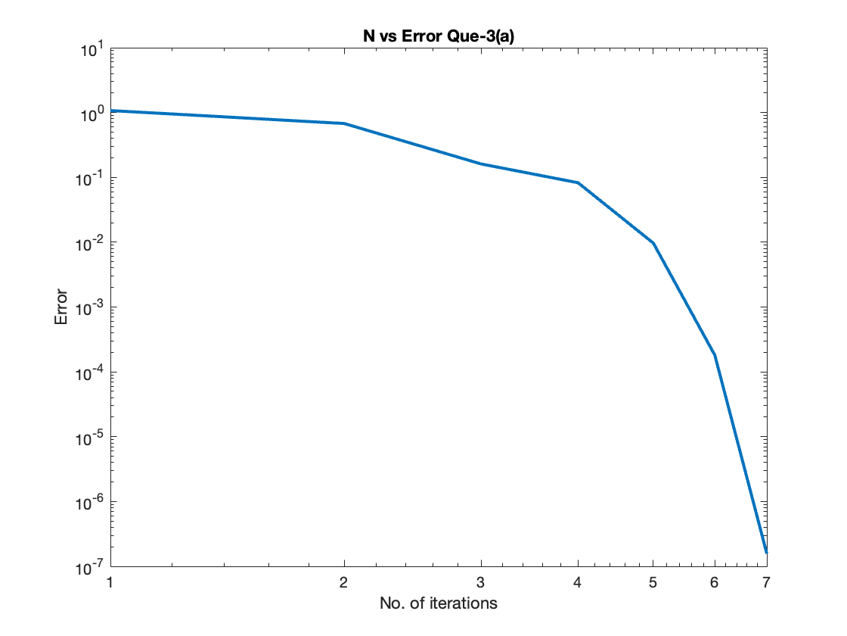

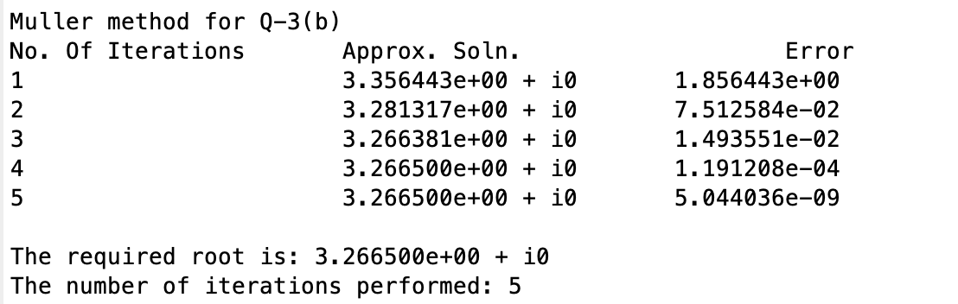

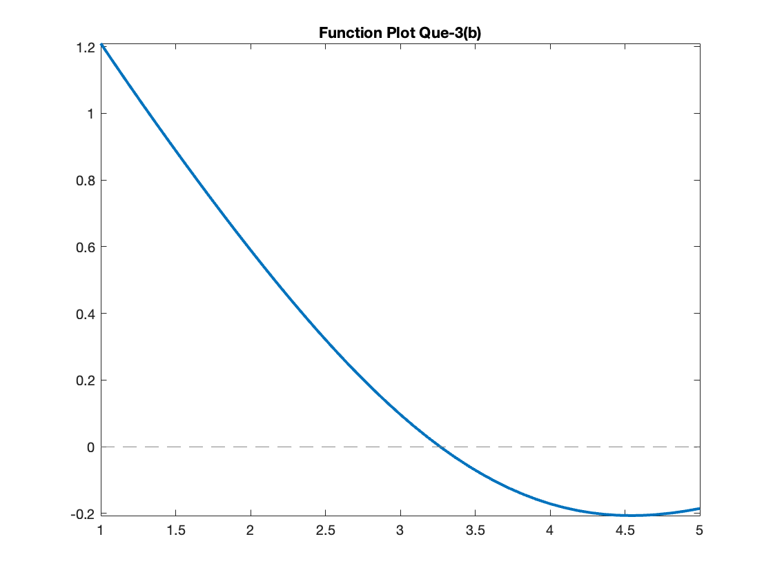

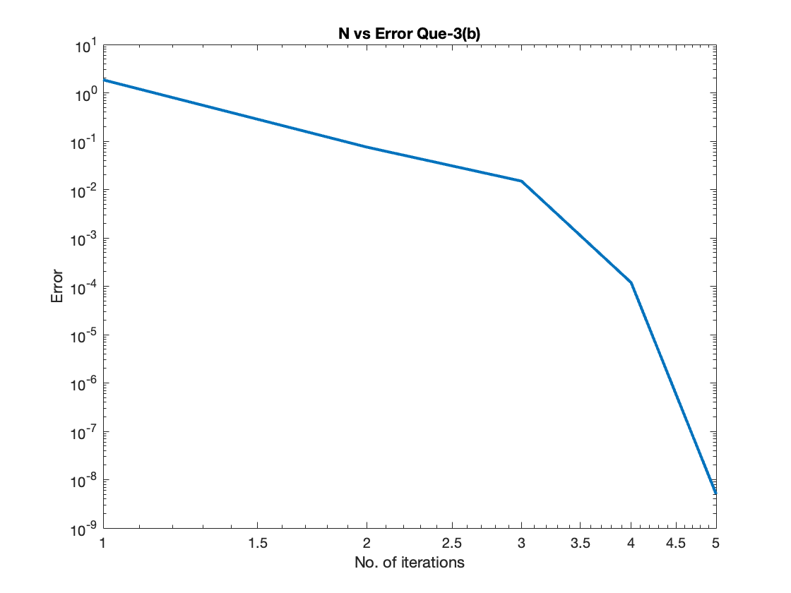

# Ques – 4

Function Taken => f(x) = x2 – 31 and g(x) = ½(x + 31/x).

