MA322 – Scientific Computing Laboratory

Lab - 04

Dipanshu Goyal 210123083

# Function plots are only done for que – 2(a) and 2(b) as que 1 and 3 will require 4D-plots.

* For termination by number of iterations, I took tolerance as 0(almost never achievable) and for termination by tolerance, I took max. iterations as a integer big enough like 1000.
* Run output_file.m to run the code.

# Ques – 1

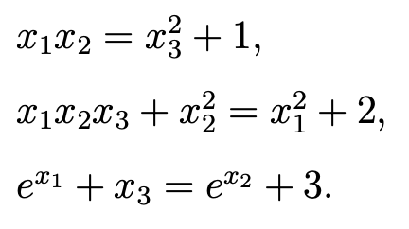

6 iterations of Newton Method for given system of equations taking x0 = [1,1,1]T as initial approximation: -

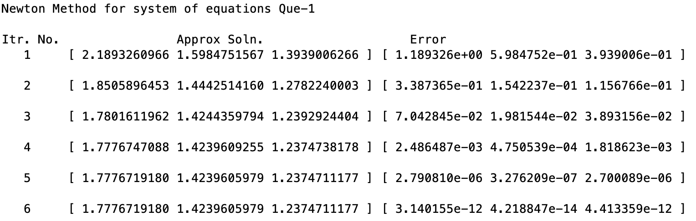

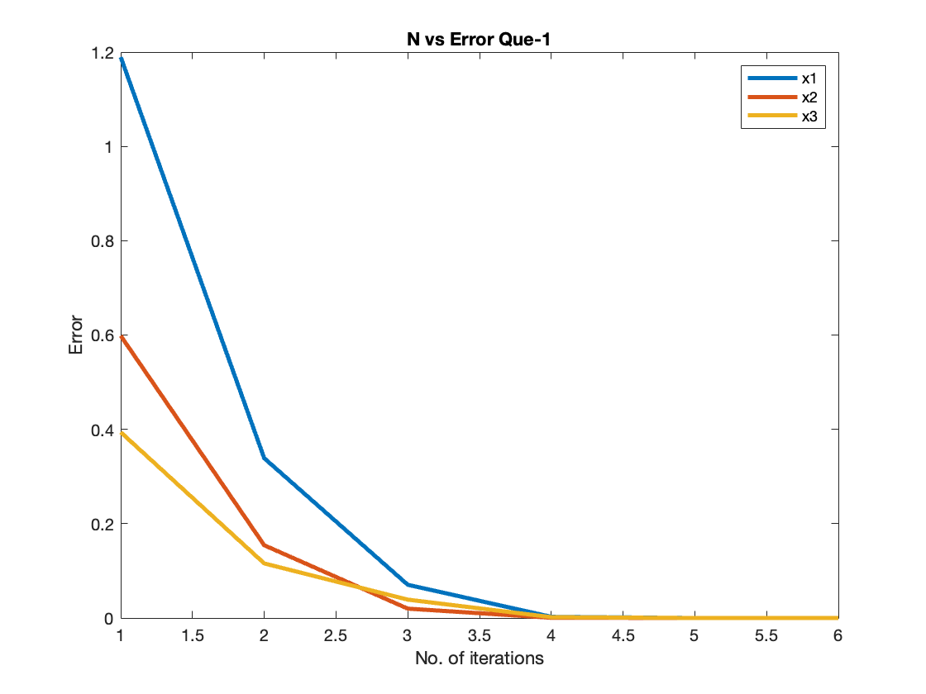

# Ques – 2

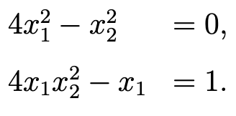

2 iterations of Newton Method for given system of equations taking x0 = [0,1]T as initial approximation: -

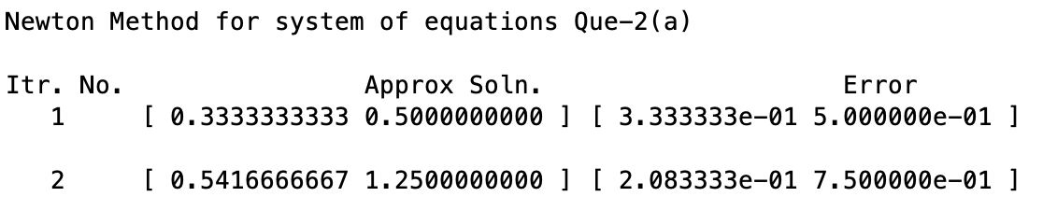

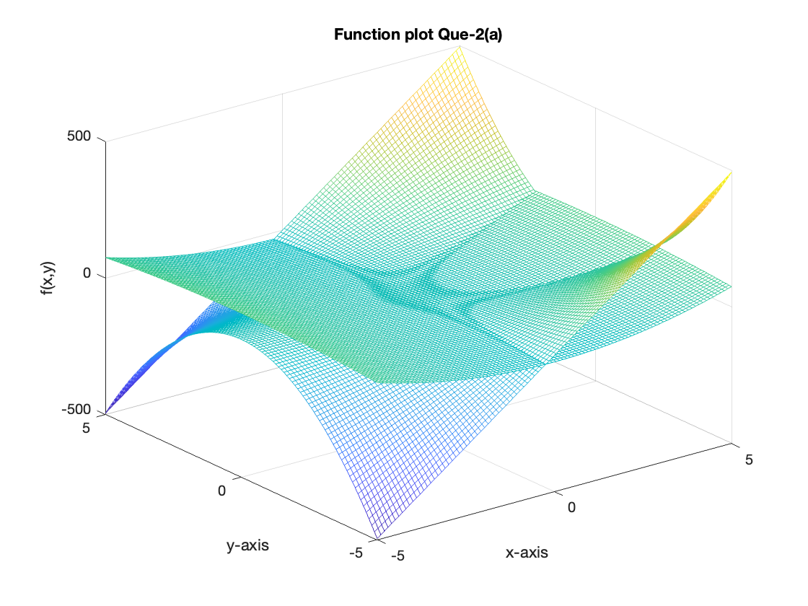

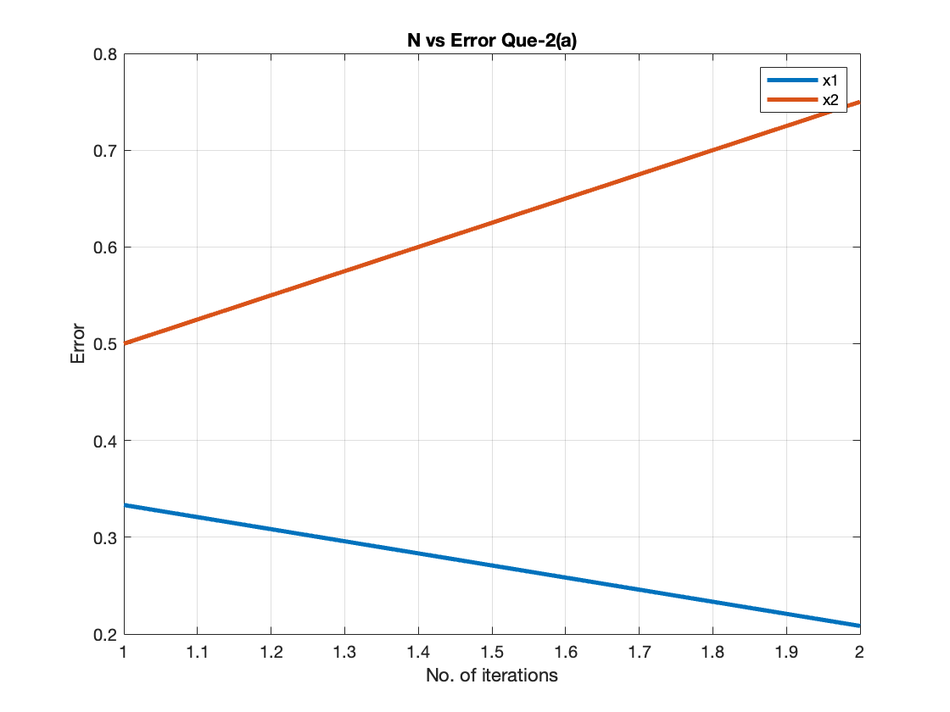

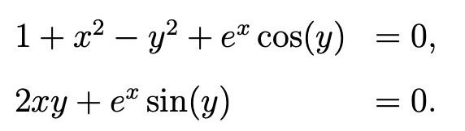

5 iterations of Newton Method for given system of equations taking x0 = [-1,4]T as initial approximation: -

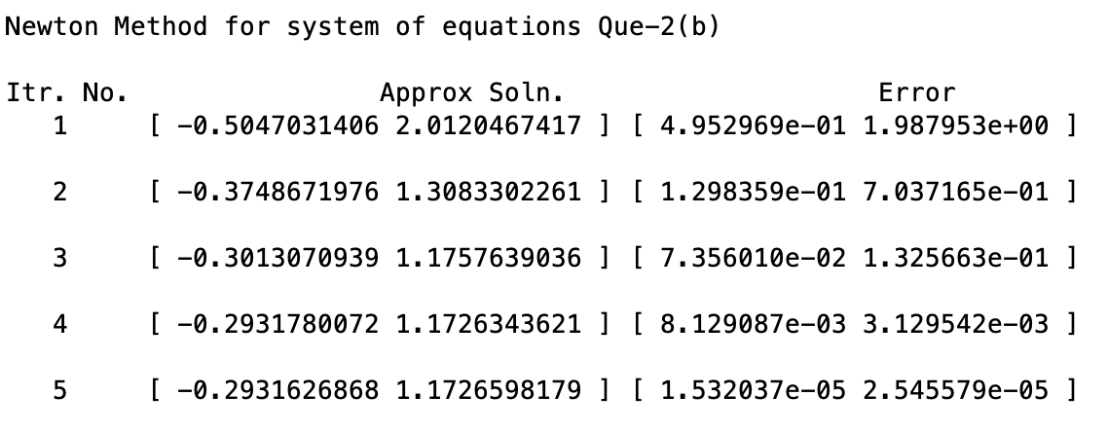

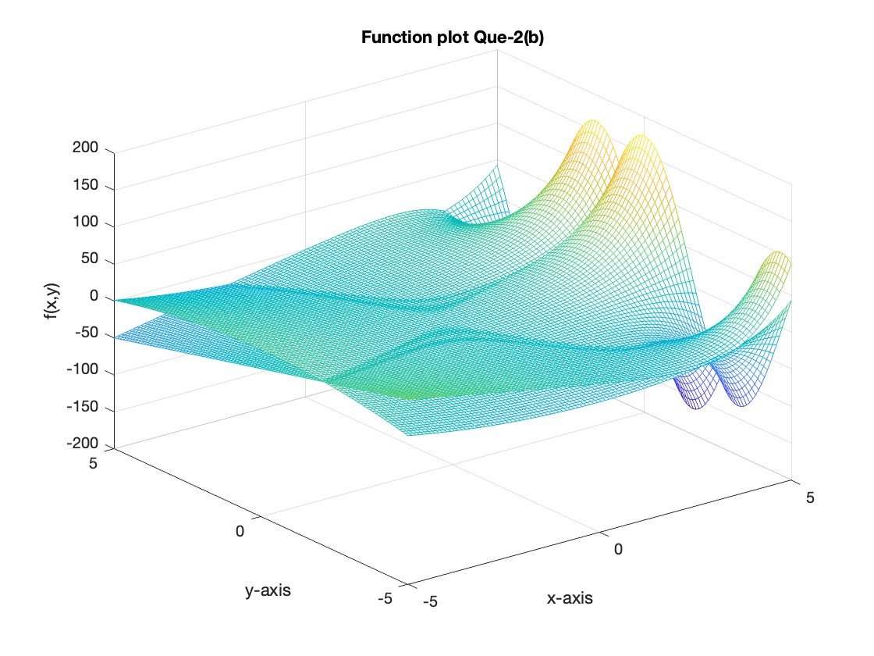

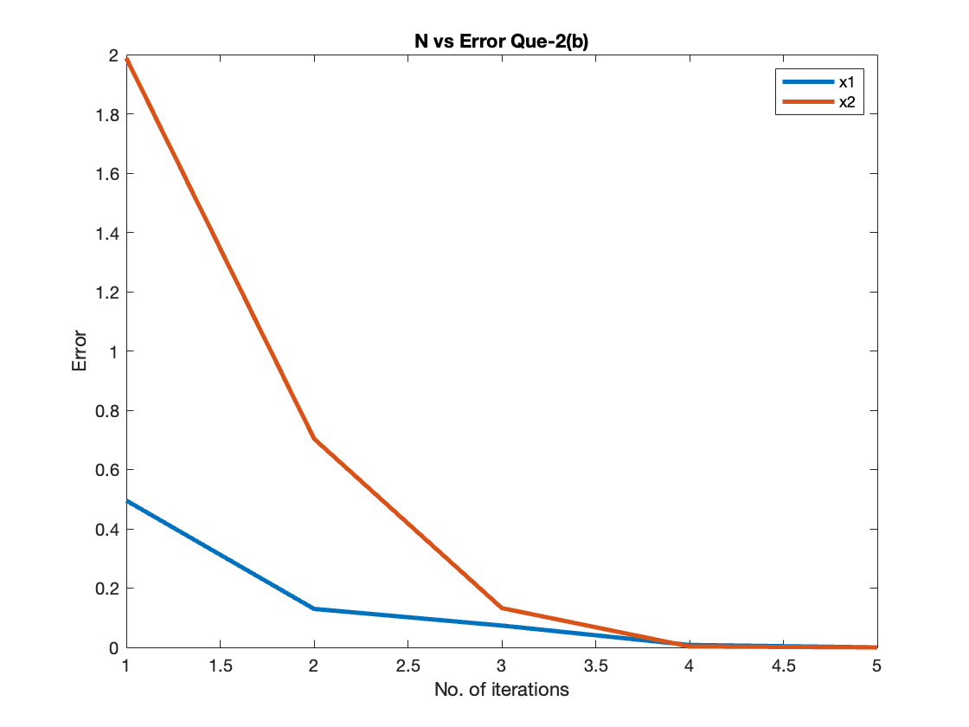

# Ques – 3

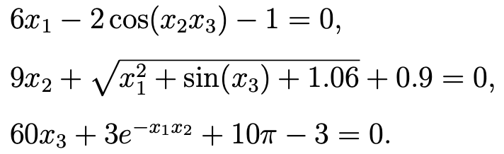

Newton Method for given system of equations taking x0 = [0,0,0]T as initial approximation and tolerance = 10-6.

