MA322 – Scientific Computing Laboratory

Lab – 06

Dipanshu Goyal 210123083

➢ Run output_file.m to run the code.

# Ques – 1

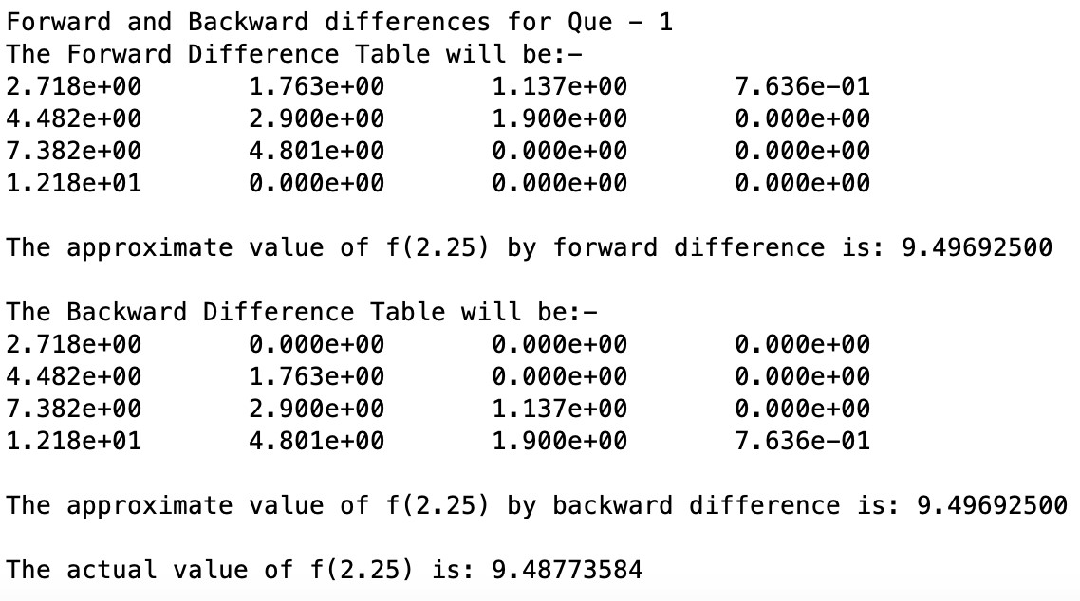

The approximate value of f (2.25) is same for both forward and backward difference method because both the methods will result in same interpolating polynomial p(x), both are just different approaches to achieve it.

Also, we observe that, the obtained value is very close to the actual value.

# Ques – 2

For forming interpolating polynomials of degree one, two and three respectively, I took the first two points for linear polynomial, then took next point and updated the difference table for quadratic polynomial and repeated same for last point to get cubic polynomial.

(a)

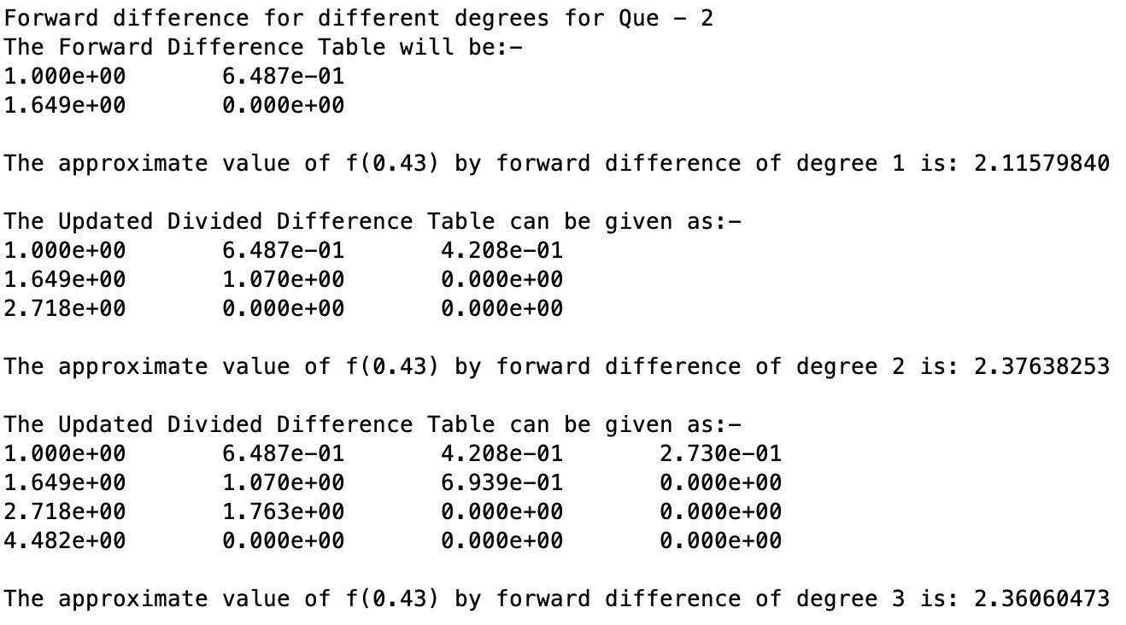

The interpolating polynomials of degree one, two and three can be plotted as follows: -

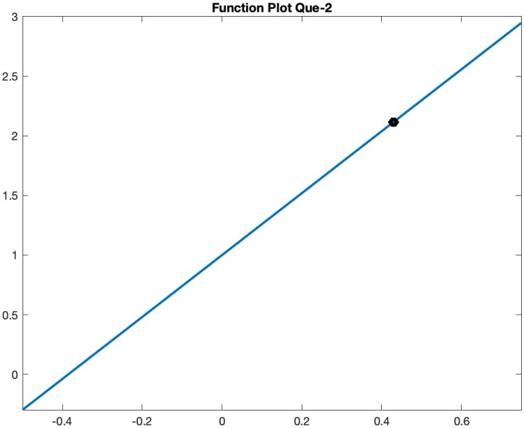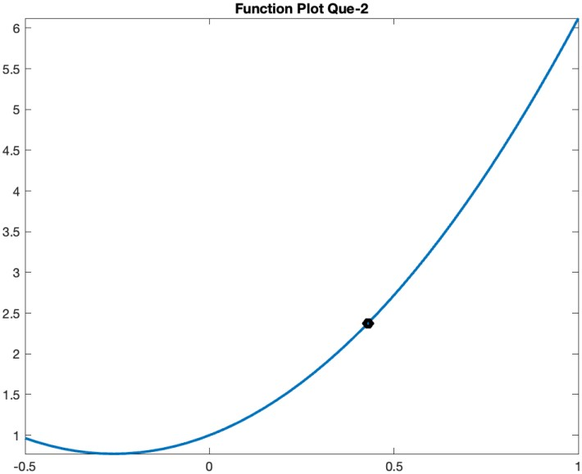

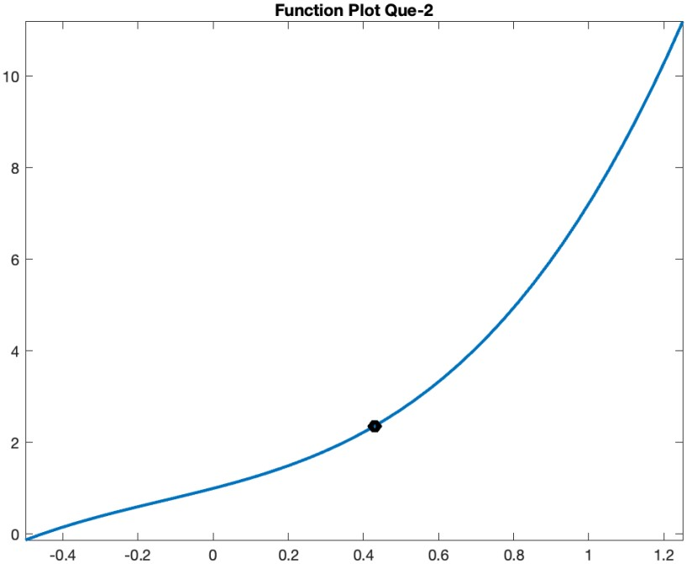

(b)

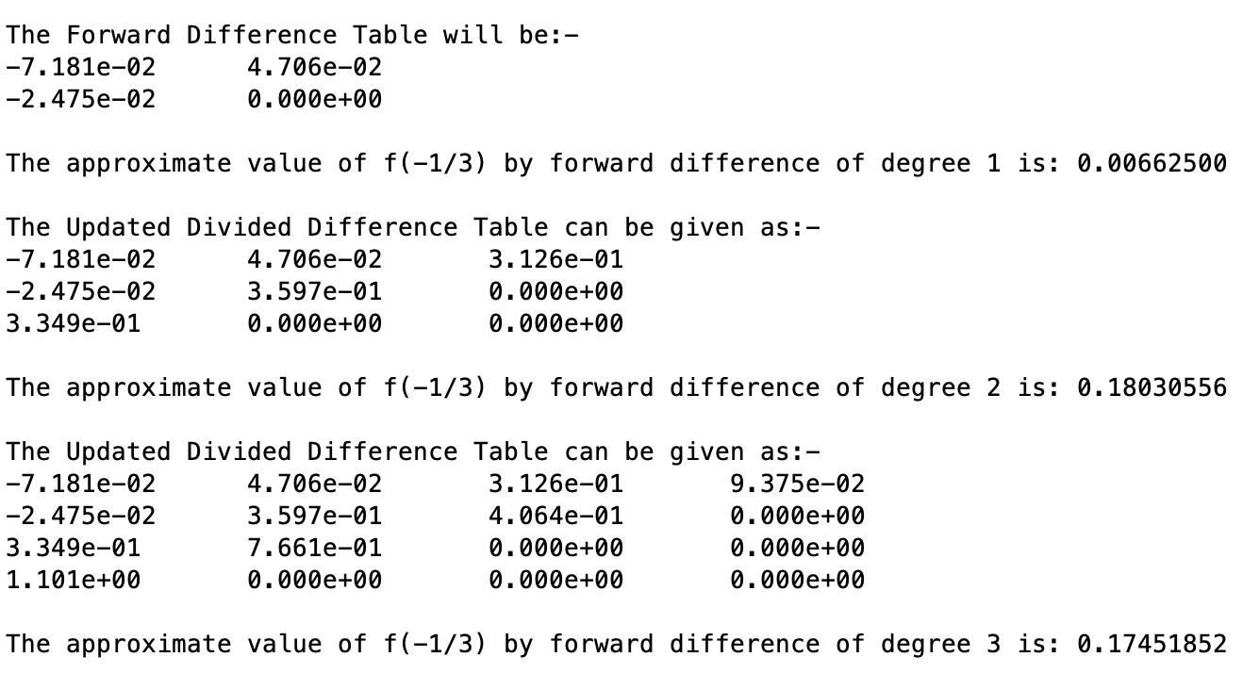

The interpolating polynomials of degree one, two and three can be plotted as follows: -

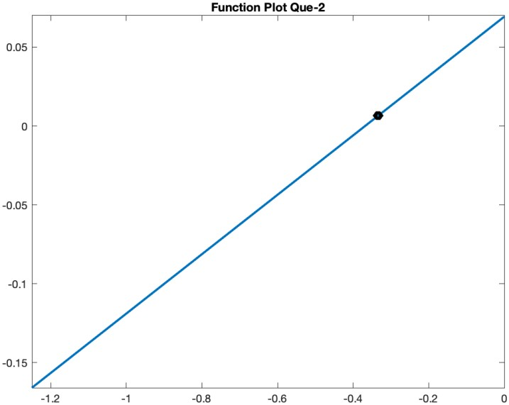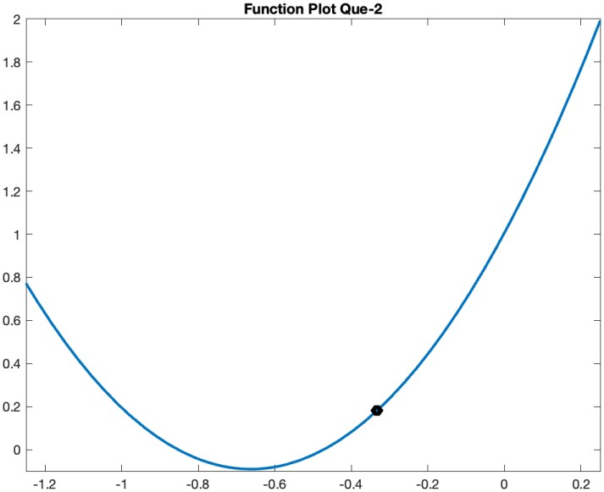

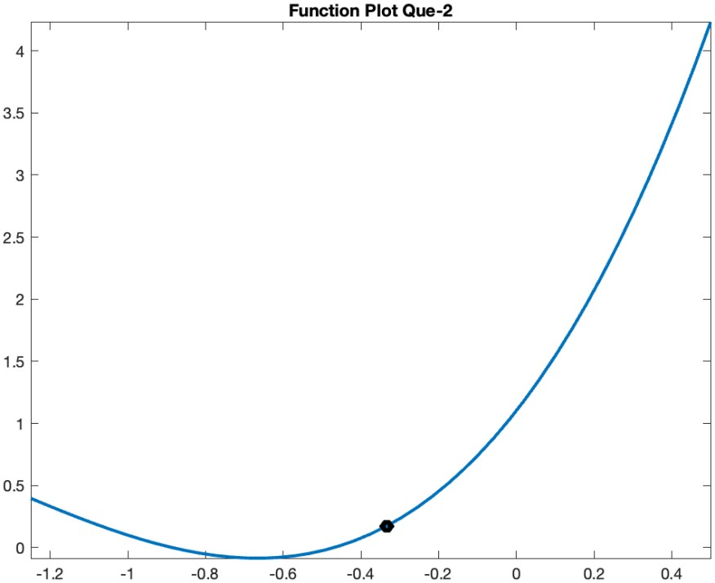

# Ques – 3

I performed the 10 iterations of interpolation of f (x) = 1/ (1 + x2) by Pn(x) by using the Lagrange method, forward difference method and backward difference method and compared the polynomial value with exact value of function at x0 = 1+ sqrt(10) i.e. 4.162278 to form the sequence {yn}, where yn = Pn(x0).

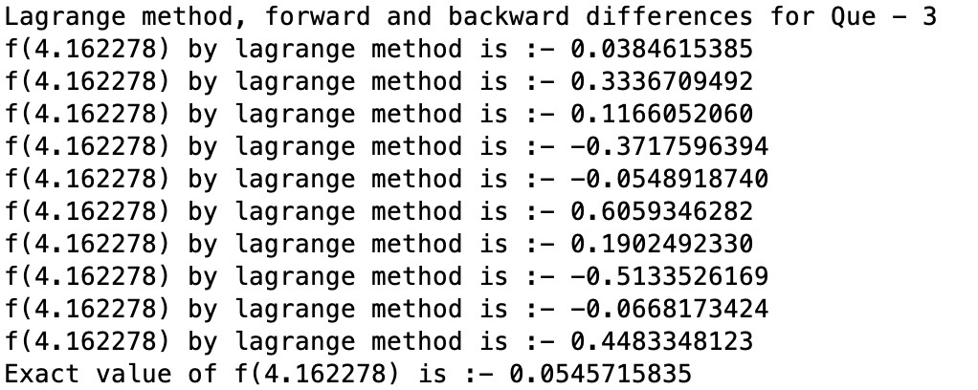

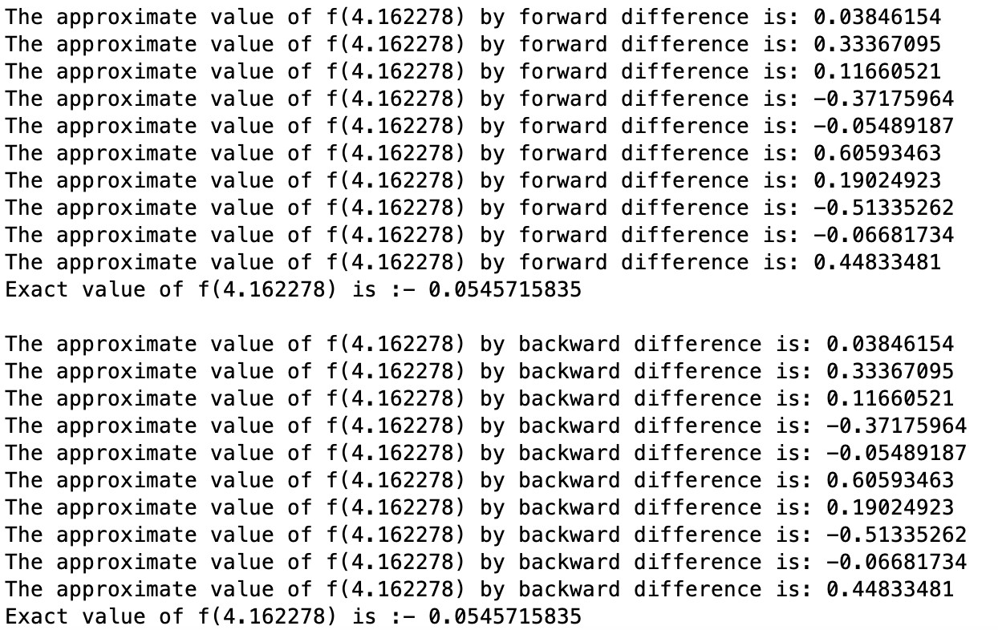

We observe that {yn} is not converging, instead it’s continuously fluctuating over different values far from the actual value. We can visualize this with the help of a plot between number of iterations and the absolute error in the obtained value, i.e., abs. error = | Pn(x0) – f(x0) |. By the plot, it is clear that the error is fluctuating instead of converging to 0.

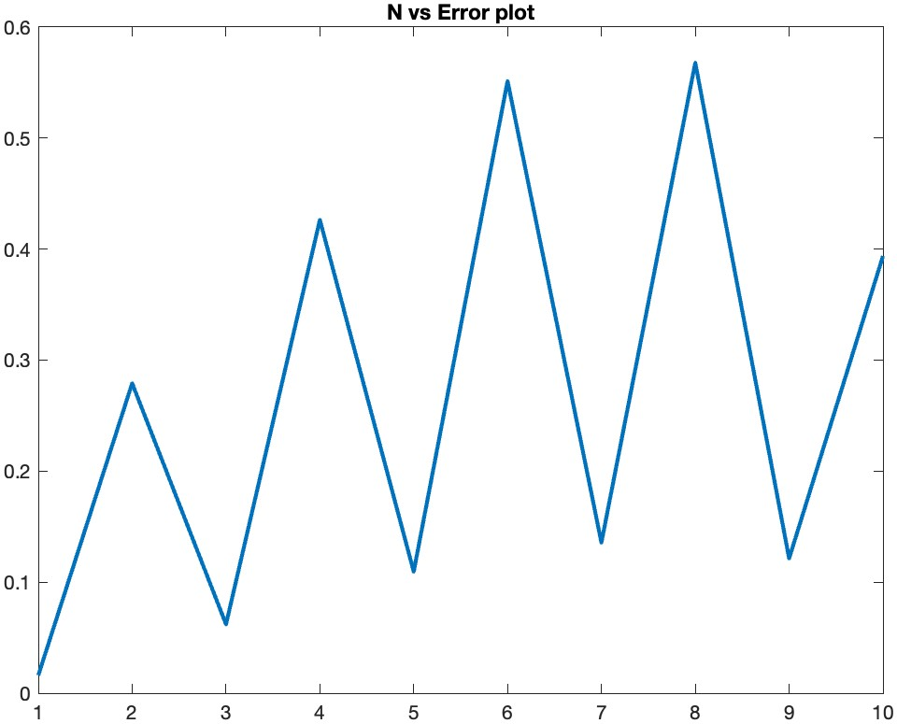

The reason behind this may be that the upper bound on error in interpolation of f(x) is increasing with increasing n because the magnitude of nth derivative of f(x) = 1/(1+x2) increases if we increase n. This shows that increasing the number of points doesn’t always guarantee convergence of interpolating polynomial to the exact function.