MA322 – Scientific Computing Laboratory

Lab - 07

Dipanshu Goyal 210123083

# Ques – 1

On approximating the given polynomial based on the given data using Hermite interpolation, we get the approximate value of f (0.25) is given by: -

H (0.25) = 1.1890697612, whereas the exact value of

f (0.25) = 1.1890699311.

The absolute error in the value of f (x0) is given by | H (x0) – f (x0) |, where H (x) is the Hermite-interpolation polynomial.

For x0 = 0.25, The absolute error is found to be 1.699303e-07.

We can observe the function and it’s interpolating polynomial by the following plot: -

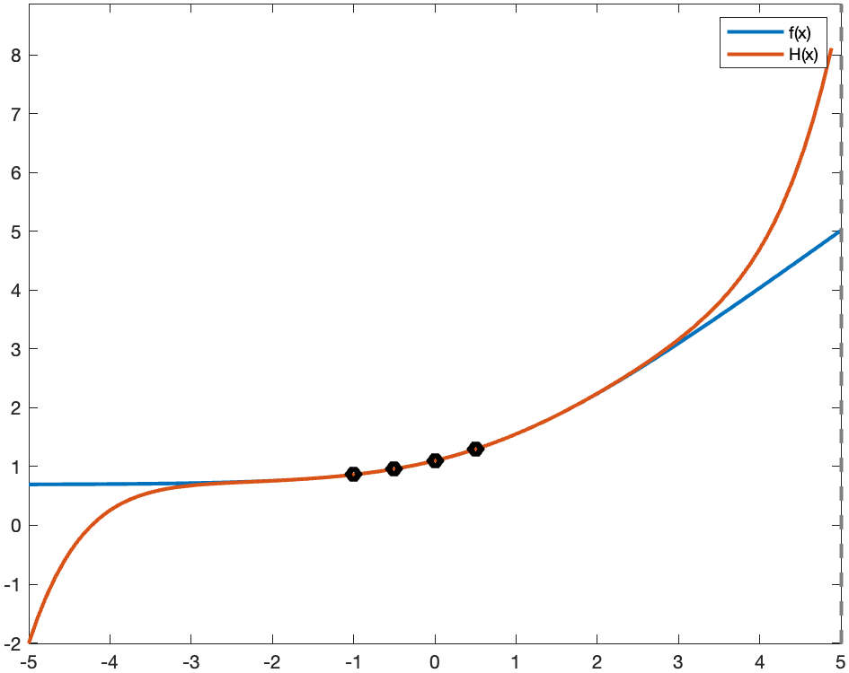

# Ques – 2

Taking the function f (t) as distance and f’(t) as speed, we can approximate the given data with the help of Hermite interpolation. After approximating the obtained Hermite interpolation polynomial can be observed with the help of the following plot: -

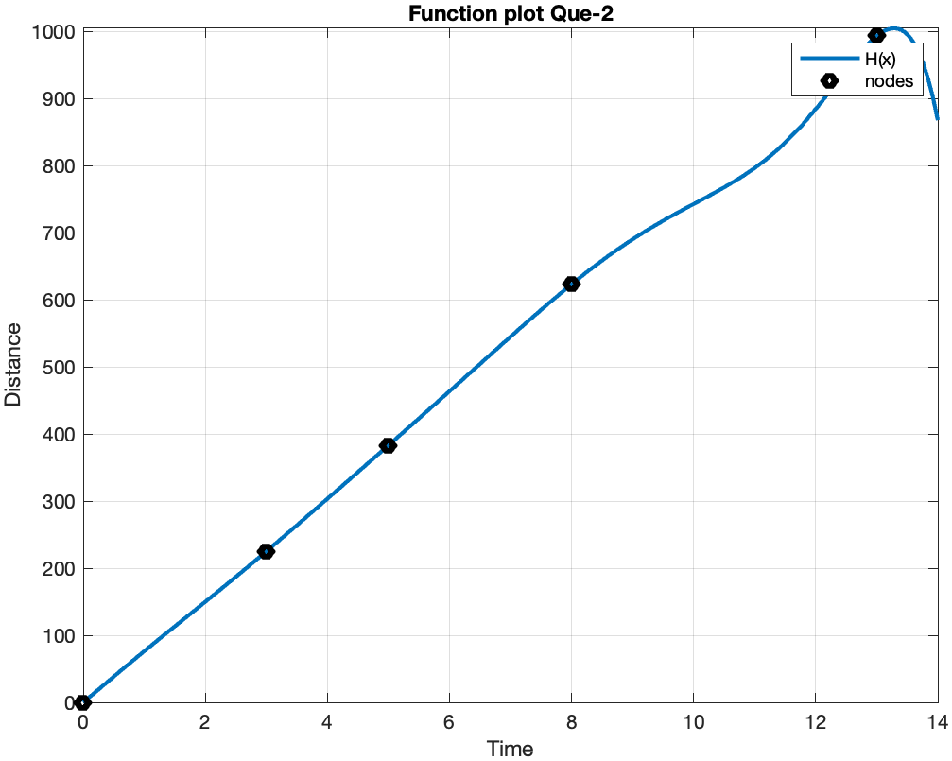

1. The approximate position of the car at t = 10 sec is 742.502839 feet.

The approximate speed of the car at t = 10 sec = 48.381736 feet/s.

1. We can observe the speed v/s time graph from the derivative of obtained H (x): -

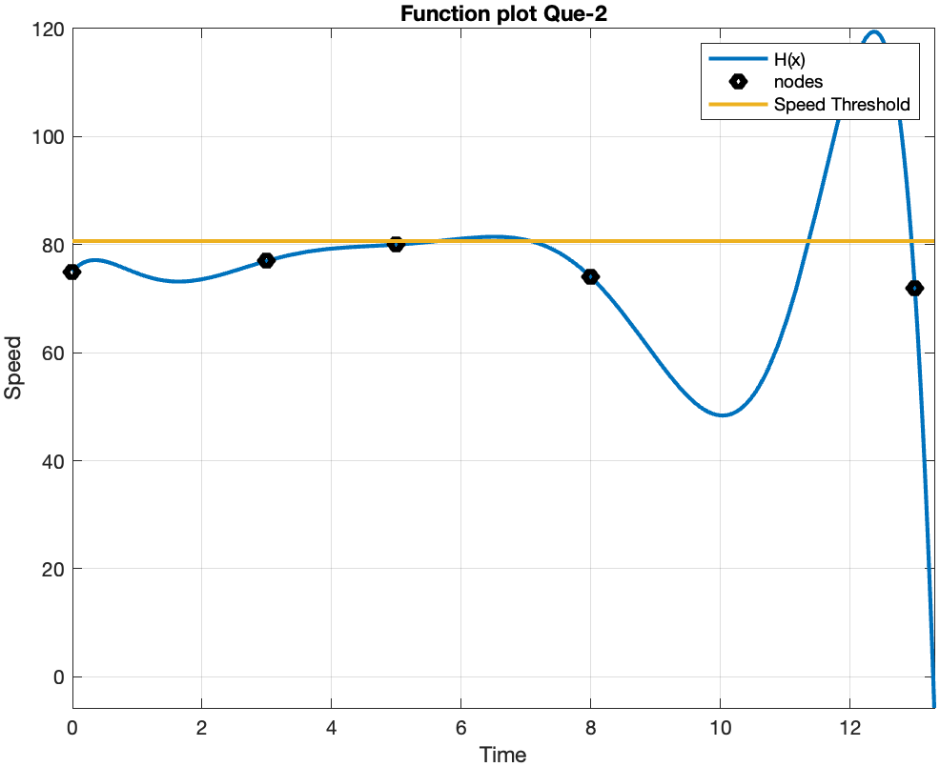

Taking 55 mi/h i.e., 80.6667 feet/sec as speed threshold, we can observe that speed clearly exceeds the threshold multiple times. Also, it first exceeds the threshold somewhere between t=5 sec and t=6 sec.

Now, for finding the time it first exceeds the threshold, I formed an array of time values ranging from 5 to 6 sec with a small interval of 0.001 sec, and calculated the value of

| threshold speed – H’(t) | for all t in the array, and took the t at which this value is minimum, i.e., time at which speed is almost close to the threshold.

Thus, we obtain an estimate of time at which car first exceeds the speed of 55 mi/h as

**t = 5.649 sec**.

1. To predict the maximum speed of car, we can observe the speed-time graph. We see that the maximum of speed time graph is obtained somewhere between t = 11 sec and t = 13 sec. So, to estimate the max value of speed, we can form an array of time values ranging from 11 to 13 sec with a small interval of 0.001 sec, and find the value of max {H’(t)} for t in this array.

By estimating maximum speed in this way, we obtain the predicted maximum speed achieved by the car is **119.417337 feet/s**.

# Ques – 3

Since, it was not mentioned which cubic spline is to be used, I used both natural and clamped cubic spline to approximate the following polynomials at given values. For clamped spline, we already know the function explicitly, so we can differentiate and find the values of f’(x0) and f’(xn) required in clamped cubic spline interpolation.

1. Exact value of f (0.43) is 2.363161.

Exact value of f'(0.43) is 4.726321.

Approximate value of f (0.43) by natural cubic spline is 2.477722.

Approximate value of f'(0.43) by natural cubic spline is 3.436564.

Actual Error in f (0.43) for natural spline is 1.145617e-01.

Actual Error in f'(0.43) for natural spline is 1.289758e+00.

Approximate value of f (0.43) by clamped cubic spline is 2.362071.

Approximate value of f'(0.43) by clamped cubic spline is 4.751932.

Actual Error in f (0.43) for clamped spline is 1.089680e-03.

Actual Error in f'(0.43) for clamped spline is 2.561015e-02.

The plot of natural cubic spline can be observed as follows: -

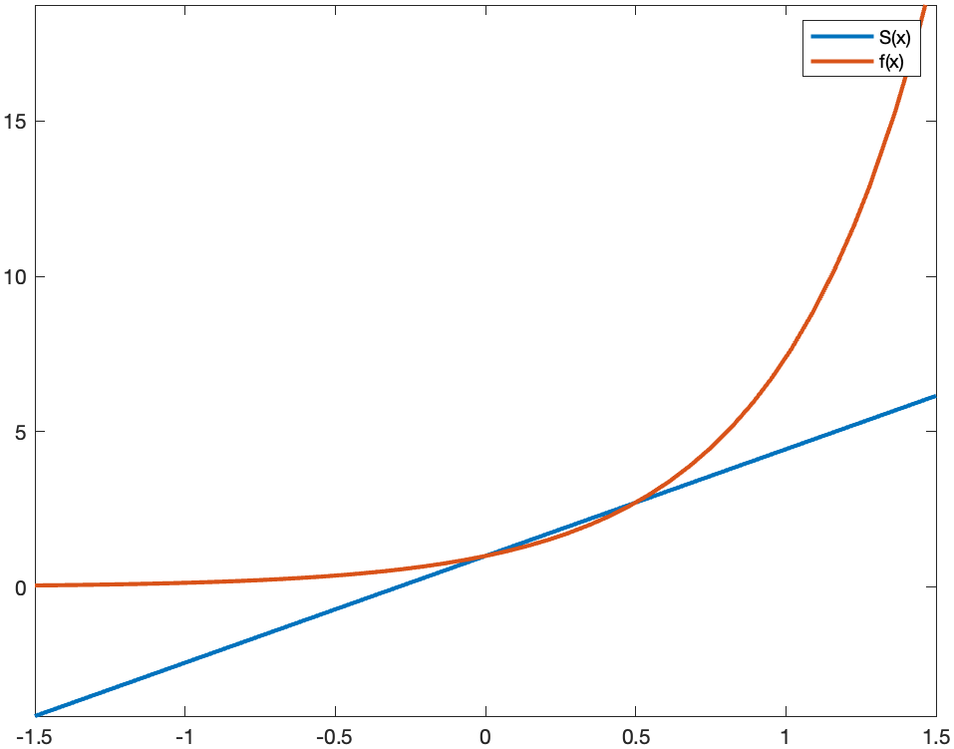

The plot for clamped cubic spline can be observed as follows: -

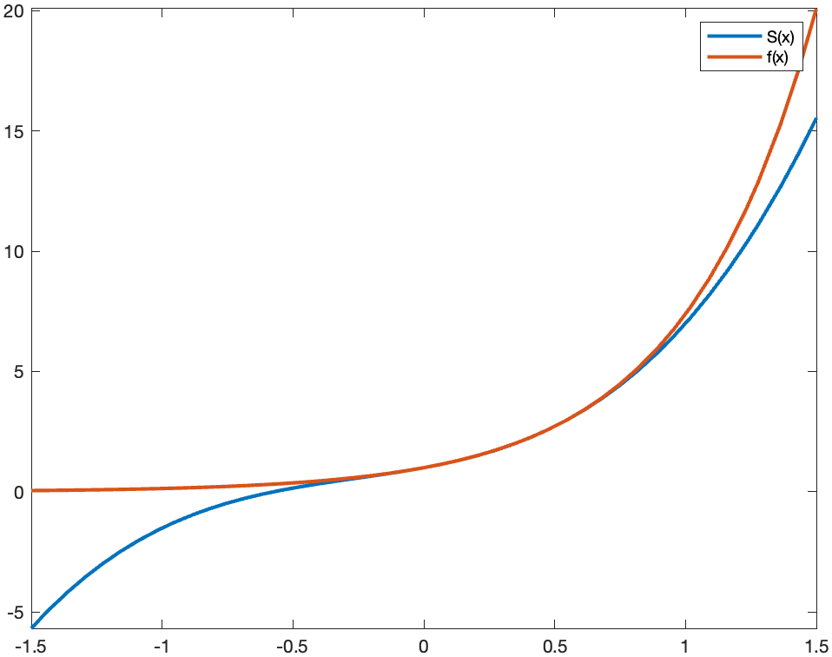

1. Exact value of f (0.25) is 1.189070.

Exact value of f'(0.25) is 0.390991.

Approximate value of f (0.25) by natural cubic spline is 1.196495.

Approximate value of f'(0.25) by natural cubic spline is 0.391529.

Actual Error in f (0.25) for natural spline is 7.424598e-03.

Actual Error in f'(0.25) for natural spline is 5.376463e-04.

Approximate value of f (0.25) by clamped cubic spline is 1.189086.

Approximate value of f'(0.25) by clamped cubic spline is 0.390994.

Actual Error in f (0.25) for clamped spline is 1.650865e-05.

Actual Error in f'(0.25) for clamped spline is 3.103286e-06.

The plot of natural cubic spline can be observed as follows: -

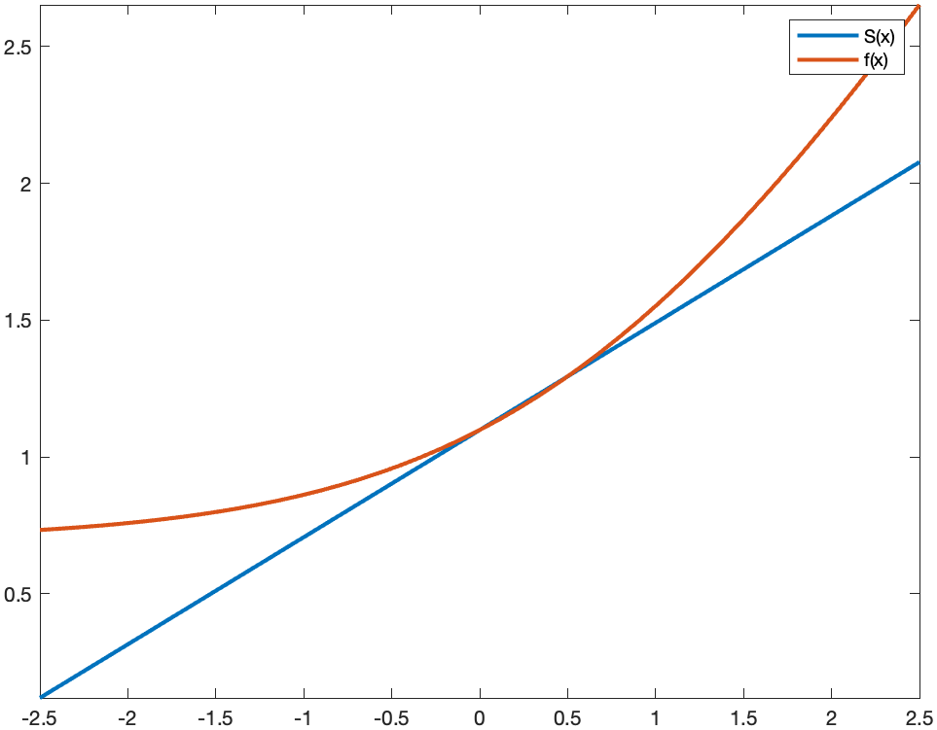

The plot for clamped cubic spline can be observed as follows: -

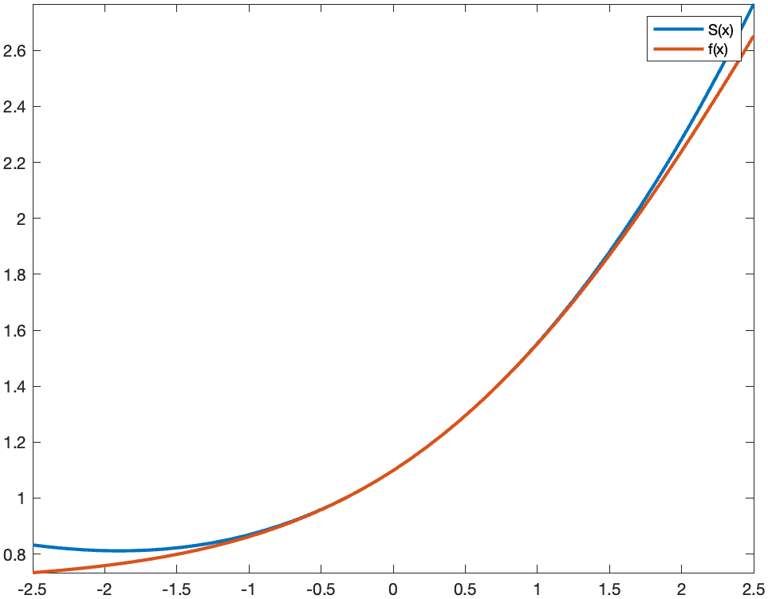

In both the cases, we observe that the clamped cubic spline is fitting and approximating the function in a better way than natural spline.

# Ques – 5

1. Approximate position of car by natural spline at t = 10 sec is: - 774.863900 feet.

Approximate speed of car by natural spline at t = 10sec is: - 74.160996 feet/sec.

1. Approximate position of car by clamped spline at t = 10 sec is: - 772.361416 feet.

Approximate speed of car by clamped spline at t = 10 sec is: - 74.573097 feet/sec.