MA322 – Scientific Computing Laboratory

Lab – 08

Dipanshu Goyal 210123083

# For the error estimate, I have calculated the actual integral using the inbuilt int (f, a, b) function in MATLAB and took its difference with the approximated integral.

* Que – 5 may take some time in execution(around 1 min) as it has to iterate through bigger values of n as the for loop proceeds.

# Ques – 1

Using the rectangle rule and taking **‘a’** as initial point of approximation, we observe the following for all the parts: -

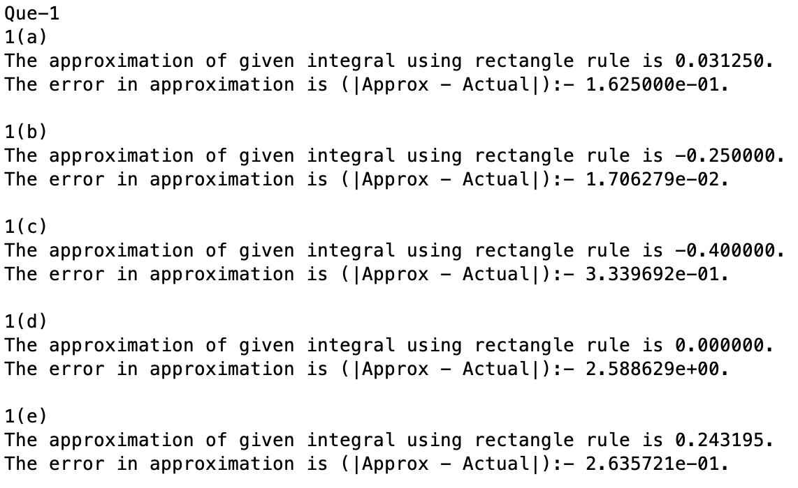

# Ques – 2

* Using the midpoint rule, we observe the following results: -

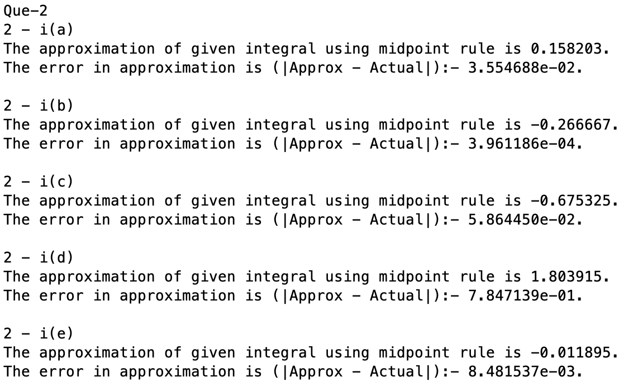

* Using the Trapezoidal Rule, we observe the following results: -

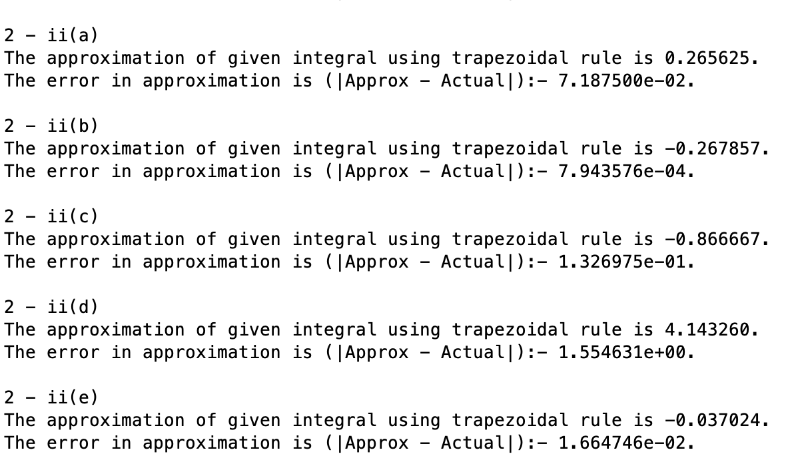

* Using the Simpson’s rule, we obtain the following results: -

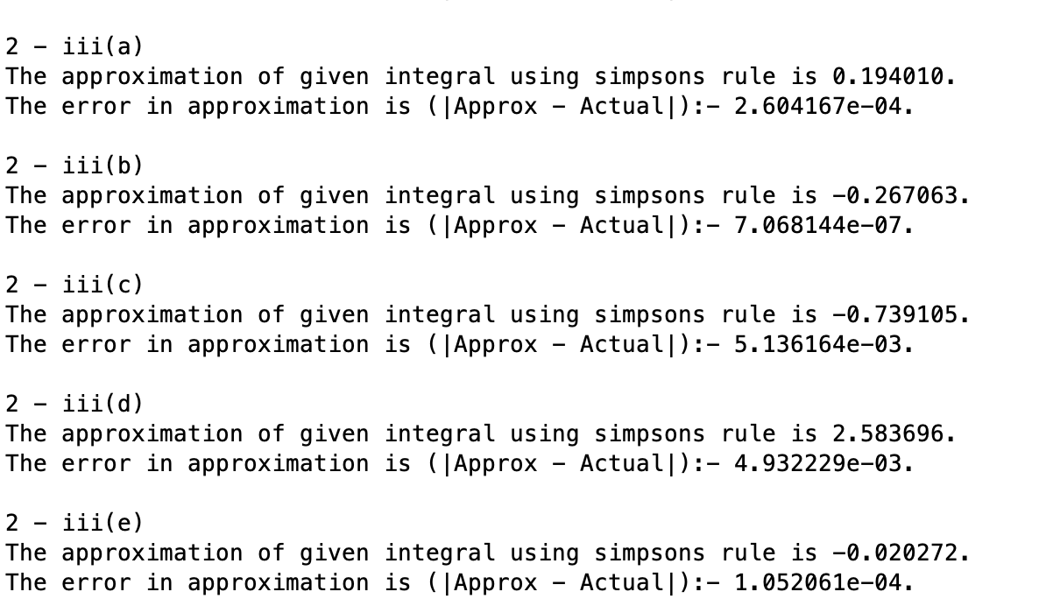

# Ques – 3

The actual value of required integral is pi i.e., 3.14159265359… Approximating it with difference rules, we get the following results: -

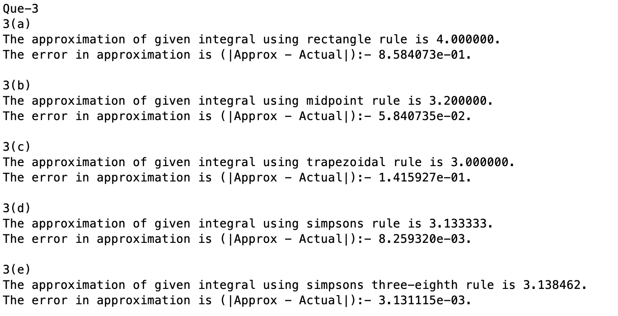

We observe that the Simpson’s one-third and Simpson’s three-eight rules are giving a value significantly closer to the actual answer, and relatively lesser error than other methods. We can get better results by using the composite versions of these methods.

# Ques – 4

For implementing composite rules, we divided the interval [a, b] int some sub-intervals [xi, xi+1] and applied that particular rule to each sub-interval for the given integral and then took the sum of results of all the sub-intervals. This gives a better estimate to the integral for continuous functions, than normally applying a rule on an interval [a, b].

Approximating the given integral using the table provided, we observe that: -



# Ques – 5

For computing n and h in this question, we can iterate over n starting from 1, take h as (b-a)/n and consider n+1 equally spaced points x0, x1, …, xn with xi = a + i*h, i = 0, 1, …, n. Now we use the composite rules on these points and find the estimate of the integral, and check if its error (|Actual integral – approximated integral|) is less than the required tolerance. We repeat this process until the tolerance condition is satisfied and then break the loop to get the value of n and h for the required composite rule. Following are the observations by doing so: -

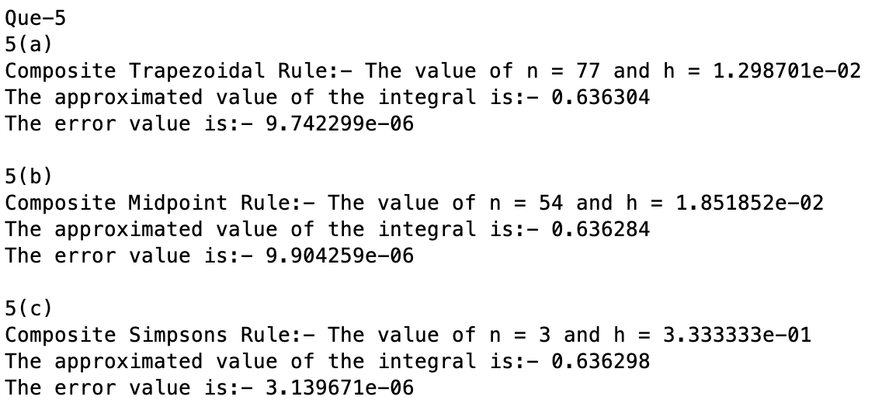

# Ques – 6

Since it isn’t mentioned, which method is to be used to estimate the distance of the track, I used the composite trapezoidal and composite rectangle rules to estimate the same. It is observed that both the rules give results significantly close to each other.

We used the fact that Distance = integral of speed w.r.t. time since v = dx/dt.

