MA322 – Scientific Computing Laboratory

Lab – 09

Dipanshu Goyal 210123083

# For the error estimate, I have calculated the actual integral using the inbuilt int (f, a, b) function in MATLAB and took its difference with the approximated integral.

* In Ques – 3, we’re asked to perform Gaussian Quadrature, so I applied both Gauss-Legendre and Gauss-Lobatto Quadrature.

# Ques – 1

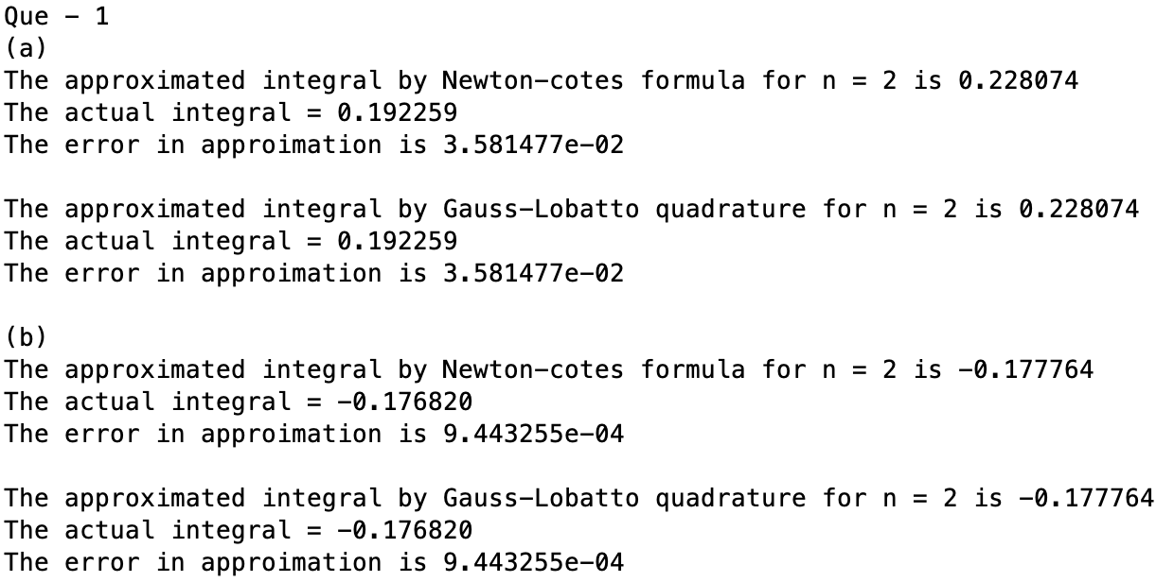

# Ques – 2

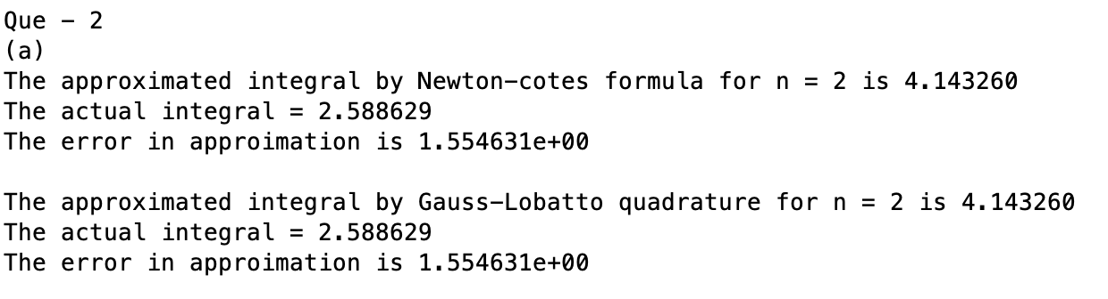

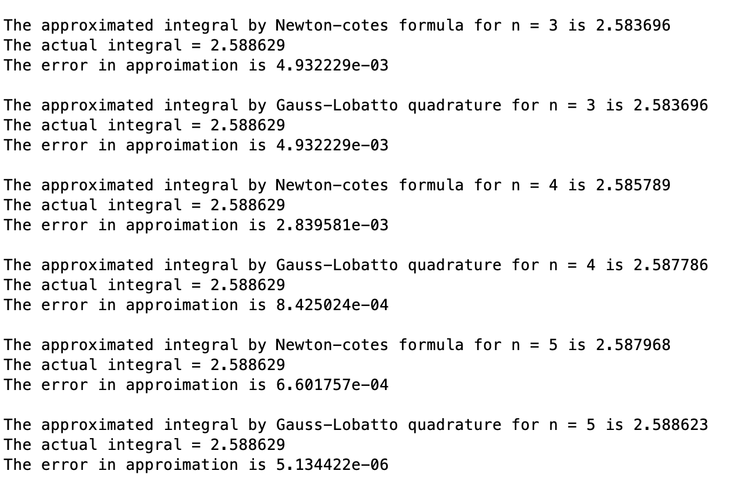

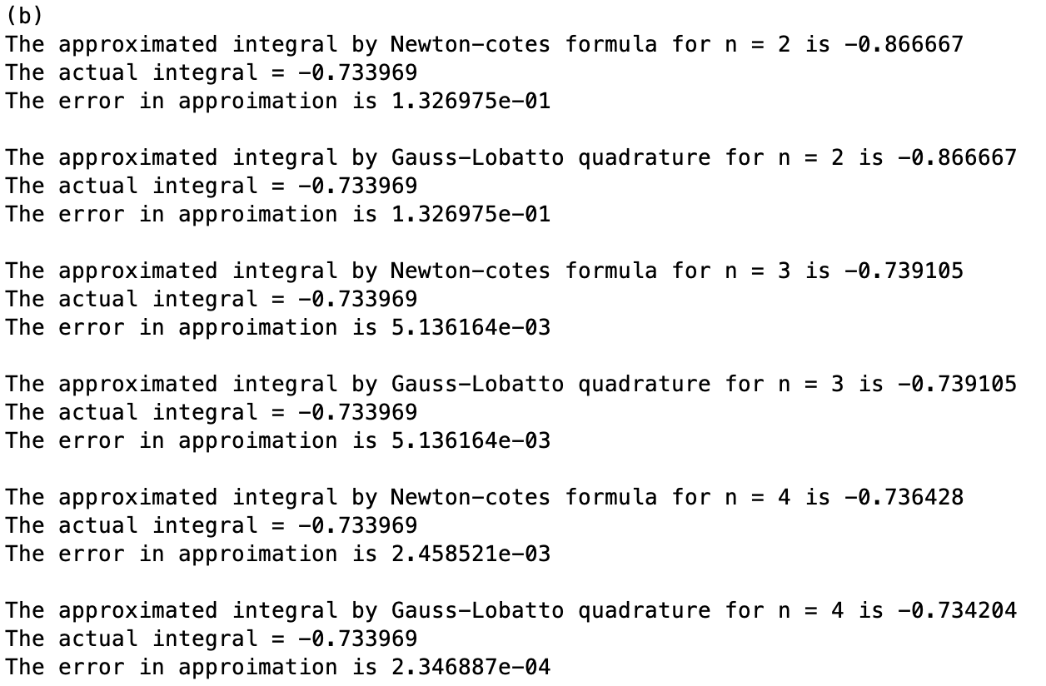

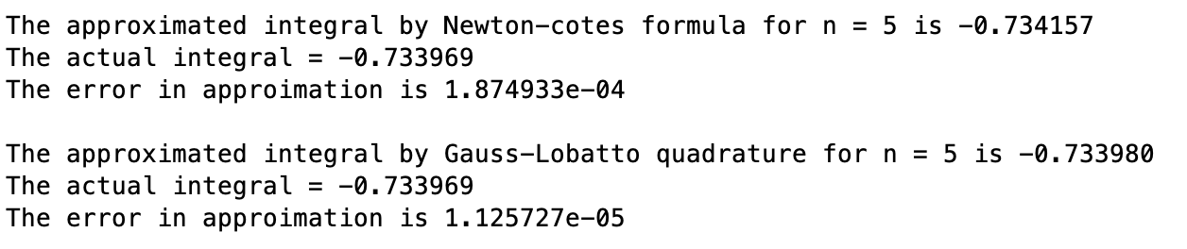

We observe that the approximations by Newton-Cotes and Gauss-Lobatto Quadrature are same for n = 2,3 and after that, Gauss-Lobatto Quadrature is giving a better approximation.

# Ques – 3

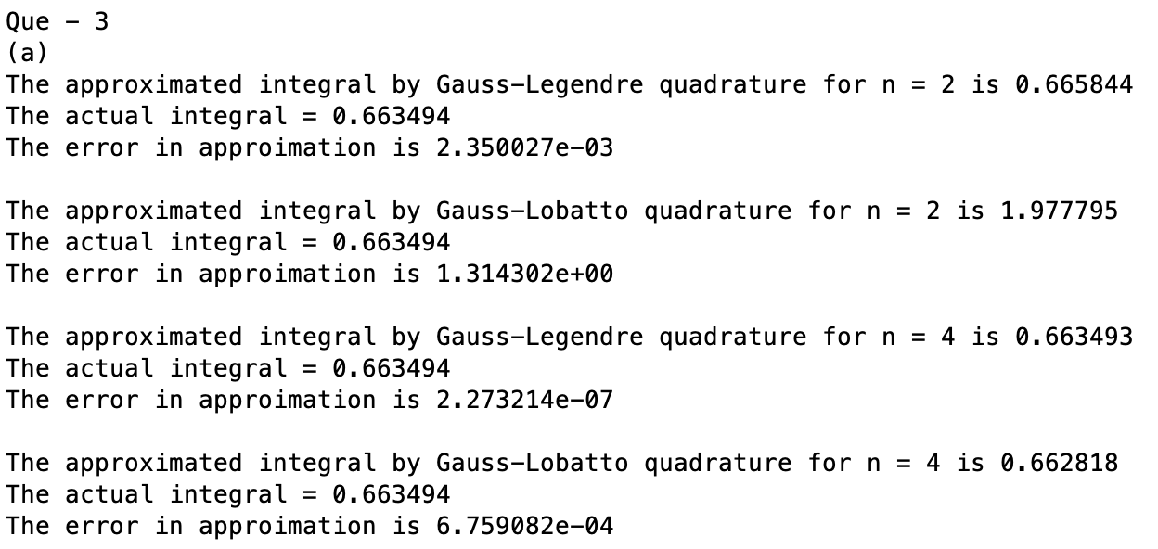

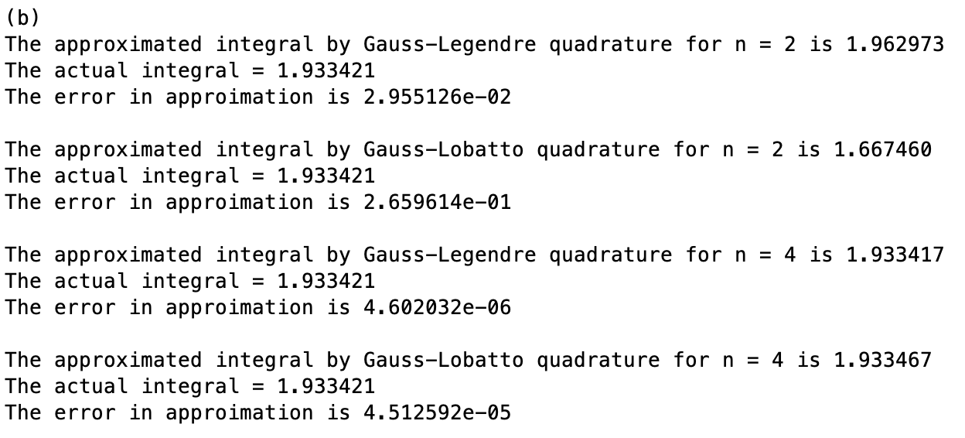

Here, we observe that Gauss-Legendre Quadrature is giving better approximations than Gauss-Lobatto Quadrature.

# Ques – 4

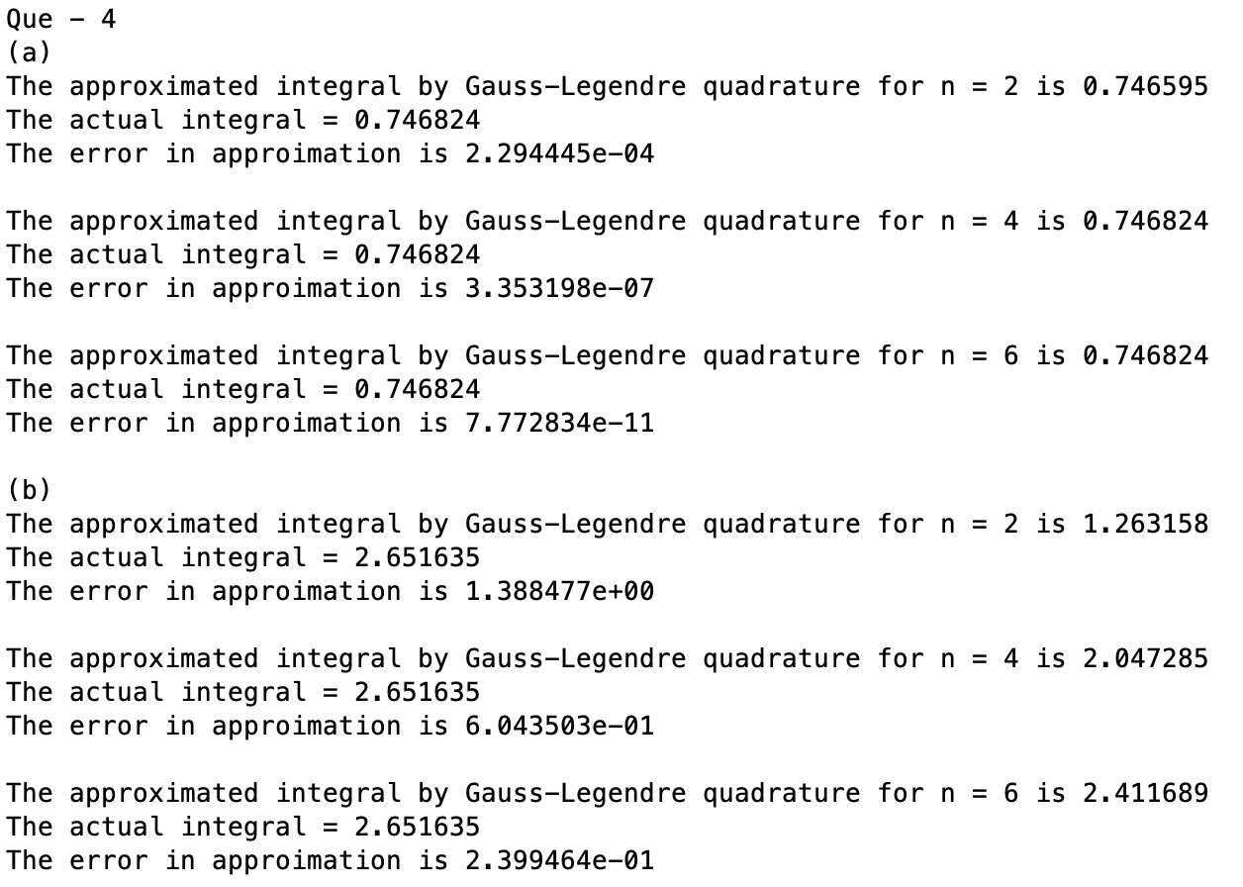

Here is a reference to the Gaussian Quadrature Rules: - <https://www.dam.brown.edu/people/alcyew/handouts/GLquad.pdf>