MA322 – Scientific Computing Laboratory

Lab – 10

Dipanshu Goyal 210123083

# Question 4 and 5 will take some time in computing as there are a series of computations required to get the plot for N vs order of convergence.

* Run output_file.m to run the code.

# Ques – 1

After applying forward and backward difference formulas to given questions, we get the following results.

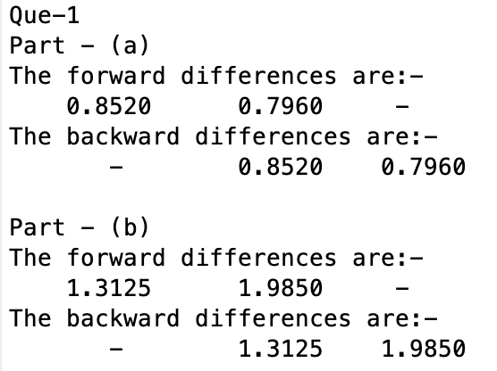

There is ‘–’ for the missing values as we can’t find forward and backward difference for respective end points in the data.

# Ques – 2

For the actual errors, the first derivatives of given functions are computed and error is taken as difference of computed difference at a point and the actual value of derivative at that point, i.e., |Approx. – Actual|.

For the error bound, the second derivatives of given functions are computed and bound is taken as the maximum value of |h*f’’(s)|/2 where h is difference between two data points xi and xi+1, and s lies between [xi, xi+1].

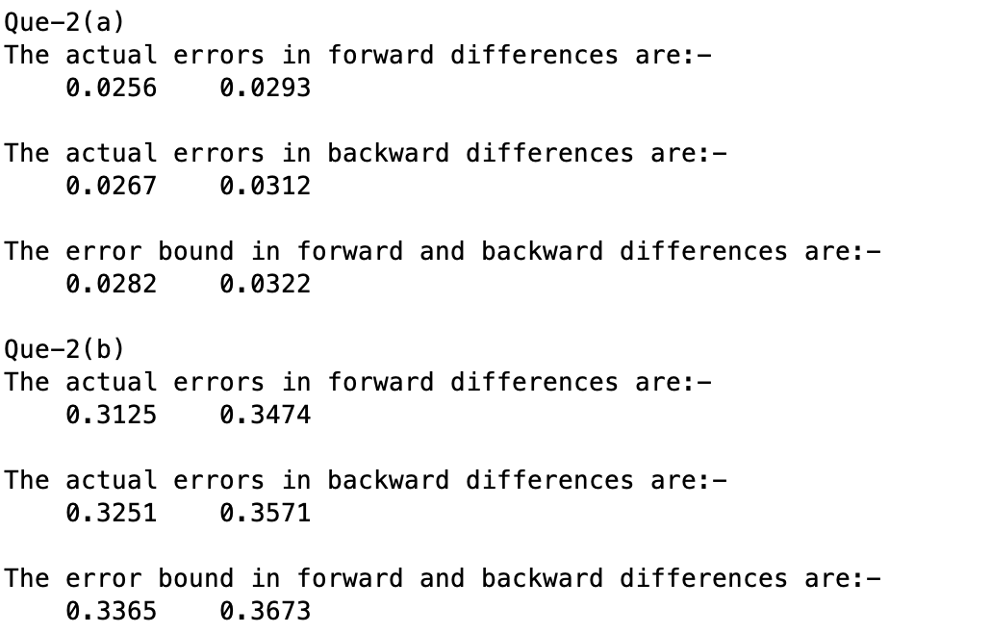

The error bounds in forward and backward differences will be same as same intervals are considered in both the differences.

# Ques – 3

To approximate the value of E(t), the forward differences of the current (i) are taken at first 4 time points and for the last time point, since forward difference can’t be calculated, backward difference is taken to approximate di/dt. Then the computed approximations are used to get approximations for E(t) using the equation: -

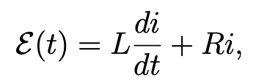

By putting the values of L, R, i and approximated di/dt, we get the following results: -

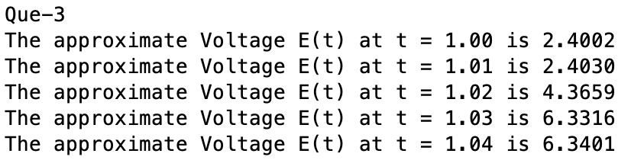

# Ques – 4

Here, for the exact solution, the given differential equation is manually solved and the solution is passed in the main function. The error is taken as the difference of exact values of y from computed solution and the approximated made by the algorithm, i.e., |Exact – Approx.|.

For each part, 4 plots are formed, namely: -

* Y(t) vs t plot for actual and approximated solutions.
* Absolute error vs t plot.
* N vs error. (Loglog plot)
* N vs order of convergence.

Where, N is number of intervals, i.e., N = (b - a)/h.

To get the last two plots, N is varied from 1 to 25, and maximum errors are taken for N and 2N. The order is calculated by log2(EN/E2N), EN and E2N being maximum errors while computing the Explicit-Euler’s method for that particular value of N.

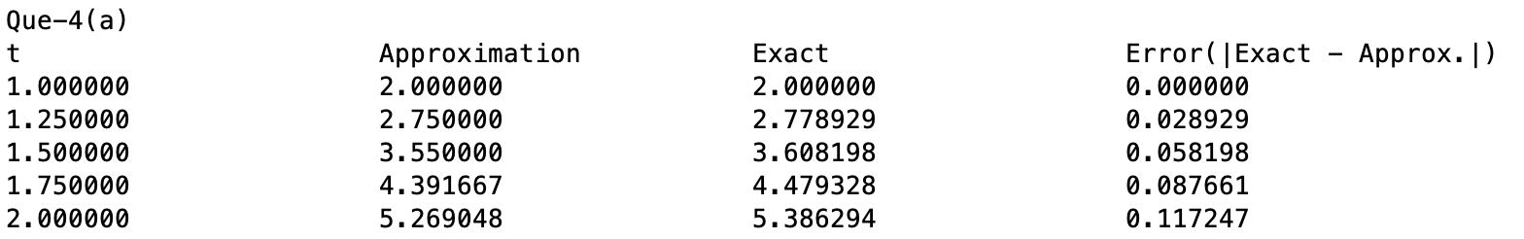

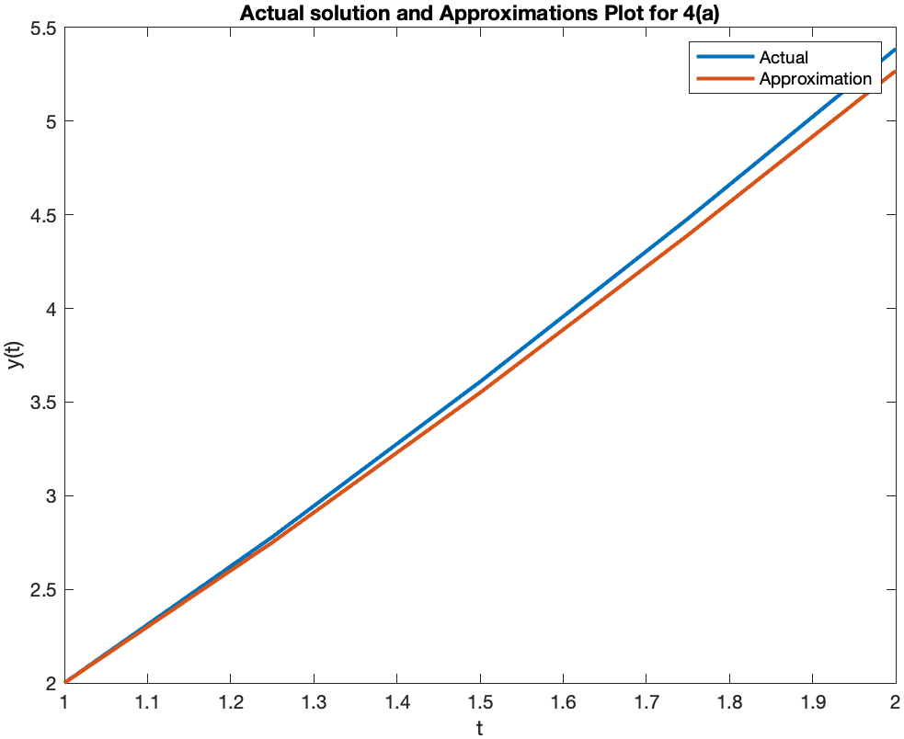

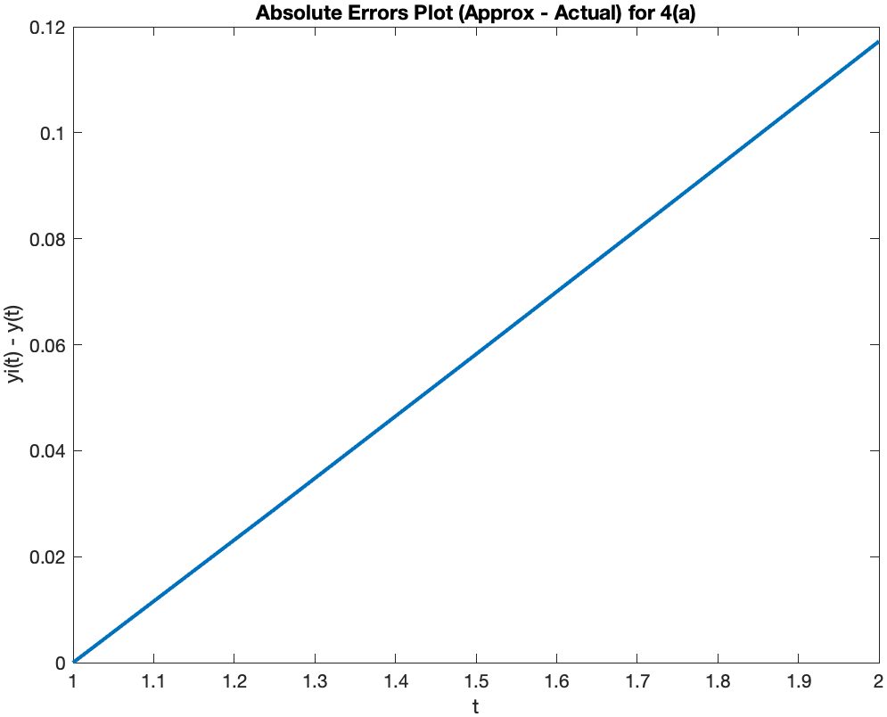

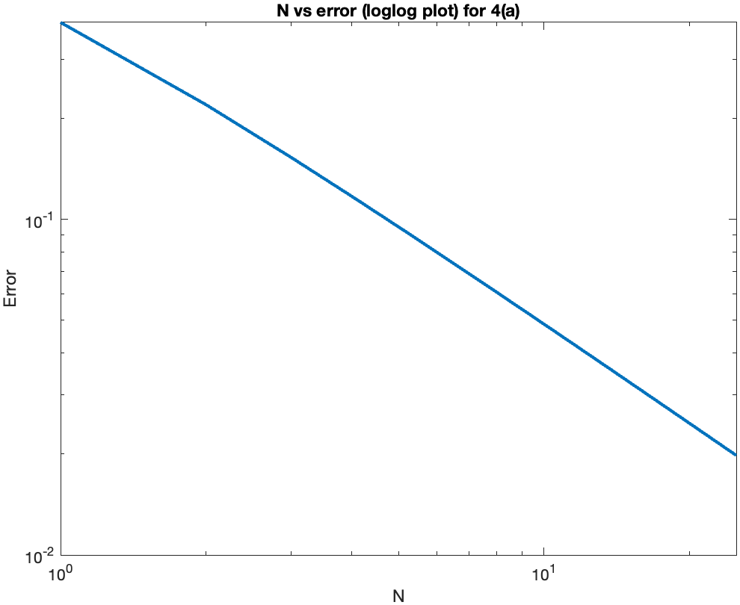

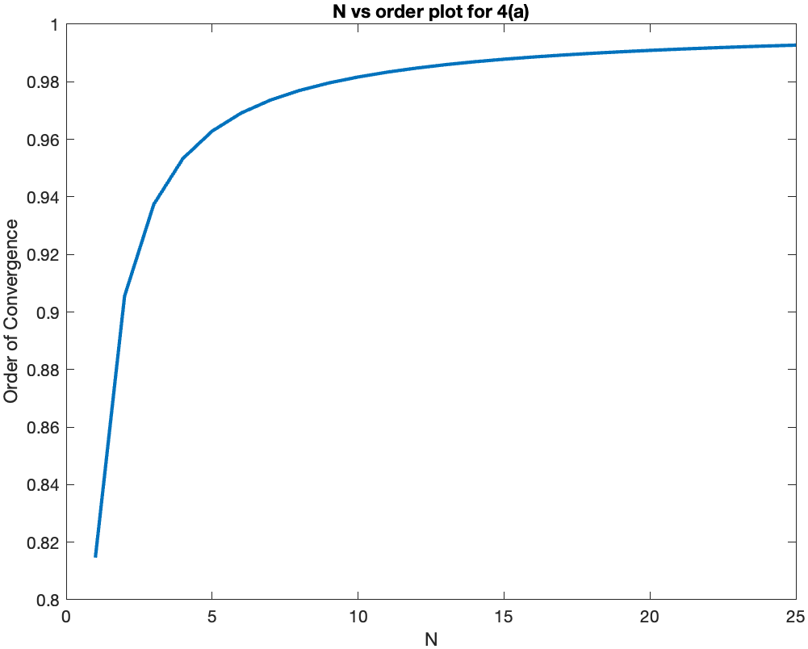

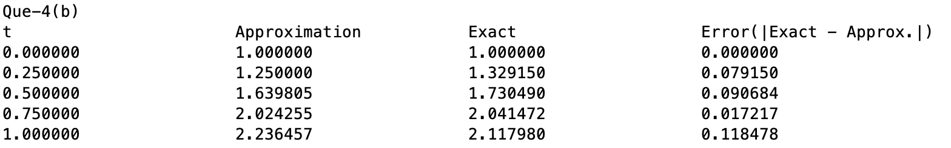

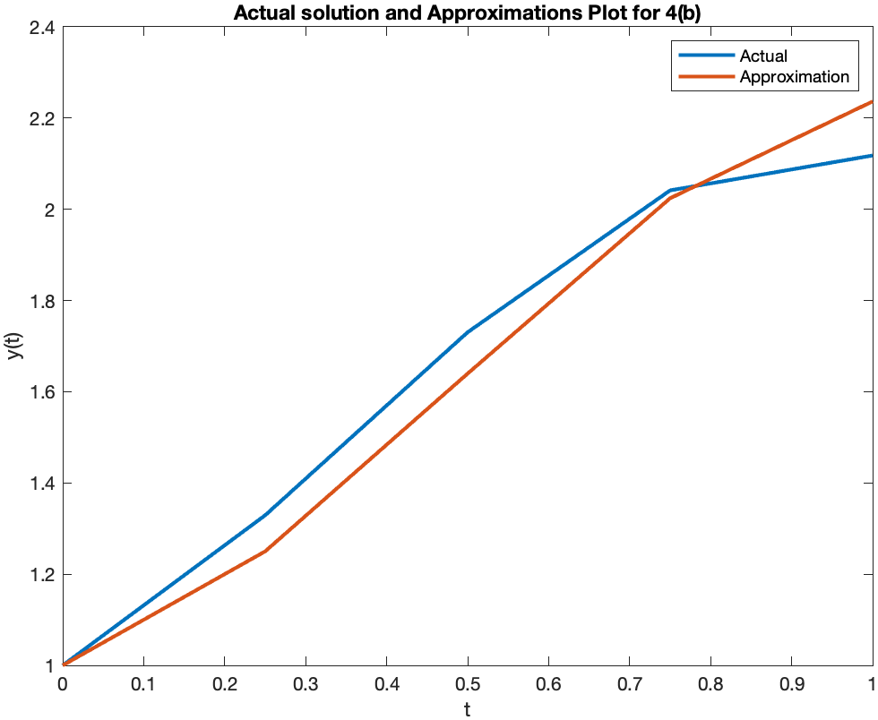

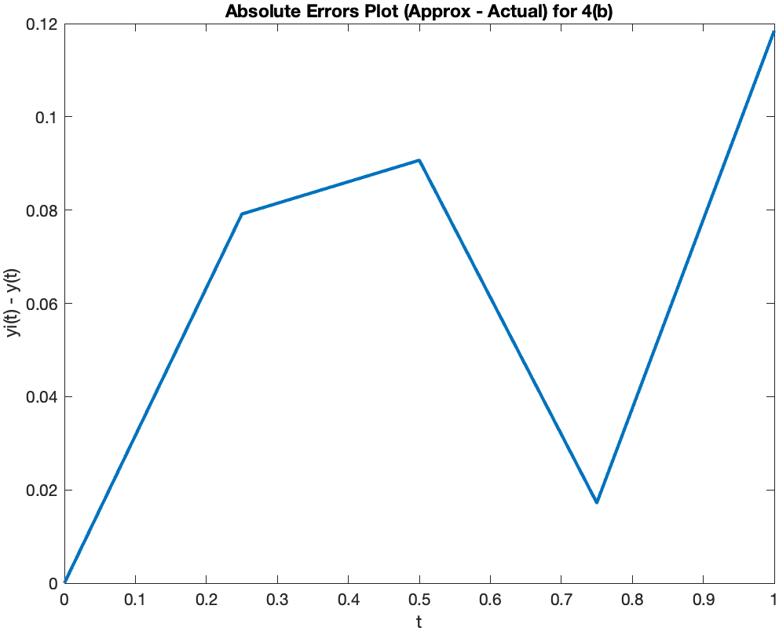

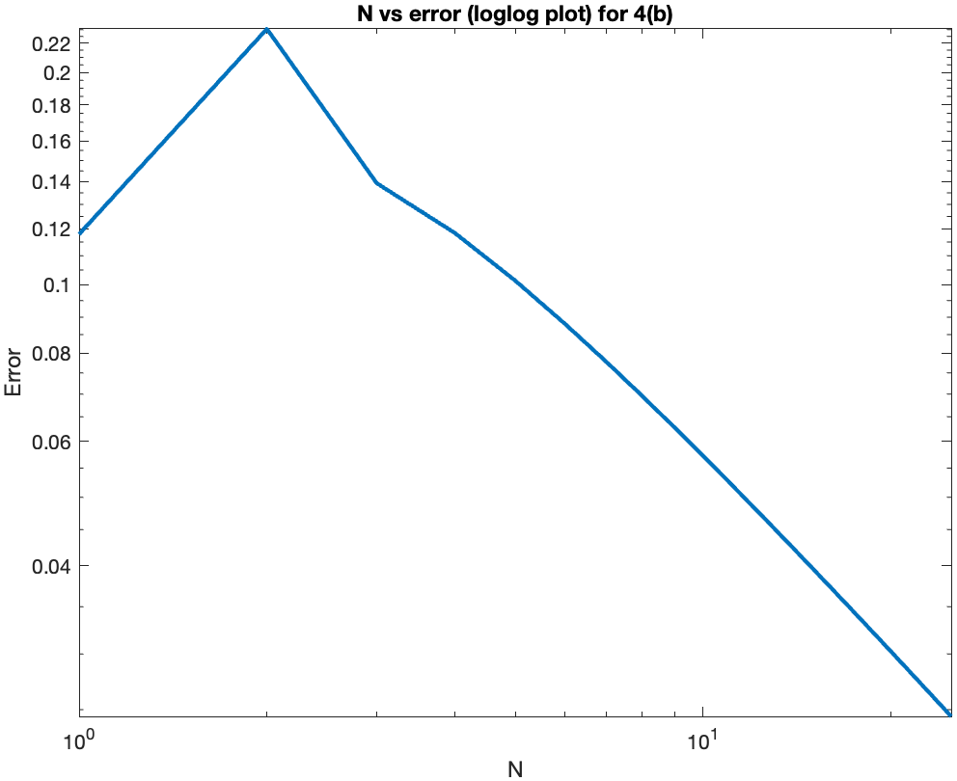

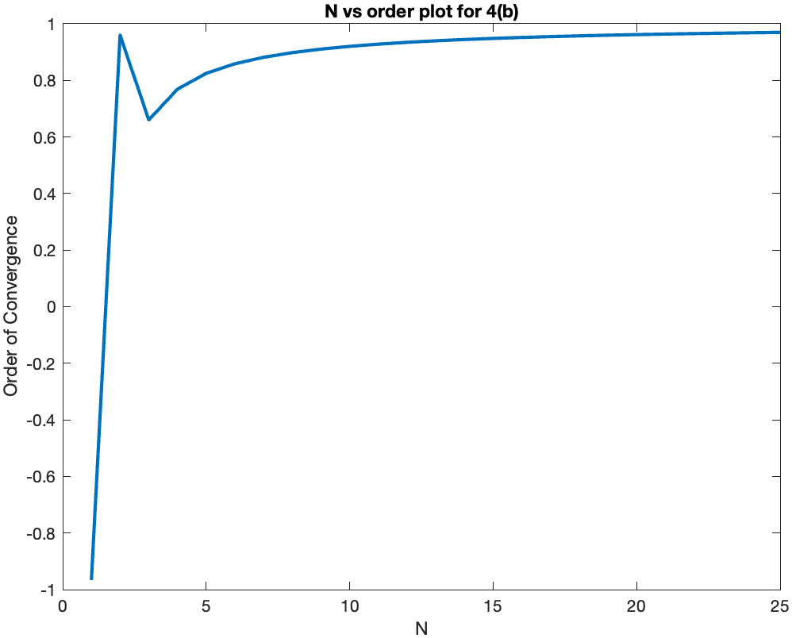

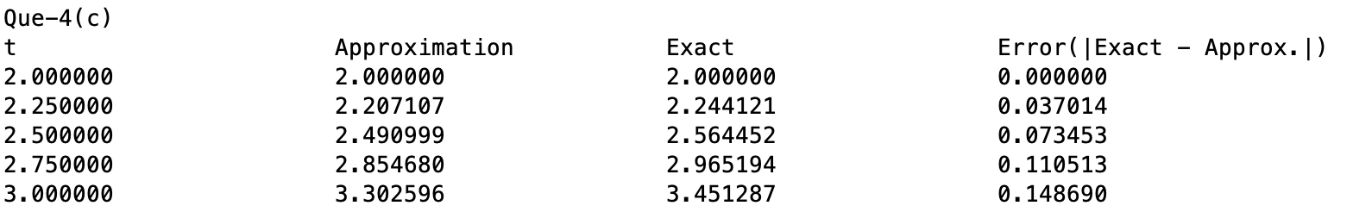

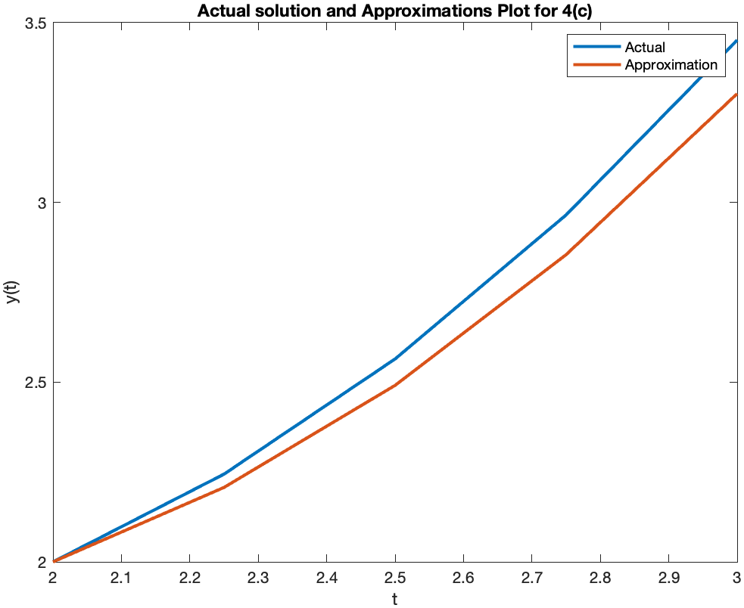

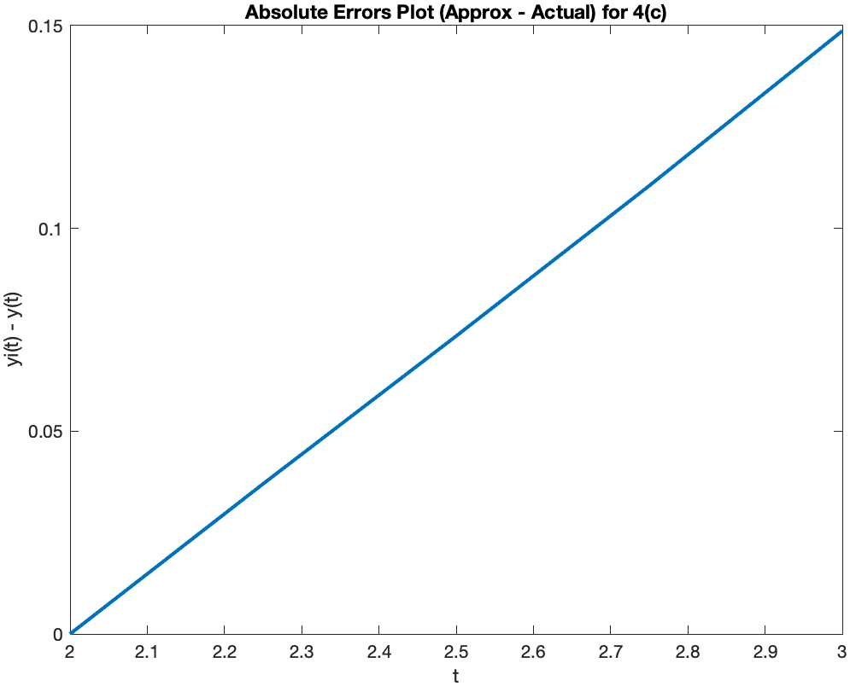

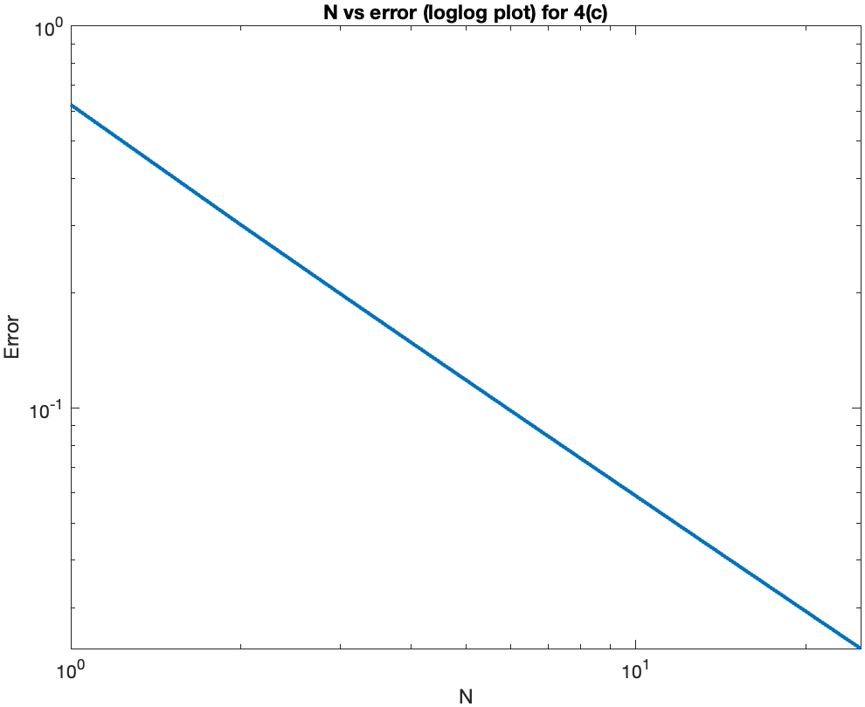

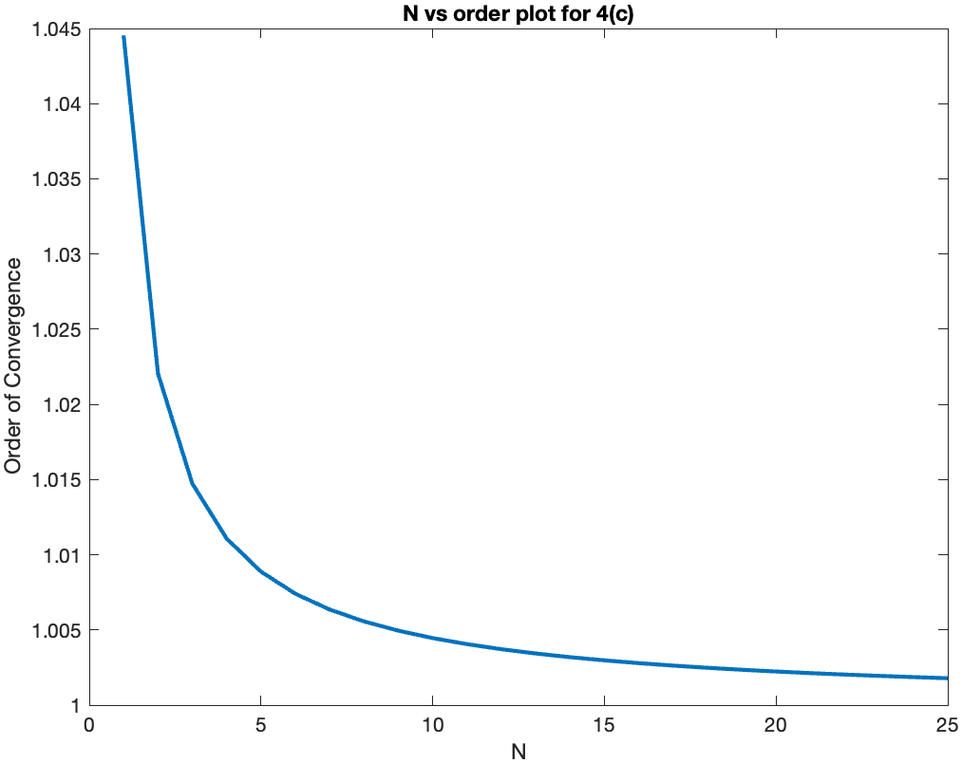

# Ques – 5

Similar to last question, the approximations and errors are calculated and the first two plots are formed for each value of h given in question. A single N vs order of convergence plot and N vs error (loglog plot) is formed for this question which is again computed similar to last question with difference being in the values of N, here N is varied from 1 to 40 for better visualization of order of convergence.

The table of containing t, Approximations and errors is too big so it is printed in the code only. Last few entries are put in the report as follows: -



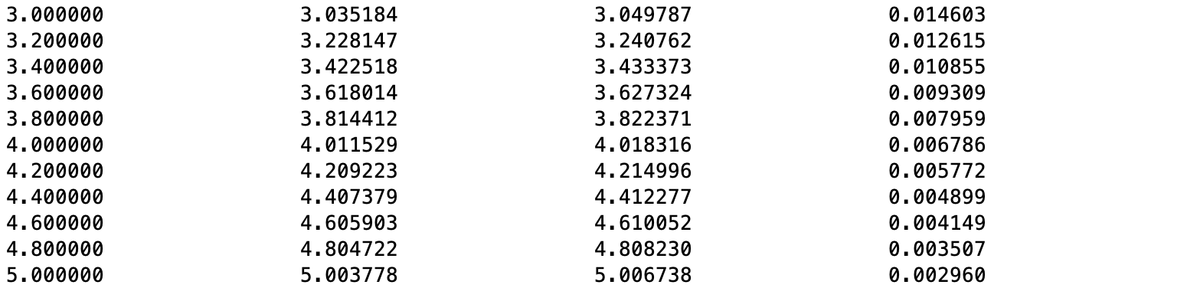



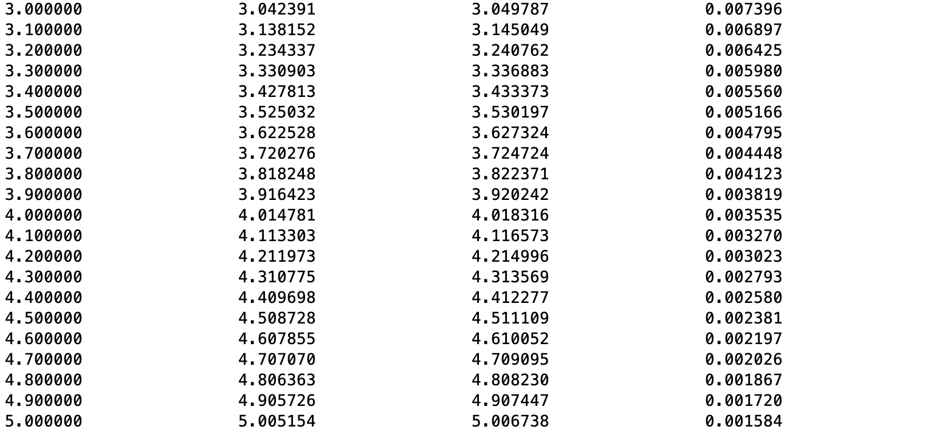



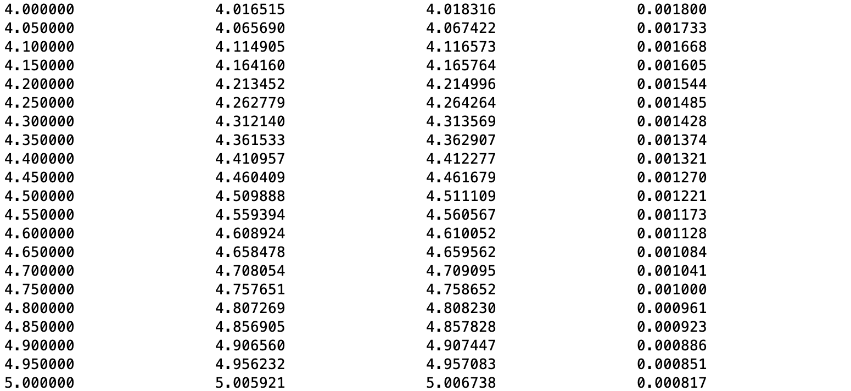

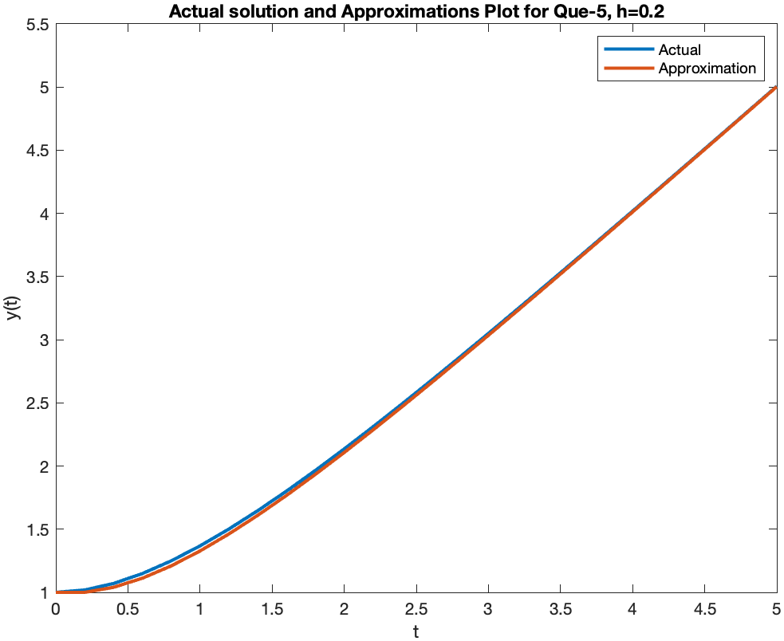 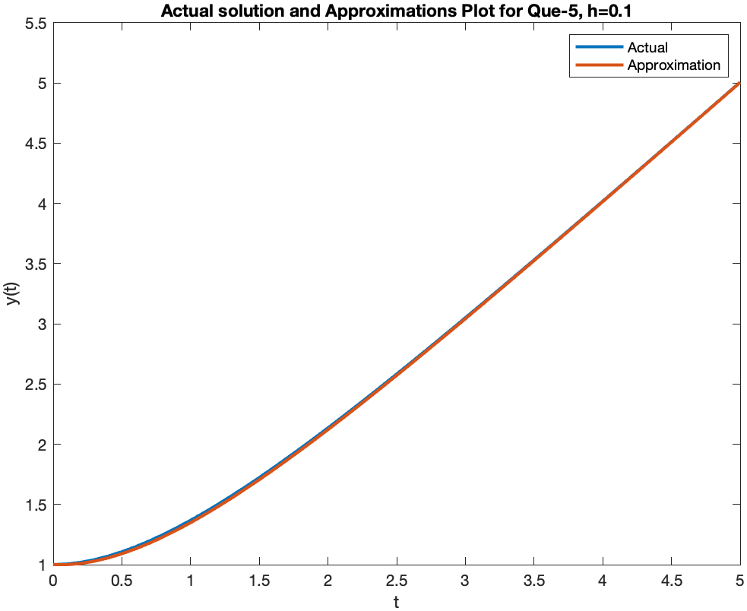

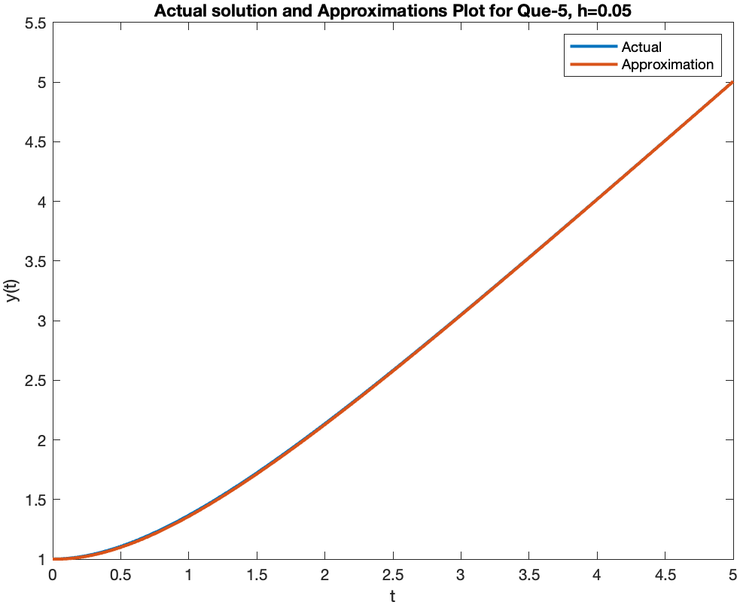 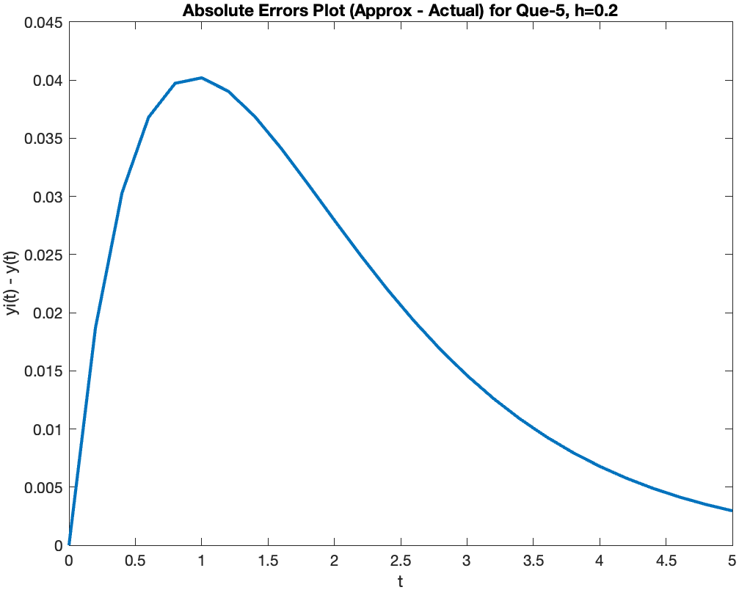

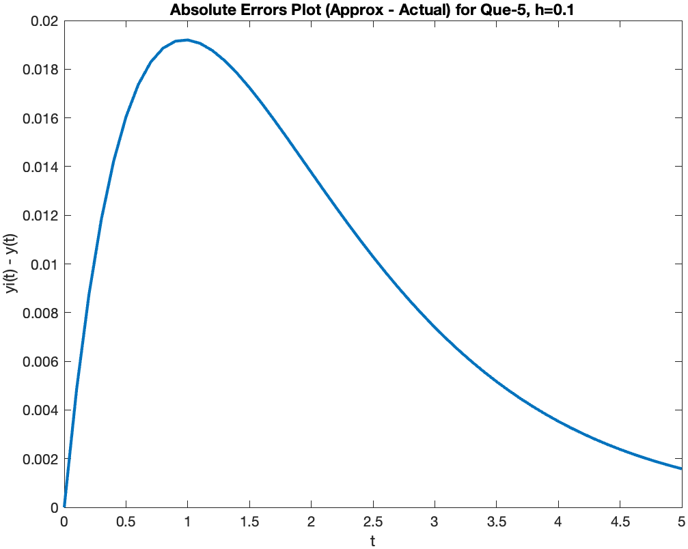 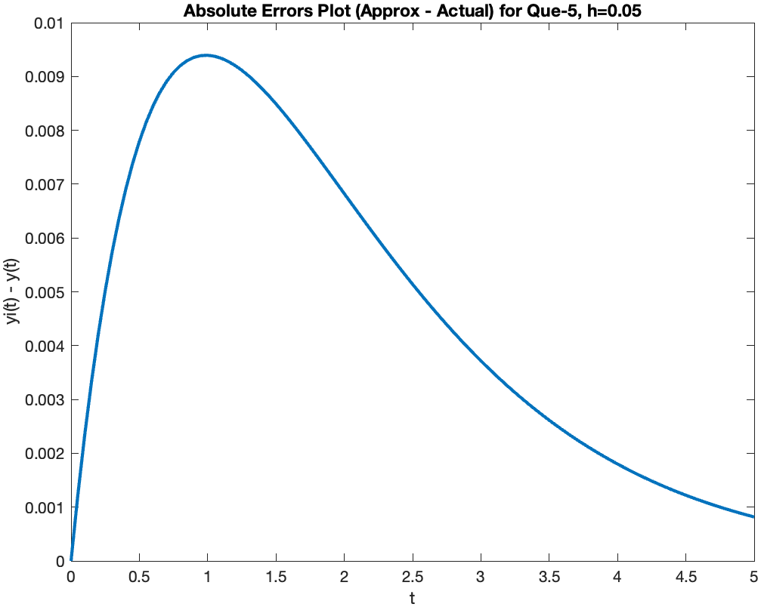

We can clearly observe that the difference between actual curve and approximated curve is diminishing with the decreasing value of h, similarly the error curve is getting smoother as h decreases from 0.2 to 0.05.

