MA374 – Financial Engineering Laboratory

Lab - 01

Dipanshu Goyal 210123083

# Binomial Asset Pricing Model

In the Binomial Asset Pricing Model, the following condition must be satisfied to ensure no arbitrage: -

**0 < d < er < u**

Where, r = risk-free interest rate.

u = up-factor.

d = down-factor.

**Ques-1: -**

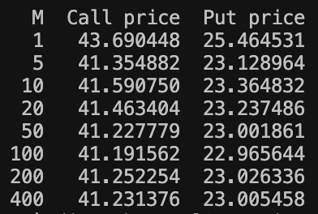

**Observation: -** The initial call and put option prices are converging to around 41.23 and 23.005 respectively.

**How large can M be: -** The result is getting more and more accurate with increasing value of M, so, theoretically M can be set to infinity to mimic a continuous model. But in practice, M can be set according to the acceptable tolerance of the error in derivative prices. This can save computation time and resources.

**Ques-2: -**

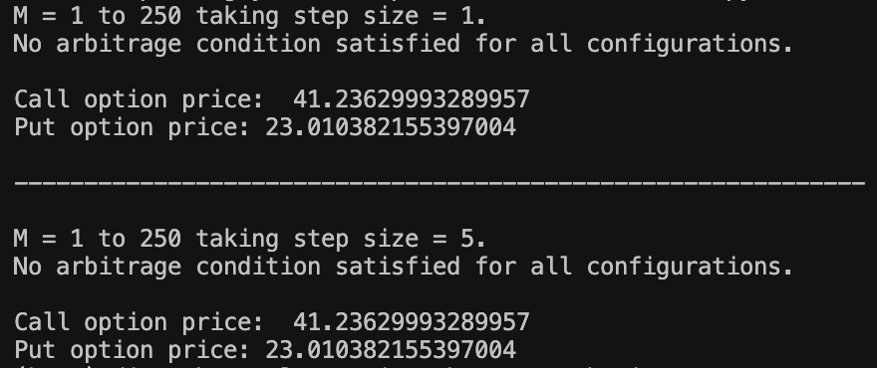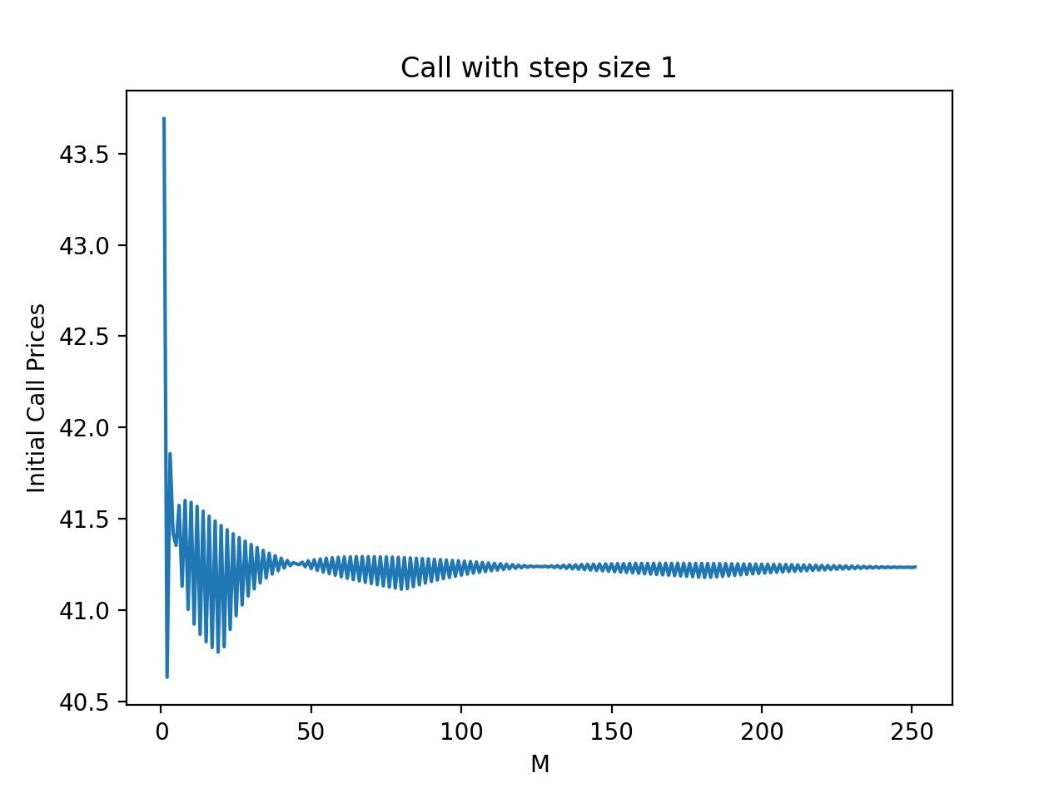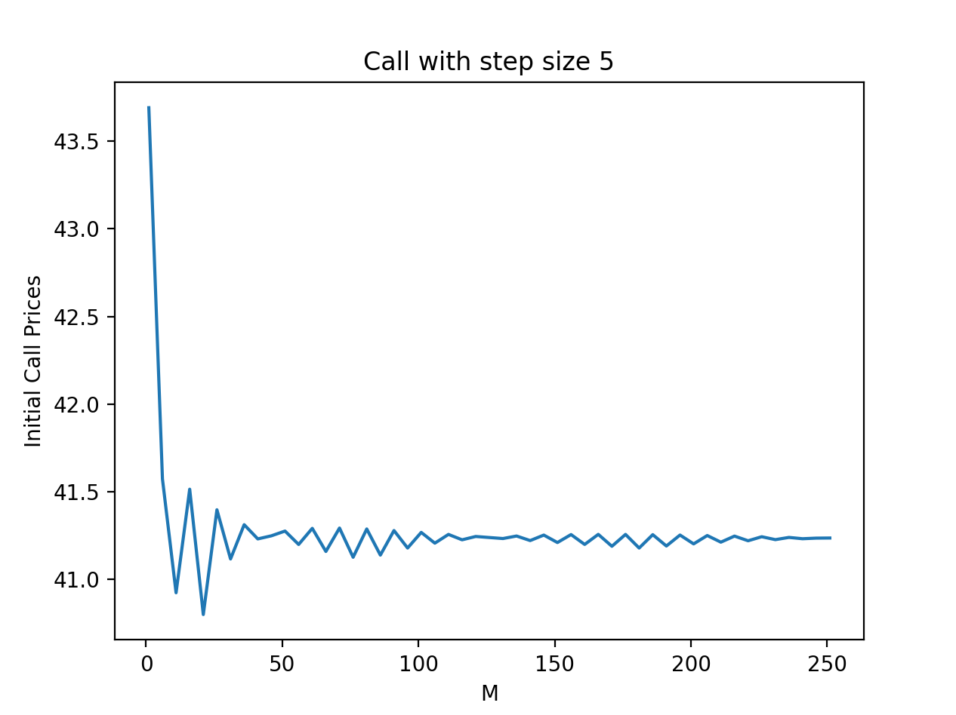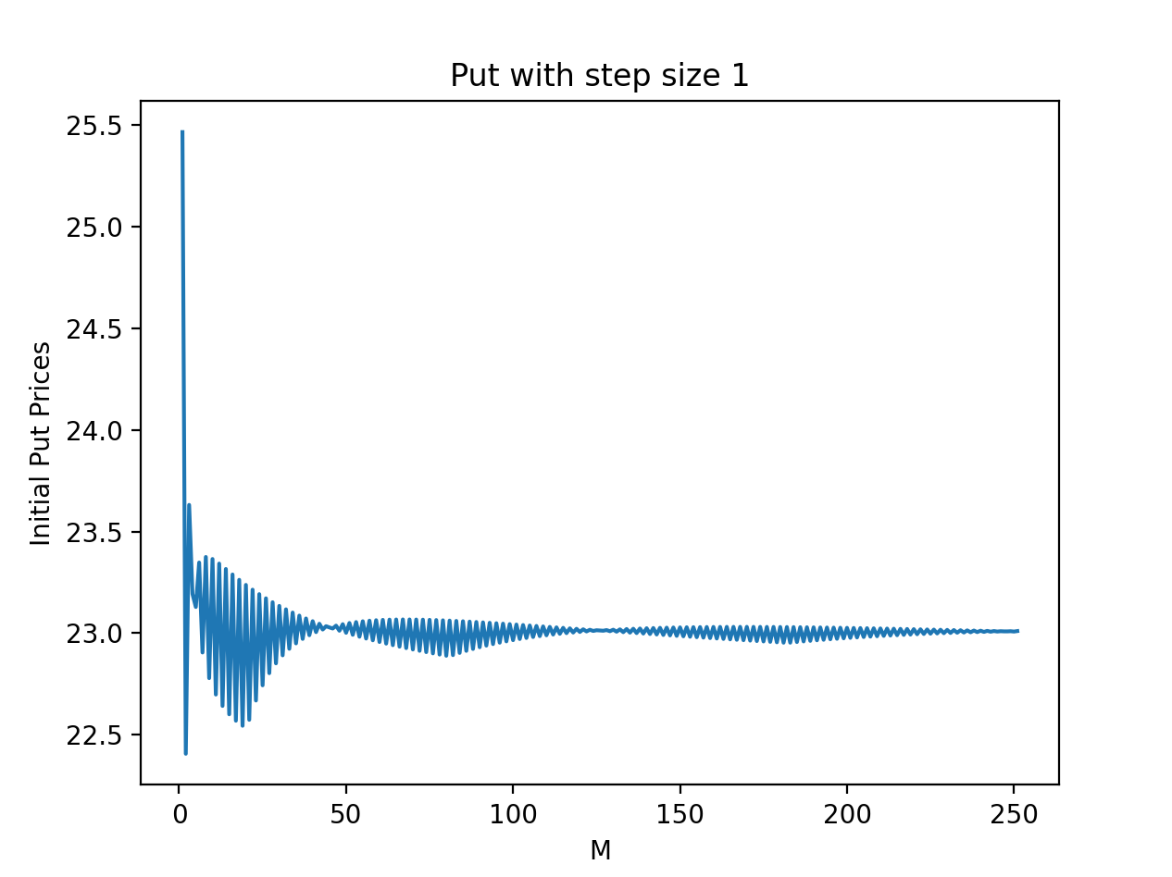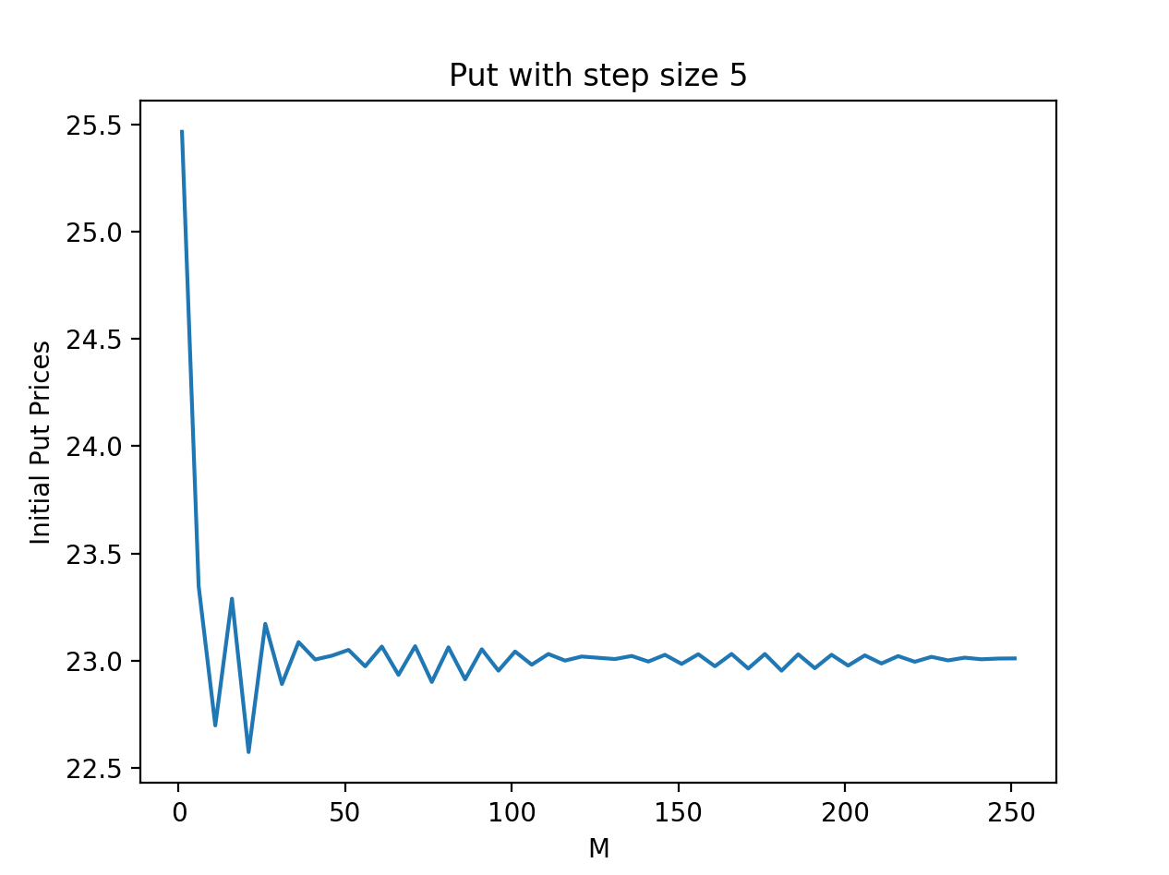

**Observation: -** Final values after converging are same irrespective of the size of step taken, but the convergence speed with step size of 5 is greater than step size of 1. As a result, oscillations about the converging value are less in graph of step size 5.

**Ques-3: -**

