MA374 – Financial Engineering Laboratory

Lab - 04

Dipanshu Goyal 210123083

# Ques – 1

1. The Markowitz efficient frontier using given M and C is as follows: -

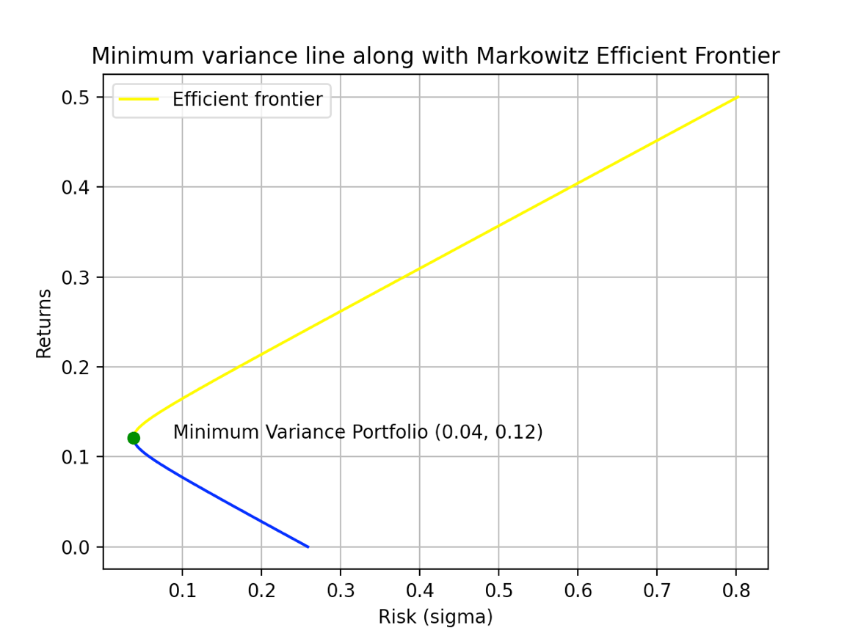

The efficient frontier is the one with higher expected return and lower standard deviation (lower risk). So, the points with higher return than the minimum variance portfolio point shows the efficient frontier on the curve.

1. The weights, return and risk of the portfolios for 10 different values on the efficient frontier are as follows: -

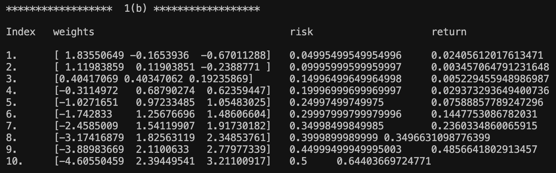

1. For 15% risk,

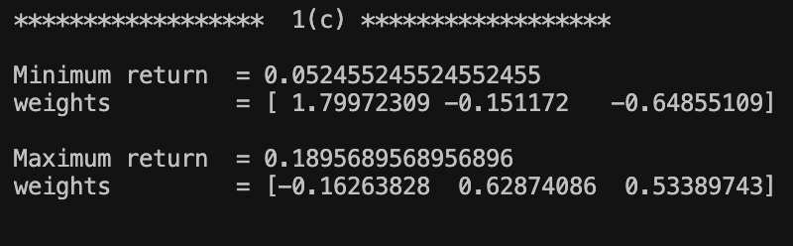

1. For 18% return, the minimum risk portfolio is: -

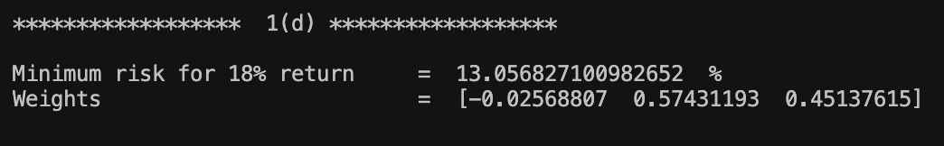

1. The market portfolio is: -

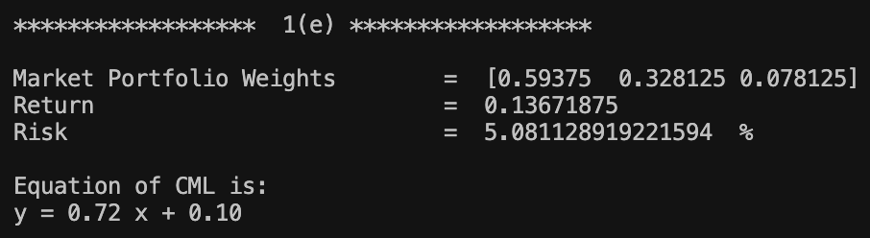

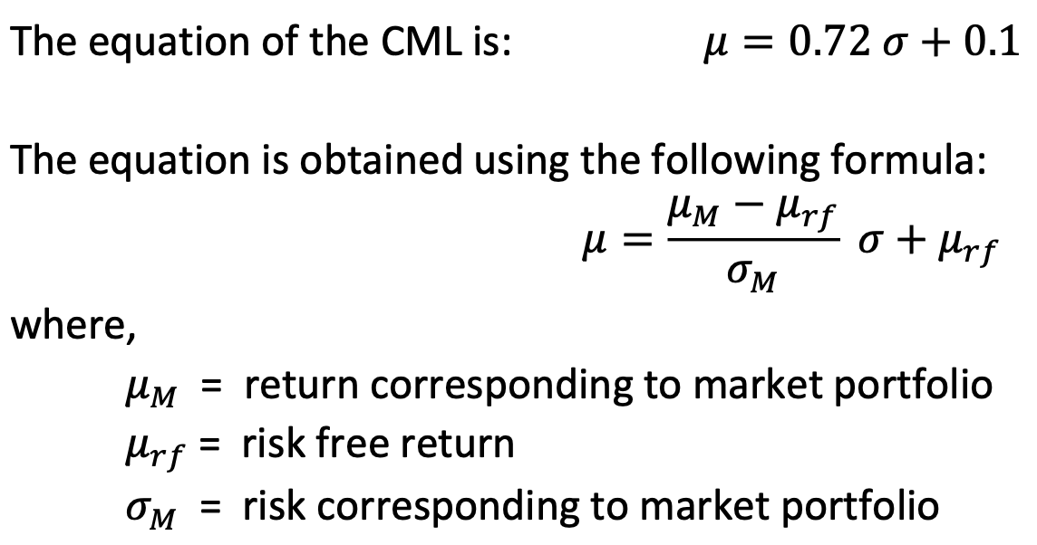

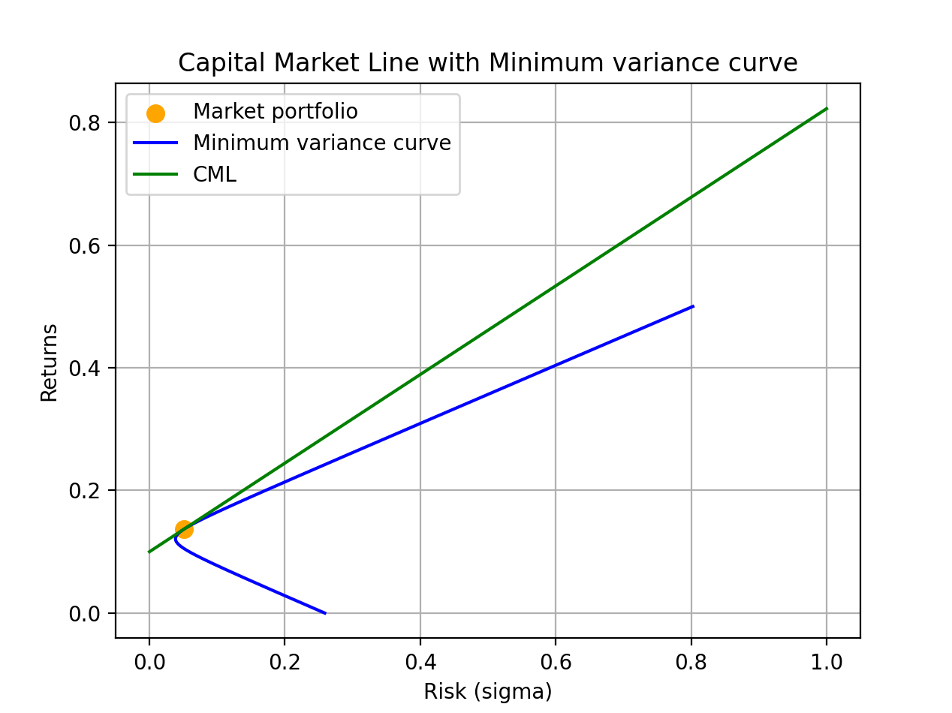

1. The required portfolio with risk at 10% is: -

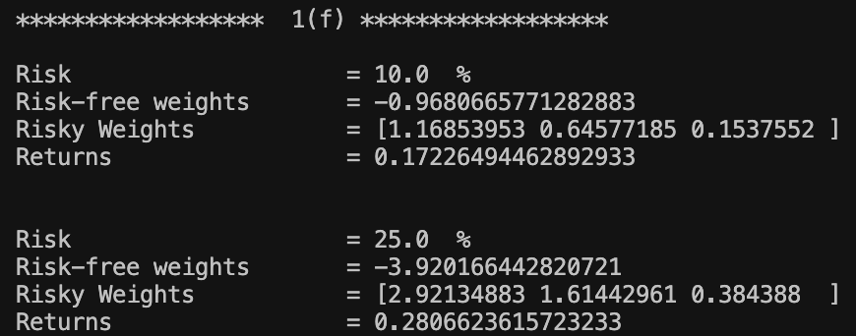

# Ques – 2

Assuming short sales are not allowed, i.e., weights are non-negative, the various plots can be obtained like: -

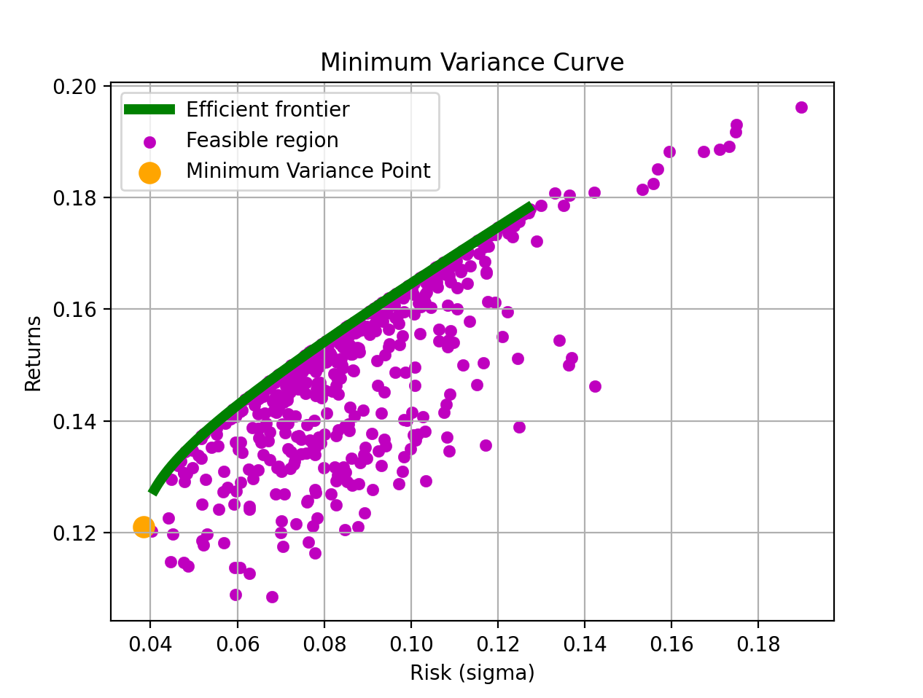

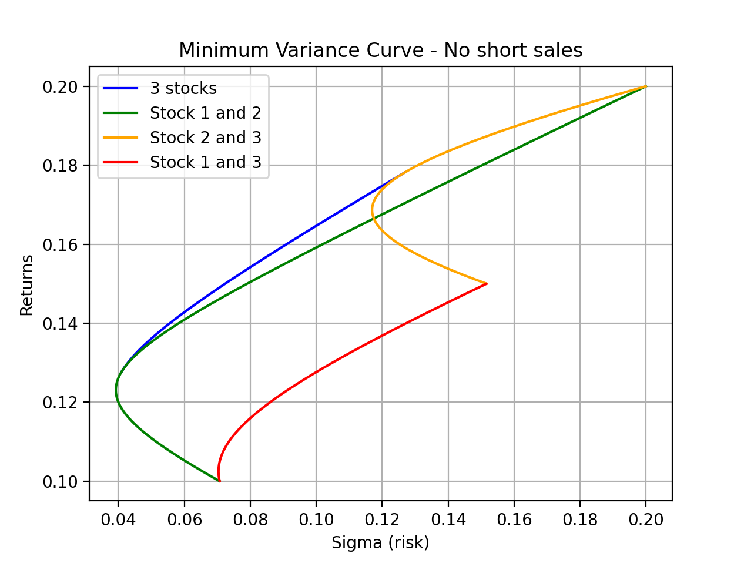

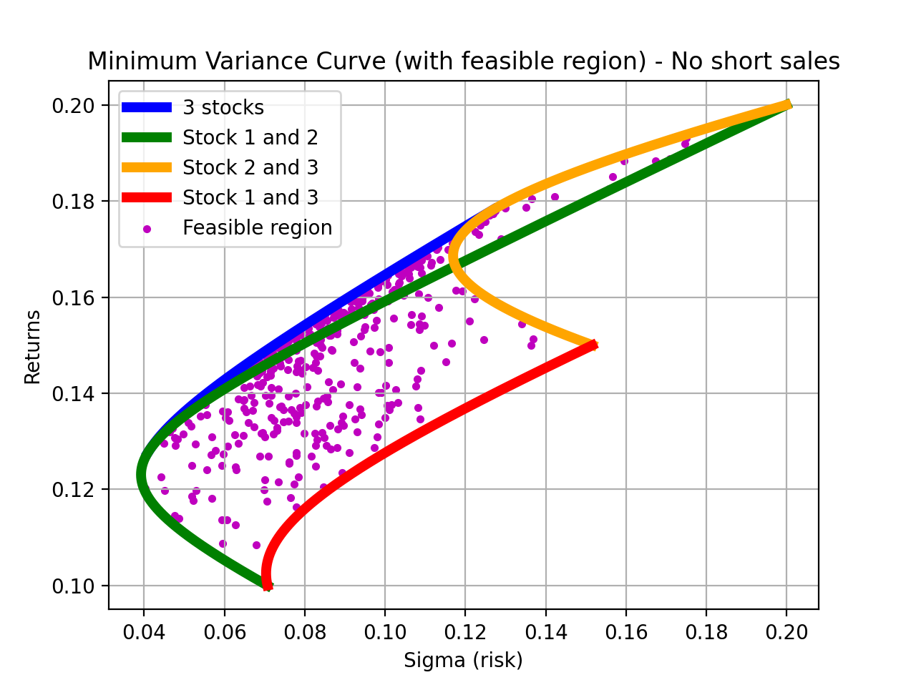

* Equation of line w1 vs w2 is: - w2 = -0.40 w1 + 0.56

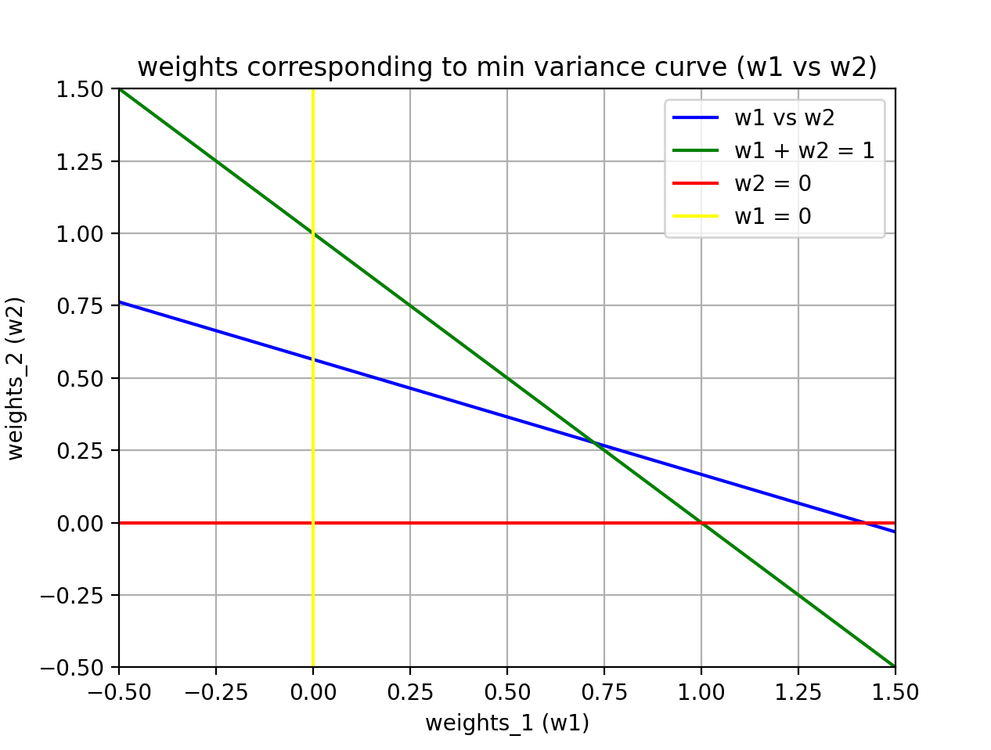

* Equation of line w2 vs w3 is: - w3 = 1.52 w2 + -0.42

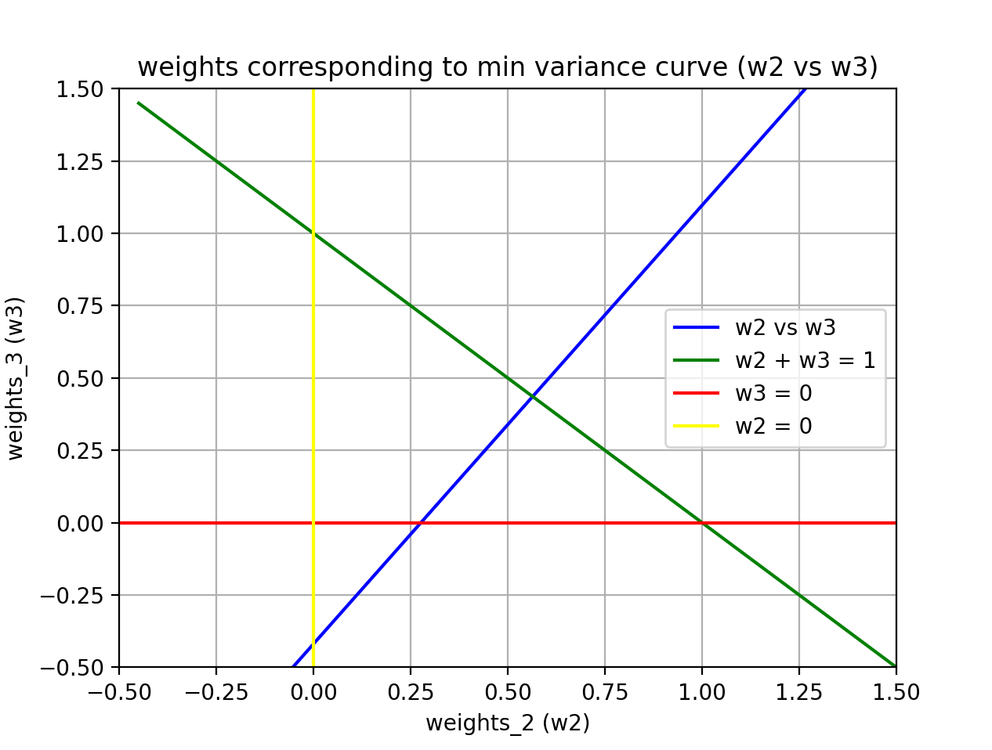

* Equation of line w1 vs w3 is: - w3 = -0.60 w1 + 0.44

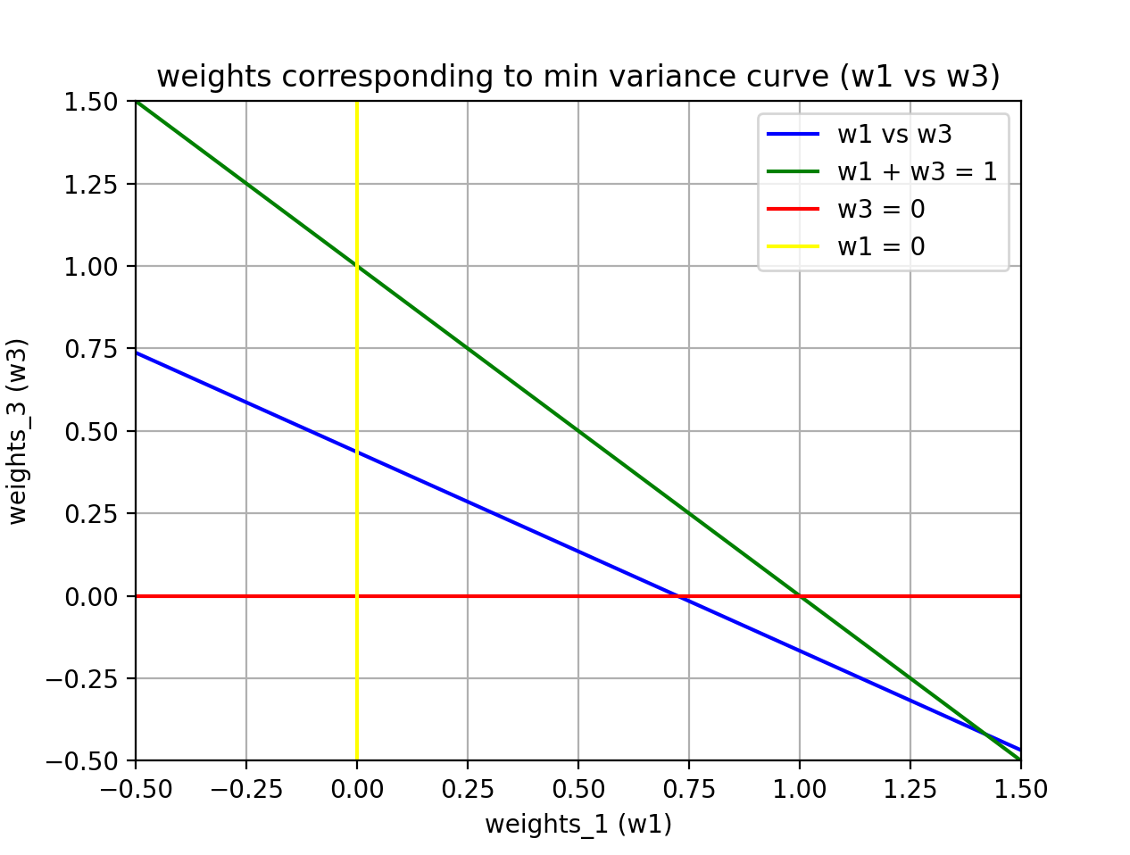

# Ques – 3

Data for 10 stocks has been obtained from NSE from Feb 2019 to Jan 2024 to get 60 different time stamps for data points. The following 10 Stocks are considered for the purpose: -

,Amul India,Interglobe Aviation, ,Tata Motors,Ultratech Cement,ONGC, SBI,TCS

● IDBI Bank  
● Amul India  
● Interglobe Aviation  
● Oil India  
● Tata Motors  
● Ultratech Cement  
● ONGC  
● Reliance Industries  
● SBI  
● TCS

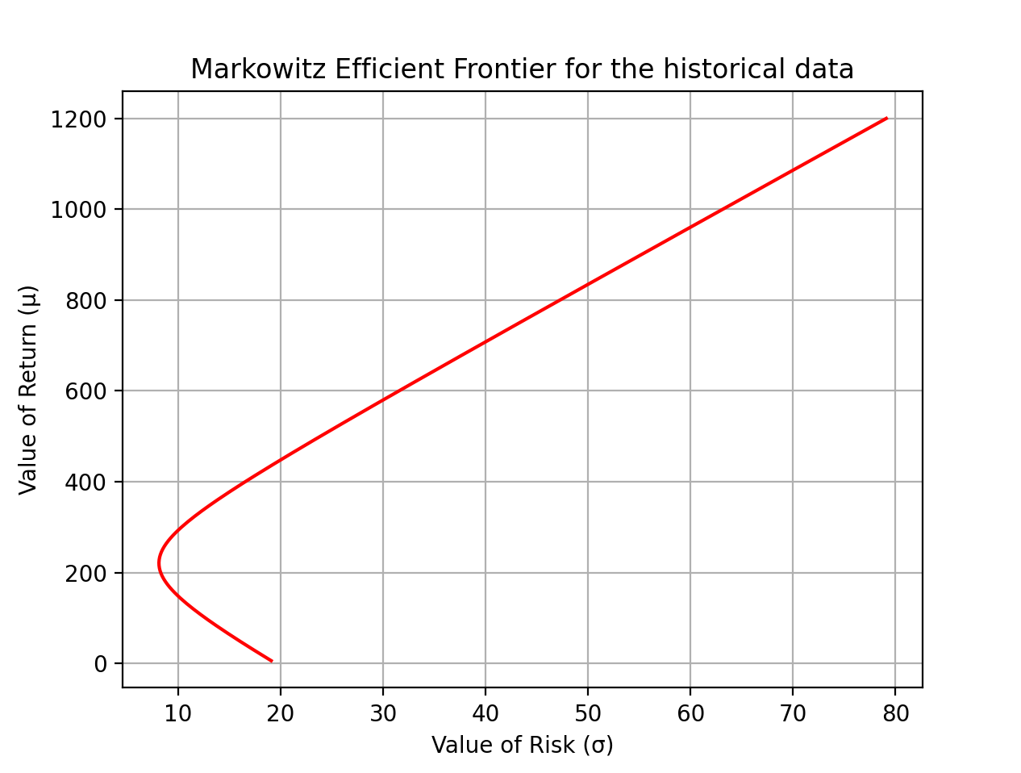

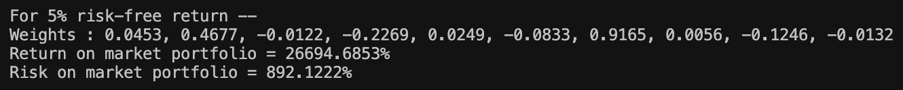

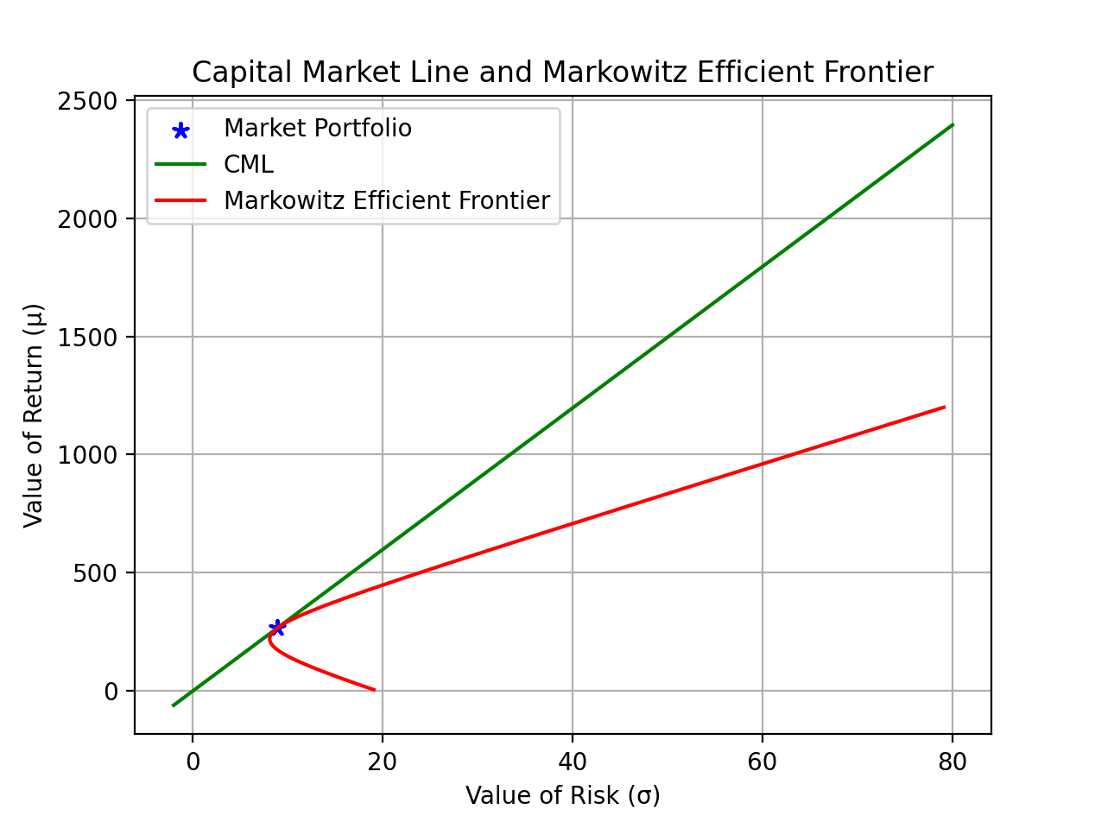

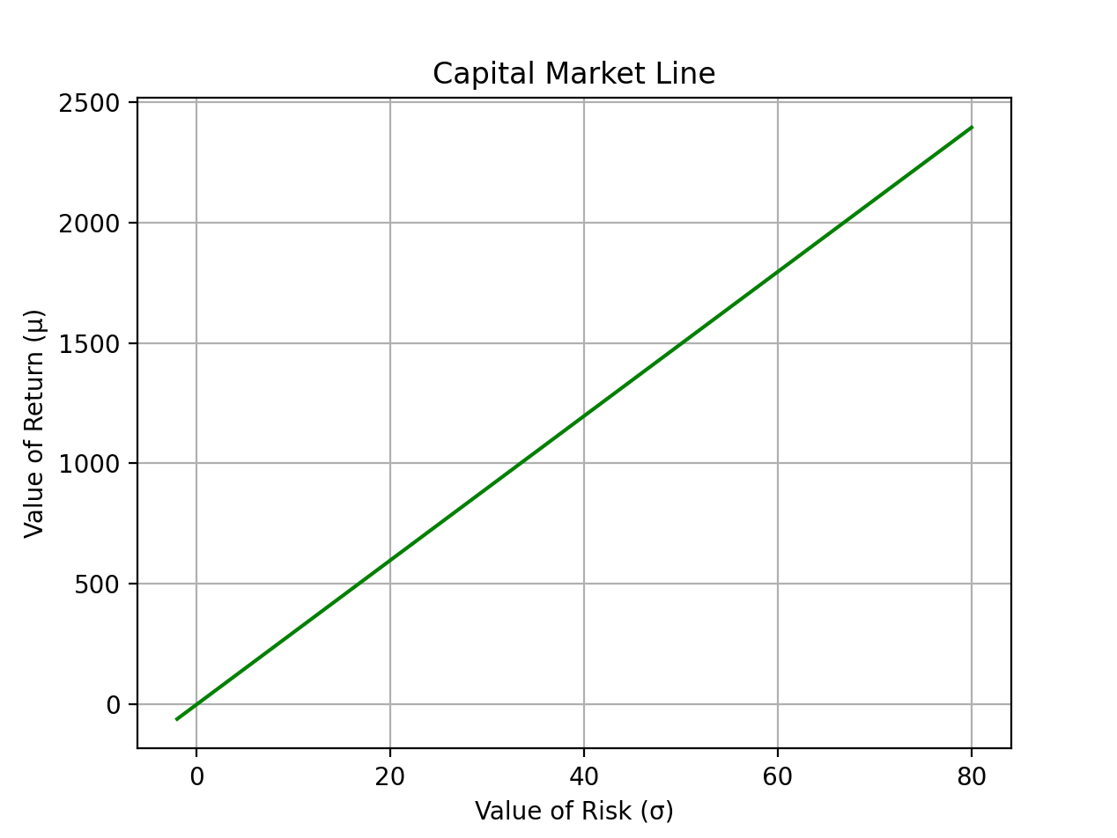

For plotting the Security Market Line, E[Ri] = Rf + (E[RM] - Rf)ß was used. Beta was generated uniformly between [-2, 2], and making use of the rest of the values, the Security Market Lines were plotted for all the 10 assets.

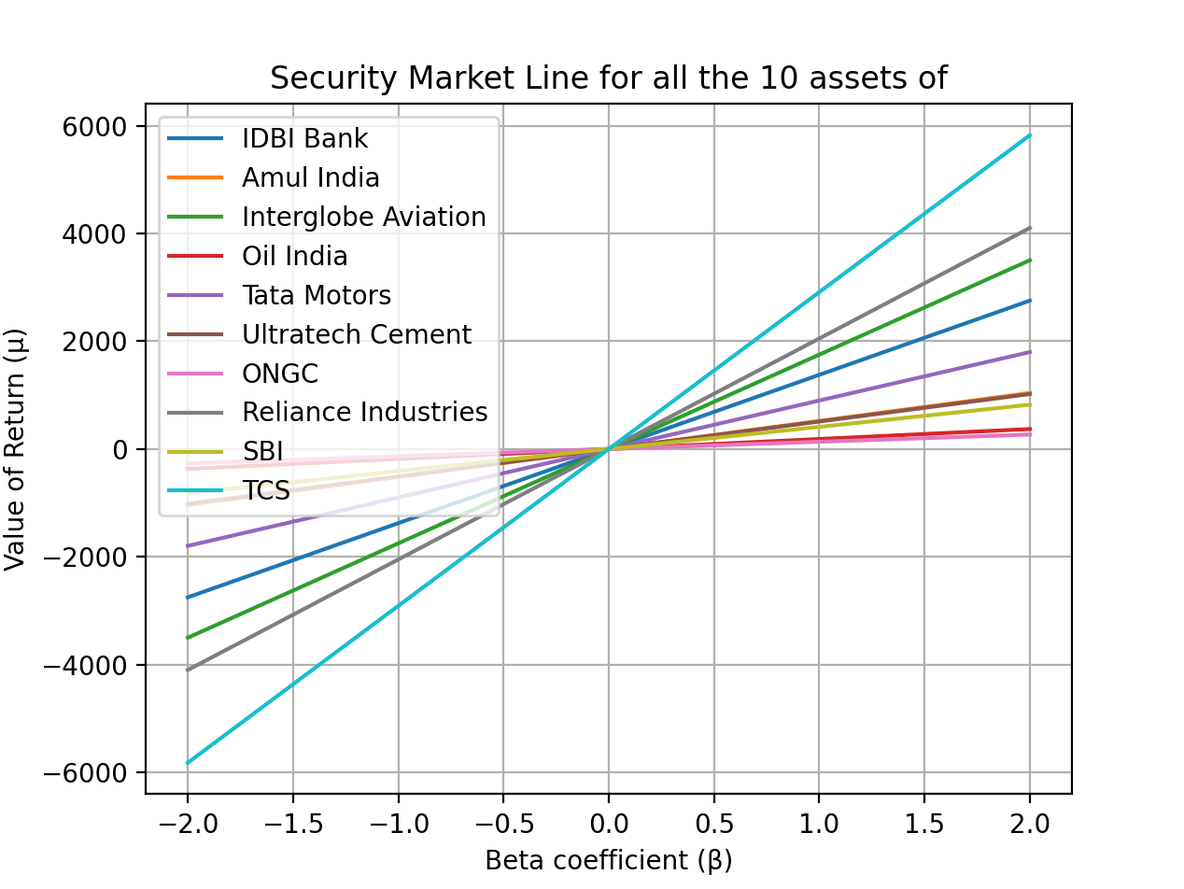

**Note: -** In the code please enter the proper path for ‘210123083_data.csv’ file if moving it to other location, else it will produce an error stating no file found.