MA374 – Financial Engineering Laboratory

Lab – 05

Dipanshu Goyal 210123083

# Ques – 1

I took the two indexes **BSE SENSEX 30** and **NIFTY 50** for the data collection. Firstly, I collected the index prices for these two indexes for the given duration. Then I collected data for 10 stocks included in SENSEX 30, 10 stocks included in NIFTY 50 and 10 stocks which are neither included in SENSEX 30 nor in NIFTY 50. Thus, I formed 2 groups of 20 stocks each by combining each group of 10 stocks from SENSEX 30 and NIFTY 50 respectively with the 10 stocks not included in either two of them.

The closing prices of both groups and the index values are stored in two csv files names ‘bsedata1’ and ‘nsedata1’.

# Ques – 2

Observations for the collected data

Market portfolio for BSE using Index: -

Market return = 0.21962133416396296

Market risk = 0.9977618198216794 %

Market portfolio for NSE using Index: -

Market return = 0.18385327842255128

Market risk = 0.960812983451128 %

* 10 stocks from the BSE Index: -

1. The plot for Markowitz efficient frontier is:

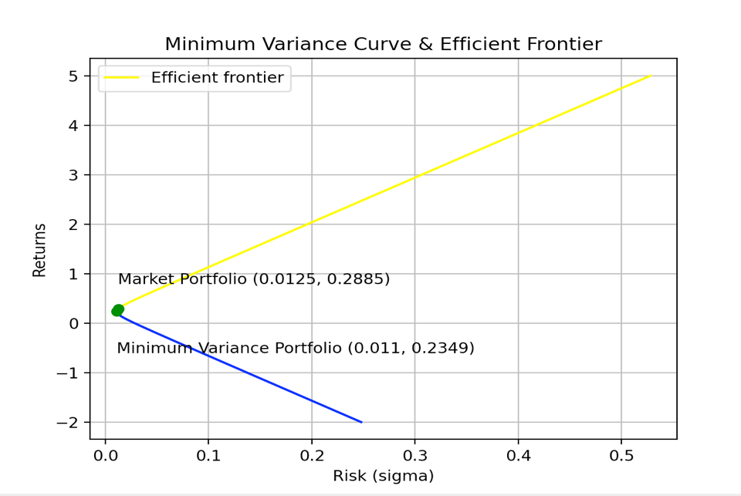

1. Market Portfolio Weights = [0.07534816, -0.16664, 0.06307248, 0.09007522, 0.24273176, -0.14503317, 0.21779174, 0.09623905, 0.21088248, 0.31553227]

Return = 0.28846446855421337

Risk = 1.2517333635070262 %

1. Equation of CML is: y = 19.0507*x + 0.0500

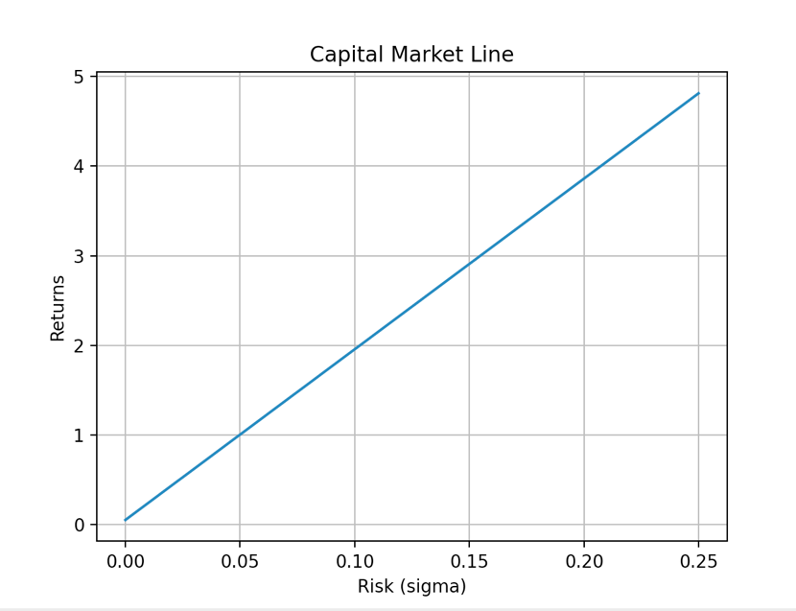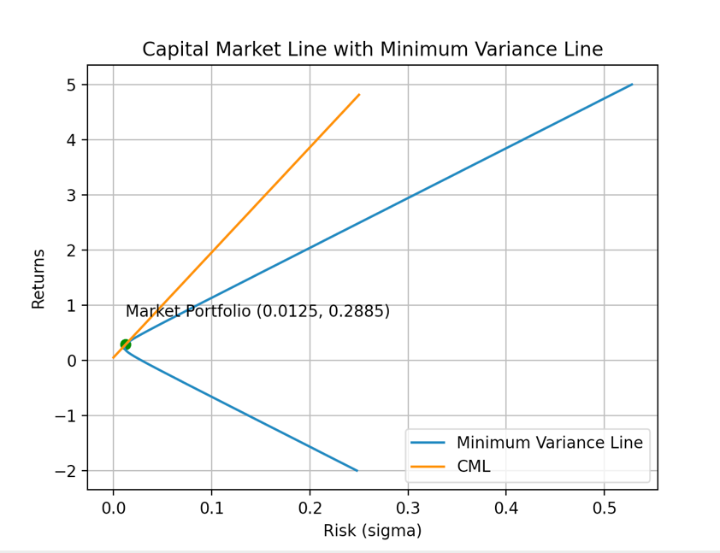

1. Equation of Security Market Line is: mu = 0.17*beta + 0.05

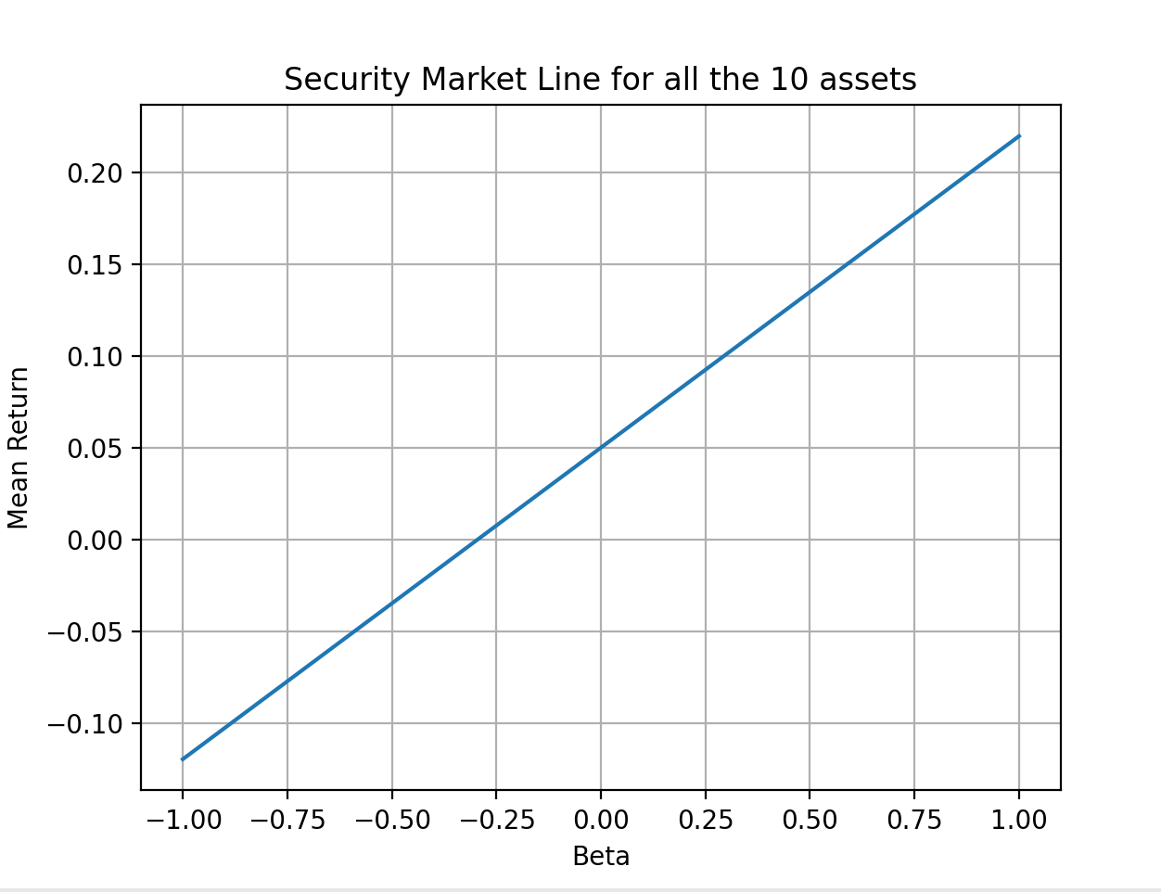

* 10 stocks from the NSE Index: -

1. The plot for Markowitz efficient frontier is:

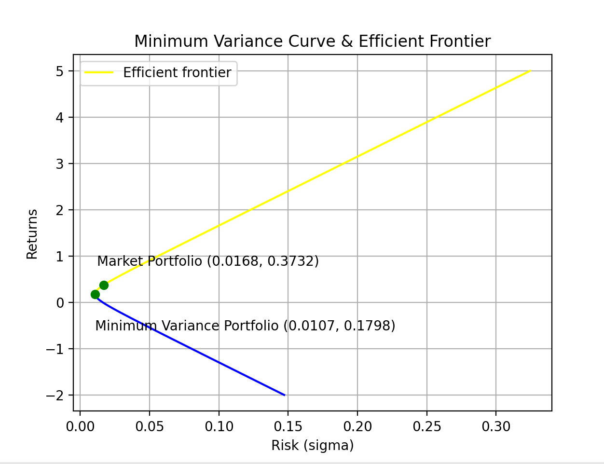

1. Market Portfolio Weights = [0.45441185, 0.5720041, 0.08399827, -0.34154213, 0.13301761, 0.00649973, 0.34451697, -0.21148159, 0.06273349, -0.10415831]

Return = 0.37317369402107814

Risk = 1.6827198439086335 %

1. Equation of CML is: y = 19.2054*x + 0.0500

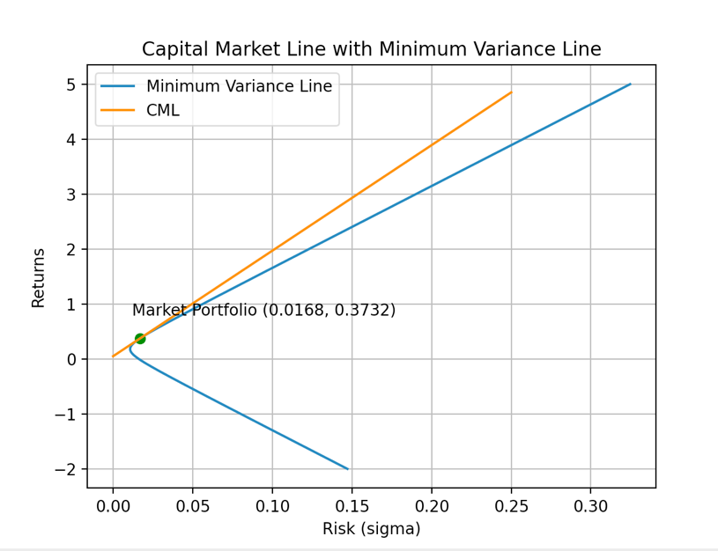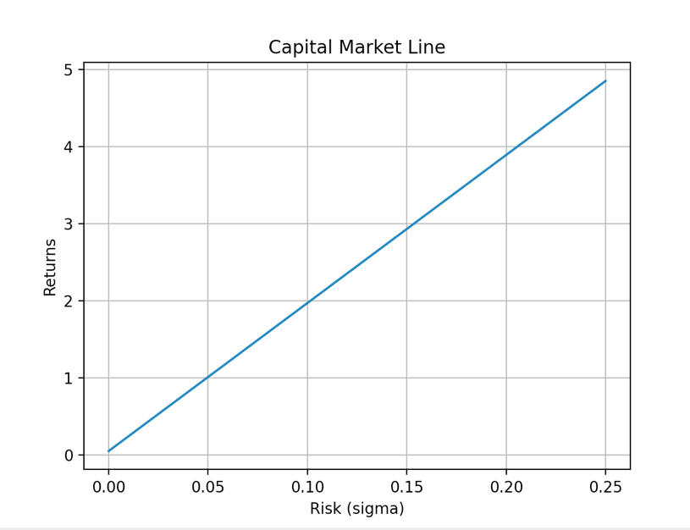

1. Equation of Security Market Line is: mu = 0.13*beta + 0.05

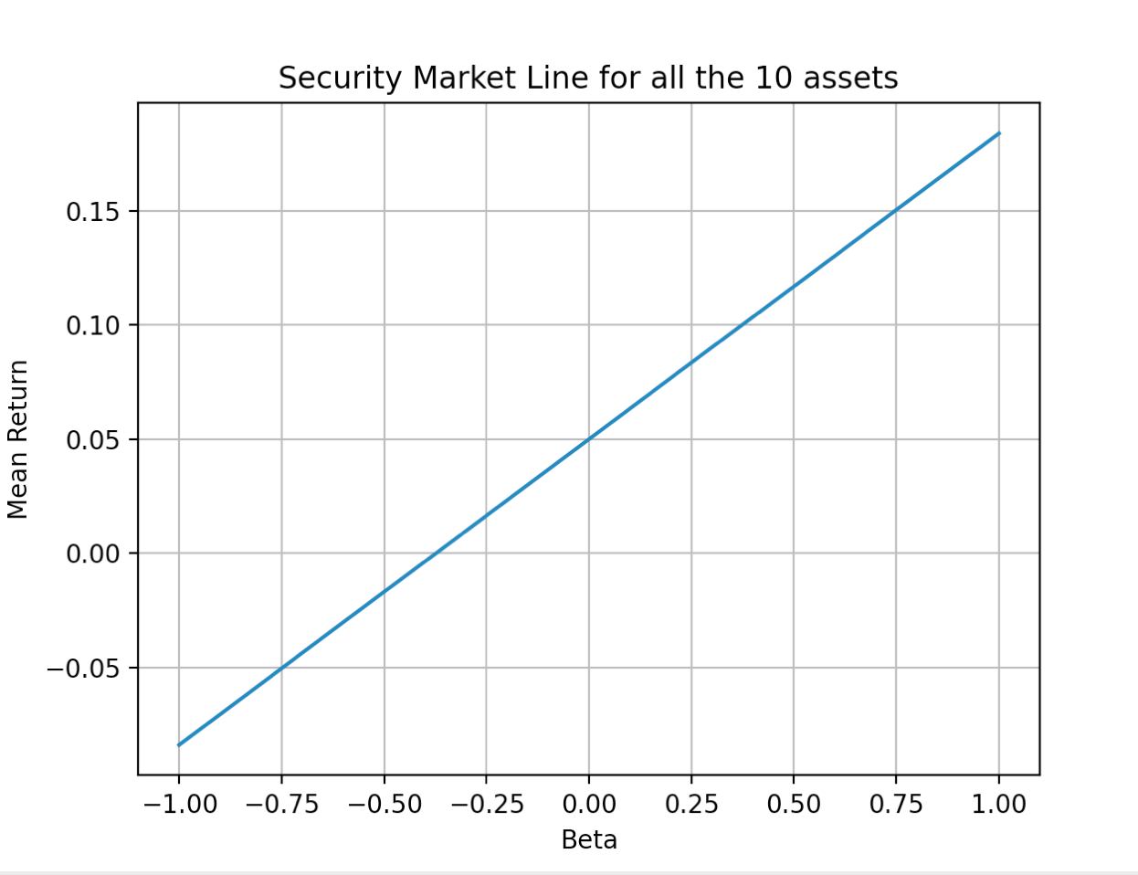

* 10 stocks not from any Index: -

1. The plot for Markowitz efficient frontier is:

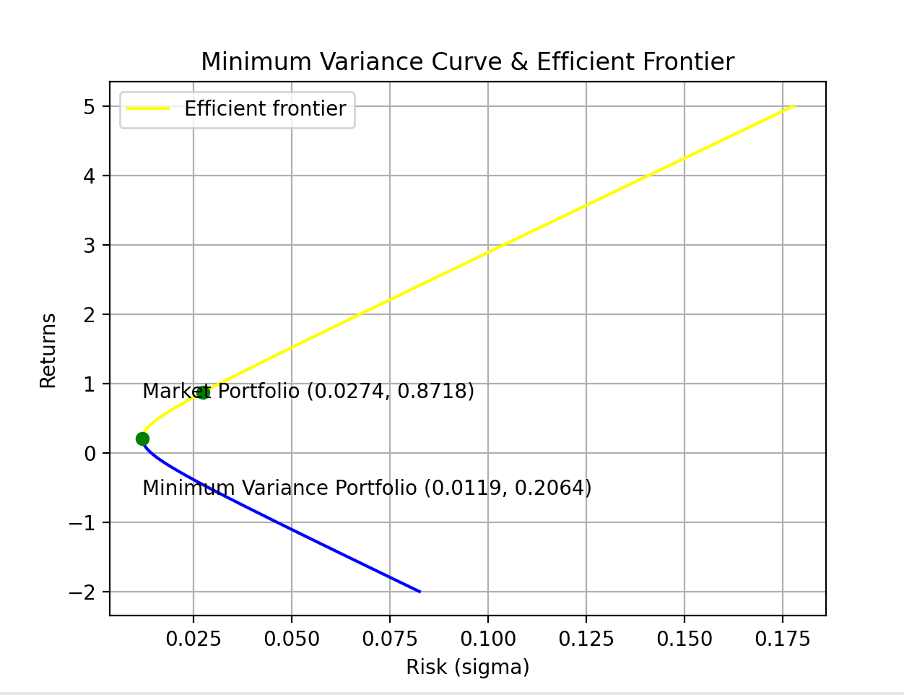

1. Market Portfolio Weights = [-0.08662322, -0.58931445, 0.64624583, -0.01729321, 0.17933864, 0.11507626, -0.36724272, 0.06639928, 0.57524466, 0.47816893]

Return = 0.8718489845030102

Risk = 2.7357253672079644 %

1. Equation of CML is: y = 30.0414*x + 0.0500

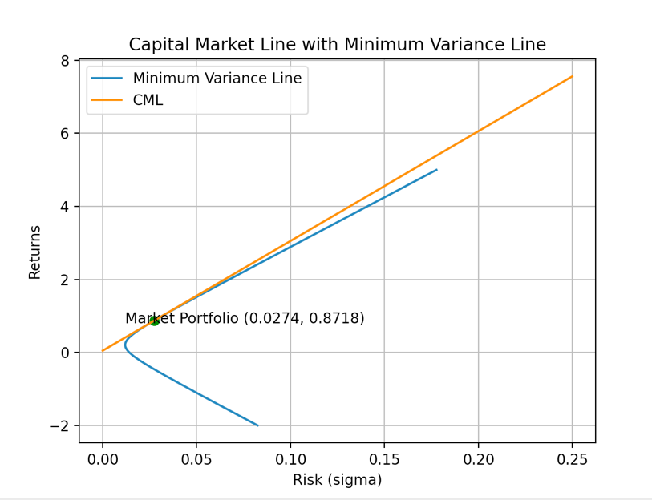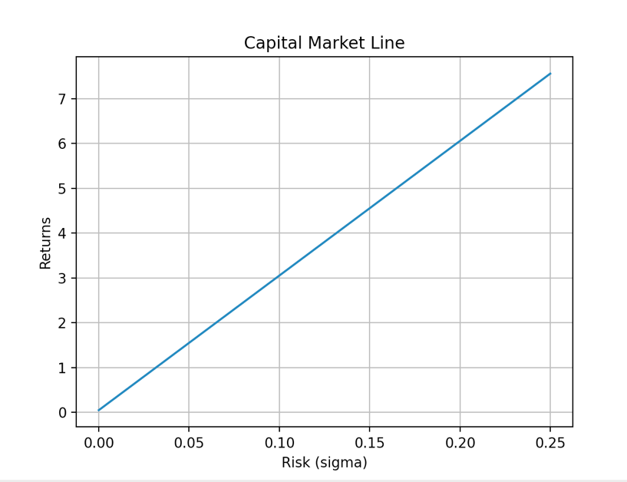

1. Eqn of Security Market Line is: mu = 0.82*beta + 0.05

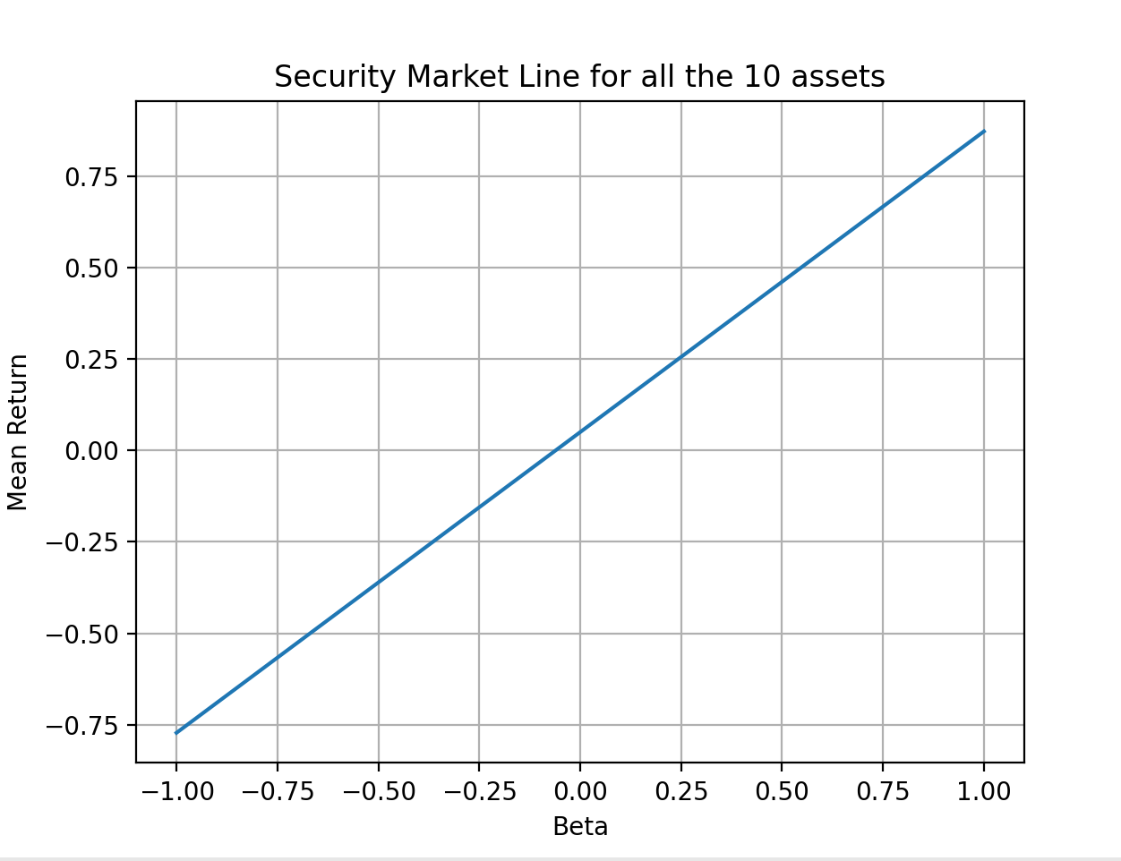

* Following tables compares the expected and actual return value of each stock, where expected value is computed by making use of the security market line (SML) equation:

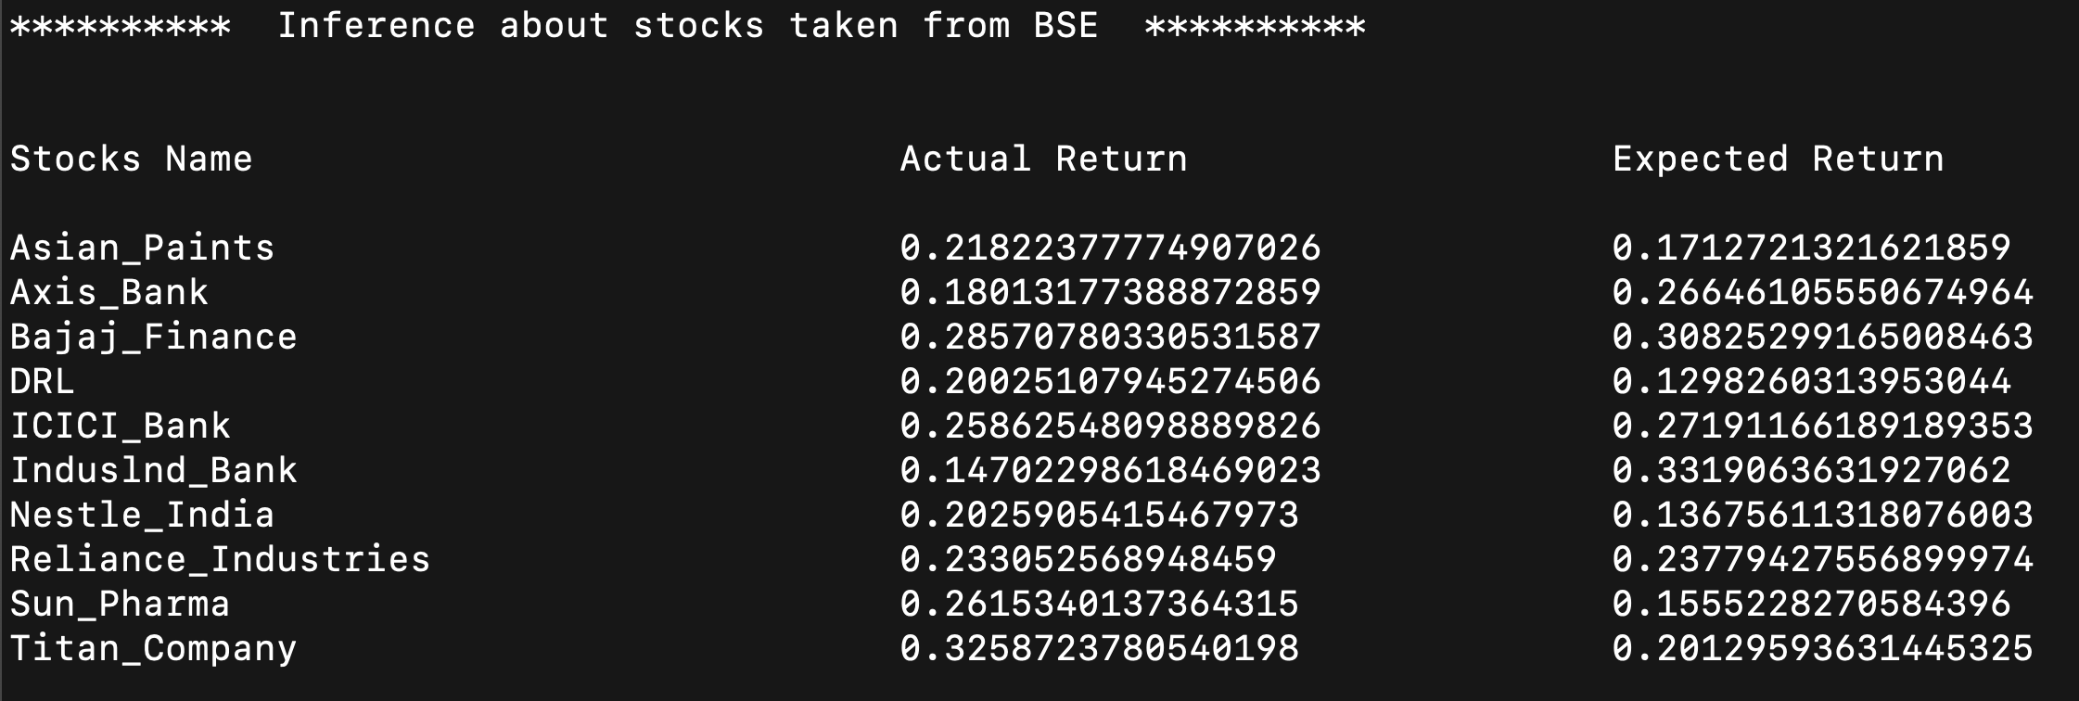

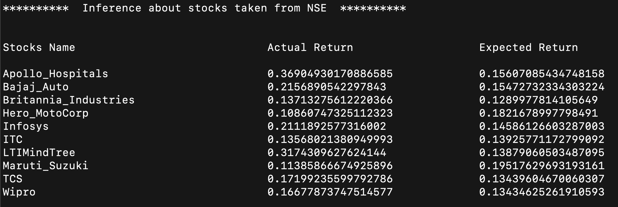

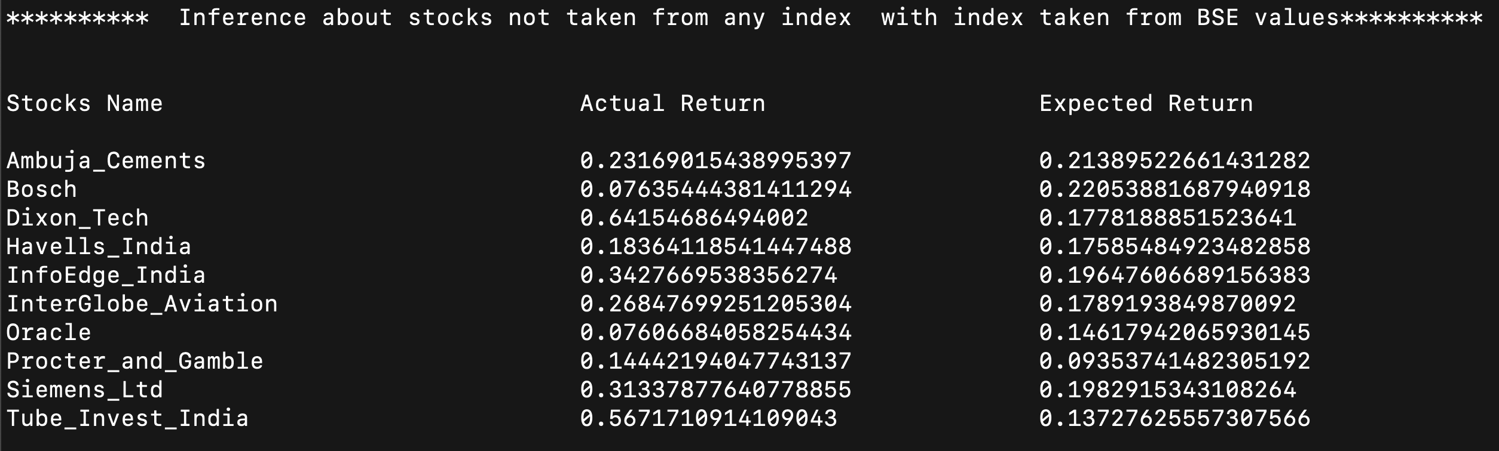

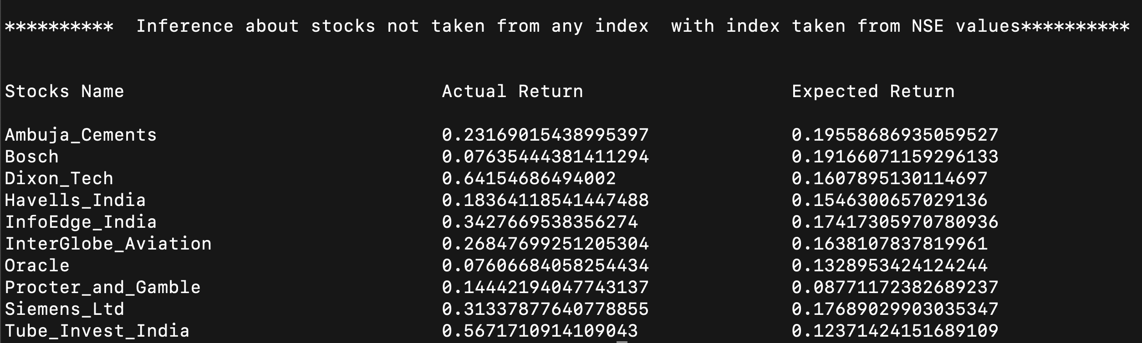

* The betas of the securities for the stocks from BSE index are: -

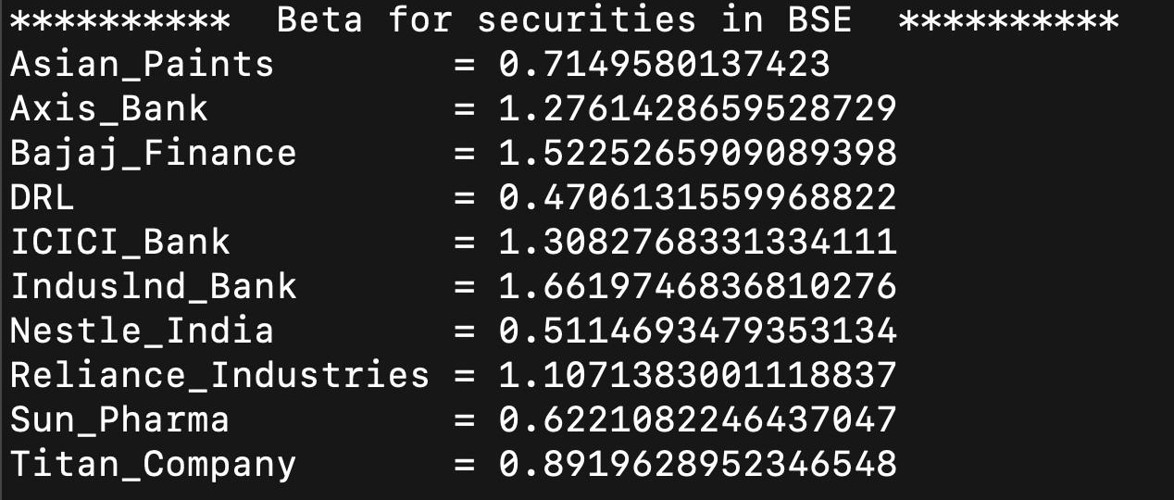

* The betas of the securities for the stocks from NSE index are: -

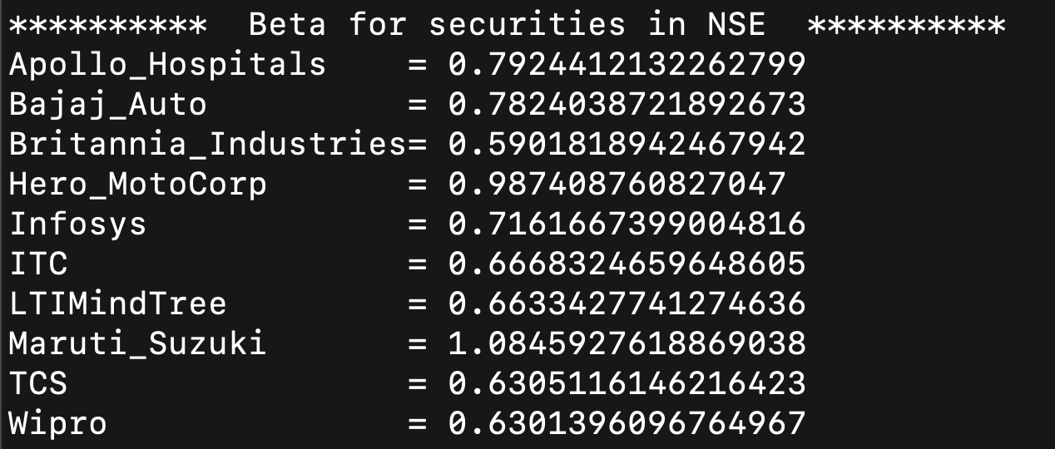

* The betas of the securities for the stocks from non-index using market portfolio from BSE index are: -

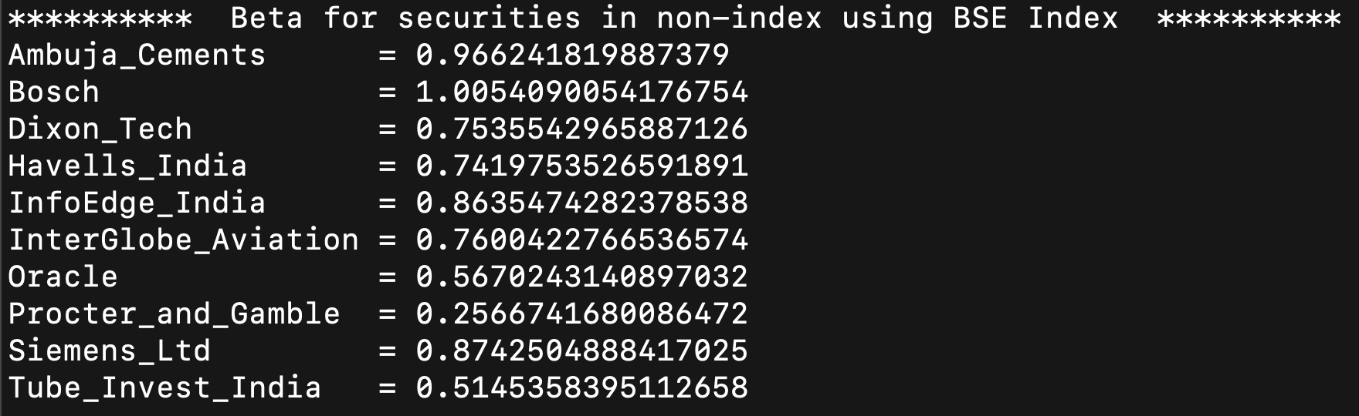

* The betas of the securities for the stocks from non-index using market portfolio from NSE index are: -

