MA374 – Financial Engineering Laboratory

Lab – 10

Dipanshu Goyal 210123083

# Ques – 1

1. 10 different asset price paths based on GBM Model in real world.

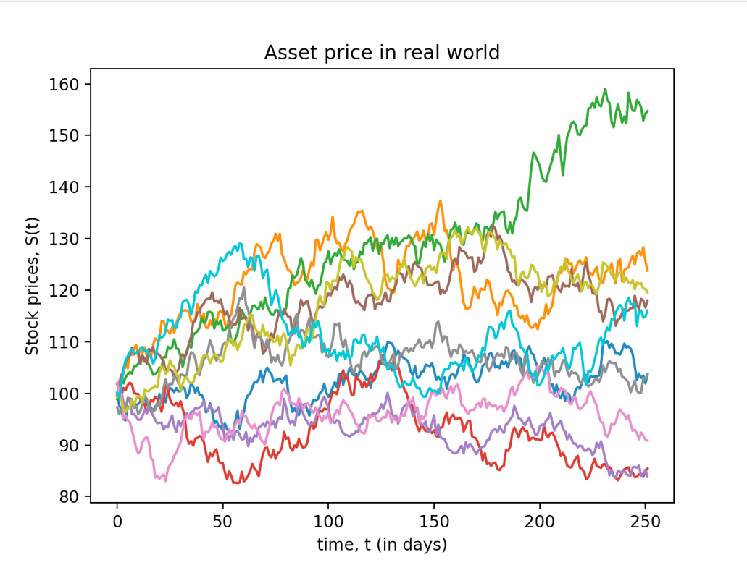

1. 10 different asset price paths based on GBM Model in risk-neutral world.

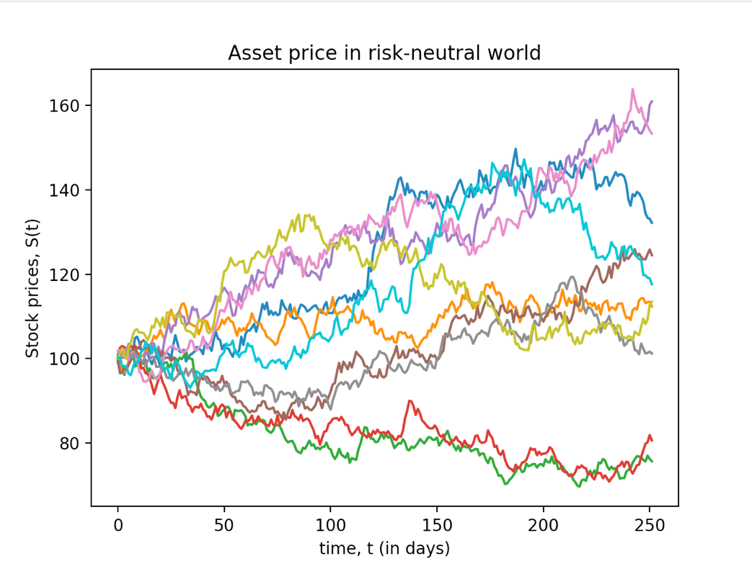

The prices of a six-month fixed-strike Asian option with various strike prices are: -

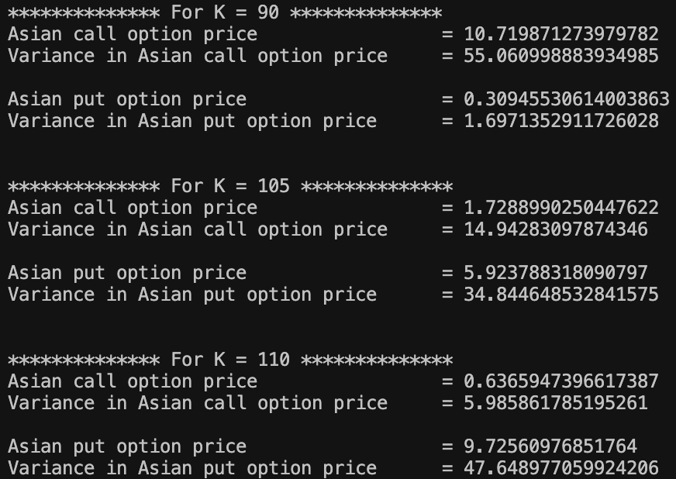

**Sensitivity Analysis: -**

1. Variation with S0: -

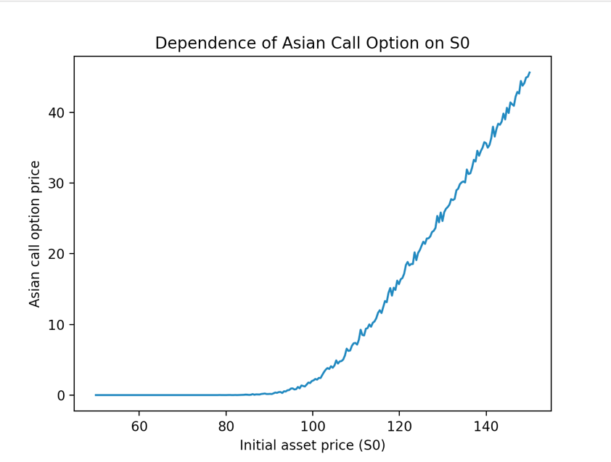 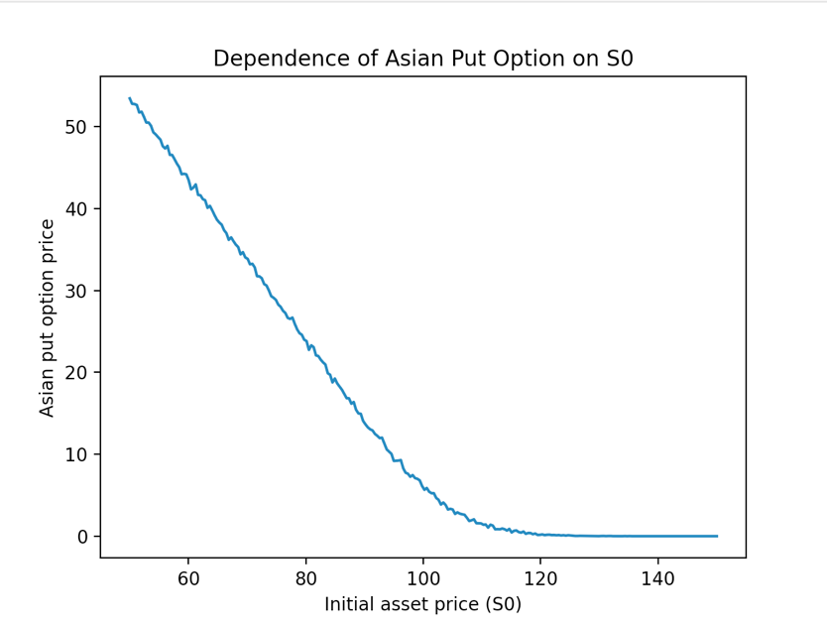

1. Variation with K: -

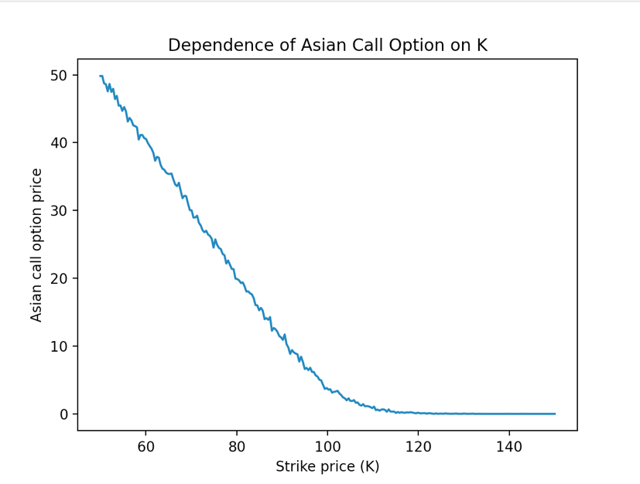 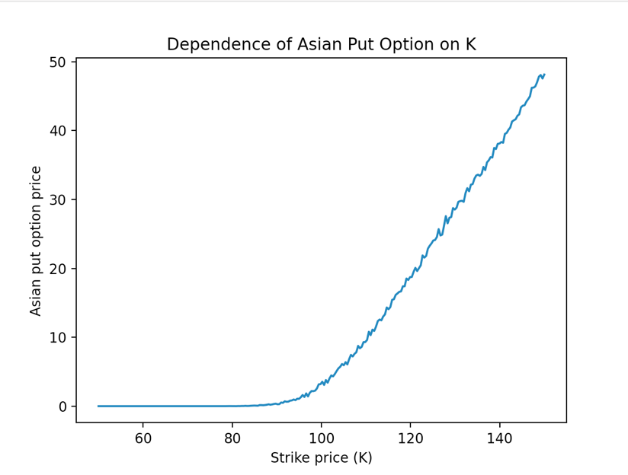

1. Variation with r: -

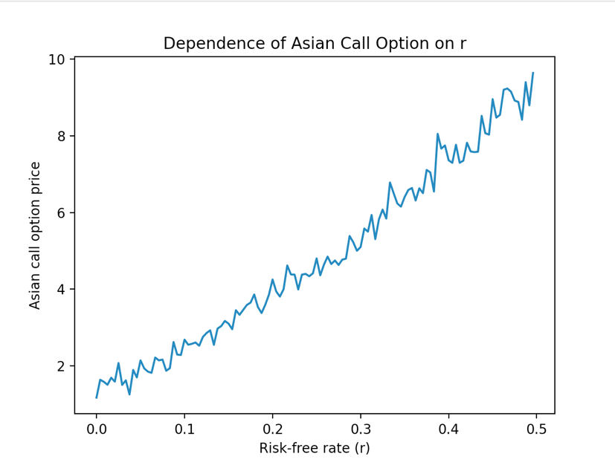 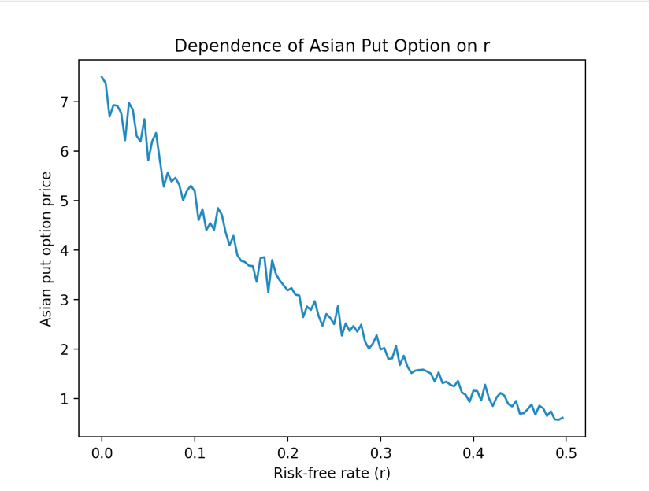

1. Variation with sigma: -

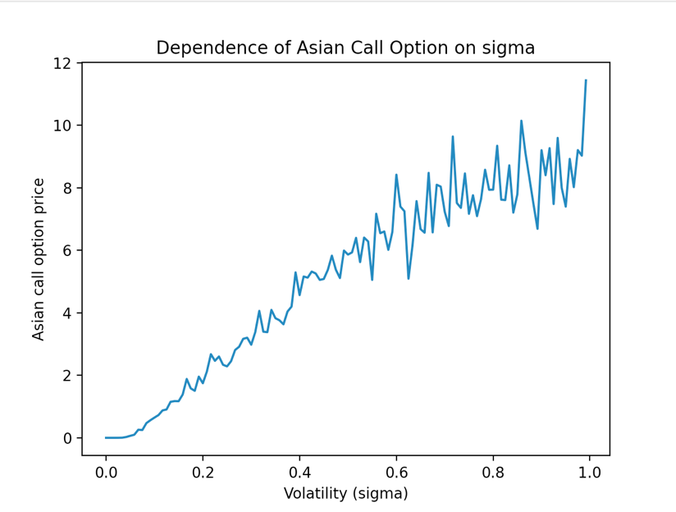 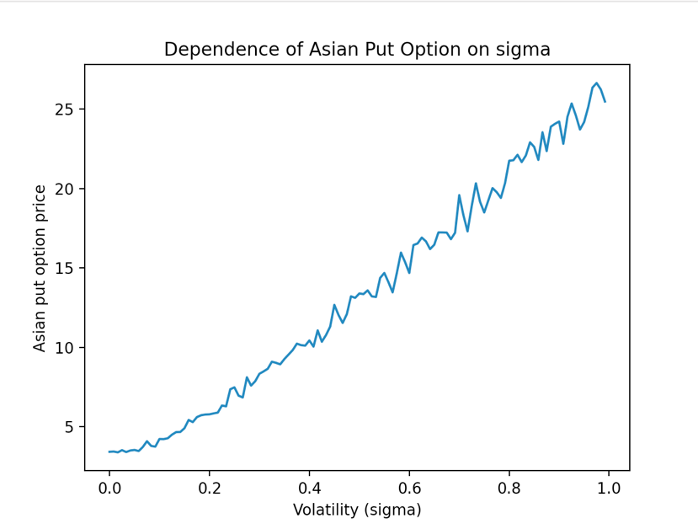

# **Observations:** -

# The price of the call option increases while that of the put option decreases, with an increase in the initial asset price, S0.

# The price of the call option decreases while that of the put option increases, with an increase in the strike prices, K.

# The price of the call option increases while that of the put option decreases, with an increase in the risk-free interest, r.

# The price of both call and put option increases with an increase in sigma.

# Ques – 2

The prices of a six-month fixed-strike Asian option with various strike prices, after performing variance reduction are: -

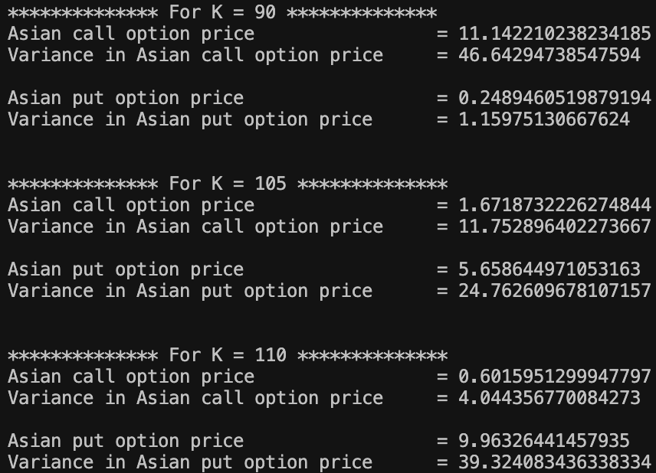

**Observations: –**

The price of both call and put options obtained using both with and without variance   
reduction, are comparable. The respective variances are compared in the following table:

1. **For Call Option: -**

|  |  |  |  |
| --- | --- | --- | --- |
| **S No.** | **Strike Price (K)** | **Variance (without reduction)** | **Variance (with reduction)** |
| **1.** | 95 | 55.060998883934985 | 46.64294738547594 |
| **2.** | 105 | 14.94283097874346 | 11.752896402273667 |
| **3.** | 110 | 5.985861785195261 | 4.044356770084273 |

1. **For Put Option: -**

|  |  |  |  |
| --- | --- | --- | --- |
| **S No.** | **Strike Price (K)** | **Variance (without reduction)** | **Variance (with reduction)** |
| **1.** | 95 | 1.6971352911726028 | 1.15975130667624 |
| **2.** | 105 | 34.844648532841575 | 24.762609678107157 |
| **3.** | 110 | 47.648977059924206 | 39.324083436338334 |

**Sensitivity Analysis after performing Variance Reduction: –**

1. Variation with S0: -

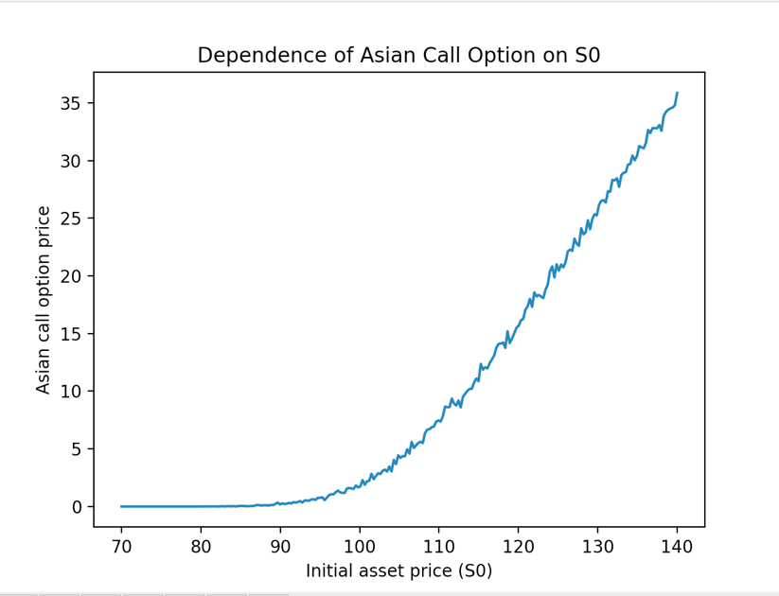 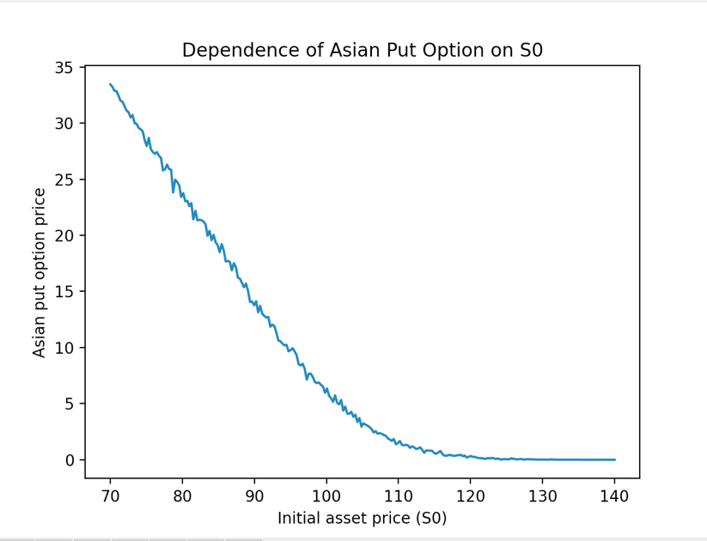

2. Variation with K: -

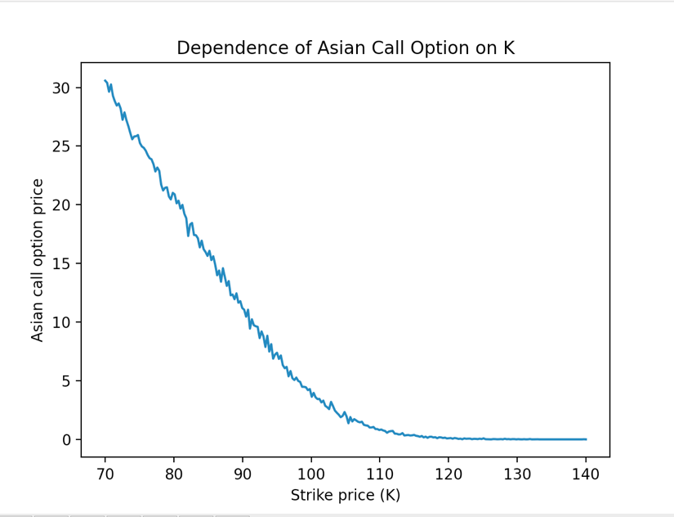 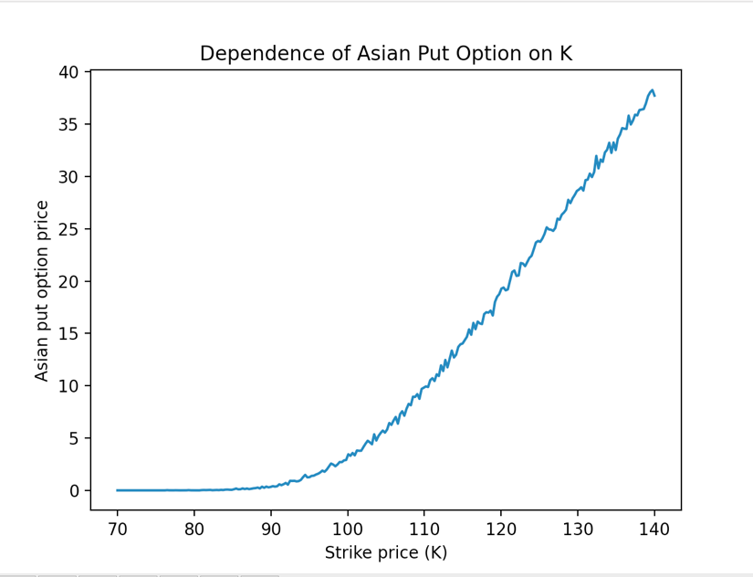

3. Variation with r: -

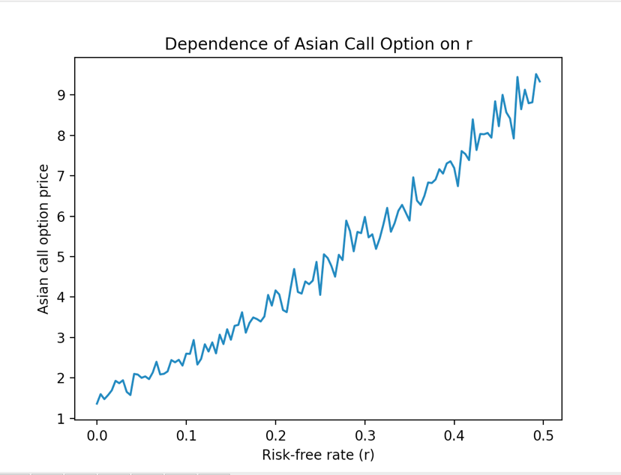 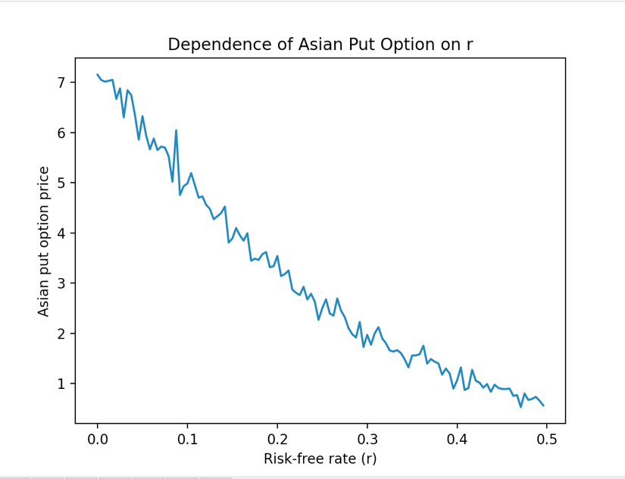

1. Variation with sigma: -

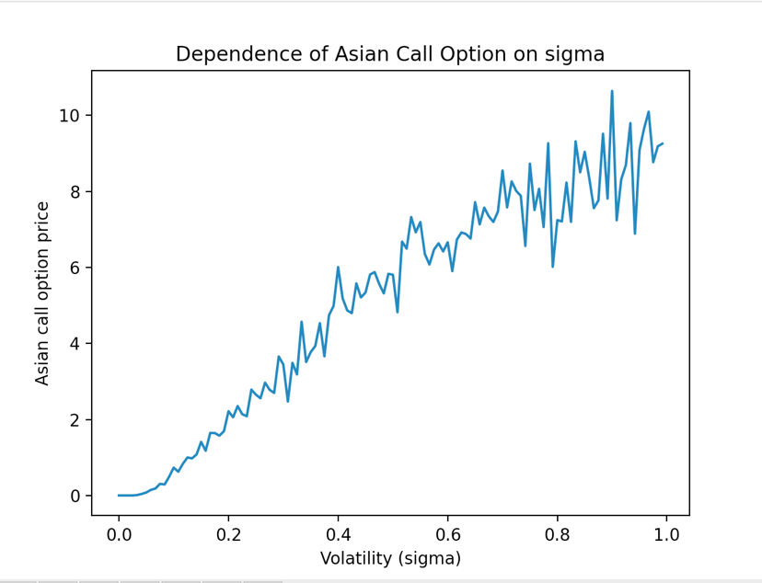 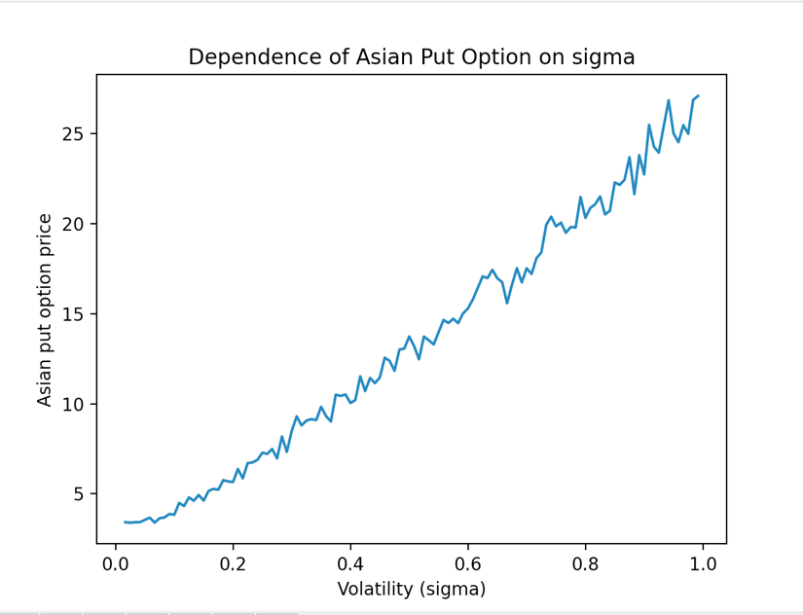

**Observations:** -

1. Earlier, we have quantitatively demonstrated that the variance reduction is achieved.   
   This claim is even more supported by the constructed plots.
2. On careful analysis, the fluctuations in the plots seem to be less than the case when   
   variance reduction was not applied. So, the scheme achieves its goal.
3. The nature of the plots is consistent with our expectations, which is explained in the   
   last question.