MA374 – Financial Engineering Laboratory

Lab – 11

Dipanshu Goyal 210123083

# Ques – 1

The term structure for the parameter set [5.9, 0.2, 0.3, 0.1] is:

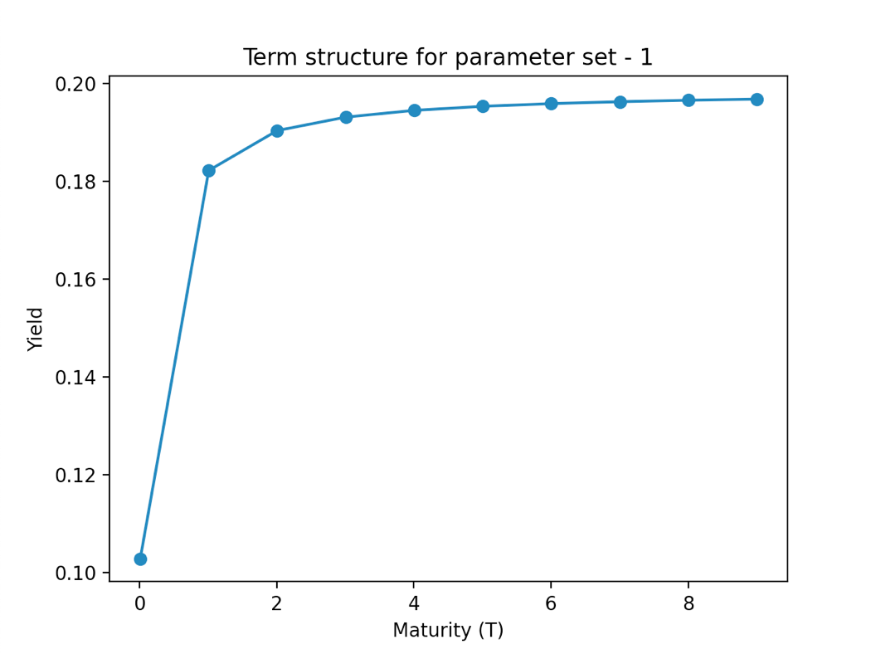

The term structure for the parameter set [3.9, 0.1, 0.3, 0.2] is:

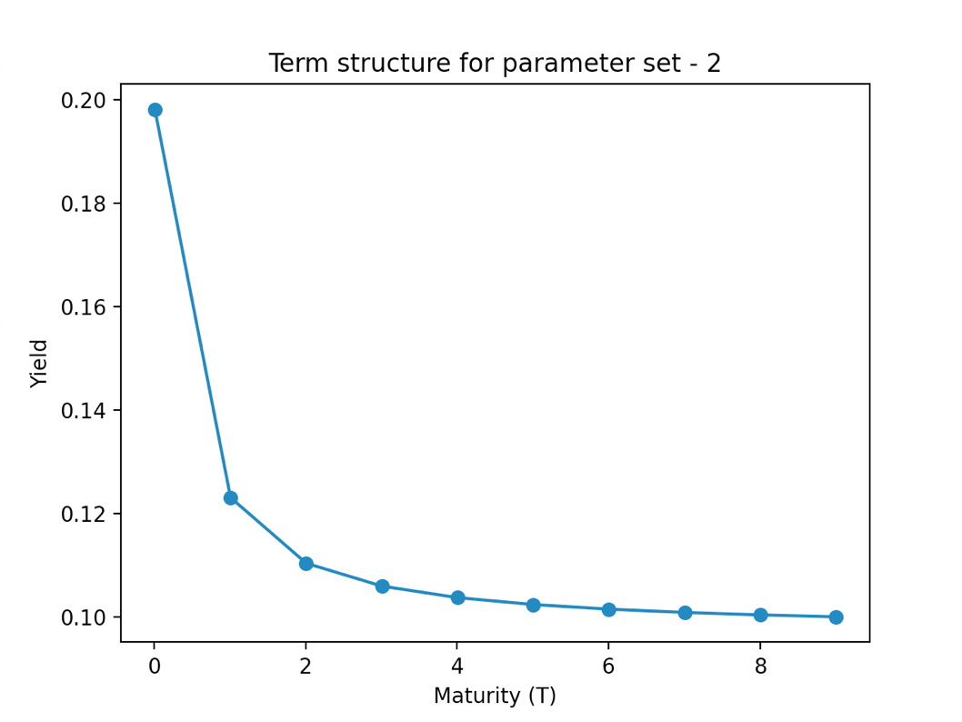

The term structure for the parameter set [0.1, 0.4, 0.11, 0.1] is:

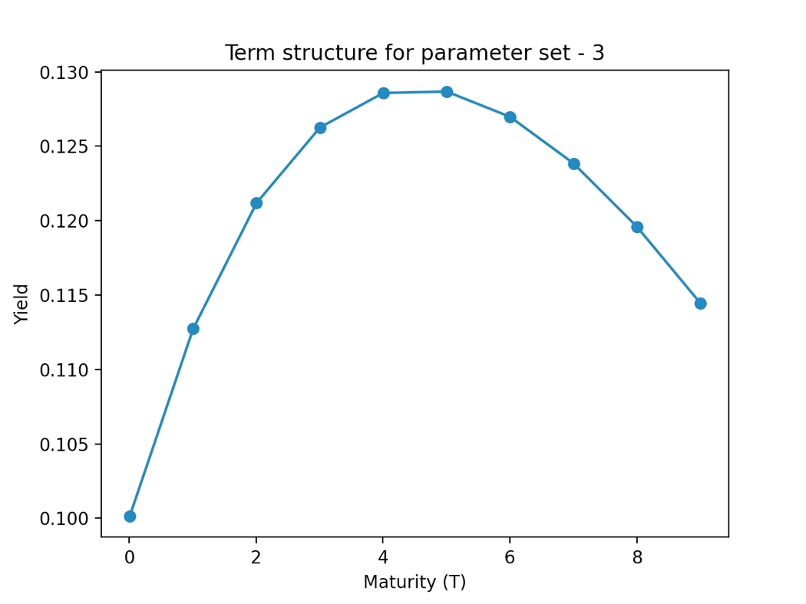

The yield curves vs maturity up to 500 time units for 10 different values of r (0) are:

1. **Parameter set – [5.9, 0.2, 0.3, 0.1]:**

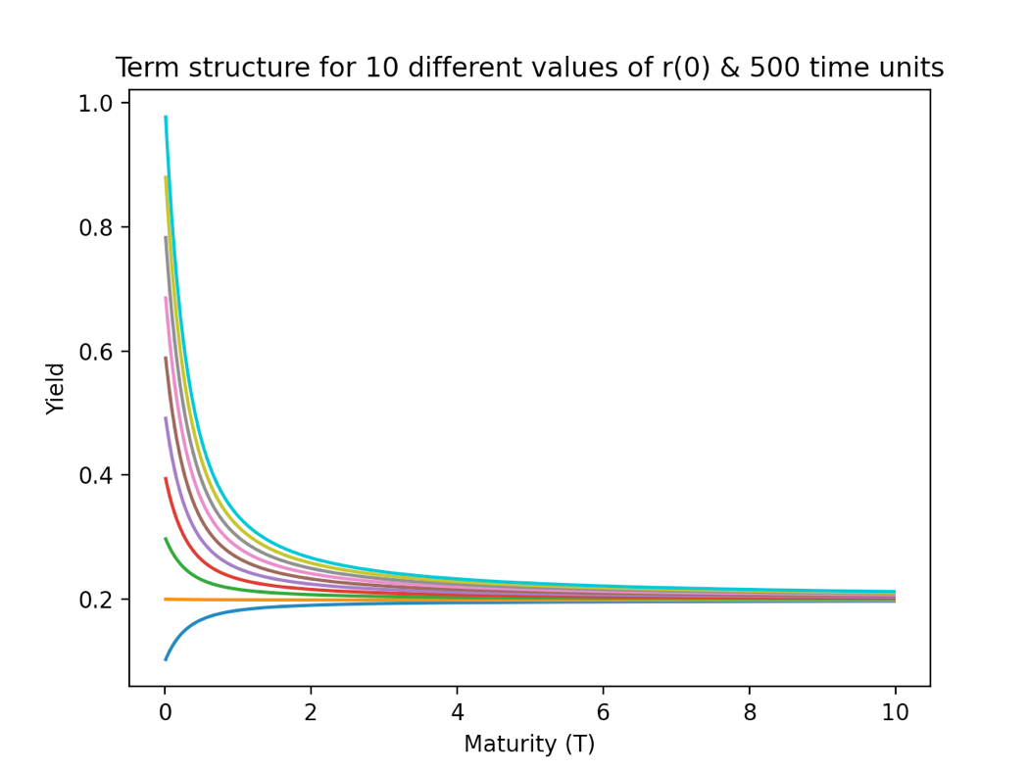

1. **Parameter set – [3.9, 0.1, 0.3, 0.2]:**

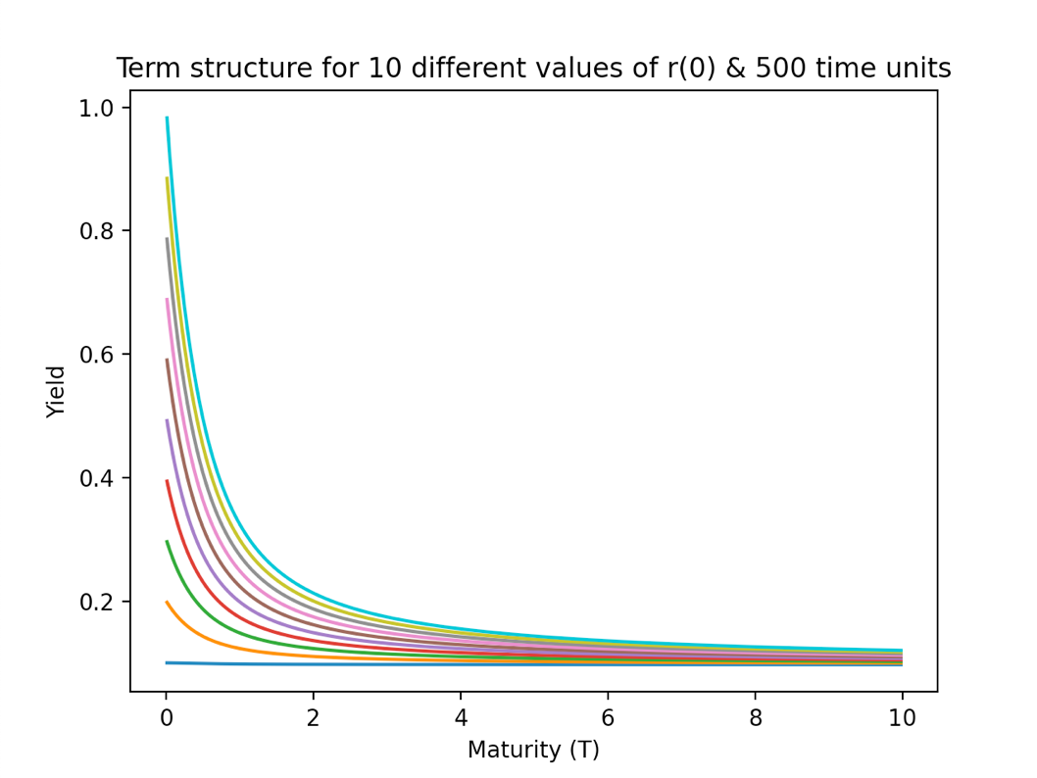

1. **Parameter set – [0.1, 0.4, 0.11, 0.1]:**

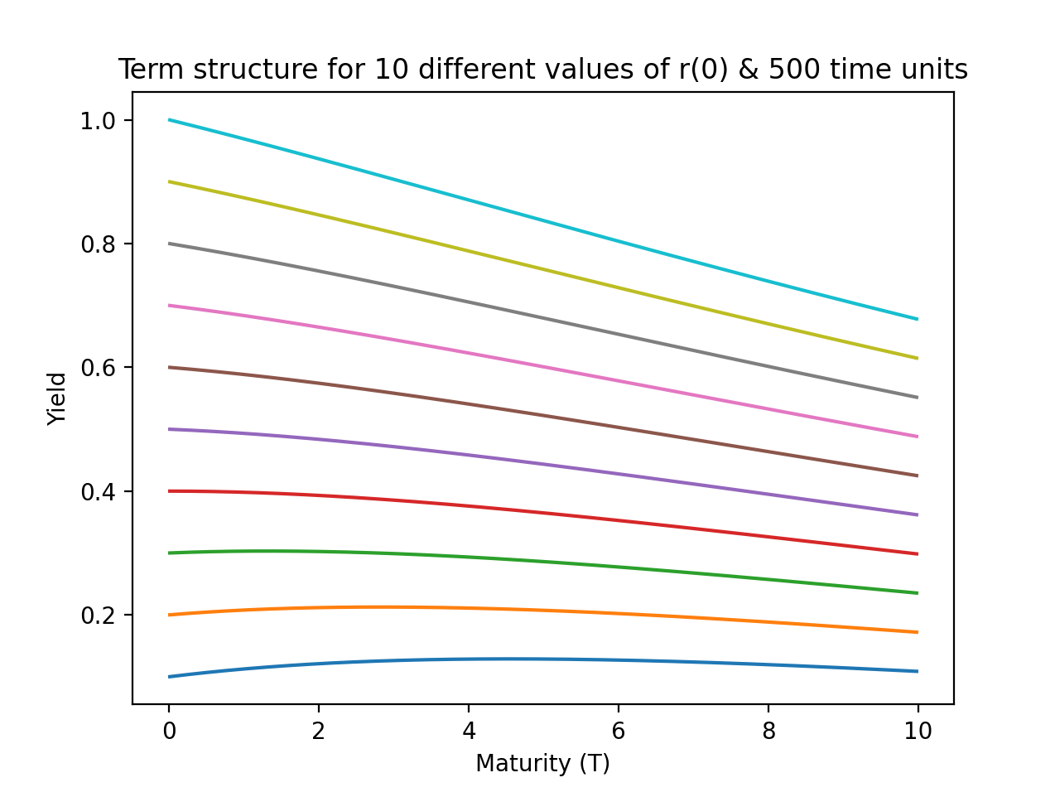

**Observations:**

1. The yield of the bond price converges to a particular value as the maturity period is increased to sufficiently high value, irrespective of the value of r(0) taken.
2. The term structure of parameters set for 10 time units show strikingly different behaviour. For the first parameter set, the yield increases and then converges. For the second one, the yield decreases and then converges, while for the last one, the yield curve has a “hump” in it.
3. The phenomenon of mean reversion is observed since high interest rate has negative trend while the low interest rate has positive trend to the reversion level. This is due to the fact that the Vasicek-Model incorporates mean reversion.

# Ques – 2

The term structure for the parameter set [0.02, 0.7, 0.02, 0.1] is:

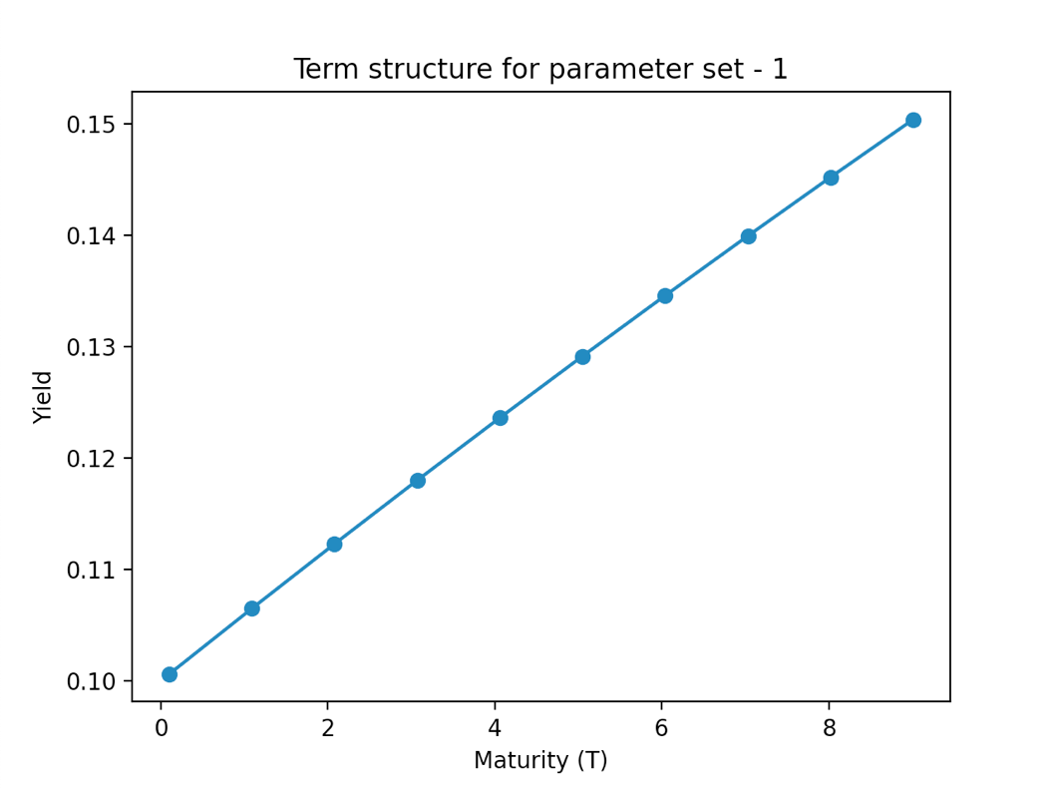

The term structure for the parameter set [0.7, 0.1, 0.3, 0.2] is:

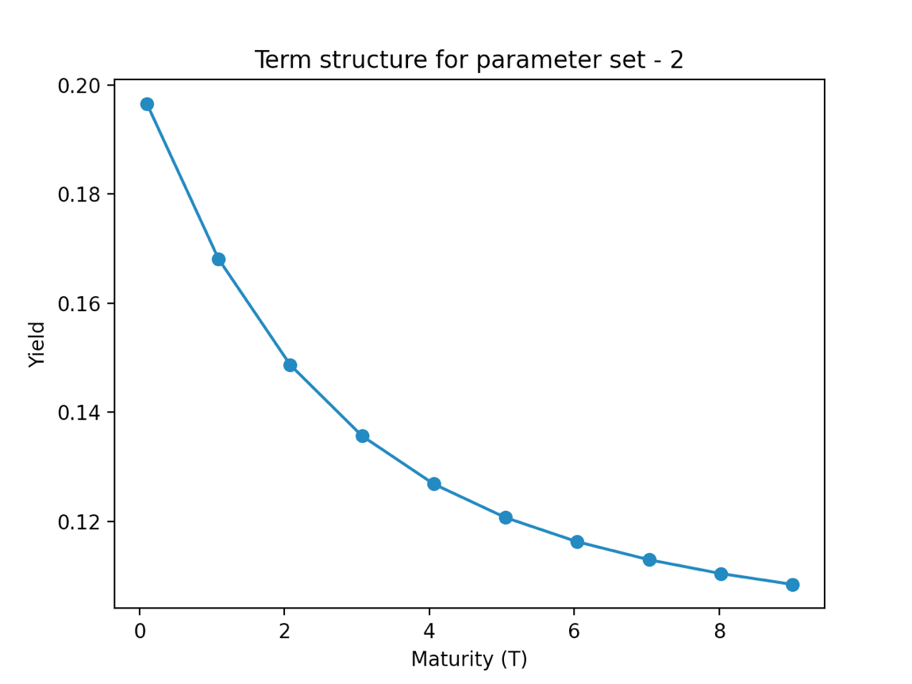

The term structure for the parameter set [0.06, 0.09, 0.5, 0.02] is:

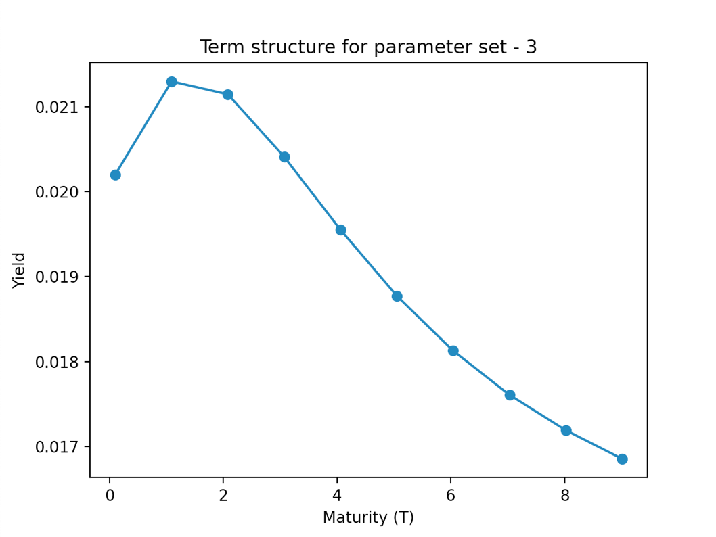

For the parameter set, [β, μ, σ] = [0.02, 0.7, 0.02], and r (0) varying from 0.1 to 1 with step size of 0.1, the yield curve vs maturity for 600 time units is:

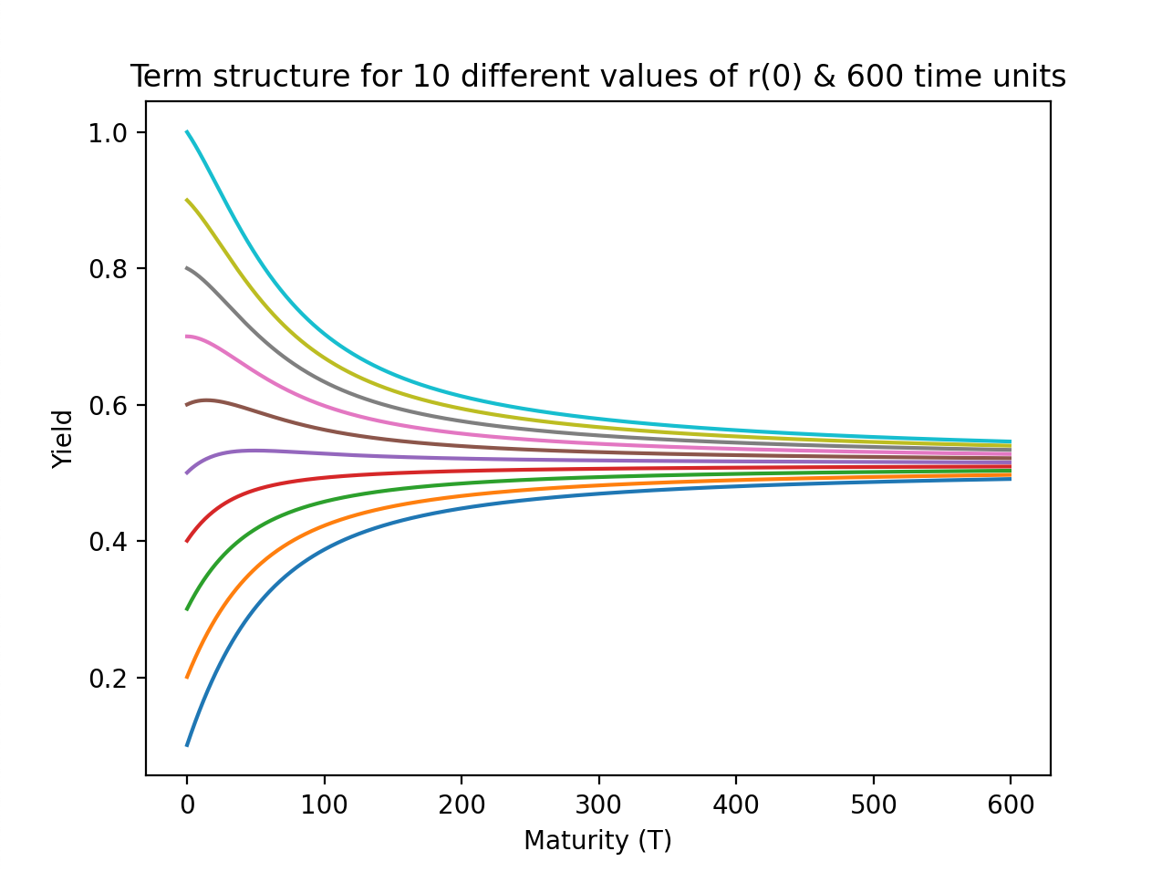

**Observations:**

1. The yield of the bond price converges to a particular value as the maturity period is increased to sufficiently high value, irrespective of the value of r(0) taken.
2. The term structure of parameters set for 10 time units show strikingly different behaviour. For the first parameter set, the yield increases and then converges. For the second one, the yield decreases and then converges, while for the last one, the yield curve has a “hump” in it.
3. The phenomenon of **mean reversion** from the plots is observed. This is due to the fact that the model assumes mean reversion towards a long-term normal interest rate level.