Happiness Prediction
Submitted for

DATA VISUALIZATION AND DASHBOARD

Submitted by:
(E23MCAG0002) Abhinav Sharma
(E23MCAG0009 Dipanshu Chaudhary
(E23MCAG0053) Sakshi Tomar

Submitted to-
Dr. Nitin Arvind Shelke

July-Dec 2023
SCHOOL OF COMPUTER SCIENCE AND ENGINEERING


INDEX

Sr. No
Content | Page No
1. | Abstract | 5
2. | Introduction and Related Work | 5
3. | Libraries which are used to visualize | 6
4. | Software Used | 7
5. | Methodology | 8
6. | Experiment Results | 11
7. | Conclusion | 15

LIST OF FIGURES

Figure No. | Title | Page No.
Fig.1 | Chart of Methodology | 8
Fig.2 | Scatter plot between Happiness Score vs Economy | 9
Fig.3 | Heat map | 11
Fig.4 | Heat map (used to check null values) | 12
Fig.5 | Horizontal Graph | 13
Fig.6 | Distribution Plot | 14

LIST OF TABLES

Table No. | Title | Page No.
1.1 |  | 8

Note: List of Figures and List of Tables shall be on separate pages.

- ABSTRACT
The primary goals of this project are to forecast happiness scores, extract valuable insights, and analyze the dataset. Given that the project is a regression when different algorithms are employed, a comparison to determine which model to use, Random Forest, linear regression, and support vector regression are used feels superior. Better decision-making is correlated with happiness. Happiness in the World Report is examined by the UN and is included in world happiness as emphasized by the UN. The Cross_val_score and the survey's questions are the basis for the rankings of national happiness relating to freedom of choice and social support decisions, Generosity, and the sense of corruption. The remaining two elements used in the computation GDP per capita and overall health measure national happiness data regarding life expectancy and these two variables are accessible to the public.
Keywords: World Happiness, Random Forest, Linear Regression, Support Vector Regression.
- INTRODUCTION AND RELATED WORK
In 2012, a world happiness report was released prior to a high-level UN meeting. In 2013, the second report was released, and in 2015, the third. Since the year 2015 The World Happiness Report is released annually by the UN. The report's features consider what has been widely discovered in investigative writing to be essential in elucidating differences at the national level in evaluations of life. Based on 156 countries' happiness indices, the World Happiness Report [2] has produced a list of the world's happiest nations. Based on various metrics that indicate the degree of contentment experienced by the typical citizen when considering themselves, they were ranked. According to some studies, participants feel happier when they laugh, both mentally and physically, in all forms of communication except Skype. This effect is attributed more to the nature of the interaction than to its duration [1]. In this report, happiness evolves over time because of various conditions or events. A few essential elements, like Inequality or unemployment don't exist because Comparable global data are not currently available for the entire country test. In the meanwhile, researchers studying personal cognition have shifted their focus to social media and digital device usage to investigate whether an individual's digital footprint can disclose elements of their identity. Simultaneously, developments in big data analysis have demonstrated that computer algorithms can predict an individual's traits based on their digital effects [3]. Everybody finds happiness in different ways and to varying degrees of fulfilment. Larger factors are involved on a global scale, where countries represent the people, and these factors have the potential to have a ripple effect on happiness levels around the world. Rather than accurately reflecting causal estimates, the factors are anticipating imperative relationships to be shown, as several of the same study sources are used to gather information, not all of them are related to one another, and on a few events, two-way relationships are probably involved.
Few libraries which are used to visualize the Happiness Prediction: -
- Matplotlib
Matplotlib is an interactive, cross-platform toolkit for graphical plotting and data visualization for Python and NumPy, the numerical extension of Python. It is free to use and open source to utilize Matplotlib. Although most of Matplotlib's code is written in Python, some parts are also written in C, Objective-C, and JavaScript for platform compatibility.
- Seaborn
A Python module called Seaborn is used for data visualization. The foundation is matplotlib. It offers a more advanced interface for creating statistical and graphical charts, whereas simple plots were created using matplotlib.
- Plotly
Plotly is an interactive, open-source charting framework written in Python that supports more than 40 unique chart types for a broad range of use cases in factual, financial, geographic, scientific, and three dimensions. A few lines of code are all that are needed to create visually appealing, interactive charts. Plots were created using the Plotly library.

- SOFTWARE USED
- Python (Programming Language): Because of its many libraries and versatility, Python has been the main programming language used for data processing, machine learning model development, and analysis.
- Scikit-learn: Using gathered data, this Python machine learning library helped implement several predictive models to predict happiness, such as Random Forest, Support Vector Machines (SVM), and Gradient Boosting.
- Jupyter Notebooks: An increasingly collaborative and iterative approach to the research process was made possible by these interactive notebooks, which facilitated data exploration, visualization, and model prototyping.
- Pandas and NumPy: These two Python libraries were widely used to handle, manipulate, and preprocess data to make sure it was suitable for analysis.
- Matplotlib and Seaborn: These Python visualization libraries were used to generate graphical data representations that helped in insights and result presentation.
- Google Colab: This cloud-based computing platform and GPU resource access made it easier to train and test models quickly for larger-scale computations and collaborative work.

4. METHODOLOGY

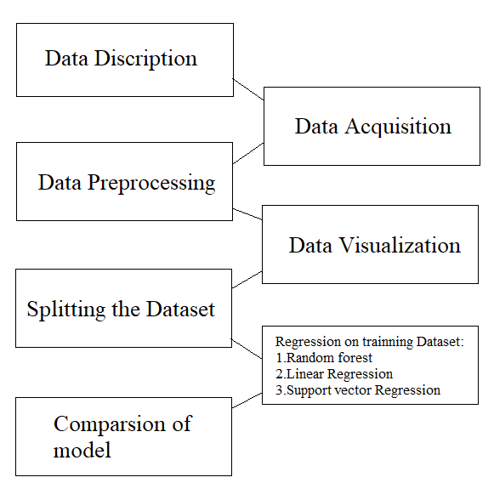

Fig 1: CHART OF METHODOLOGY

- Data Description:
The world happiness report from 2015–2 is contained CSV files in the dataset. The United Nations periodically modifies its standards for measuring global happiness, so nearly all CSV files have varying numbers of columns.
- Data Preprocessing and Visualization:
The dataset had no missing values, so the next step was to see if it did. To hold the CSV files for the corresponding years. Each report had a different column name, which was changed to a cozy feature name. The features' correlation revealed a strong correlation between GDPs per capita and healthy life expectancy, demonstrating the superiority of higher income. Plotting between these features helps to clarify this.
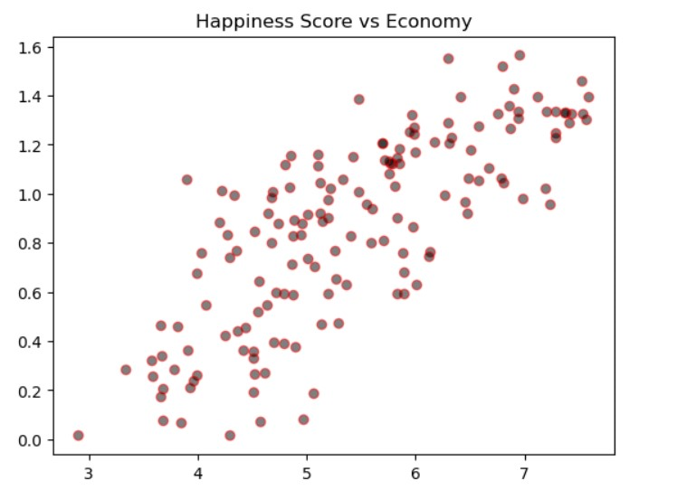
Fig.2

- Splitting the Dataset:
Splitting of the Dataset is important to avoid bias prediction on training data. While Fitting ML algorithms can cause overfitting. Hence, the Dataset was split into 70:30 ratio.
- Linear Regression:
Linear regression is used to fit the model. It is the most basic and commonly used regression model. After checking the correlation between all the features and dependent variable happiness score, 3 features namely happiness ranking, Freedom of life choices and healthy life expectancy were used as independent variables.
- Random Forest:
Every decision tree has a high variance, in the random forest, several trees are combined in parallel creating a low variance. It uses the begging technique to get a better result. The basic idea is to combine many decision trees and determine a final output instead of relying on a single decision tree. The model is fitted using a random forest regressor on training data and predictions are made on testing data.
- Support Vector Regression:
SVR is especially helpful in handling datasets with high dimensionality or non-linear relationships between features and target variables. Regression tasks benefit greatly from its ability to handle non-linear relationships between variables.

- EXPERIMENTAL RESULTS
We will be using cross validation to avoid the chance of overfitting. We will apply cross validation for linear regression and the results are 0.632. After we will check the cross-validation score for Random Forest Regression and the results are -3.795. Now checking the cross validation for Support Vector Regression and the results are -2.830.

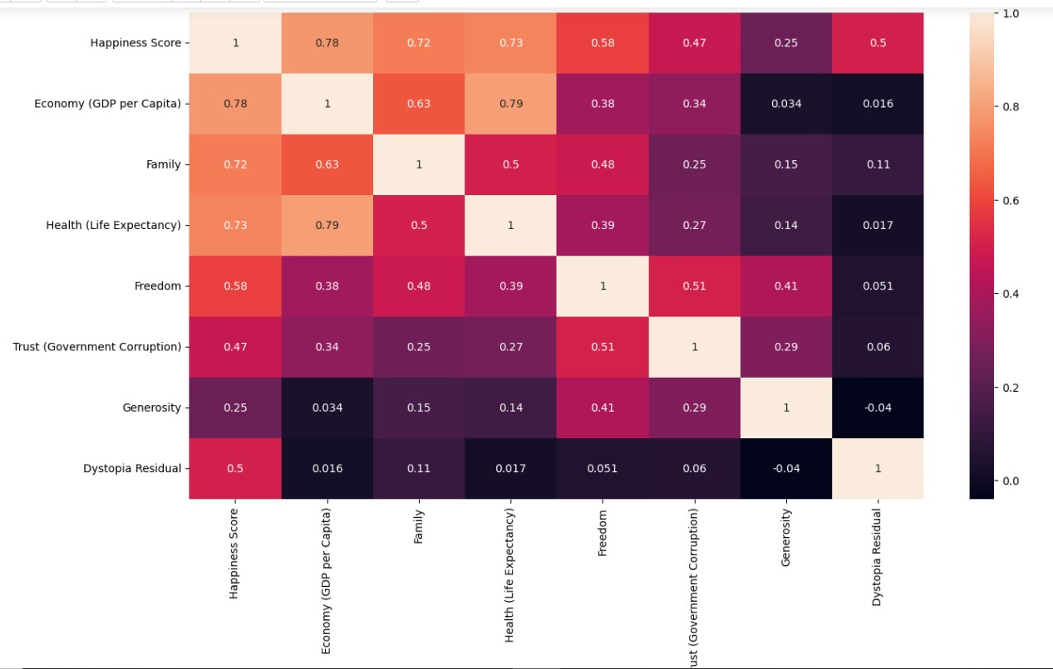
Fig.3 Heat map

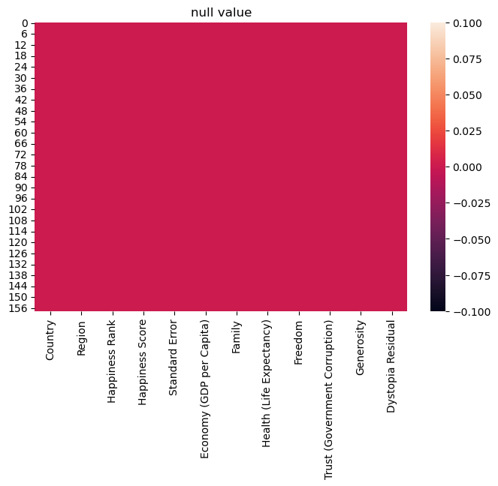

Fig.4 Heat Map

This graph represents the presence of null values in dataset

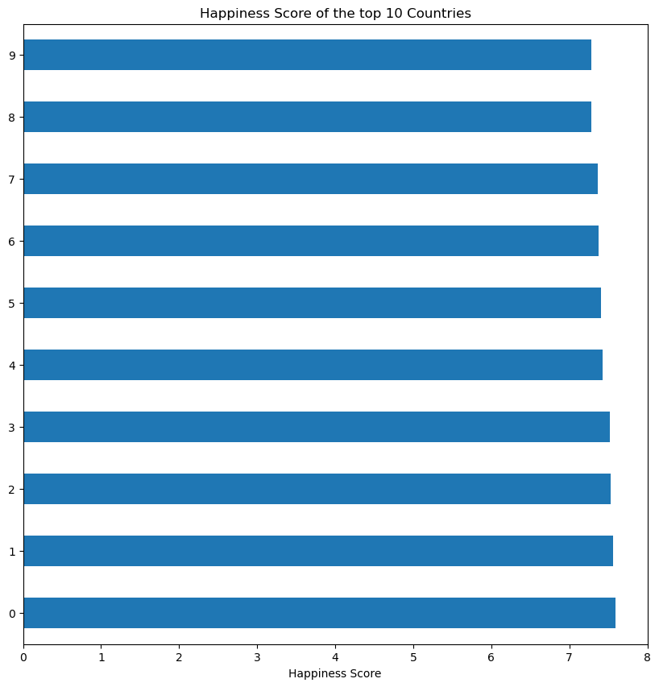
Fig. 5

This horizontal graph shows the happiness score of top 10 countries of the dataset.

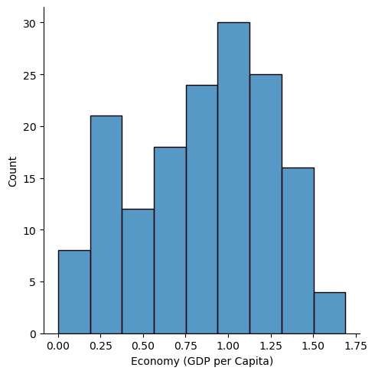
Fig. 6

This graph represents the distribution of the economy column

- CONCLUSION
From the above Cross Validation score of we can infer that Linear Regression is the best model to proceed further. Now we will fit the model using the best parameters and the results are shown below:
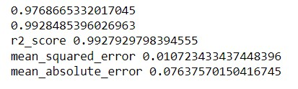

REFERENCES

[1] E. Diener, R. A. Emmons, R. J. Larsem, and S. Griffin, “The Satisfaction With Life Scale,” J Pe Assess, vol. 49, no.pp.
71–75, Feb. 1985, doi: 10.1207/s15327752jpa4901_13.
[2] [2]J. Neidhardt, N. Rümmele, and H. Werthner, “Predicting happiness: user interactions and sentiment analysis in an online travel forum,” Information Technology and Tourism, vol. 17, no. 1, pp. 101–119, Mar. 2017, doi: 10.1007/s40558-017-0079-2.
[3] A. Abdollahi, S. Hosseinian, H. Panahipour, M. Najafi, and F. Soheili, “Emotional intelligence as a moderator between perfectionism and happiness,” Sch Psychol Int, vol. 40, no. 1, pp. 88–103, Feb. 2019, doi: 10.1177/0143034318807959.

