|  |  |  |
| --- | --- | --- |
| **Student Name** |  | **Student Number** |
|  |  |  |

**Portfolio Introduction**

**Workshop Activities 50% Weighting**

**Mini Project 50% Weighting**

**This completed portfolio will need submitting to Canvas by the due date.**

**Questions please email**

**Dr Sarah Slater**

**s.i.slater@wlv.ac.uk**

**Portfolio**

Contents

Workbook 1 4

Activity 1.1: Actual voltage across 5V breadboard pins. 4

Activity 1.2: Actual voltage across 3.3V breadboard pins. 4

Activity 1.3: Potential Divider Calculations 4

Activity 1.4: 3V Calculations from either the 5V supply or 3.3V supply 5

Activity 1.5: Voltage Divider circuit readings from Breadboard circuit. 6

Activity 1.6: LED Circuits 6

Activity 1.7: Current Measurement 7

Activity 1.8: Fritzing for 4 switches & LEDS 9

Activity 1.9: Fritzing for Number 0-7 10

Workbook 2 11

Activity 2.1: LED Flashing to show decimal number 63 as binary. 11

Activity 2.2: 4 LED’s for counting up in binary from 0 to 15. 12

Activity 2.3: Traffic Lights 15

Workbook 3 17

Activity 3.1: Circuit Diagram of Button & LED 17

Activity 3.2: 3 Switches & Led 19

Activity 3.3: 8 Buttons & LEDs (SWITCH STATEMENTS) 21

Workbook 4 23

Activity 4.1: Serial Port 23

Activity 4.2: Serial Port binary to decimal 26

Activity 4.3: Calibrating Analogue Information 28

Activity 4.4: Temperature Sensor & Serial Port 31

Workbook 5 33

Activity 5.1: RGB Led and switches 33

Activity 5.2: Distance Sensor 35

Activity 5.3: 1602 LCD Display 37

Workbook 6 40

Activity 6.1: PWM 40

Workbook 7 42

Activity 7.1: 2 Arduinos – using Digital Pins 42

Activity 7.2: 2 Arduinos – using Serial I/O 44

Workbook 8 46

Activity 8.1: Stepper Motor Circuit Diagram 46

Activity 8.2: 2 Stepper Motors 48

Workbook 9 49

Activity 9.1: Windscreen Wiper Code using Servos & Temperature Sensor 49

Individual Project (50%) 51

Rationale 51

Timescales 51

Equipment 51

The Project 51

Step 1 produce adetailed description of your project. 51

Step 2 Circuit Diagram&Fritzing Schematic 51

Step 3 A Program 52

Step 4 Testing 52

Step 5 Conclusions 52

Layout 52

Marking 52

All sections carry equal marks. 52

If you prefer, you may use Tinkercad to show a component layout, rather than a circuit Diagram in Fritzing or other circuit design software, though a circuit diagram is more useful as this is what you would most likely see if you were working on embedded systems.

# Workbook 1

## Activity 1.1: Actual voltage across 5V breadboard pins.

# 5.03

## Activity 1.2: Actual voltage across 3.3V breadboard pins.

3.32

Explain in around 100 words why you think the value read by a multi meter on a circuit, may be different to a simulator value such as TinkerCad.

If the read value is 4.84V on a 5V supply, what would be a sensible tolerance to quote, explain your answer.

## Activity 1.3: Potential Divider Calculations

Show the working on how you achieved 2.5V

## Activity 1.4: 3V Calculations from either the 5V supply or 3.3V supply

## Activity 1.5: Voltage Divider circuit readings from Breadboard circuit.

## Activity 1.6: LED Circuits

Each resistor Value

331

332

Total resistance Calculation

1/R(parallel)=1/R1 + R2

= 1/331 + 1/332

= 0.00302115 + 0.00301205

1/R(parallel) = 0.0060332

R(parallel) =165.75

Measured Resistance

3

If measured resistance is not the same, why not? If you simulated this, why might the real value be

different.

## Activity 1.7: Current Measurement

Calculation of current flowing into LED

6.9

Actual measured value of current

15.06

Why might they be different?

## Activity 1.8: Fritzing for 4 switches & LEDS

# Activity 1.9: Fritzing for Number 0-7

# Workbook 2

## Activity 2.1: LED Flashing to show decimal number 63 as binary.

63 as binary, including working

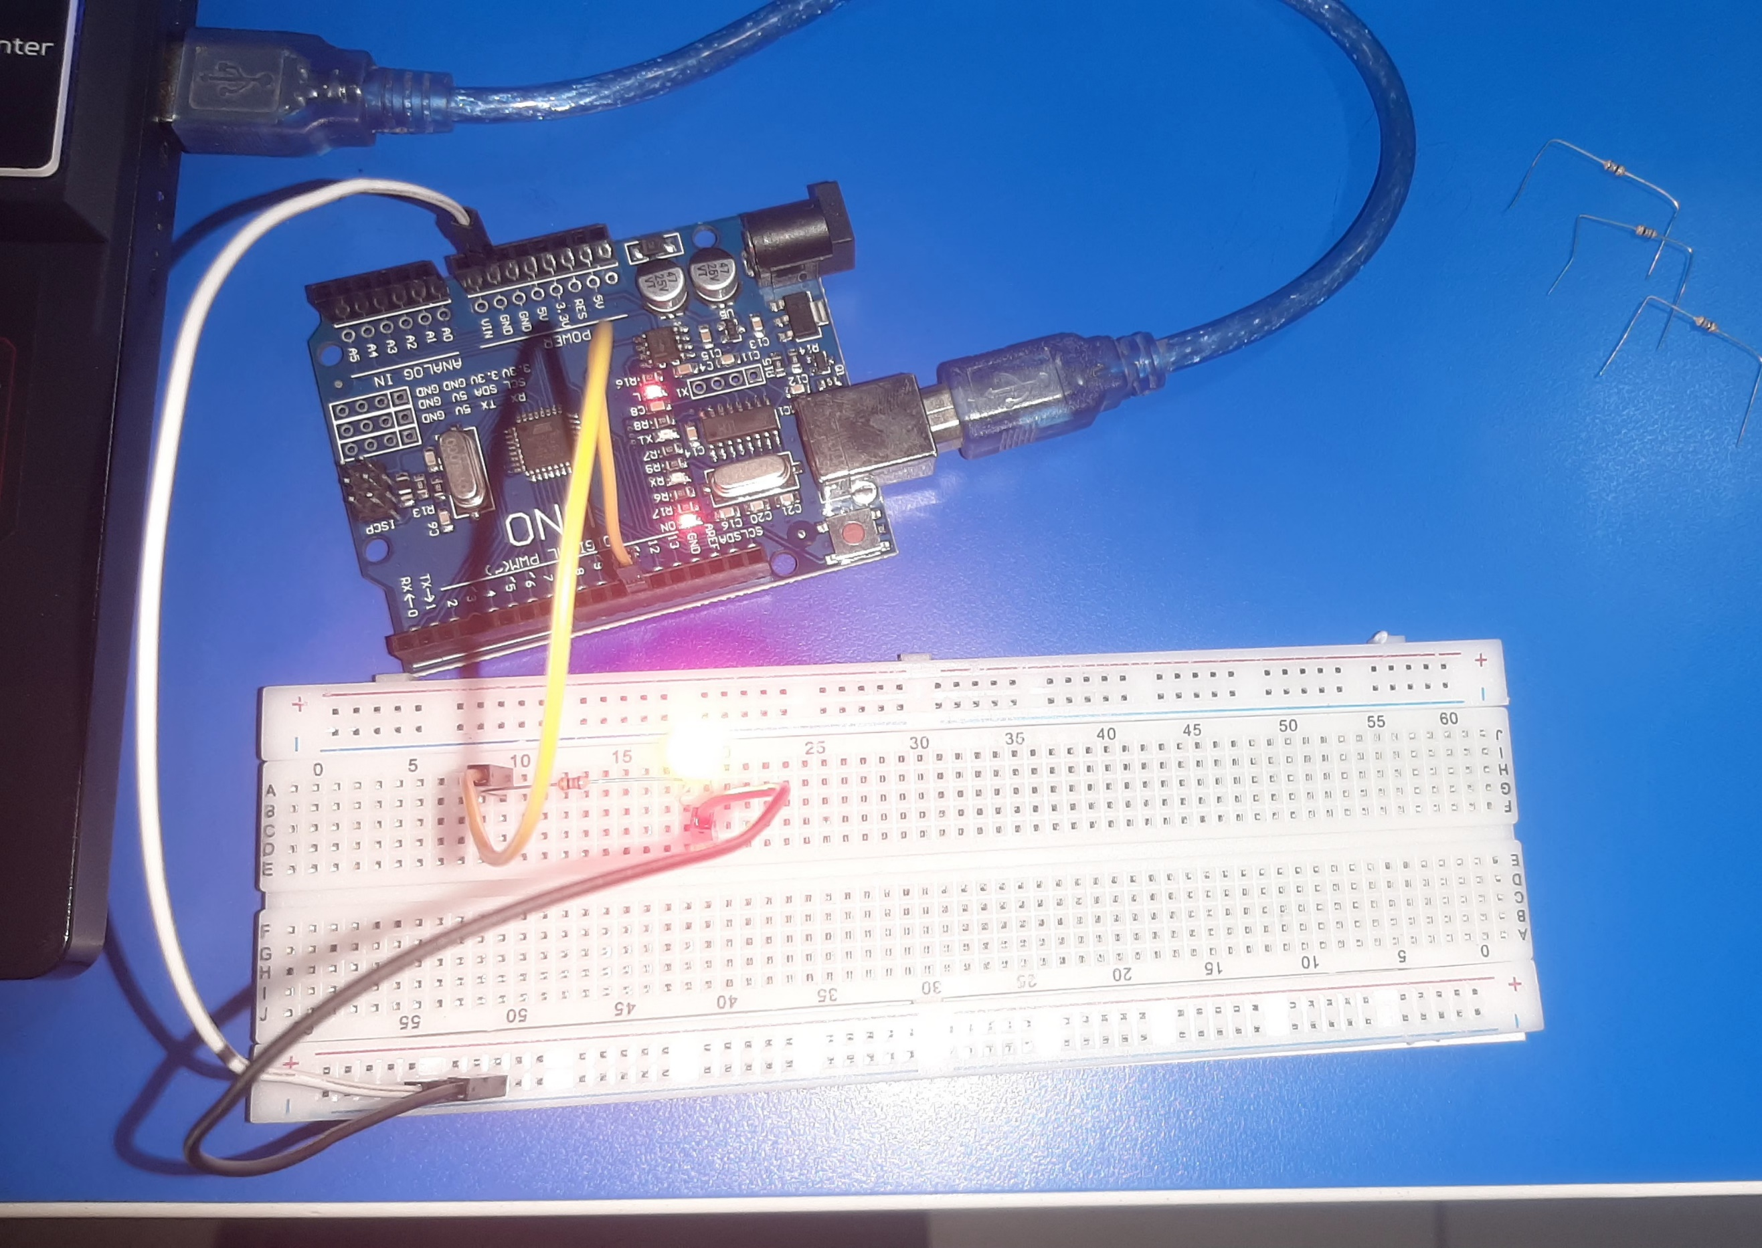

Copy & Post your code with a suitable comment at the top of code with your name & student number ☺

## Activity 2.2: 4 LED’s for counting up in binary from 0 to 15.

Fritzing Circuit diagram for Step 4 i.e. 4 LEDs

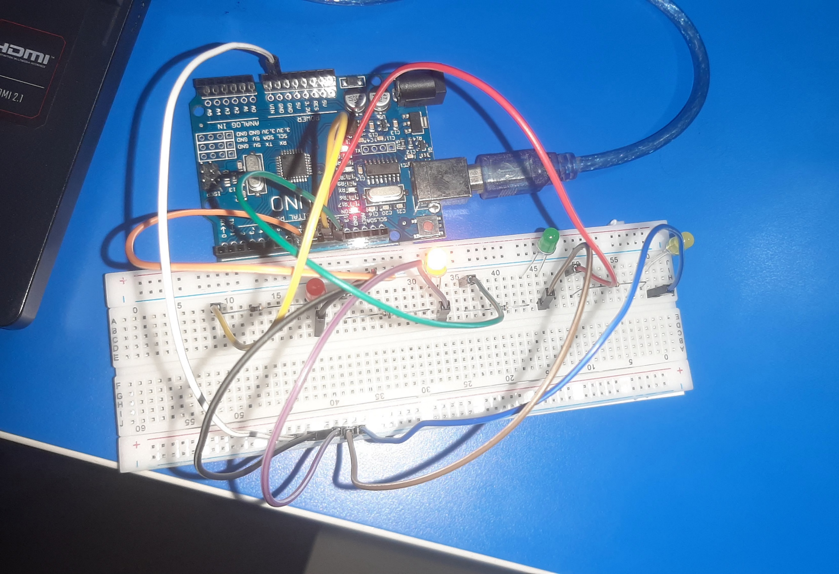

Arduino Program for Step 4 i.e. 4 LEDs

## Activity 2.3: Traffic Lights

Fritzing Circuit diagram for Step 4 i.e. 4 LEDs

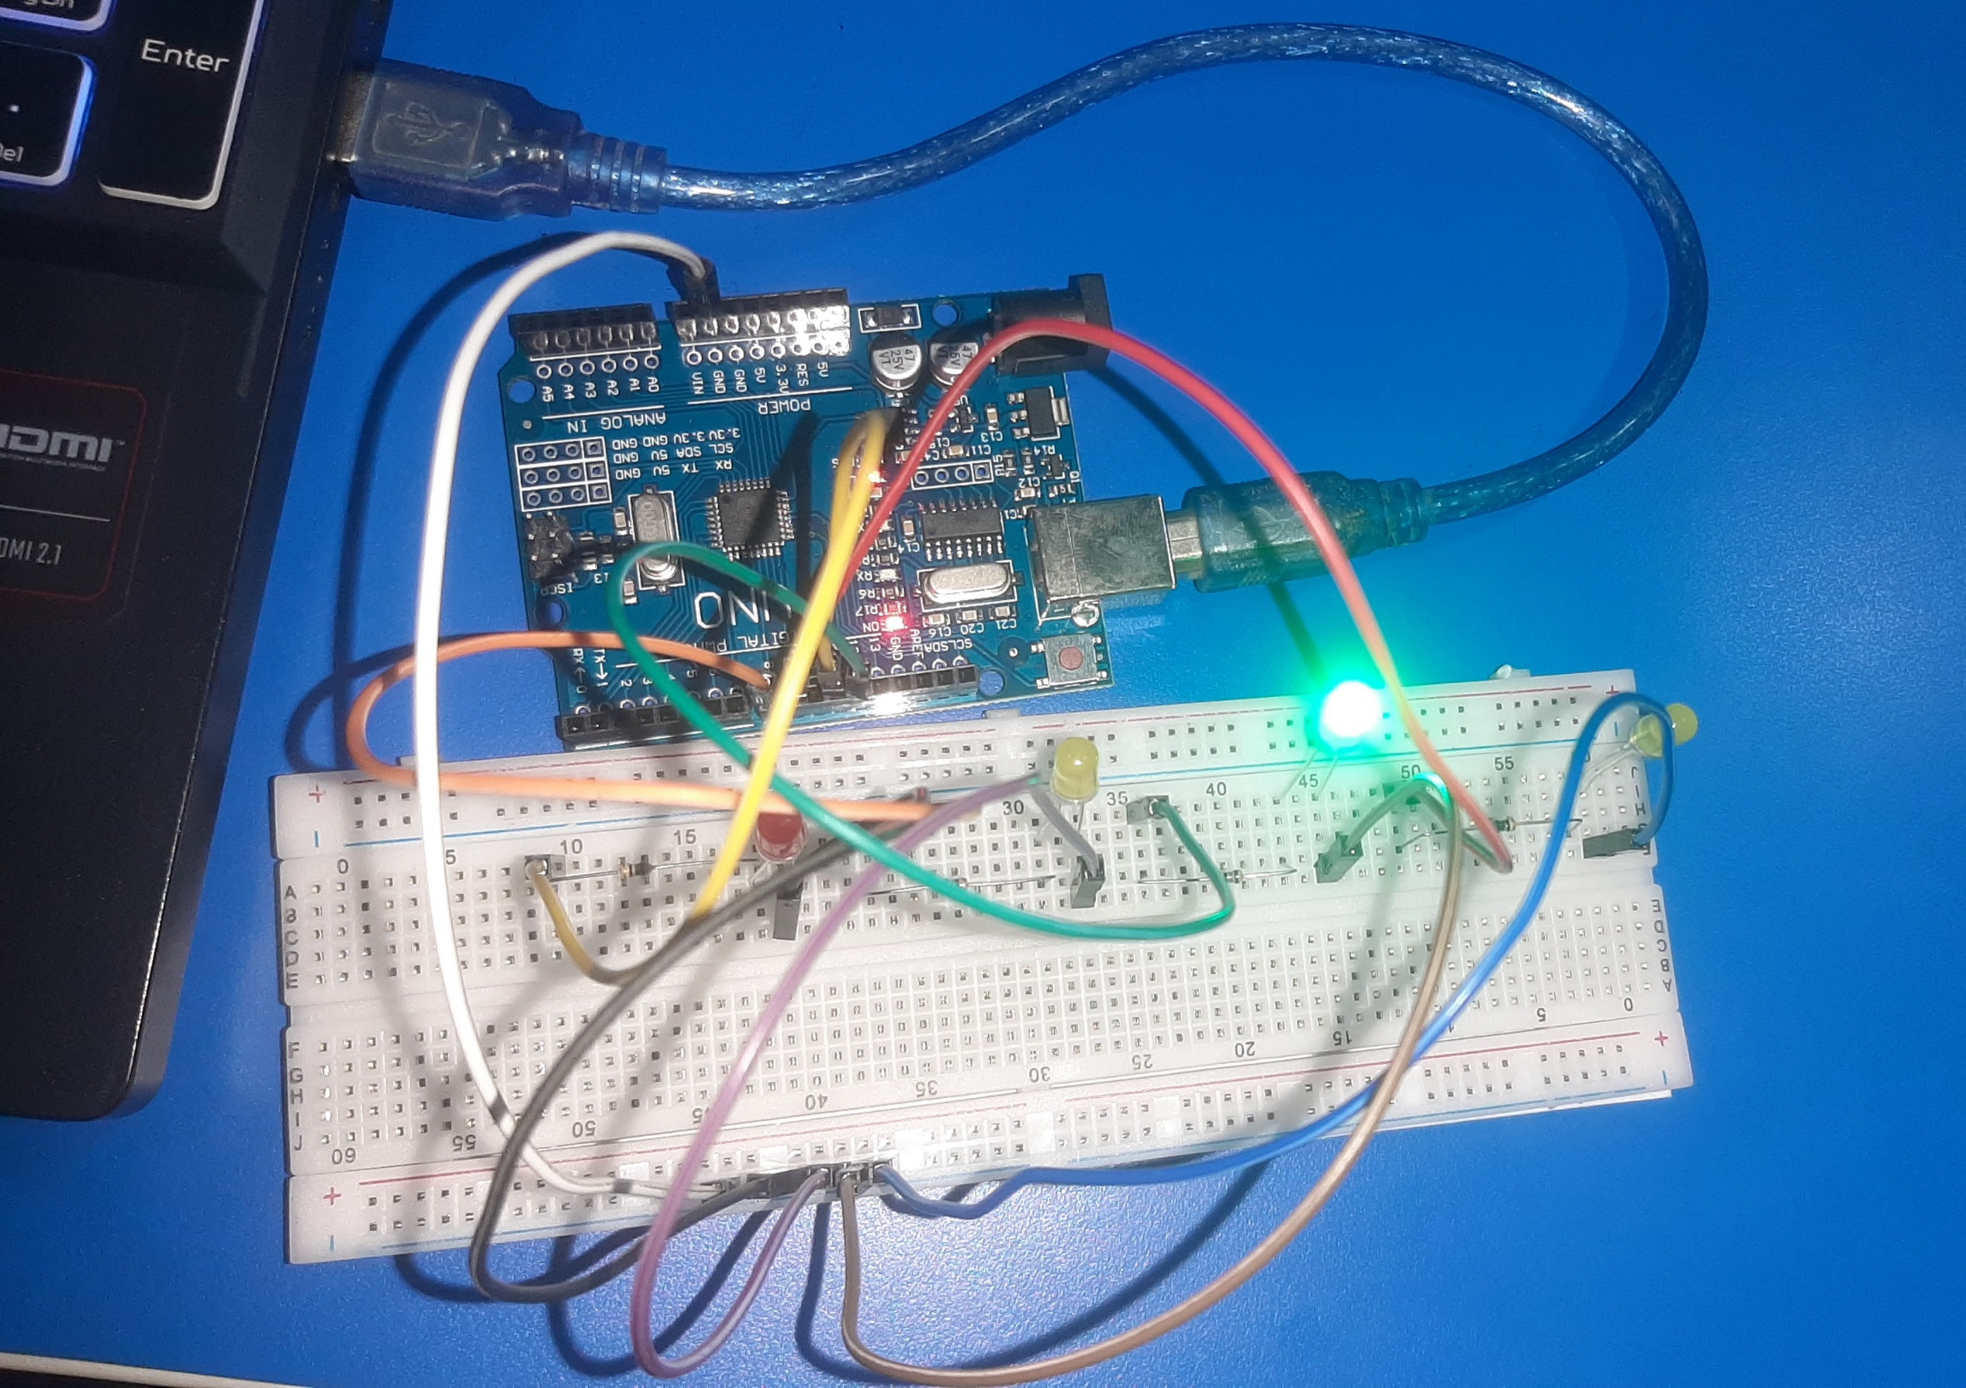

Arduino Program for Step 4 i.e. 4 LEDs

# Workbook 3

## Activity 3.1: Circuit Diagram of Button & LED

Fritzing

## Activity 3.2: 3 Switches & Led

Fritzing Circuit Diagram

Arduino Program

## Activity 3.3: 8 Buttons & LEDs (SWITCH STATEMENTS)

Fritzing

Arduino Program

# Workbook 4

## Activity 4.1: Serial Port

Fritzing

Arduino Program

Screen Shot of Serial Port

## Activity 4.2: Serial Port binary to decimal

Code

Screen Shot of Serial Port

## Activity 4.3: Calibrating Analogue Information

Code

Pot Resistance Clockwise

Pot Resistance Anti-clockwise

Sample of Values

Pot Resistance against Voltage change

|  |  |
| --- | --- |
| Pot Resitance | Voltage Measured |
|  |  |
|  |  |
|  |  |
|  |  |
|  |  |

Screen Shot of Meaningful Serial Port Output, not just numbers

## Activity 4.4: Temperature Sensor & Serial Port

Code - Centigrade to Serial port, but when button Pressed Fahrenheit Displayed Instead

Screen Shot of Serial Port

# Workbook 5

## Activity 5.1: RGB Led and switches

Fritzing

Arduino Program

## Activity 5.2: Distance Sensor

Arduino Code

Take a picture of your distance sensor and include it here, please reduce the size and quality as it will be too large else ☺

## Activity 5.3: 1602 LCD Display

Fritzing

Arduino Program

Take a picture of your LCD and include it here, please reduce the size and quality as it will be too large else ☺

# Workbook 6

## Activity 6.1: PWM

Fritzing

Arduino Program

# Workbook 7

## Activity 7.1: 2 Arduinos – using Digital Pins

Fritzing

Arduino Program

## Activity 7.2: 2 Arduinos – using Serial I/O

Fritzing

Arduino Program

# Workbook 8

## Activity 8.1: Stepper Motor Circuit Diagram

Circuit Diagram

Arduino Program

## Activity 8.2: 2 Stepper Motors

Arduino Program

# Workbook 9

## Activity 9.1: Windscreen Wiper Code using Servos & Temperature Sensor

Arduino Code

# Individual Project (50%)

## Rationale

Throughout the module you have used a range of sensors and actuators with an Arduino to complete weekly tasks. For the mini project we would like you to research and create a small embedded project in an area of your choice, such as:

* Games
* Networking
* IT Security
* Systems Engineering
* Smart Technology
* Artificial Intelligence

Previous projects have included a reaction game that gives a score depending on how fast you hit a button, this has buttons to restart the application, and an LCD to show scores, and information.

This project should be your own work, YOU MUST NOT COPY A PROJECT FROM THE INTERNET.

## Timescales

This project should be started around week 5 and continue until the deadline, when it will be submitted in the Portfolio.

## Equipment

You are free to use Tinkercad, or your own kit.

## The Project

### Step 1 produce adetailed description of your project.

This should clearly describe what you are intending to build and may contain some diagrams of how the sensor/switches input is to be processed by the Arduino. Then what kind of output is intended to be seen or heard by the user. Please mention any tools you intend to use.

### Step 2 Circuit Diagram&Fritzing Schematic

You are required to produce a circuit diagram of your work showing any calculations you made, so these might be suitable resistor values for any LED’s you use. These calculations are covered on the module. The circuit diagram should not be hand drawn but should follow the format of circuits from the module.

### Step 3 A Program

You will need to write some software for this project and a listing of the code with suitable comments will need to be included.

### Step 4 Testing

You will be required to produce some suitable test data that you would expect to be able to measure such as voltages, test code.

Once your prototype is complete you will be expected to test your circuit and compare the actual values to your initial test data, and comment on the results.

### Step 5 Conclusions

You are required to write a summary of the work along with a short half page reflection on how you found the work.

### Layout

The report should be suitably laid out for a report, using headings, references if required in Harvard style, and appendices used for any lengthy code. All diagrams should be produced on a PC, and hand-written work is not acceptable.

### Marking

# All sections carry equal marks.