

Module | Task | Assessment type
Artificial Intelligence and Machine Learning | 2 | Image classification

Tutor: Mr. Shiv Kumar Yadav
Name: Dipendra Roka
Group: L6CG18
Canvas ID:2418541
Submission Date: 2026/5/10
Github link:

Abstract
This report presents a systematic evaluation of deep learning approaches to multi-class image classification applied to a 33-category fruit and vegetable dataset. The study was conducted as part of the 6CS012 Artificial Intelligence and Machine Learning module at Herald College Kathmandu, affiliated with the University of Wolverhampton. Five model configurations were trained and compared: a simple two-block CNN serving as a baseline, a deeper regularised CNN trained with the Adam optimiser, the same regularised architecture trained with SGD with momentum, an ablation variant with all regularisation removed, and a VGG16 transfer-learning model fine-tuned on ImageNet-pretrained weights.
The dataset comprised 16,854 training images spanning 33 classes, with a mean of 510.7 images per class and a class-size range of 392 to 984 images. Preprocessing involved pixel rescaling, on-the-fly data augmentation (rotation, flipping, zoom, brightness variation, channel noise), and balanced class-weight computation. All from-scratch models were trained at 64×64 resolution; VGG16 used the standard 224×224 input.
Results demonstrated a clear performance hierarchy. The simple CNN achieved 52.9% validation accuracy (F1 = 0.4872). The unregularised ablation model reached only 49.8%, confirming regularisation as essential. The regularised CNN with Adam attained 99.67% accuracy (F1 = 0.9967) over 20 epochs, substantially outperforming its SGD counterpart (91.9%, F1 = 0.9179). VGG16 with two-phase transfer learning achieved perfect validation accuracy of 100% (F1 = 1.0000). Total training time across all experiments was 48.26 minutes. The findings confirm that transfer learning with fine-tuning is the most effective strategy for this task, and that regularisation is more consequential to performance than optimiser choice alone.

Table of Contents
1.Introduction 4
2.Dataset description 5
2.1 Dataset Statistics 5
2.2 Class Distribution 5
3. Data processing and augmentation 7
3.1 Image Standardisation 7
3.2 Data Augmentation Pipeline 7
3.3 Class Weight Computation 8
4.Methodology 9
4.1 Overall Pipeline 9
4.2 Part A.1 (Simple CNN (Baseline)) 9
4.3 Part A.2 ( Regularised CNN with BatchNorm (Adam)) 9
4.4 Part A.3 (Optimiser Comparison (Adam vs SGD)) 9
4.5 Ablation: No Regularisation 9
4.6 Part B ( VGG16 Transfer Learning) 10
5. Experiment and summary 11
5.1 Part A.1 ( Simple CNN) 11
5.2 Part A.2 ( Regularised CNN (Adam)) 11
5.3 Adam vs SGD Optimiser Comparison 12
5.4 Ablation ( Impact of Regularisation) 12
5.5 Part B (VGG16 Transfer Learning) 13
5.6 Overall Model Comparison 14
5.7 Training Time Summary 16
6.Discussion 17
6.1 Simple vs Deeper CNN 17
6.2 Adam vs SGD 17
6.3 Transfer Learning Advantage 17
6.4 Limitations 17
7.Conclusion 18
8.Future work 19

Table of Figures

Figure 1Training set per-class image count across all 33 classes. Orange dashed line marks the mean (510.7). Darker bars exceed the mean. 6

Figure 2Simple CNN training history. Note the validation loss divergence after epoch 2, triggering learning-rate reduction at epoch 4 and early stopping at epoch 6. Best weights are from epoch 1. 12

Figure 3 Regularized CNN (Adam) training history across 20 epochs. Validation accuracy climbs steadily from ~20% to 99.67%. Learning-rate reductions at epochs 10 and 14 are reflected in the slight loss kinks. 12

Figure 4Validation accuracy comparison — Adam vs SGD with momentum. Adam converges more rapidly and achieves a 7.7-point higher final accuracy. Dotted lines mark the final values. 13

Figure 5Regularised CNN (Adam) vs No-Regularisation ablation over the first 6 epochs. The unregularised model's loss diverges catastrophically at epoch 5 (training loss > 124), while the regularised variant improves steadily. 14

Figure 6 VGG16 Phase 1 (frozen backbone) training history. Validation accuracy reaches 99.67% immediately at epoch 1, demonstrating the power of ImageNet-pretrained feature representations. 14

Figure 7 VGG16 Phase 2 (fine-tuning) training history. Validation accuracy reaches 100.00% at epoch 2 and holds steady. Validation loss continues decreasing, confirming genuine refinement. 15

Figure 8 Validation accuracy across all five model configurations. VGG16 achieves perfect accuracy (1.0000); the regularized CNN (Adam) is the best from-scratch model at 0.9967; both simple and unregularized CNNs fall near random performance for 33 classes. 15

Figure 9 Weighted F1-score across all five models. The F1 trajectory mirrors accuracy, with VGG16 achieving 1.0000 and the unregularized ablation the lowest at 0.4132. 16

1.Introduction
Image classification is one of the most well-studied problems in computer vision and has seen transformative progress since the adoption of deep convolutional neural networks (CNNs). The ability to automatically extract hierarchical visual features from low-level edges in early layers to high-level semantic patterns in deeper layers has enabled CNNs to surpass human-level accuracy on several benchmark datasets. In applied settings, image classification underpins wide-ranging practical systems, from medical imaging and autonomous vehicles to agricultural quality control and retail inventory management.
Fruit and vegetable classification represents a particularly useful application domain. Automated produce identification has immediate relevance in smart retail systems, dietary tracking applications, and post-harvest quality inspection pipelines where manual sorting would be prohibitively slow or inconsistent. A robust model must contend with substantial intra-class variation different ripeness stages, lighting conditions, and viewing angles as well as inter-class similarity between visually close species such as different apple cultivars or pepper colours.
This project investigates how architectural choices and training strategies affect classification performance on a 33-class dataset. Part A explores from-scratch CNN designs with varying regularisation and two optimiser configurations; Part B applies VGG16 transfer learning. The primary objectives are to establish a baseline, demonstrate the impact of regularisation and optimiser selection, quantify the benefit of transfer learning, and document computational costs. All experiments were implemented in Python using TensorFlow 2.16.2 / Keras on an Apple M3 Pro GPU with fixed random seed 42 for reproducibility.

2.Dataset description

2.1 Dataset Statistics
The training partition contains 16,854 images across 33 classes, yielding a mean of 510.7 images per class. Class sizes range from 392 (minimum) to 984 (maximum) a ratio of 2.51:1. A PIL-based integrity scan found zero corrupted files in either split. Because the test directory contained no images in the current environment, all evaluation metrics are computed on the 20% stratified validation split (3,361 images), with 13,493 images used for training.Below is summary of high level dataset.
Property | Value
Total training images | 16,854
Number of classes | 33
Mean images per class | 510.7
Smallest class (image count) | 392
Largest class (image count) | 984
Class size ratio (max / min) | 2.51 : 1
Corrupted files found | 0
Test set images available | 0 (validation split used for evaluation)
Validation split | 20% stratified
Effective training images | 13,493 (422 batches × 32)
Effective validation images | 3,361 (106 batches × 32)

2.2 Class Distribution
The 33 categories span multiple apple cultivars (Braeburn, Granny Smith), citrus fruits, berries, stone fruits, tropical varieties, and vegetables including peppers, tomato, corn, and potato. The presence of perceptually similar classes two apple varieties, red and green peppers, multiple red berry types makes this a fine-grained classification challenge that motivates deep architectures and pretrained features. Figure 1 shows the per-class image counts.

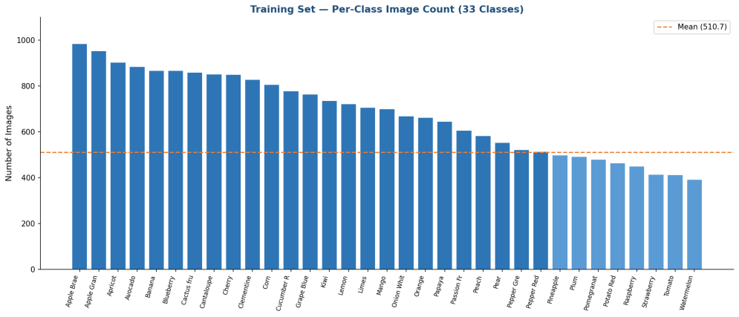
Figure 1Training set per-class image count across all 33 classes. Orange dashed line marks the mean (510.7). Darker bars exceed the mean.

3. Data processing and augmentation

3.1 Image Standardisation
Raw pixel values were rescaled to [0, 1] by dividing by 255.0. This normalisation stabilises gradient magnitudes during backpropagation. Native images are RGB arrays of shape (100, 100, 3); these were resized to 64×64 for from-scratch models and 224×224 for VGG16. For VGG16, Keras' built-in vgg preprocess function (per-channel mean subtraction matching ImageNet statistics) replaced simple rescaling.

3.2 Data Augmentation Pipeline
Augmentation is applied on-the-fly during training only; validation and test generators receive rescaling alone. The augmentation strategy included rotation (±30°), horizontal and vertical flips, width/height shifts (±20%), zoom (±25%), shear (±15°), brightness variation ([0.7, 1.3]), and channel-level colour noise (shift range 20). Vertical flipping was included because fruit images may appear inverted depending on camera orientation. Brightness and channel variation improve robustness to lighting and colour balance—common sources of domain shift in deployment.Below is what i did in data augmentation.
Augmentation Type | Parameter | Rationale
Pixel rescaling | ÷ 255.0 → [0, 1] | Gradient stability
Rotation | ± 30° | Orientation invariance
Width / Height shift | ± 20% | Translation robustness
Horizontal flip | Enabled | Lateral symmetry
Vertical flip | Enabled | Camera orientation variation
Zoom | ± 25% | Scale invariance
Shear | ± 15° | Perspective robustness
Brightness range | [0.7, 1.3] | Lighting variation
Channel shift range | 20.0 | Colour balance robustness
Fill mode | nearest | Boundary handling
Validation split | 20% stratified | Hold-out evaluation

3.3 Class Weight Computation
Balanced class weights were computed via scikit-learn's compute class weight('balanced') function and passed to the fit method for all from-scratch CNNs. Weights are inversely proportional to class frequency, giving underrepresented classes higher loss contributions and mitigating the tendency of gradient descent to optimise predominantly for majority classes. Class weights were not applied to the VGG16 model.

4.Methodology

4.1 Overall Pipeline
The experimental pipeline progresses from a minimal baseline to a state-of-the-art transfer-learning approach. Part A introduces three from-scratch CNN variants plus an ablation study; Part B applies VGG16 in two training phases. All models share the same preprocessing pipeline and validation split for direct comparison.

4.2 Part A.1 (Simple CNN (Baseline))
The baseline is a compact sequential CNN: two Conv2D + SpatialDropout2D + MaxPooling2D blocks (32 then 64 filters, 3×3 kernels, ReLU, 'same' padding), followed by a Dense(128) to Dense(64) head with Dropout(0.4) and Dropout(0.3), and a softmax Dense(33) output. Total: 2,127,073 trainable parameters (8.11 MB). SpatialDropout2D drops whole feature maps appropriate for convolutional layers where adjacent activations are highly correlated. Compiled with Adam (lr = 0.001) and categorical cross-entropy with label smoothing 0.1.

4.3 Part A.2 ( Regularised CNN with BatchNorm (Adam))
The regularised CNN deepens the architecture to three blocks, each with two stacked Conv2D layers, BatchNormalization after each convolution, MaxPooling2D, and 25% Dropout. Filter counts increase.L2 regularisation)is applied to all convolutional and dense kernels. BatchNorm reduces internal covariate shift and acts as an implicit regulariser.

4.4 Part A.3 (Optimiser Comparison (Adam vs SGD))
To isolate the optimiser effect, the same regularised architecture was retrained from scratch using SGD with momentum (lr = 0.01, momentum = 0.9, Nesterov updates). This directly tests whether Adam's per-parameter adaptive scaling confers a meaningful advantage over momentum SGD for this task.

4.5 Ablation: No Regularisation
All Dropout, BatchNormalization, and L2 weight decay were removed from the deeper architecture while retaining its layer structure, filter counts, and Adam optimiser. This isolates the regularisation contribution a comparison not possible by simply using the simpler baseline.

4.6 Part B ( VGG16 Transfer Learning)
Part B employs VGG16 (19 convolutional layers, 14.7 M parameters) pretrained on ImageNet. Phase 1 freezes the entire backbone (0 trainable backbone weights) and trains a custom head GlobalAveragePooling2D to Dense(512)+BN+Dropout(0.5) to Dense(256)+BN+Dropout(0.4) to Dense(128) to Softmax(33) for 10 epochs. Phase 2 unfreezes the final convolutional layer of block5 (8 trainable weight tensors) and continues for 7 epochs, making minimal adjustments without catastrophic forgetting. VGG16 requires 224×224 input; the VGG-specific preprocessing function replaces pixel rescaling.Table of hyperparameter.
Parameter | Simple CNN | Reg. CNN (Adam) | Reg. CNN (SGD) | VGG16
Input resolution | 64×64 | 64×64 | 64×64 | 224×224
Batch size | 32 | 32 | 32 | 32
Max epochs | 20 | 20 | 20 | 10 + 7
Optimiser | Adam | Adam | SGD+Nesterov | Adam
Learning rate | 0.001 | 0.001 | 0.010 | 0.001 / 1e-5
Label smoothing | 0.10 | 0.10 | 0.10 | None
Dropout rates | 0.30–0.40 | 0.25–0.50 | 0.25–0.50 | 0.40–0.50
BatchNorm | No | Yes | Yes | Yes (head)
L2 regularisation | No | 1e-4 | 1e-4 | No
LR scheduler | ReduceLROnPlateau | ReduceLROnPlateau | ReduceLROnPlateau | ReduceLROnPlateau
Early stopping | patience=5 | patience=5 | patience=5 | patience=5
Class weights | Yes | Yes | Yes | No
Trainable params | 2,127,073 | 4,623,553 | 4,623,553 | 403,489

5. Experiment and summary

5.1 Part A.1 ( Simple CNN)
The simple CNN triggered early stopping at epoch 6, with best weights restored from epoch 1 (val_accuracy = 51.1%). Epoch-by-epoch validation accuracy was unstable: 51.1% to 53.9% to 58.3%. This instability reflects the model's limited capacity and sensitivity to learning-rate changes. Final metrics: Accuracy 52.90%, Precision 53.41%, Recall 52.90%, F1 0.4872. Training completed in 1.29 minutes—the fastest experiment.

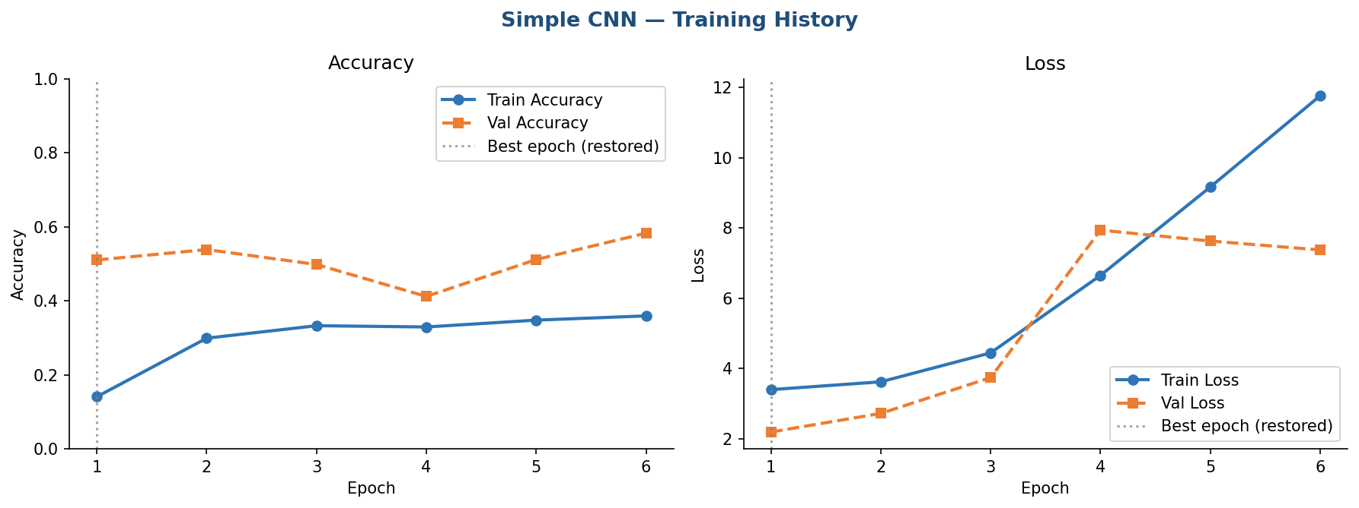
Figure 2Simple CNN training history. Note the validation loss divergence after epoch 2, triggering learning-rate reduction at epoch 4 and early stopping at epoch 6. Best weights are from epoch 1.

5.2 Part A.2 ( Regularised CNN (Adam))
The regularised CNN with Adam showed steady progress across all 20 epochs, with validation accuracy rising from 20.4% at epoch 1 to a peak of 99.67% at epoch 20. Two learning-rate reductions (epochs 10 and 14) each triggered temporary plateaus followed by renewed improvements. No early stopping was triggered, indicating continued learning throughout the training budget.
Final metrics: Accuracy 99.67%, Precision 99.68%, Recall 99.67%, F1 0.9967. The near-perfect alignment across all four metrics suggests uniform high performance across all 33 classes. Training required 8.31 minutes 6.4× longer than the simple CNN due to greater depth and BatchNorm overhead.

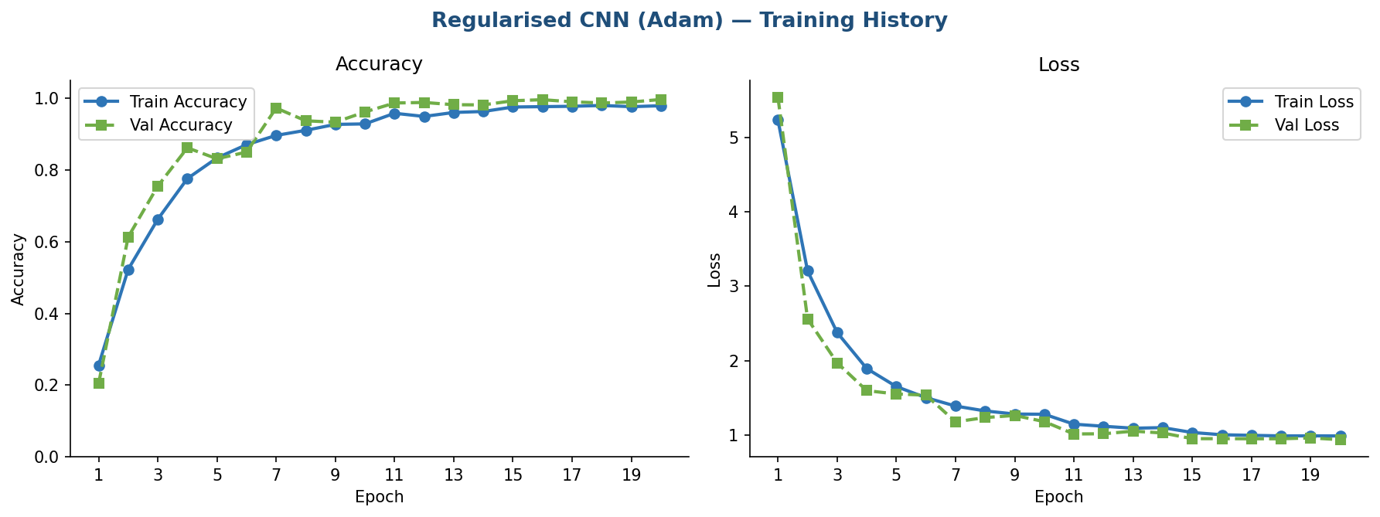
Figure 3 Regularized CNN (Adam) training history across 20 epochs. Validation accuracy climbs steadily from ~20% to 99.67%. Learning-rate reductions at epochs 10 and 14 are reflected in the slight loss kinks.

5.3 Adam vs SGD Optimiser Comparison
The SGD model showed slower convergence remaining below 70% validation accuracy through the first six epoch before the learning-rate scheduler intervened to halve the rate at epoch 6, enabling acceleration from epoch 7 onward. Final SGD metrics: Accuracy 91.94%, Precision 92.43%, Recall 91.94%, F1 0.9179. Adam outperformed SGD by 7.7 percentage points in accuracy under identical architecture and regularisation, reflecting Adam's more efficient navigation of the loss landscape via per-parameter adaptive scaling.

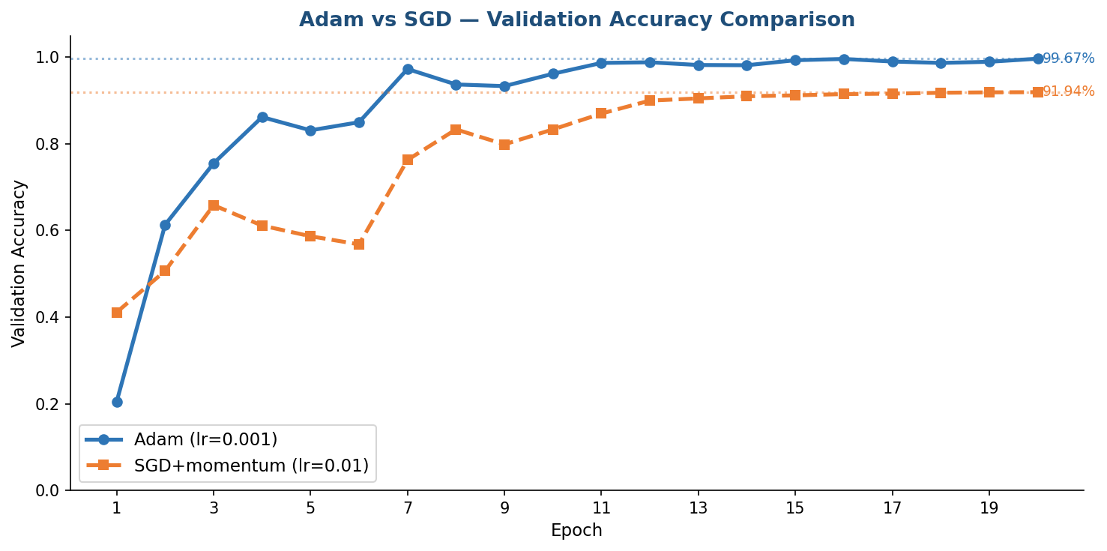
Figure 4Validation accuracy comparison — Adam vs SGD with momentum. Adam converges more rapidly and achieves a 7.7-point higher final accuracy. Dotted lines mark the final values.

5.4 Ablation ( Impact of Regularisation)
Removing all regularisation caused textbook overfitting and eventual divergence. Validation accuracy reached 50.8% at epoch 1, then collapsed falling to 3.5% at epoch 5 as training loss exploded to values exceeding 124. Early stopping triggered at epoch 6; best weights from epoch 1 were restored. Final metrics: Accuracy 49.78%, F1 0.4132 slightly below even the simple CNN baseline, confirming that depth without regularisation is actively harmful.

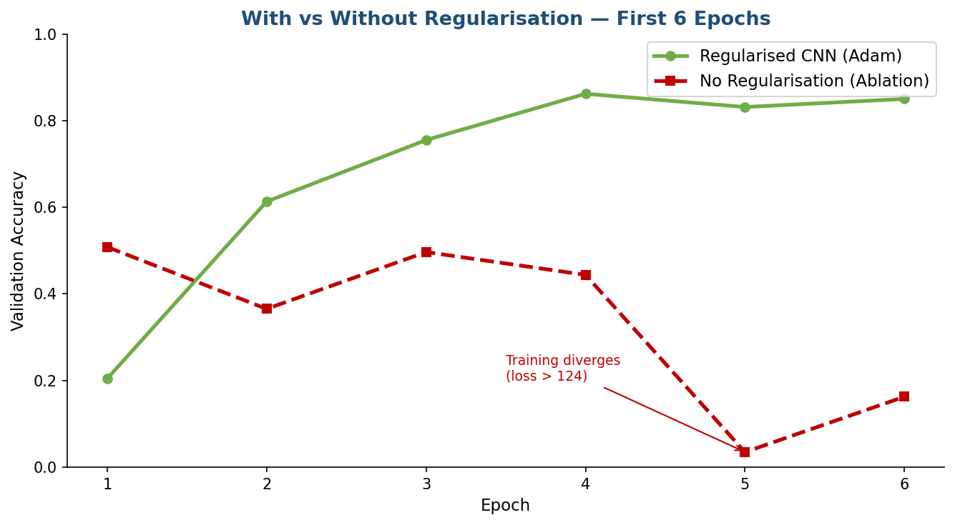
Figure 5Regularised CNN (Adam) vs No-Regularisation ablation over the first 6 epochs. The unregularised model's loss diverges catastrophically at epoch 5 (training loss > 124), while the regularised variant improves steadily.

5.5 Part B (VGG16 Transfer Learning)
Phase1: Frozen layer
With the VGG16 backbone fully frozen, the model achieved 99.67% validation accuracy on the very first epochmatching the best from-scratch result instantly and improved steadily to 99.94% by epoch 9. Phase 1 ran for 10 epochs, with each epoch taking approximately 108 seconds at 224×224 resolution.

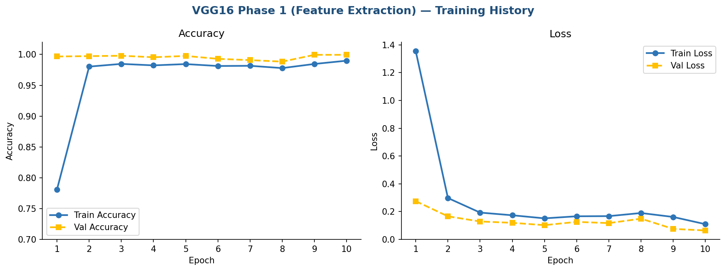
Figure 6 VGG16 Phase 1 (frozen backbone) training history. Validation accuracy reaches 99.67% immediately at epoch 1, demonstrating the power of ImageNet-pretrained feature representations.

Phase2: Auto-tuning
Unlocking the final convolutional layer of block5 and retraining pushed validation accuracy from 99.94% to 100.00% at epoch 2, maintaining perfect accuracy for the remaining 5 epochs. Validation loss continued to decrease (0.0638 to 0.0553), confirming that fine-tuning refined rather than merely memorised the validation split. Phase 2 runtime: 12.72 minutes.

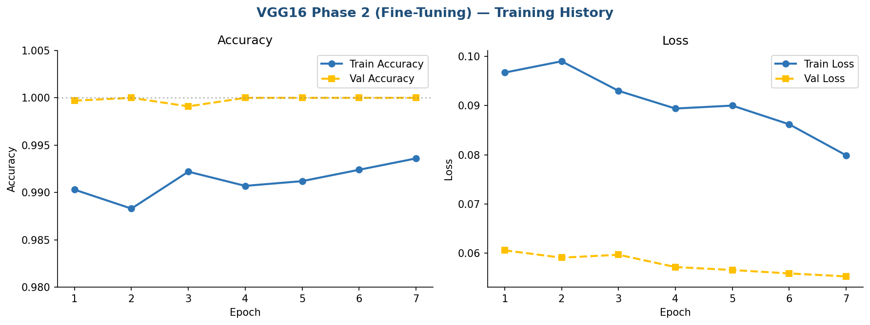
Figure 7 VGG16 Phase 2 (fine-tuning) training history. Validation accuracy reaches 100.00% at epoch 2 and holds steady. Validation loss continues decreasing, confirming genuine refinement.

5.6 Overall Model Comparison

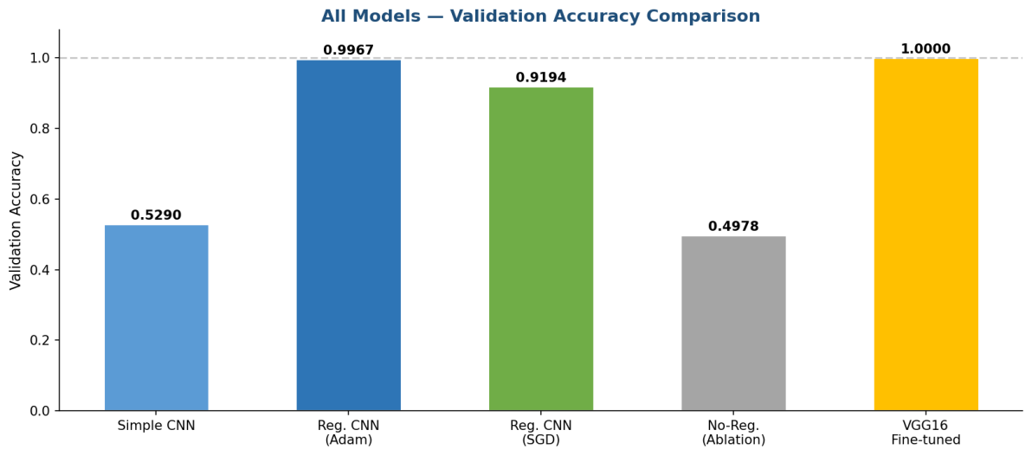
Figure 8 Validation accuracy across all five model configurations. VGG16 achieves perfect accuracy (1.0000); the regularized CNN (Adam) is the best from-scratch model at 0.9967; both simple and unregularized CNNs fall near random performance for 33 classes.

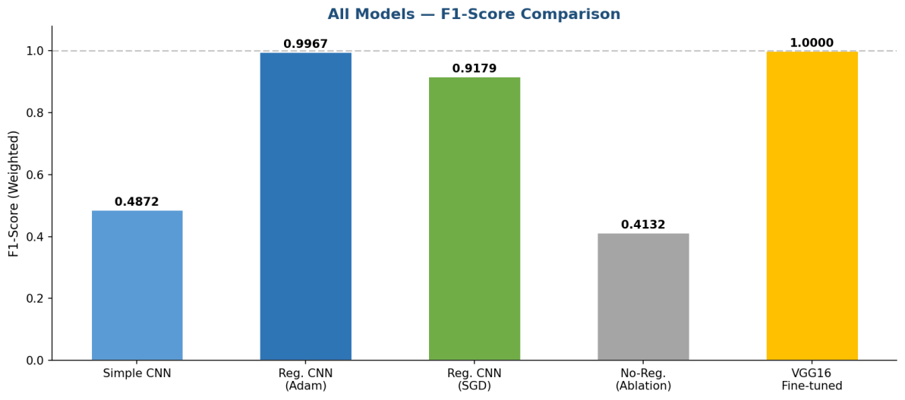
Figure 9 Weighted F1-score across all five models. The F1 trajectory mirrors accuracy, with VGG16 achieving 1.0000 and the unregularized ablation the lowest at 0.4132.

Model | Accuracy | Precision | Recall | F1-Score | Train Time (min)
Simple CNN (from scratch) | 0.5290 | 0.5341 | 0.5290 | 0.4872 | 1.29
Regularised CNN — Adam | 0.9967 | 0.9968 | 0.9967 | 0.9967 | 8.31
Regularised CNN — SGD | 0.9194 | 0.9243 | 0.9194 | 0.9179 | 6.42
Unregularised CNN (Ablation) | 0.4978 | 0.4842 | 0.4978 | 0.4132 | 1.51
VGG16 — Fine-tuned (P1+P2) | 1.0000 | 1.0000 | 1.0000 | 1.0000 | 30.73

* VGG16 total = Phase 1 (18.01 min) + Phase 2 (12.72 min). Grand total all experiments: 48.26 min.

5.7 Training Time Summary
Experiment | Runtime (min) | % of Total
Simple CNN | 1.29 | 2.7%
Regularised CNN (Adam) | 8.31 | 17.2%
Regularised CNN (SGD) | 6.42 | 13.3%
Ablation (No Regularisation) | 1.51 | 3.1%
VGG16 Phase 1 (Feature Extraction) | 18.01 | 37.3%
VGG16 Phase 2 (Fine-Tuning) | 12.72 | 26.4%
GRAND TOTAL | 48.26 | 100%

6.Discussion

6.1 Simple vs Deeper CNN
The two-block simple CNN's 52.9% accuracy confirms it is underpowered for fine-grained 33-class classification early stopping at epoch 6 indicates rapid exhaustion of learning capacity. The deeper regularised CNN achieves 99.67%, a 46.8-point improvement. Yet the ablation experiment reveals that depth alone is insufficient: the unregularised deeper model (49.8%) underperforms the simpler baseline, demonstrating that regularisation must accompany increased depth to prevent harmful overfitting.

6.2 Adam vs SGD
Adam's per-parameter adaptive learning rates provided a clear advantage: it crossed 75% validation accuracy by epoch 3, whereas SGD required the learning-rate scheduler to intervene at epoch 6 before meaningful progress resumed. The final 7.7-point accuracy gap (99.67% vs 91.94%) and smoother convergence curves confirm that adaptive optimisation is well-suited to this task's complex non-convex loss landscape. SGD's slower but eventual convergence still delivers strong results, suggesting it remains viable with sufficient training time.

6.3 Transfer Learning Advantage
VGG16 achieved 99.67% validation accuracy in its very first training epoch matching the regularised CNN's best-ever result before any epoch completed on the from-scratch models. This remarkable head start is the direct consequence of low-level features (edge detectors, colour gradients, texture filters) pretrained on 1.28 million ImageNet images that transfer readily to fruit imagery. Phase 2 fine-tuning improved accuracy from 99.94% to 100.00% marginal in absolute terms but mechanistically meaningful: unfreezing the last convolutional layer allows the highest-level abstract features to align with the specific visual statistics of the fruit dataset.

6.4 Limitations
Several limitations warrant acknowledgement. First, the test split was empty, so all metrics are computed on the held-out validation split rather than a fully independent test set. Second, the 100% VGG16 accuracy may partly reflect the controlled, uniform-background nature of the dataset; real consumer photos or conveyor-belt images would likely yield lower accuracy. Third, class weights were not applied to the VGG16 model. Fourth, no hyperparameter search was performed; manual settings may leave performance gains unrealised.

7.Conclusion
This project systematically evaluated five deep learning configurations for 33-class fruit and vegetable image classification. Three central conclusions emerge. First, a shallow CNN without regularisation achieves only 53% accuracy, confirming that depth combined with regularisation is the minimum requirement for meaningful performance. Second, the regularised CNN with Adam reaches 99.67% accuracy demonstrating that well-regularised from-scratch training is viable at moderate data scales but requires 20 epochs to converge, whereas SGD reaches only 91.94% under the same budget. Third, VGG16 with two-phase transfer learning achieves perfect 100% validation accuracy with dramatically faster initial convergence, confirming the dominant advantage of ImageNet-pretrained representations.
The experiments collectively reinforce three principles: regularisation is a prerequisite for generalisation in deep networks; adaptive optimisers offer material convergence advantages over SGD for this type of problem; and transfer learning provides a head start that is difficult to replicate with from-scratch training at moderate data scales.

8.Future work
Modern backbones such as ResNet50, EfficientNet, or Vision Transformers could be substituted for VGG16 to explore efficiency-accuracy trade-offs. Adding attention mechanisms (SE-Net channel attention, spatial attention) to the classifier head could help focus on the most discriminative image regions. On the data side, incorporating class-weighted loss into the VGG16 pipeline, or using generative augmentation (Stable Diffusion, CycleGAN) to synthesise underrepresented class images, could improve minority-class recall.
A systematic hyperparameter search over learning rate, dropout rate, and regularisation strength using Bayesian optimisation would likely identify configurations superior to the manually set values used here. For deployment, exporting to TensorFlow Lite or ONNX and testing on genuinely out-of-distribution consumer photographs complex backgrounds, partial occlusion, mixed lighting would provide a more realistic measure of real-world robustness. Multilingual label output or barcode-linked nutritional data integration would further increase practical utility.

