CERBERUS
eBPF-Based Intrusion Prevention System for Linux
Project Report
"Observe. Detect. Prevent."
Vellore Institute of Technology, Chennai
Operating System
Faculty: Sivagami M
30 October 2026

Submitted by
Team Member | Registration Number
Ishan S Bhat | 25BCE1082
Dipesh Raj S | 25BCE1016
Badri Narayan Sahu | 25BCE1167

Contents
1. Team Members
2. Abstract
3. Modules of the Project
4. Sample Code
5. Sample Screenshots
6. Software Tools Used in Developing the Project
7. Name of the AI Tool Used in Making This Report
8. AI Tools / Libraries / Classes Used in Developing the Project
9. Team Members' Contribution

1. Team Members
The project was developed as a three-member team using a shared Git repository. Work was developed on feature branches and merged into main through pull requests; the repository history records the development stages described in this report.
Name | Registration Number
Ishan S Bhat | 25BCE1082
Dipesh Raj S | 25BCE1016
Badri Narayan Sahu | 25BCE1167

2. Abstract
Cerberus is a Linux-based Intrusion Prevention System (IPS) built with eBPF as the enforcement backend. Unlike conventional monitoring tools that only watch system activity, Cerberus attaches an eBPF program to the Linux Security Module (BPF LSM) framework and therefore takes part in the kernel's actual security decisions: when a suspicious file open is detected, the program returns -EPERM and the operation is blocked before it completes, instead of merely being logged afterwards. A separate network policy applies the same BPF LSM decision point to outgoing connections through lsm/socket_connect, with independent IPv4/IPv6 block and allow maps and its own monitor/enforce mode.
The security policy lives in BPF hash and array maps and is fully dynamic. It supports global rules by file name or parent-directory/file-name path, deny rules scoped to a specific process (comm) or user ID, and a sandbox mode in which a process may only open allowlisted targets — any other open is denied. A global monitor/enforce mode selects whether matching accesses are only reported or actively denied, and can be switched at runtime without reloading the eBPF program.
A user-space agent written in C++ loads the eBPF program through a libbpf-generated skeleton, attaches it to the lsm/file_open hook, consumes security events from a BPF ring buffer and displays alerts such as [BLOCKED INTRUSION] and [MONITOR ALERT] with PID, UID, process name and matched rule. An interactive CLI (add, addpath, addproc, adduid, sandbox, allow, mode, status, list) and a policy configuration file allow rules to be added, removed and reconfigured while the system is live.
The kernel-side program is written in C and compiled to BPF bytecode with Clang; kernel portability is achieved with CO-RE (Compile Once – Run Everywhere) using BTF information dumped into vmlinux.h by bpftool. The agent is compiled with G++ and linked against libbpf. The whole project is built and tested on Kali GNU/Linux Rolling, where integration test scripts (test_cli.sh, test_phase35.sh, test_phase4.sh) verify rule enforcement, both policy modes, runtime rule changes, scoped and sandbox rules, and clean shutdown. The project evolved in stages — tracepoint monitoring, BPF LSM enforcement, dynamic blocklists, process-based policies, and IP-based network policy — and demonstrates the key distinction between observing kernel events (monitoring) and participating in kernel security decisions (prevention).

3. Modules of the Project
The codebase is split by responsibility. The kernel side is kept as a single BPF translation unit so that every hook program shares the same maps and ring buffer; the user space is modularised per concern. The module architecture below is the one used in the repository (source: README.md).
USER SPACE
+--------------------------------------------------+
| main.cpp lifecycle, signals, event loop |
| | |
| |-- bpf_loader skeleton, attach, map FDs |
| |-- config policy-file parsing |
| |-- cli command parsing/dispatch |
| |-- events ring buffer + alerts |
| +-- policy rules + mode + rule views |
| (all share util) |
+-----------------------^--------------------------+
| ring buffer
+-----------------------v--------------------------+
| BPF translation unit: src/bpf/ips_core.bpf.c |
| |-- maps.bpf.h all map definitions |
| |-- helpers.bpf.h emit_event, key build |
| |-- rules.bpf.h deny/sandbox checks |
| +-- hooks/file_open.bpf.h |
+--------------------------------------------------+

3.1 Shared kernel / user-space ABI
include/cerberus/common.h defines everything that must be identical on both sides of the kernel boundary: the struct event record (pid, uid, denied flag, rule/VA types, 16-byte process name, 256-byte matched rule key), the rule-key layouts (plain NAME keys and fixed-slot PATH keys), the scoped-rule key (process name + UID + rule), the policy mode constants (MONITOR / ENFORCE) and rule-type constants (NAME, PATH, SANDBOX). File names can never contain a forward slash, so NAME and PATH keys can safely share one BPF hash map without ambiguity.

3.2 Kernel-side eBPF IPS core (C)
src/bpf/ips_core.bpf.c is the single BPF translation unit; it includes the shared pieces below so all hooks share the same maps:
• maps.bpf.h — all BPF maps: blocklist (hash, 1024 entries), scoped_rules (hash, 1024), allowlist (hash, 1024), sandboxed (hash, 256), policy_mode (array, 1 entry), the IPv4/IPv6 network maps net_block4 / net_block6 / net_allow4 / net_allow6, net_mode (array, 1 entry) and the 256 KiB ring buffer rb.
• helpers.bpf.h — emit_event() (ring-buffer reserve/submit) and the rule-key builders build_name_key() / build_path_key() that read dentry names with BPF_CORE_READ / bpf_probe_read_kernel_str.
• rules.bpf.h — rule matching with fixed precedence: sandbox check (allowlist-only), then global, process-scoped and UID-scoped deny rules.
• hooks/file_open.bpf.h — the lsm/file_open hook BPF_PROG(restrict_file_open), which inspects the file's dentry, builds both key forms, consults the policy mode and either allows the open (return 0) or denies it (return -EPERM).
• hooks/socket_connect.bpf.h — the lsm/socket_connect hook (Phase 5), which inspects outgoing IPv4/IPv6 connection attempts, consults the network block/allow maps and returns -EPERM in network enforce mode.

3.3 User-space Cerberus agent (C++)
main.cpp — Process lifecycle: signal handling (SIGINT/SIGTERM with no SA_RESTART so a blocked poll returns EINTR), loads the config file, starts the BPF runtime, sets monitor mode as the safe default, and runs the main loop draining the ring buffer while accepting CLI commands; on exit it detaches and reports the event count.
bpf_loader.cpp — Opens and loads the generated skeleton (ips_core_bpf__open_and_load), attaches the LSM programs, and exposes the map file descriptors (blocklist, scoped_rules, allowlist, sandboxed, policy_mode, net_block4, net_block6, net_allow4, net_allow6, net_mode, rb) to the rest of the agent.
policy.cpp / policy.h — The rule codec and map operations: builds NAME and fixed-slot PATH keys, decodes them back for display, adds/removes global, scoped and allowlist entries, enables/disables sandboxing, gets/sets the global monitor/enforce mode, counts entries and prints the list view.
config.cpp / config.h — Parses the policy file (mode, name, path, proc, uid, sandbox, allow directives; '#' comments) and applies each directive to the BPF maps; startup data is loaded from blocklist.txt by default or from an explicit path given as the first argument.
cli.cpp / cli.h — Interactive command interface: non-blocking command reading via select() over STDIN so commands never block event delivery; handles batched/pasted commands and implements add, addpath, remove, rmpath, addproc, rmproc, adduid, rmuid, sandbox, unsandbox, allow, unallow, list, mode, status, help, quit.
events.cpp / events.h — Creates the ring-buffer consumer (ring_buffer__new), translates each event into a colour-coded alert line ([BLOCKED INTRUSION] / [MONITOR ALERT]) preserving the CLI prompt, and keeps the event count for status and shutdown summary.
policy_net.cpp / net_cli.cpp / net_events.cpp — Phase 5 network policy: IPv4/IPv6 block and allow maps, net-mode handling, address validation and canonicalisation, and [NET CONNECT BLOCKED] / [NET WOULD BLOCK] / [NET OUTBOUND] alerts through the same ring buffer.
util.h — Header-only text helpers (trim, token splitting) shared by the config and CLI parsers.

3.4 Build pipeline
The Makefile automates the full pipeline: bpftool btf dump generates headers/vmlinux.h from /sys/kernel/btf/vmlinux; Clang compiles the BPF translation unit to build/ips_core.bpf.o (-target bpf, x86 target); bpftool gen skeleton produces build/ips_core.skel.h; finally G++ compiles all agent sources and links build/cerberus_agent against libbpf/liblelf/libz.

3.5 Policy configuration and tests
• blocklist.example.txt — documented example policy file showing all supported directives.
• tests/test_cli.sh — CLI behaviour: immediate prompt, batched commands, enforcement from the CLI, clean exit.
• tests/test_phase35.sh — config loading, both modes, runtime rule changes, ring-buffer alerts and clean shutdown.
• tests/test_phase4.sh — process rules, UID rules, sandbox default-deny, allowlisting, monitor-mode reporting, list output and clean shutdown (uses a statically linked probe binary).

3.6 Policy configuration and tests
Cerberus implements an IP-based network security module using the eBPF Linux Security Module (BPF LSM) framework. It attaches to the lsm/socket_connect hook to inspect outgoing network connection attempts before they are established.It monitors and controls outgoing network connection attempts at the kernel level.
This hook is invoked when an application attempts to establish a socket connection. Our eBPF program intercepts the request, extracts the destination IP address, and evaluates it against the configured network policies.

Key Features:
- IPv4 and IPv6 Support: Inspects both IPv4 and IPv6 destination addresses.
- IP Blocklist: Maintains blocked destination IP addresses using net_block4 and net_block6 BPF maps.
- IP Allowlist: Maintains permitted destination IP addresses using net_allow4 and net_allow6 BPF maps.
- Independent Network Mode: Uses a separate net_mode map to switch between MONITOR and ENFORCE modes independently of file security.
- Runtime Policy Updates: Network rules can be added and removed through the interactive CLI without reloading the eBPF program.
- Event Reporting: Network events are transferred to the user-space agent through the shared BPF ring buffer.
- BPF Maps:
The implementation uses separate BPF maps to store network policies:
Map | Purpose
net_block4 | IPv4 blocklist
net_block6 | IPv6 blocklist
net_allow4 | IPv4 allowlist
net_allow6 | IPv6 allowlist
net_mode | Stores the network security mode
rb | Transfers events from kernel space to userspace
- These maps allow the userspace agent to update policies while the eBPF program accesses them inside the kernel.

Working:
- When a process attempts an outgoing connection, the lsm/socket_connect hook is triggered.
- The eBPF program identifies the address family and extracts the destination IP address, port and protocol.
- It checks the destination IP against the corresponding blocklist and allowlist maps.
- Block rules have precedence over allow rules.
- In MONITOR mode, matching rules generate alerts without preventing the connection.
- In ENFORCE mode, a matching block rule causes the hook to return -EPERM, preventing the connection.
Network Alerts:
- [NET OUTBOUND] – Reports outgoing connection activity.
- [NET WOULD BLOCK] – Reports a blocked-IP match in monitor mode.
- [NET CONNECT BLOCKED] – Reports a connection denied in enforce mode.
This module provides IP-based outbound connection control while maintaining a clear separation between file security and network security policies.
Operating Modes:
Monitor Mode
- Detects outgoing connection attempts.
- Reports matching block rules.
- Does not deny connections.
Enforce Mode
- Evaluates network policies and enforces block rules.
- Denies connections matching a block rule.
- Returns -EPERM to reject the connection.
Policy Evaluation:
Cerberus follows a block-first policy:
- Check whether the destination IP matches a blocklist entry.
- If it matches, deny the connection in Enforce mode.
- Otherwise, check the allowlist.
- If neither rule matches, allow the connection by default.
A matching block rule takes precedence over an allow rule.
Kernel-to-Userspace Communication:
Network events are transferred from the eBPF program to the userspace C++ agent using a BPF ring buffer.
The agent displays information such as:
- Process ID (PID)
- Process name
- Destination IP address
- Destination port
- Protocol

Usage:
Start the Cerberus agent:
sudo ./build/cerberus_agent
Add an IPv4 block rule:
block-ip 127.0.0.1
Display configured rules:
list
Enable enforcement:
net-mode enforce
Current Scope and Limitations
- Filtering is based on destination IP addresses, not domain names.
- CIDR-based subnet rules are not supported.
- The current implementation handles outgoing TCP connection attempts and connected UDP sockets.
- Unconnected UDP sendto() traffic is not covered by the socket_connect hook.
- The module does not perform packet-level inspection.
- Network security mode operates independently of file security mode.

4. Sample Code
The excerpts below are taken verbatim from the project sources (the exact file and line range is noted under each excerpt). They illustrate the complete enforcement path: the kernel-side LSM hook, the policy maps, event reporting, the shared ABI, and the user-space loader and alert rendering.

4.1 Kernel-side enforcement hook
Attached to the BPF LSM file_open security hook; decides allow / report / deny for every file open in the system.
SEC("lsm/file_open")
int BPF_PROG(restrict_file_open, struct file *file)
{
struct scoped_rule_key skey = {};
struct dentry *dentry;
struct qstr parent_name;
struct qstr base_name;
__u32 zero = 0;
__u32 uid;
__u8 *mode;
int denied;
int sandbox;
/*
* Get the file's dentry.
*/
dentry = BPF_CORE_READ(
file,
f_path.dentry
);
if (!dentry)
return 0;
base_name = BPF_CORE_READ(
dentry,
d_name
);
parent_name = BPF_CORE_READ(
dentry,
d_parent,
d_name
);
/*
* Decide whether matches are denied or
* only reported.
*/
mode = bpf_map_lookup_elem(
&policy_mode,
&zero
);
denied = (
mode &&
*mode == CERBERUS_MODE_ENFORCE
);
uid = bpf_get_current_uid_gid();
sandbox = process_is_sandboxed(&skey);
/*
* PATH rule form.
*/
if (parent_name.name)
{
build_path_key(
skey.rule,
&parent_name,
&base_name
);
/*
* A sandboxed process is allowed as soon as
* either key form appears in its allowlist.
*/
if (sandbox && allow_matches(&skey))
return 0;
if (
!sandbox &&
check_deny_rules(&skey, uid, denied))
{
return denied ? -EPERM : 0;
}
}
/*
* NAME rule form.
*/
build_name_key(
skey.rule,
&base_name
);
if (sandbox)
{
if (allow_matches(&skey))
return 0;
/*
* Default-deny: the sandboxed process tried
* to open something that is not allowlisted.
*/
emit_event(
skey.rule,
CERBERUS_RULE_SANDBOX,
denied
);
return denied ? -EPERM : 0;
}
if (check_deny_rules(&skey, uid, denied))
return denied ? -EPERM : 0;
/*
* No rule matched: allow the operation.
*/
return 0;
}
#endif /* CERBERUS_HOOK_FILE_OPEN_BPF_H */
Source: src/bpf/hooks/file_open.bpf.h (verbatim, lines 12-133) — CERBERUS-eBPF repository

4.2 Rule table, policy-mode and event maps
All maps are defined in one header included once by the single BPF translation unit, so every hook shares the same maps without map-in-map tricks.
struct {
__uint(type, BPF_MAP_TYPE_HASH);
__uint(max_entries, 1024);
__type(key, char[256]);
__type(value, struct rule_value);
} blocklist SEC(".maps");
/* ...... scoped_rules, allowlist, sandboxed maps: same
pattern, see src/bpf/maps.bpf.h ...... */
struct {
__uint(type, BPF_MAP_TYPE_ARRAY);
__uint(max_entries, 1);
__type(key, __u32);
__type(value, __u8);
} policy_mode SEC(".maps");
struct {
__uint(type, BPF_MAP_TYPE_RINGBUF);
__uint(max_entries, 256 * 1024);
} rb SEC(".maps");
Source: src/bpf/maps.bpf.h (excerpt) — CERBERUS-eBPF repository

4.3 Ring-buffer event emission
The kernel program reserves space in the BPF ring buffer, fills pid, uid, process name, verdict and the matched rule key, then submits the event to user space.
/*
* Report a matched rule to user space.
*
* "key" is the exact rule key that matched, so the
* agent can display which rule triggered the event.
*/
static __always_inline void emit_event(
const char *key,
unsigned char rule_type,
int denied)
{
struct event *e;
e = bpf_ringbuf_reserve(
&rb,
sizeof(*e),
0
);
if (!e)
return;
e->pid =
bpf_get_current_pid_tgid() >> 32;
e->uid =
bpf_get_current_uid_gid();
e->denied =
denied ? 1 : 0;
e->rule_type =
rule_type;
e->evt_type =
CERBERUS_EVT_FILE_OPEN;
e->reserved = 0;
bpf_get_current_comm(
&e->comm,
sizeof(e->comm)
);
/*
* Copy the matched rule key into the event.
* For PATH rules this is the fixed slot layout.
*/
__builtin_memcpy(
e->rule,
key,
sizeof(e->rule)
);
bpf_ringbuf_submit(e, 0);
}
Source: src/bpf/helpers.bpf.h (excerpt) — CERBERUS-eBPF repository

4.4 Rule lookup precedence
Inside the hook, deny rules are evaluated with fixed precedence: global rules first, then process-scoped rules, then UID-scoped rules.
/*
* Check global, process and UID deny rules
* against the rule key currently in skey->rule.
*
* Returns 1 if a rule matched (event already emitted).
*/
static __always_inline int check_deny_rules(
struct scoped_rule_key *skey,
__u32 uid,
int denied)
{
struct rule_value *rule;
/*
* Global rule.
*/
rule = bpf_map_lookup_elem(
&blocklist,
skey->rule
);
if (rule)
{
emit_event(
skey->rule,
rule->type,
denied
);
return 1;
}
/*
* Process rule.
*/
bpf_get_current_comm(
skey->comm,
sizeof(skey->comm)
);
skey->uid = CERBERUS_UID_ANY;
rule = bpf_map_lookup_elem(
&scoped_rules,
skey
);
if (rule)
{
emit_event(
skey->rule,
rule->type,
denied
);
return 1;
}
/*
* UID rule.
*/
__builtin_memset(
skey->comm,
0,
sizeof(skey->comm)
);
skey->uid = uid;
rule = bpf_map_lookup_elem(
&scoped_rules,
skey
);
if (rule)
{
emit_event(
skey->rule,
rule->type,
denied
);
return 1;
}
return 0;
}
Source: src/bpf/rules.bpf.h (excerpt) — CERBERUS-eBPF repository

4.5 Shared kernel / user-space ABI
Included by BOTH the eBPF program and the C++ agent so both sides interpret event records, rule keys and policy modes identically.
#define CERBERUS_MODE_MONITOR 0
#define CERBERUS_MODE_ENFORCE 1
#define CERBERUS_RULE_NAME 1
#define CERBERUS_RULE_PATH 2
#define CERBERUS_RULE_SANDBOX 3
#define CERBERUS_PATH_SLOT 64
#define CERBERUS_UID_ANY 0xFFFFFFFFu
struct scoped_rule_key {
char comm[16];
unsigned int uid;
char rule[256];
};
/* ...... comments abridged in this excerpt; full file:
include/cerberus/common.h ...... */
#define CERBERUS_EVT_FILE_OPEN 1
struct rule_value {
unsigned char type; /* CERBERUS_RULE_* */
};
struct event {
unsigned int pid;
unsigned int uid;
unsigned char denied; /* 1 = blocked, 0 = monitor-only */
unsigned char rule_type; /* CERBERUS_RULE_* */
unsigned char evt_type; /* CERBERUS_EVT_* */
unsigned char reserved;
char comm[16];
char rule[256]; /* matched rule key (slot layout for path rules) */
};
Source: include/cerberus/common.h (excerpt) — CERBERUS-eBPF repository

4.6 Alert rendering in the user-space agent
The agent consumes ring-buffer events and prints colour-coded alerts (BLOCKED INTRUSION / MONITOR ALERT) without blocking the CLI prompt.
/*
* Called whenever the eBPF program reports
* a matching access.
*/
static int handle_event(
void *ctx,
void *data,
size_t data_sz)
{
const struct event *e =
static_cast<const struct event *>(data);
if (data_sz < sizeof(*e))
return 0;
g_event_count++;
std::string target;
if (e->rule_type == CERBERUS_RULE_SANDBOX)
{
target =
std::string("(sandbox default-deny) ") +
policy_decode_rule(e->rule, e->rule_type);
}
else
{
target = policy_rule_label(e->rule, e->rule_type);
}
bool had_prompt = cli_prompt_active();
if (had_prompt)
std::cout << "\n";
std::cout
<< (e->denied
? "\033[1;31m[BLOCKED INTRUSION]\033[0m "
: "\033[1;33m[MONITOR ALERT] \033[0m ")
<< "PID: "
<< std::setw(6)
<< e->pid
<< " | UID: "
<< std::setw(5)
<< e->uid
<< " | Process: "
<< std::setw(12)
<< e->comm
<< " | Target: "
<< target
<< std::endl;
if (had_prompt)
cli_print_prompt();
return 0;
}
Source: src/agent/events.cpp (excerpt) — CERBERUS-eBPF repository

4.7 Loading the eBPF skeleton
The agent uses the bpftool-generated skeleton (ips_core_bpf__open_and_load / __attach) and obtains map file descriptors used for runtime policy management.
bool bpf_runtime_start(bpf_maps& maps)
{
/*
* Open and load the eBPF skeleton.
*/
g_skel = ips_core_bpf__open_and_load();
if (!g_skel)
{
std::cerr
<< "[-] Failed to load BPF skeleton.\n";
return false;
}
/*
* Attach the LSM program.
*/
if (ips_core_bpf__attach(g_skel))
{
std::cerr
<< "[-] Failed to attach BPF LSM hook.\n";
bpf_runtime_stop();
return false;
}
/*
* Get file descriptors for our maps.
*/
maps.policy.rules_fd =
bpf_map__fd(g_skel->maps.blocklist);
maps.policy.scoped_fd =
bpf_map__fd(g_skel->maps.scoped_rules);
maps.policy.allow_fd =
bpf_map__fd(g_skel->maps.allowlist);
maps.policy.sandbox_fd =
bpf_map__fd(g_skel->maps.sandboxed);
maps.policy.mode_fd =
bpf_map__fd(g_skel->maps.policy_mode);
maps.ringbuf_fd =
bpf_map__fd(g_skel->maps.rb);
if (
maps.policy.rules_fd < 0 ||
maps.policy.scoped_fd < 0 ||
maps.policy.allow_fd < 0 ||
maps.policy.sandbox_fd < 0 ||
maps.policy.mode_fd < 0)
{
std::cerr
<< "[-] Failed to get BPF map FDs.\n";
bpf_runtime_stop();
return false;
}
return true;
}
Source: src/agent/bpf_loader.cpp (excerpt) — CERBERUS-eBPF repository

4.8 Kernel-side Network Connection Enforcement Hook

This code attaches the eBPF program to the Linux Security Module socket_connect hook. It inspects outgoing IPv4 and IPv6 connection attempts, checks the destination IP against the configured blocklist and allowlist, and applies the network security policy. If a blocked address is accessed in Enforce mode, the connection is rejected using -EPERM.
Source: src/bpf/hooks/socket_connect.bpf.h
SEC("lsm/socket_connect")
int BPF_PROG(restrict_socket_connect,
struct sock *sk,
struct sockaddr *address,
int addrlen)
{
struct sockaddr sa = {};
unsigned char addr[16] = {};
unsigned short port = 0;
unsigned char protocol = 0;
int family;
int enforced;
int matched_block = 0;
int matched_allow = 0;

__u32 zero = 0;
__u8 *mode;

bpf_probe_read_kernel(&sa, sizeof(sa), address);
family = sa.sa_family;

mode = bpf_map_lookup_elem(&net_mode, &zero);
enforced = (mode && *mode == CERBERUS_MODE_ENFORCE);

if (family == CERBERUS_AF_INET)
{
struct sockaddr_in sin = {};

if (addrlen < (int)sizeof(sin))
return 0;

bpf_probe_read_kernel(&sin, sizeof(sin), address);
__builtin_memcpy(addr, &sin.sin_addr, sizeof(sin.sin_addr));

port = sin.sin_port;
protocol = BPF_CORE_READ(sk, sk_protocol);

__u32 key4 = 0;
__builtin_memcpy(&key4, addr, sizeof(key4));

if (bpf_map_lookup_elem(&net_block4, &key4))
matched_block = 1;
else if (bpf_map_lookup_elem(&net_allow4, &key4))
matched_allow = 1;
}
else if (family == CERBERUS_AF_INET6)
{
struct sockaddr_in6 sin6 = {};

if (addrlen < (int)sizeof(sin6))
return 0;

bpf_probe_read_kernel(&sin6, sizeof(sin6), address);
__builtin_memcpy(addr, &sin6.sin6_addr, sizeof(sin6.sin6_addr));

port = sin6.sin6_port;
protocol = BPF_CORE_READ(sk, sk_protocol);

if (bpf_map_lookup_elem(&net_block6, addr))
matched_block = 1;
else if (bpf_map_lookup_elem(&net_allow6, addr))
matched_allow = 1;
}
else
{
return 0;
}

int verdict = CERBERUS_NET_VERDICT_ALLOWED;

if (matched_block)
{
verdict = (
enforced
? CERBERUS_NET_VERDICT_DENIED
: CERBERUS_NET_VERDICT_BLOCKED_MONITOR
);
}
else if (matched_allow)
{
verdict = CERBERUS_NET_VERDICT_ALLOWED;
}

emit_net_event(
addr,
(unsigned char)family,
protocol,
port,
verdict,
matched_block,
matched_allow
);

if (matched_block && enforced)
return -EPERM;

return 0;
}

4.9 Network Policy Maps
These maps store the IPv4 and IPv6 network blocklist and allowlist entries. The net_mode map maintains the network security mode independently of the file security mode. The shared ring buffer transfers network events from kernel space to the user-space agent.
Source: src/bpf/maps.bpf.h
struct {
__uint(type, BPF_MAP_TYPE_HASH);
__uint(max_entries, 1024);
__type(key, __u32);
__type(value, __u8);
} net_block4 SEC(".maps");

struct {
__uint(type, BPF_MAP_TYPE_HASH);
__uint(max_entries, 1024);
__type(key, __u8[16]);
__type(value, __u8);
} net_block6 SEC(".maps");

struct {
__uint(type, BPF_MAP_TYPE_HASH);
__uint(max_entries, 1024);
__type(key, __u32);
__type(value, __u8);
} net_allow4 SEC(".maps");

struct {
__uint(type, BPF_MAP_TYPE_HASH);
__uint(max_entries, 1024);
__type(key, __u8[16]);
__type(value, __u8);
} net_allow6 SEC(".maps");

struct {
__uint(type, BPF_MAP_TYPE_ARRAY);
__uint(max_entries, 1);
__type(key, __u32);
__type(value, __u8);
} net_mode SEC(".maps");

struct {
__uint(type, BPF_MAP_TYPE_RINGBUF);
__uint(max_entries, 256 * 1024);
} rb SEC(".maps");
4.10 Network Policy Interface
Description:
The network policy interface declares functions used by the user-space agent to parse IP addresses, add and remove block and allow rules, change the network security mode, count configured rules and display the network rule list.
Source: src/agent/policy_net.h
bool policy_net_parse_ip(
const std::string& text,
unsigned short& family,
unsigned char (&addr)[16],
std::string& canonical);

bool policy_net_add_block(
const policy_maps& maps,
const std::string& ip);

bool policy_net_remove_block(
const policy_maps& maps,
const std::string& ip);

bool policy_net_add_allow(
const policy_maps& maps,
const std::string& ip);

bool policy_net_remove_allow(
const policy_maps& maps,
const std::string& ip);

bool policy_net_set_mode(int net_mode_fd, unsigned char mode);

unsigned char policy_net_get_mode(int net_mode_fd);

unsigned int policy_net_count_blocks(const policy_maps& maps);

unsigned int policy_net_count_allows(const policy_maps& maps);

std::string policy_net_decode_addr(
const unsigned char (&addr)[16],
unsigned short family);

void policy_net_list(const policy_maps& maps);

4.11 Network Event Handling
The network event handler receives connection events and converts destination addresses into readable IPv4 or IPv6 format. It identifies the network protocol and displays the process ID, UID, process name, destination IP address, port and policy verdict. Different event labels distinguish normal outbound connections, monitor-mode matches and blocked connections.
Source: src/agent/net_events.cpp
static std::string net_addr_text(const struct net_event *e)
{
char buf[INET6_ADDRSTRLEN] = {};

unsigned short af = (
e->family == CERBERUS_AF_INET6 ? AF_INET6 : AF_INET
);

if (inet_ntop(af, e->addr, buf, sizeof(buf)) == nullptr)
return "<malformed>";

return std::string(buf);
}

static std::string net_proto_text(const struct net_event *e)
{
switch (e->protocol)
{
case CERBERUS_IPPROTO_TCP:
return "tcp";

case CERBERUS_IPPROTO_UDP:
return "udp";

default:
return "proto " + std::to_string(e->protocol);
}
}

void print_net_event(const struct net_event *e)
{
std::string tag;

switch (e->verdict)
{
case CERBERUS_NET_VERDICT_DENIED:
tag = "[NET CONNECT BLOCKED]";
break;

case CERBERUS_NET_VERDICT_BLOCKED_MONITOR:
tag = "[NET WOULD BLOCK ]";
break;

default:
tag = "[NET OUTBOUND ]";
break;
}

if (e->matched_allow)
tag += " (allow) ";

if (e->matched_block)
tag += " (block) ";

bool had_prompt = cli_prompt_active();

if (had_prompt)
std::cout << "\n";

std::cout
<< tag
<< " PID: " << std::setw(6) << e->pid
<< " | UID: " << std::setw(5) << e->uid
<< " | Process: " << std::setw(12) << e->comm
<< " | Target: " << net_addr_text(e)
<< ":" << ntohs(e->port)
<< " (" << net_proto_text(e) << ")"
<< std::endl;

if (had_prompt)
cli_print_prompt();
}
5. Sample Screenshots
CAPTURED SCREENSHOTS
The figures below are actual terminal captures from the Kali Linux machine used to verify the project. Cerberus was built from source and run as root; the agent was exercised through its interactive CLI, and the results are shown exactly as printed.
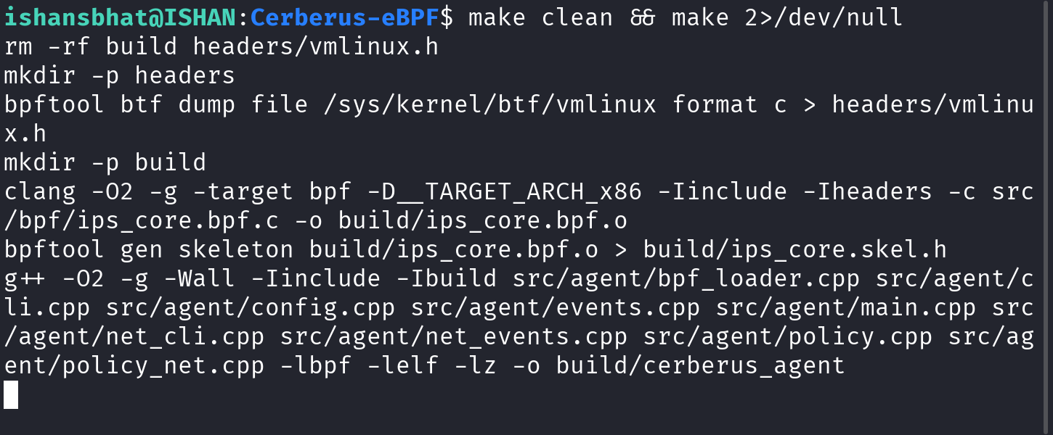
Fig. 1 — Build pipeline: BTF/vmlinux.h generation, eBPF bytecode compilation, skeleton generation and C++ agent link.
How to capture (Kali Linux): make clean && make 2>/dev/null
Expected result:
Expected: The four-stage pipeline is echoed: bpftool BTF dump generating headers/vmlinux.h, clang compiling build/ips_core.bpf.o, bpftool gen skeleton creating build/ips_core.skel.h, and g++ linking build/cerberus_agent. (Compiler warnings from the generated vmlinux.h were redirected for the capture.)
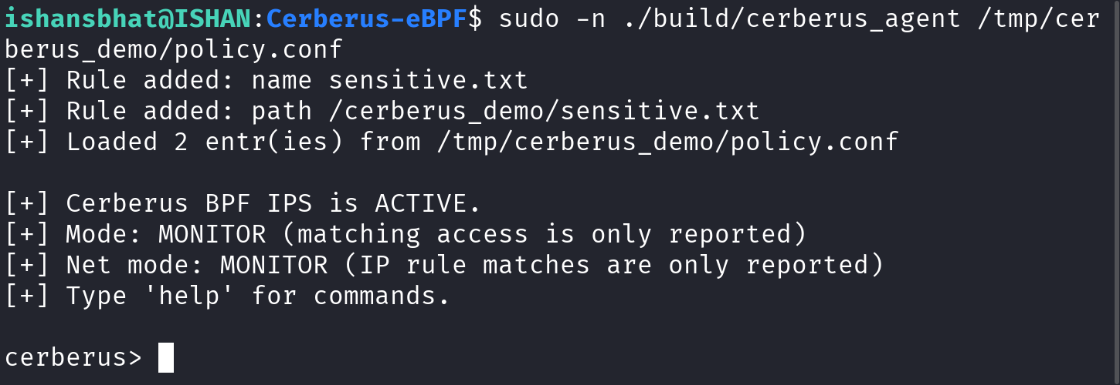
Fig. 2 — Agent startup: two rules loaded from the policy file, monitor mode active and the interactive prompt ready.
How to capture (Kali Linux): sudo -n ./build/cerberus_agent /tmp/cerberus_demo/policy.conf
Expected result:
Expected: The agent reports the two rules loaded from the policy file, activates the BPF LSM hook, shows MONITOR mode for both file and network policy, prints the command hint and displays the cerberus> prompt.
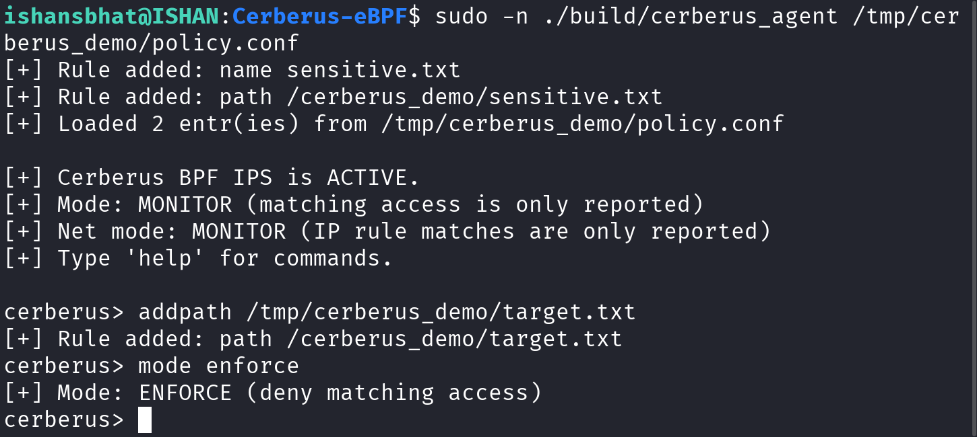
Fig. 3 — Runtime policy update: a PATH rule is added and the agent switches from MONITOR to ENFORCE mode.
How to capture (Kali Linux): cerberus> addpath /tmp/cerberus_demo/target.txt ; cerberus> mode enforce
Expected result:
Expected: [+] Rule added: path /cerberus_demo/target.txt and [+] Mode: ENFORCE (deny matching access).
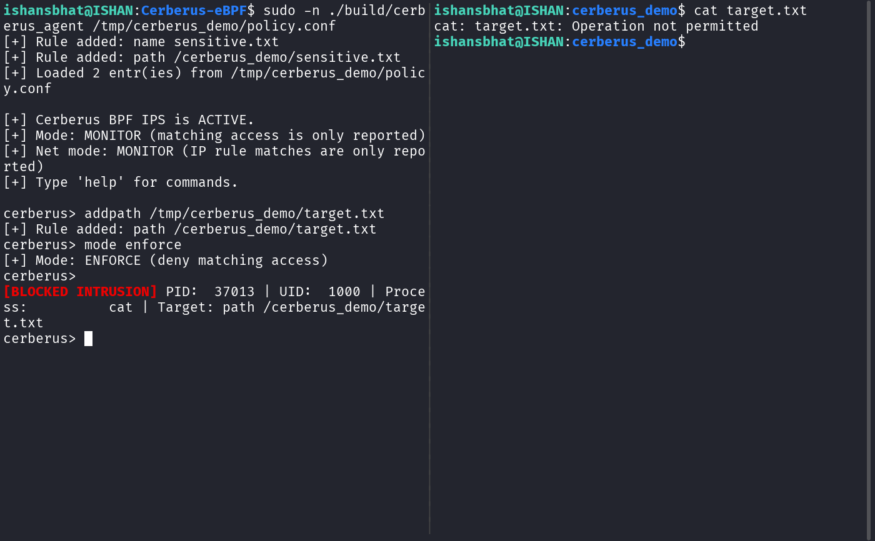
Fig. 4 — Active prevention: the open is denied with EPERM and the agent reports a BLOCKED INTRUSION event. PATH rules store the last two path components, so the displayed key /cerberus_demo/target.txt corresponds to /tmp/cerberus_demo/target.txt.
How to capture (Kali Linux): cat target.txt (right-hand pane, working directory /tmp/cerberus_demo)
Expected result:
Expected: The cat attempt fails with 'Operation not permitted'; the agent prints a red [BLOCKED INTRUSION] alert with PID, UID, process name and the matched PATH rule.
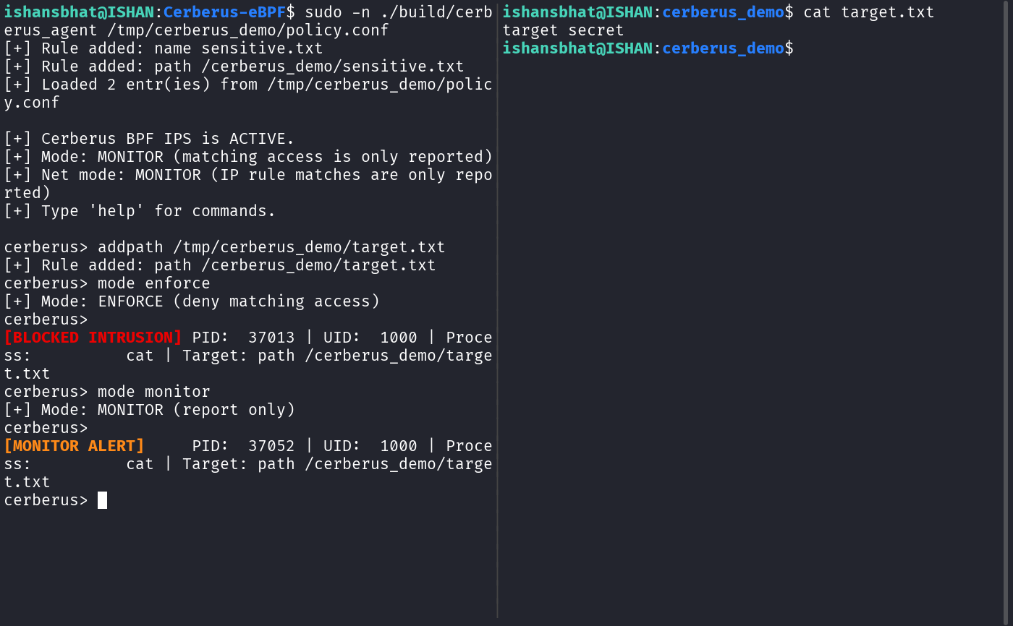
Fig. 5 — Monitor mode: the same access is allowed (the file content is printed) but reported as a MONITOR ALERT.
How to capture (Kali Linux): cerberus> mode monitor ; cat target.txt (right-hand pane, working directory /tmp/cerberus_demo)
Expected result:
Expected: The cat now succeeds and prints the file contents; the agent prints a yellow [MONITOR ALERT] for the same target instead of denying it.
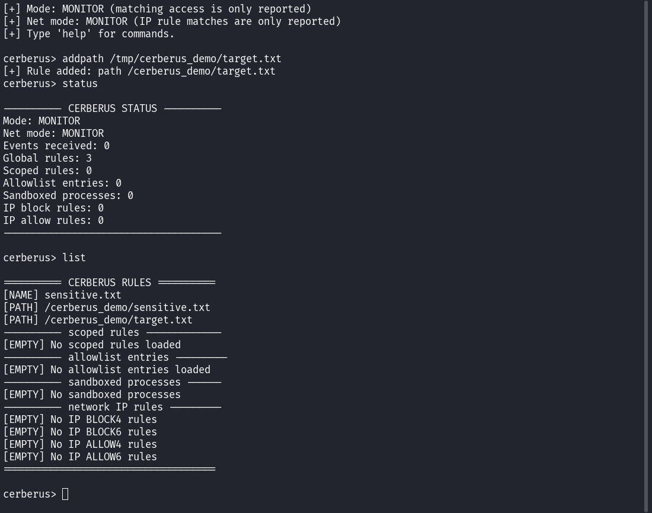
Fig. 6 — Status and rule listing after the runtime changes: mode, event count, rule counts and the loaded policies.
How to capture (Kali Linux): cerberus> status ; cerberus> list
Expected result:
Expected: The status panel shows MONITOR mode, the event counter, three global rules and zero scoped/allowlist/sandbox entries; list shows the three global rules and the empty sections.
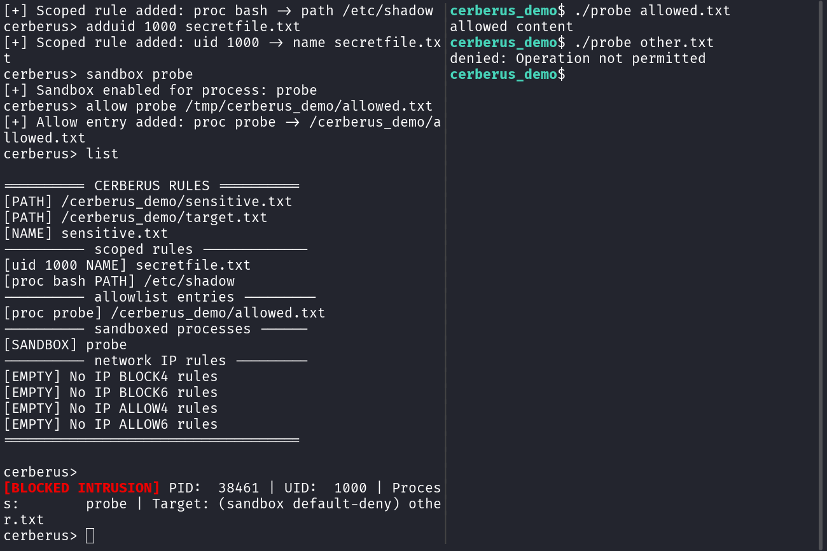
Fig. 7 — Process-scoped, UID-scoped and sandbox policies. The sandboxed probe may open its allowlisted file, while any other open is default-denied and reported as a BLOCKED INTRUSION.
How to capture (Kali Linux): cerberus> addproc bash /etc/shadow ; cerberus> adduid 1000 secretfile.txt ; cerberus> sandbox probe ; cerberus> allow probe /tmp/cerberus_demo/allowed.txt
Expected result:
Expected: The agent acknowledges the process rule, UID rule, sandbox and allowlist entry; list shows all of them. The static probe reads its allowlisted file but is denied (Operation not permitted) on any other file, and the denial is reported as a sandbox default-deny event.
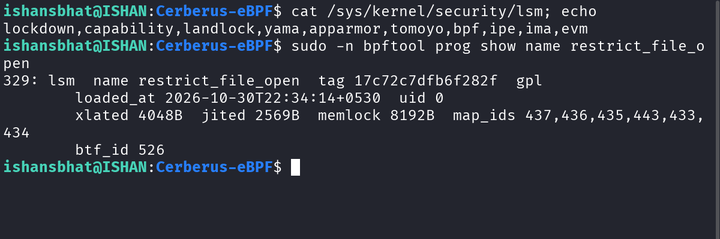
Fig. 8 — Kernel-side verification: bpf is an active LSM and the restrict_file_open program is loaded and attached.
How to capture (Kali Linux): cat /sys/kernel/security/lsm; echo ; sudo -n bpftool prog show name restrict_file_open
Expected result:
Expected: /sys/kernel/security/lsm contains bpf; bpftool lists a program of type lsm named restrict_file_open with its tag, load time, translated/JITed sizes, map ids and BTF id.
Network Security Demonstrations (Figure 5.1 – Figure 5.6)
The figures below are actual terminal captures from the Fedora Linux verification machine used for the network security phase of this project. Cerberus was built from source and run as root; the agent was driven through its interactive CLI and the connection attempts were generated with curl (and the connect_test.py fixture from tests/). All output is shown exactly as printed.
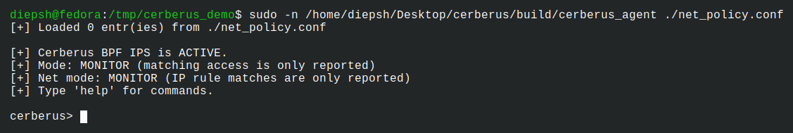
Figure 5.1: Cerberus Network Security Initialization
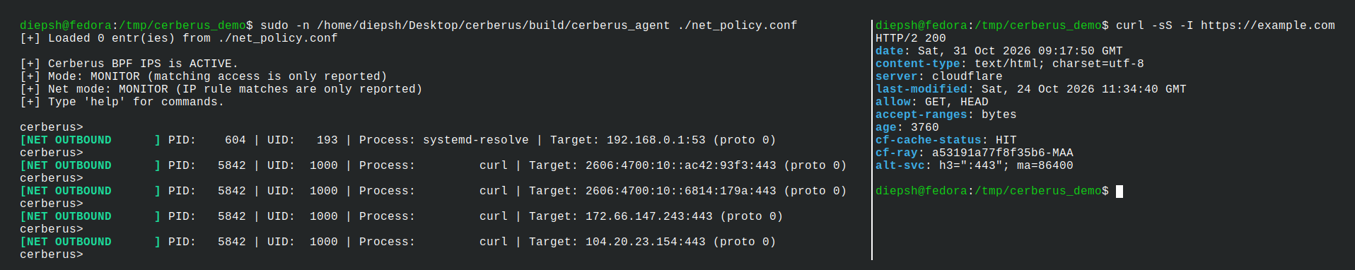
Figure 5.2: Monitoring Outgoing Network Connections
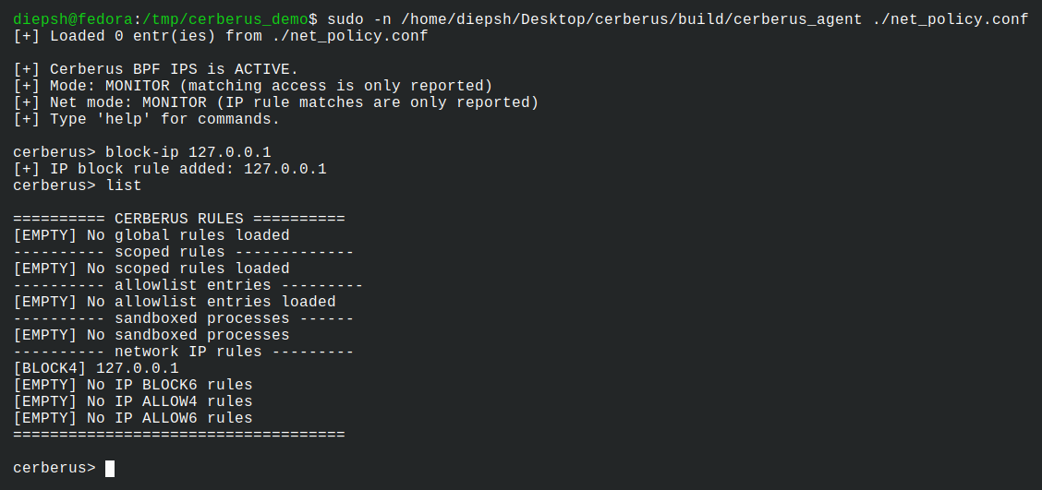
Figure 5.3: Adding an IP Address to the Network Blocklist
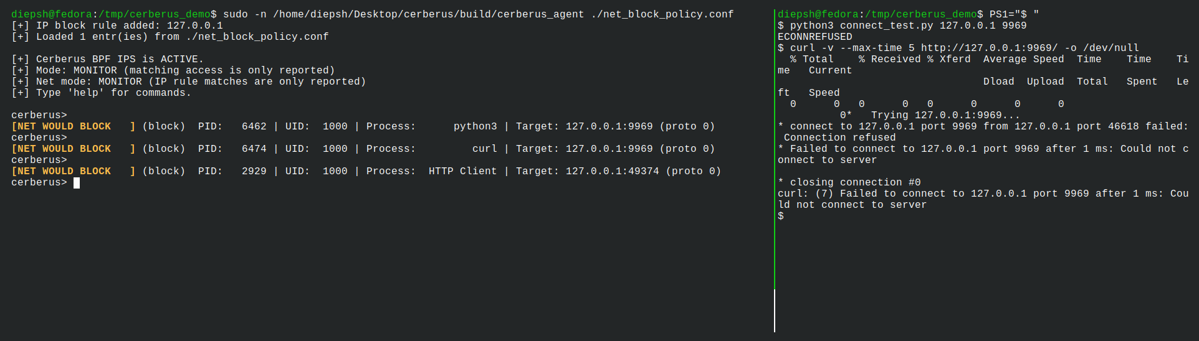
Figure 5.4: Network Block Rule Detection in Monitor Mode
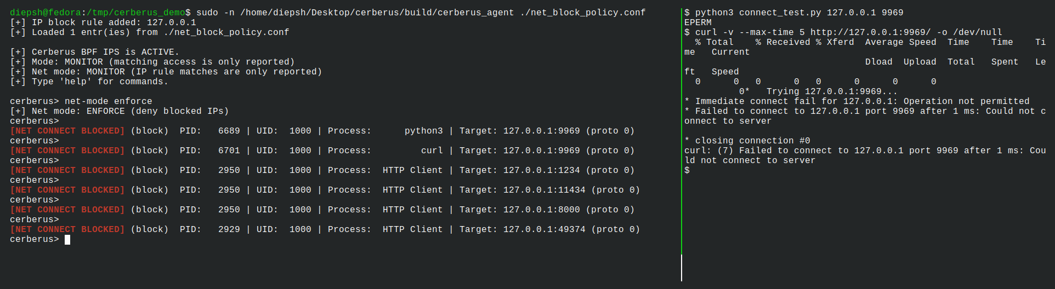
Figure 5.5: Network Connection Blocking in Enforce Mode
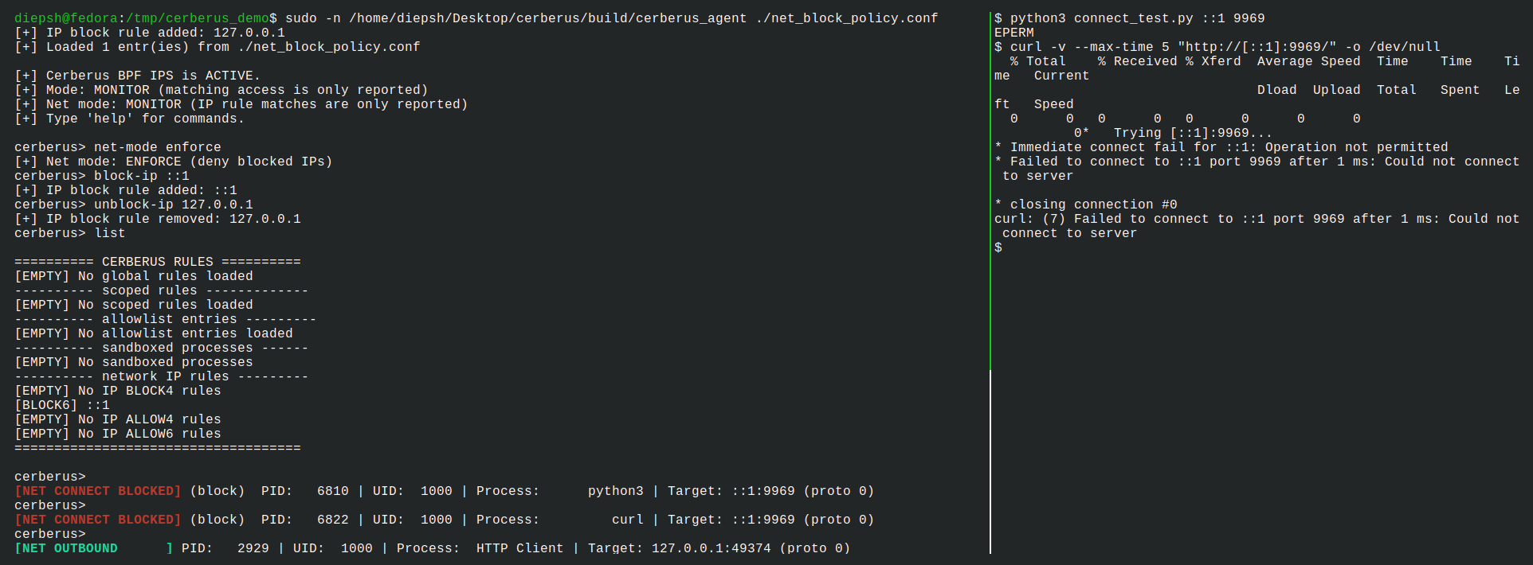
Figure 5.6: IPv6 Network Security Demonstration

6. Software Tools Used in Developing the Project
The development platform is Kali GNU/Linux Rolling 2026.2 (Debian-based; kernel 7.1.5+kali-amd64). The eBPF and BPF LSM components require a Linux kernel with BTF, and the kernel-side component cannot run on other operating systems. Source code is edited in Visual Studio Code.
Tool | Version / package used | Purpose in the project
Kali GNU/Linux | Kali Rolling 2026.2 (kernel 7.1.5+kali-amd64; BTF + BPF LSM) | Host OS; provides kernel BTF (/sys/kernel/btf/vmlinux) and BPF LSM support required to attach the security hook
Visual Studio Code | 1.133.0 | Source editor used for all C / C++ / Makefile / test-script development
Clang / LLVM | 21.1.8 | Compiles the eBPF translation unit to BPF bytecode (clang -target bpf)
GNU G++ | 15.2.0 | Compiles and links the C++ user-space agent to build/cerberus_agent
GNU Make | 4.4.1 | Build automation — Makefile-based four-stage pipeline
bpftool | 7.8.0 (libbpf 1.8) | Dumps BTF to vmlinux.h, generates the BPF skeleton, and verifies loaded programs/LSM hooks
libbpf | 1.8 | User-space eBPF runtime library (skeleton loading, map operations, ring-buffer polling); linked via -lbpf
libelf / zlib | system packages (-lelf -lz) | ELF manipulation and decompression libraries linked with the agent (-lelf -lz) as required by libbpf
Bash | 5.3.9 | Integration test scripts under tests/
Git / GitHub | Git 2.53.0 / GitHub | Version control; feature-branch and pull-request workflow used for team development
To record exact versions on the Kali machine (optional):
uname -r # kernel version (BPF LSM / BTF)
clang --version && g++ --version && bpftool version
git --version && code --version

7. Name of the AI Tool Used in Making This Report
AI Tool | Extent of Use
DeepSeek V4.1 Flash Free (via OpenCode) | Structuring and drafting of this report document, inserting and captioning the captured terminal screenshots, filling the verified tool versions, and formatting the Word file.
No other AI tools were used in the preparation of this report.

8. AI Tools / Libraries / Classes Used in Developing the Project

8.1 AI tool used during development
AI Tool | Nature of Assistance
DeepSeek V4.1 Flash Free (via OpenCode) | AI coding assistant used by the team during development and documentation via OpenCode (design discussion, implementation and debugging of the C/C++ sources, README and report).

8.2 Programming languages
Language | Where Used
C | Entire kernel-side eBPF program (compiled to BPF bytecode)
C++ | Entire user-space agent (loader, policy engine, config parser, CLI, event viewer)
Bash | Integration test scripts (tests/) and build invocation
No Python libraries or Java classes are used in the core implementation: the project logic is written entirely in C and C++, with Bash used only for the integration test scripts and build invocation (Section 8.2).

8.3 C / C++ libraries and kernel interfaces used
Library / Interface | Role in the Project
libbpf (bpf/bpf_helpers.h, bpf/bpf_tracing.h, bpf/bpf_core_read.h; libbpf.h, bpf/bpf.h) | BPF-side helpers (BPF_PROG, core reads, ringbuf) and the user-space runtime: skeleton open/load/attach, bpf_map_update_elem / lookup / delete / get_next_key for all rule maps, ring_buffer__new / ring_buffer__poll for event delivery
BPF skeleton (build/ips_core.skel.h, generated by bpftool) | Auto-generated interface binding the C++ agent to the BPF object and its maps
vmlinux.h (generated from /sys/kernel/btf/vmlinux) | CO-RE kernel type definitions enabling one binary to bind across kernel versions (BTF)
libelf + zlib (linked -lelf -lz) | ELF parsing/dependencies pulled in by libbpf to load the BPF ELF object
C++ standard library (iostream, fstream, sstream, string, cstring, cstdlib, cerrno, iomanip) | Agent logic: CLI, configuration parsing, policy codec, alert formatting
POSIX interfaces (signal.h sigaction, sys/select.h select, unistd.h read) | Signal-safe shutdown and non-blocking command input so the CLI never blocks event polling

9. Team Members' Contribution
The contributions below are summarised from the repository's commit and pull-request history. Commit hashes are included as evidence.

9.1 Ishan S Bhat (25BCE1082)
Contribution:
Repository integration and codebase restructuring. Handled the pull-request merges that brought the initial monitoring/BPF-LSM, dynamic-blocklist, agent-refactor and IP-network-security work onto the main line (merge commits 049b8f2, 408a966, 61e8305, bf6eadb and 7cbf425), along with the feature-branch sync merge 37c2414. Authored commit f698b66 ('refactor: restructure agent and BPF sources'), which reorganised the agent and BPF sources into the current module layout.

9.2 Dipesh Raj S (25BCE1016)
Contribution:
Kernel-side eBPF/BPF LSM implementation and network security. Authored the initial eBPF-only monitoring implementation (540f745), the BPF LSM file-access blocking implementation (a57953c), the project documentation in README.md (1bd5f6c), and the Phase 5 IP-based network security implementation (6da8ffb, a03b22e, 86740ab).

9.3 Badri Narayan Sahu (25BCE1167)
Contribution:
Dynamic blocklist feature. Authored commit 4bc71ab ('feat: add dynamic BPF blocklist') on the feature/dynamic-blocklist branch, which was merged into main through PR #4 (merge commit 61e8305).

