Python NetaCad

Intro to Python

What makes a language?
Ans:
1. an alphabet: a set of symbols used to build words of a certain language

2. a lexis: a set of words the language offers it users (aka a dictionary)

3. a syntax: a set of rules used to determine if a certain string of words forms a valid sentence (e.g., “I am a python” is syntactically correct phrase while “I a python am” isn’t)

4. semantics: a set of rules determining if a certain phrase makes sense (e.g., “I ate a doughnut” makes sense, but “A doughnut ate me” doesn’t)

Compilation: The source program is translated once (however, this act must be repeated each time you modify the source code) by getting a file (e.g., an .exe file if the code is intended to be run under MS windows) containing the machine code. Now you can distribute the file worldwide; the program that performs this translation is called a compiler or translator.

Interpretation: you (or any user of the code) can translate the source program each time it has to be run. The program performing this kind of transformation is called an interpreter, as it interprets the code every time it is intended to be executed. It also means that you cannot just distribute the source code as-is, because the end user also needs the interpreter to execute it.

Due to historical reasons, languages designed to be utilized in the interpretation manner are often called scripting languages, while the source programs encoded using them are called scripts.

What makes Python so special?
Ans:

1. Its easy to learn: The time needed to learn Python is shorter than for many other languages; this means that it’s possible to start the actual programming faster.

2. Its easy to teach: The teaching workload is smaller than that needed by other languages; this means that the teacher can put more emphasis on general (language-independent) programming technique, not wasting energy on exotic tricks, strange exceptions and incomprehensible rules.

3. Its easy to use: It’s easy to use for writing new software – it’s often possible to write code faster when using Python.

4. Its easy to understand: Its also often easier to understand someone else’s code faster if it is written in Python.

5. Its easy to obtain, install and deploy: It is free, open and multi-platform; not all languages can boast that.

An implementation of Python refers to “a program or environment, which provides support for the execution of programs in the Python language, as represented by the Cpython reference implementation.”

How interpreter works?

The machine executes the Python code indirectly by running the Cpython interpreter, which is a C program compiled to machine code. The interpreter reads Python bytecode and performs the actual operations using native instructions that the CPU understands.

Difference between Python Shell and CLI in our OS: Python Shell is a special interactive environment that runs inside the command prompt after you type python. CLI in our OS doesn’t understand python code unlike Python Shell.

IDLE: Its a python program which uses Tkinter (Python’s GUI toolkit). As soon as you open IDLE, it launches Python Shell window. This window is an interactive Python REPL (Read-Eval-Print Loop).

Delimiter in python is a character used to separate data into distinct parts. For e.g., “ or ‘ for strings in python.

A literal is data whose values are determined by the literal itself. You use literals to encode data and put them into your code.

The characteristic of the numeric value which determines its kind, range and application is called type.

Integers are devoid of fractional part.

Boolean values are the result of weighing truthfulness of an expression or setting a variable as True or False.

Difference between print() and input(): The print() function sends data to the console, while the input() function gets data from the console.

The input function comes with an optional parameter: the prompt string.

When the input() function is called, program’s flow is stopped until the user has entered an input and/or pressed the ‘Enter’ key.

Using an input() function without prompt string can give users time to read the instructions and when done, they can press ‘Enter’.

a % b = a – b * (a//b)
a // b = floor(a/b)

Comparison operators: == (assignment operator), =! (not equal to operator), >, >=, <, <=

Conditional Statements (like if….else) are used for controlling flow based on conditions.

Things to know about if...else

- You mustn’t use else without a preceding ‘if’.

- ‘else’ is always the last branch of the cascade, regardless of whether you’ve used ‘elif’ or not.

- ‘else’ is optional part of the cascade, and may be omitted

- If there is an ‘else’ branch in cascade, only one of all the branches is executed.

- If there is no ‘else’ branch, it’s possible that none of the available branches is executed.

Pseudocode: It is a kind of notation which is not an actual programming language (it can neither be compiled or executed), but it is formalized, concise and readable. For example:

# find the largest number from host of user given numbers
largest_number = -999999999
number = int(input())
if number == -1:
print(largest_number)
exit()
if number > largest_number:
largest_number = number
# Go to line 02

Digit separator in python

Code: print(1111, 1_111) → 1111

Dollar and cents printer

Code:
def proper_format(tax):
dollars = int(tax)
cents = round((tax – dollars) * 100)
print(f”{dollars} dollars and {cents:02d} cents”)

# d → means integer (decimal) format
# 2 → means minimum width is 2 digits
# 0 → means pad with leading zeros if it’s less than 2 digits

Computer Logic

Statement: If we have some free time, and the weather is good, we will go for a walk.

We’ve used the conjunction and, which means that going for a walk depends on the simultaneous fulfillment of these two conditions. In the language of logic, such a connection of conditions is called conjunction.

Statement: If you are in the mall or I am in the mall, one of us will buy a gift for Mom.

The appearance of the word or means that the purchase depends on at least one of these conditions. In logic, such a compound is called a disjunction.

It’s clear that Python mush have operators to build conjunctions and disjunctions. Without them, the expressive power of the language would be substantially weakened. They’re called logical operators.

Binary operators: They operate on two operands (that’s what binary means).

The and operator

One logical conjunction operator in Python is the word and. It’s a binary operator with a priority that is lower than the one expressed by the comparison operators.

The or operator

A disjunction operator is word or. It’s a binary operator with a lower priority than and.

The not operators

It’s a unary operator performing a logical negation. It’s operation is simple: it turns truth into falsehood and falsehood into truth.
This operator is written as the word not, and its priority is very high: the same as the unary + and -.

De Morgan’s law:

The negation of a conjunction is the disjunction of the negations.
The negation of a disjunction is the conjunction of the negations.

Code:
not (p and q) == (not p) or (not q)
not (p or q) == (not p) and (not q)

Bitwise operators

There are four operators that allow you to manipulate single bits of data. They are called bitwise operators.

Here are all of them:

- & (ampersand) – bitwise conjunction;

- | (bar) – bitwise disjunction;

- ~ (tilde) – bitwise negation;

- ^ (caret) – bitwise exclusive or (xor).

- << : binary left shift and >> : binary right shift

The arguments of these operators must be integers; we must not use floats here.

Logical operators take their arguments as a whole regardless of how many bits they contain. The operators are aware only of the value: zero (when all the bits are reset) mean False; not zero (when at least one bit is set) mean True.
The difference in the operation of the logical and bit operators is important: the logical operators do not penetrate into the bit level of its argument. They’re only interested in the final integer value.

Example:

bit = i & j

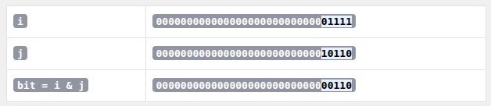
A bitmask allows you to check, set, reset or toggle the bit at a specific position in a binary number without affecting other bits. For example:

flag_register = 0b00001000 # Only bit 3 is 1
the_mask = 0b00001000 # We want to check bit 3

if flag_register & the_mask:
print("Bit 3 is set") # This prints
else:
print("Bit 3 is not set")

Example of bitwise shift:
var = 17
var_right = var >> 1
var_left = var << 2
print(var, var_left, var_right)

Output: 17 68 8

Bitwise negation

- Python uses two’s complement to represent integers.

- Bitwise negation ~n flips all bits.

- That flipping results in a number equal to -n – 1.

Priority table

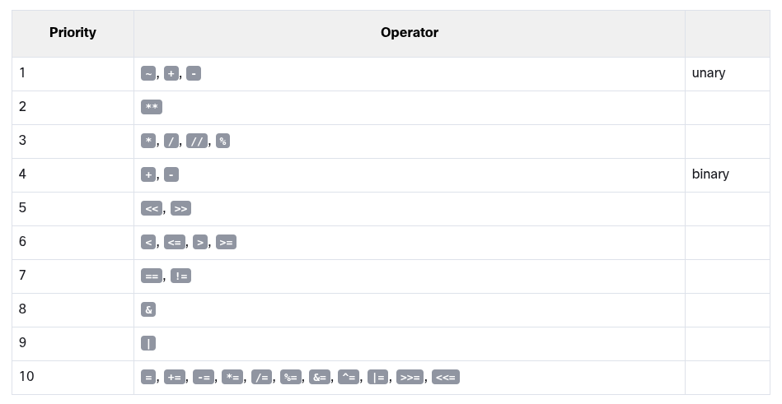
Scalars and Complex Data Types

In Python, there are scalar (primitive) types like int, float, bool, and complex, which represent single, indivisible values.

Then there are complex or structured data types like str, list, tuple and dict, which are composed of multiple elements and can be broken down using indexing or iteration.

‘str’ is special because it’s immutable but it’s iterable. It’s not a scalar because we can break it down into individual characters with indexing. But since its immutable, changing a string inside a function creates a new string unlike other complex data types which are mutable.

Lists

The list is a type of data in Python used to store multiple objects. It is an ordered and mutable collection of comma-separated items between square brackets.

The value inside the brackets which selects one element of the list is called an index, while the operation of selecting an element from the list is known as indexing. Index can be a result of an expression instead of a literal.

Functions vs methods

A method is owned by the data it works for, while a function is owned by the whole code. This also means that invoking a method requires some specification of the data from which the method is invoked.

In general, a typical function invocation may look like this:

result = function(arg)

The function takes an argument, does something, and returns a result.

A typical method invocation usually looks like this: result = data.method(arg). The name of the method is preceded by the name of the data which owns the method. Next, you add a dot, followed by the method name, and a pair of parenthesis enclosing the arguments.
Bubble Sort gets it’s name from how a larger number is pushed back in the list like a bubble in a glass of champagne.

Functions

We need function due to following reasons:

- If a particular fragment of the code begins to appear in more than one place, consider the possibility of isolating it in the form of a function.

- A good, attentive developer divides the code into well-isolated pieces, and encodes each of them in the form of a function. The process is called decomposition.

- Decomposition helps if a piece of code becomes so large that reading and understanding it may cause a problem, consider dividing it into separate, smaller problems, and implement each of them in the form of a separate function.

- If you’re going to divide the work among multiple programmers, decompose the problem to allow the product to be implemented as a set of separately written functions packed together in different modules.

Where do functions come from?

- Built-in functions: Always available without any additional effort on the behalf of the programmers.

- Preinstalled Modules: Available in number of modules, it is very useful but used significantly less. It is installed together with the python and used with some additional steps.

- Directly from your code: You can write your own functions, place them inside your code and use them freely.

- There’s an another way. It’s connected with classes.

What happens when you try to invoke a function before you define it?

An exception is thrown. Namely, the NameError exception.

What will happen when you run the code below?

def hi():
print(‘hi’)
hi(5)

An exception will be thrown ( the TypeError). This means you called the function with the wrong number of arguments.

You can pass information to functions by using parameters.

Parameters vs Arguments

Parameters are placeholders defined in the function definition. Arguments are the actual values passed during the function call.
A function is defined with certain parameters, and certain arguments are provided to the function during invocation (function call).

Parameters exist only inside the functions in which they have been defined, and the only place where the parameters can be defined is a space between a pair of parentheses in the def statement. To assign a value to the parameter, function call is required with corresponding argument.

It’s legal and possible, to have a variable named the same as a function’s parameter. Code:
def message(number):
print(‘Enter a number:’, number)

number = 1234
message(1)
print(number)

Shadowing occurs when a local variable or parameter in a function has the same name as a variable in the outer scope (like global scope). The local one ‘shadows’ (hides) the outer one within the function’s scope.

Positional parameter passing

A technique which assigns the i^{th} (first, second, and so on) argument to the i^{th} (first, second, and so on) function parameter is called positional parameter passing, while the arguments passed in this way are named positional arguments. Positional parameter passing means the order matters. The first argument is assigned to the first parameter, the second to the second, and so on.

Keyword argument passing

Python offers another convention for passing arguments, where the meaning of the argument is dictated by its name, not by its position – it’s called keyword argument passing. Code:

def introduction(first_name, last_name):
print("Hello, my name is", first_name, last_name)

introduction(first_name = "James", last_name = "Bond")
introduction(last_name = "Skywalker", first_name = "Luke")

Parametrized function

It happens at times that a particular parameter’s values are in use more often than others. Such arguments may have their default (predefined) values taken into consideration when their corresponding arguments have been omitted. Code:
def introduction(first_name, last_name="Smith"):
print("Hello, my name is", first_name, last_name)

Danger! It’s important to remember that positional arguments mustn’t follow keyword arguments. Code:

def add(a,b,c,d=4):
print(a+b+c+d)
add(a=1, b=2, 3) # Syntax Error because is 3 for c or d?

Danger! A non-default argument cannot follow a default argument. It leads to SyntaxError.
Code:

def greet(name="Sima", age):
print(f"Hello {name}, you are {age} years old.")

greet(16)

Python sees that name has a default value but age has no default value and comes after name. This is confusing because should 16 go to name or age.

is Operator in Python

The is operator compares the identity of two objects. It checks whether two variables point to the same object in memory. Example:

a = [1, 2, 3]
b = a
c = [1, 2, 3]

print(a is b) # True (same object)
print(a == b) # True (same value)

print(a is c) # False (different object)
print(a == c) # True (same value)

None is a special built-in constant in Python that represents the absence of a value. It is implemented as a singleton object, which means there’s only one instance of None in a Python program. Example:

x = None
print(x is None)

If nothing is returned from a function, None is returned.

If you try to access a variable created inside a function beyond the block of function, NameError occurs.

