Cybersecurity Incident Timeline
Security Awareness & Incident Analysis Report
Prepared by: Dipesh Sapkota
Bootcamp: Upskills Cybersecurity
Course Assignment: Lab 1 – Cybersecurity Incident Timeline
Date: May 2026

Executive Summary
Cybersecurity incidents have continuously shaped the evolution of modern defensive strategies, security frameworks, compliance standards, and incident response methodologies. This report analyzes five historically significant cyberattacks between 1988 and 2020, identifying their attack methods, business impact, failed security controls, and the security improvements that emerged afterward.
The attacks included in this report are:
- Morris Worm (1988)
- ILOVEYOU Worm (2000)
- Target Breach (2013)
- WannaCry Ransomware (2017)
- SolarWinds Supply Chain Attack (2020)
The objective of this project is to understand how cybersecurity failures occur, how attackers exploit weak controls, and how organizations adapt by implementing stronger security practices.

Introduction
Cybersecurity incidents are rarely isolated technical failures. Most successful attacks occur because of weak processes, poor visibility, lack of patching, inadequate monitoring, insecure configurations, or insufficient employee awareness.
By studying major cyberattacks across multiple decades, security professionals can identify recurring patterns and improve defensive strategies. This report presents a timeline-based analysis of five major attacks and explains how each incident influenced modern cybersecurity controls and governance.

Research Table – Major Cybersecurity Attacks
Attack | Year | Attack Type | Real-World Impact | What Failed | Control Introduced
Morris Worm | 1988 | Internet Worm | Infected approximately 6,000 Unix systems, causing major internet slowdowns and operational disruption. Estimated damages ranged from $100,000 to $10 million. | Weak software security, lack of network segmentation, insecure Unix services (sendmail and fingerd). | Led to the creation of the first Computer Emergency Response Team (CERT/CC) and increased focus on secure coding and vulnerability management.
ILOVEYOU | 2000 | Email Worm / Social Engineering Malware | Spread globally within hours and caused an estimated $10 billion in damages by overwriting files and disrupting email systems. | Poor email filtering, lack of user awareness training, unrestricted script execution in email attachments. | Organizations adopted stronger email security controls, attachment filtering, endpoint antivirus protection, and security awareness training.
Target Breach | 2013 | Point-of-Sale (POS) Malware / Credential Theft | 40 million credit card records stolen along with customer personal data. Significant financial losses and reputational damage. | Weak third-party vendor security, insufficient network segmentation, inadequate monitoring of lateral movement. | Accelerated adoption of Zero Trust principles, vendor risk management programs, network segmentation, and EMV chip technology.
WannaCry | 2017 | Ransomware Worm | Affected more than 150 countries, disrupted hospitals, logistics, telecommunications, and government systems. Caused billions in losses. | Failure to patch known vulnerabilities, outdated Windows systems, poor asset management. | Reinforced mandatory patch management programs, vulnerability scanning, backup strategies, and emergency security update procedures.
SolarWinds | 2020 | Supply Chain Attack | More than 18,000 organizations downloaded compromised updates, including U.S. government agencies and major corporations. | Lack of software supply chain validation, excessive trust in vendor updates, insufficient detection capabilities. | Increased focus on Zero Trust Architecture, software supply chain security, code signing validation, and SBOM (Software Bill of Materials) initiatives.

Visual Timeline

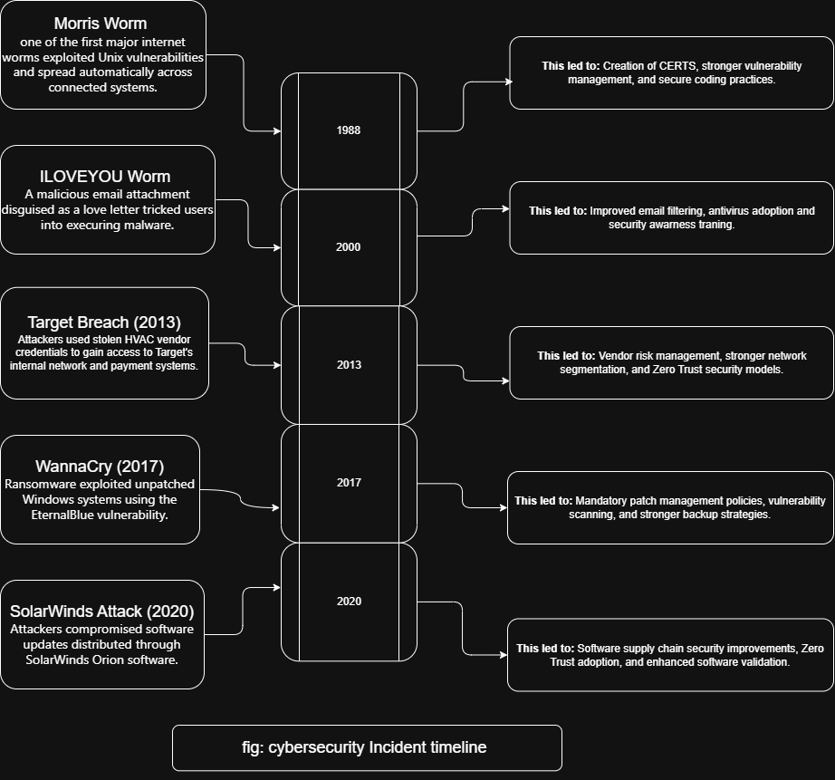

Analysis Questions
Q1: Which two attacks had the most lasting impact on modern security practice? Why?
The two attacks with the most lasting impact on modern cybersecurity practices were the WannaCry ransomware attack and the SolarWinds supply chain attack. Security patches and zero trust models are taken basic and most important security measures as they can escalate in global infrastructure crisis if not taken seriously in present days.

Q2: What common theme do you see across at least three attacks? Which security principle was violated?
A common theme across the Morris Worm, ILOVEYOU, and WannaCry attacks was the rapid self-propagation of malware across connected systems. These attacks spread widely because organizations lacked proper patch management, network segmentation, and security awareness. The security principles violated included defense in depth and availability.

Q3: Target Breach – Which NIST Cybersecurity Framework (CSF) function was most lacking?
The most lacking NIST Cybersecurity Framework function in the Target Breach was Protect. Although the attackers initially entered through stolen third-party vendor credentials, the breach became catastrophic because Target lacked sufficient network segmentation and access controls to protect sensitive payment systems.

Q4: Add One More Attack Not on the List
Equifax Breach (2017)
Attack Type: Web Application Breach / Data Theft
Impact: Personal data of approximately 147 million individuals was exposed, including Social Security numbers and financial information.
What Failed: Failure to patch a known Apache Struts vulnerability, weak vulnerability management, and inadequate asset visibility.
Lesson Learned: Organizations must maintain continuous patch management, accurate asset inventories, and proactive vulnerability monitoring.
Key Lessons Learned
The attacks analyzed in this report reveal several recurring cybersecurity lessons:
Unpatched systems remain one of the most dangerous organizational weaknesses.
Human error and social engineering continue to be highly effective attack vectors.
Third-party vendors can introduce major security risks.
Network segmentation and least privilege are critical for limiting attacker movement.
Continuous monitoring and rapid incident response are essential for minimizing damage.
Modern organizations must adopt proactive security models rather than relying solely on perimeter defenses.
Conclusion
Cybersecurity has evolved significantly over the past several decades, but the core causes of major breaches remain surprisingly consistent. Weak security practices, inadequate monitoring, poor patch management, and excessive trust continue to enable attackers.
Each attack discussed in this report influenced the development of modern cybersecurity controls, frameworks, and operational strategies. By understanding these historical incidents, organizations can better prepare for future threats and strengthen their overall security posture.
The evolution from the Morris Worm to SolarWinds demonstrates that cybersecurity is no longer only a technical issue — it is a business, operational, and national security priority.

References
Fbi.gov
School of International and Public Affairs Case Consortium (SIPA‐21‐0021.1)
CERT Coordination Center (CERT/CC)
National Institute of Standards and Technology (NIST)
Microsoft Security Response Center
CISA (Cybersecurity and Infrastructure Security Agency)
Verizon Data Breach Investigations Report (DBIR)
krebsonsecurity.com
CrowdStrike Threat Intelligence

