[](https://codeavour.org/#)

**AN INTERNATIONAL CODING AND AI COMPETITION FOR KIDS HOSTED BY MOTWANI JADEJA FOUNDATION :**

**Ahmedabad October 10 2022 :** Codeavour 2022 (4th Edition)is the biggest and well recognized Global AI & Coding Competition hosted annually by STEMpedia at an International Level for students of Age Group 7-18 years, where they make innovative projects in PictoBlox for the future. The Event is jointly hosted with Stempedia and ARTWORK.

An opportunity to explore the exciting world of AI, Coding and Robotics with interactive activities and projects and to develop critical thinking, creativity, collaboration, and communication.

**A Global Platform to learn AI and Coding :**

The Ideology behind the name is to motivate kids to show the endeavour to code for the betterment of society. The Event is globally recognized and has 90+ countries and more than 1000 schools participated. This competition will boost and also develop a basic foundation for kids in Python , Java, AI, and other coding ways.

The aim of this international competition for kids is to encourage kids to develop an interest in STEM, especially programming, and to develop critical thinking, creativity, collaboration, and communication – the four C’s of 21st-century skills while also bringing solutions to real-world problems.

In Codeavour 2022, there are more than 60 prizes in total worth $20,000.

**Registration Process :**



**Registrations open on**

10th October 2022.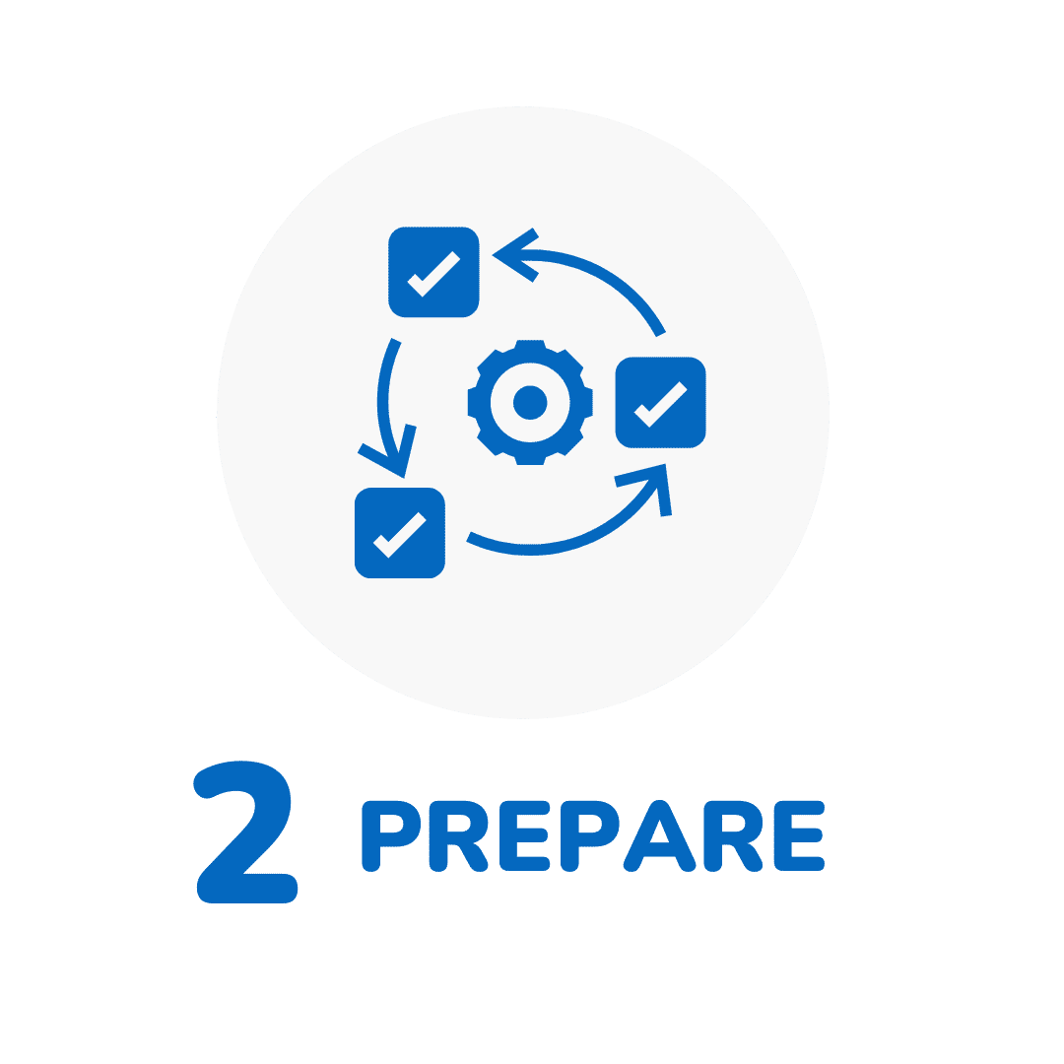

Develop skills with interactive tutorials and AI Bootcamps.



Submit your innovations by 10th January 2023.

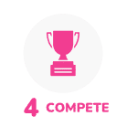

Find out the champions on

**31st January 2023.**

The participation fee for Indian nationals is INR 1000. For those living outside India, the participation fee is USD 15.

It helps kids create stories, animations, games, innovative projects using PictoBlox and AI & Robotics Kits with your creativity and coding skillset. It plays a vital role in shaping the Future Technology and Industrial Development.Thus, Definitely a boon to kids when they learn while growing up.

**About Motwani Jadeja Foundation :**

Our Title sponsor is Jadeja Foundation. Motwani Jadeja Foundation supports a global network of entrepreneurial thinkers, artists, writers and tech innovators driven by the values of individual freedom and excellence.

Asha Jadeja Motwani, Founder of Motwani Foundation as well as Silicon Valley based venture capitalist said ,” From the age of 6, Children must learn to code and must understand what is computation, It's very easy as kids being exposed to smartphones, understand what it means to create an app “ and claims it to be a good news as Children of this generation are exposed to access AI tools.

**About STEMpedia** :

STEMpedia is an education-tech startup in Ahmedabad, India, that creates a platform with tools to simplify learning-by-doing in STEM for children. It is a pioneer in STEM education in India and other developing nations along with providing its products and services in 40+ countries since 2016. It is supported by eminent organisations such as the Motwani Jadeja Foundation, Startup India, Startup Nexus of the American Embassy, CIIE.CO at IIM Ahmedabad, Industries Commissionerate of the Government of Gujarat, techXchange - India UK, PCB Power Market, etc. It has also been a key player in the Atal Tinkering Labs initiative by NITI Aayog. For more information, please visit https://thestempedia.com/

**About ARTPARK :**

AI & Robotics Technology Park (ARTPARK) is an non profit foundation established by the Indian Institute of Science (IISc), Bengaluru with support from the AI Foundry in a public-private collaborative model, to promote technology innovations in AI (Artificial Intelligence) & Robotics. With seed funding of INR 170 Cr ($22Mn) from the Department of Science & Technology (DST), Govt. of India, under the National Mission on Interdisciplinary Cyber-Physical Systems (NM-ICPS), the ecosystem is designed to bring about a collaborative consortium of partners from industry, academia, and government bodies. These innovations will be channelized to create a societal impact by executing ambitious mission-mode R&D projects in healthcare, education, mobility, infrastructure, agriculture, retail, and cybersecurity that focus on problems unique to India.

**NITI Aayog :**

NITI Aayog ,the apex public policy think tank of the Government of India, and the nodal agency tasked with catalysing economic development, and fostering cooperative federalism through the involvement of State Governments of India in the economic policy-making process using a bottom-up approach uniquely focuses on thematic policy interventions that encourage convergence across Central Ministries, State Governments, development partners, sectoral experts and professionals.

This approach to governance is applied to achieve the objectives:

To design strategic and long-term policy and programme frameworks and initiatives, and monitor their progress and their efficacy. The lessons learnt through monitoring and feedback will be used for making innovative improvements, including necessary mid-course corrections.

To provide advice and encourage partnerships between key stakeholders and national and international like-minded think tanks, as well as educational and policy research institutions.

To create a knowledge, innovation and entrepreneurial support system through a collaborative community of national and international experts, practitioners and other partners.

To offer a platform for the resolution of inter-sectoral and inter-departmental issues to accelerate the implementation of the development agenda.

**To register for events and collaboration ,visit us at** <https://codeavour.org/>