**Script 1- Students Perspective**

1. Are you a B. Com graduate struggling to attain your dream job? Time for some new change!
2. Upskill and upgrade your accounting and taxation, with the DAT/CPAT program, which is a gateway to a successful career in finance. From basics of accounting to advanced taxation strategies, making you industry-ready.
3. DAT/CPAT focuses on practical training where you will learn directly from industry experts who bring real-world experience into the classroom.
4. And the best part! A supportive community gives access to resources that help you succeed every step of the way.
5. Certification from the CPAT program opens doors to countless opportunities in accounting firms, taxation, and beyond. It’s a solid one-year course.
6. So, why wait? Enroll with a simple admission process and graduate with the career of your dreams!
7. [Contact details]
8. The most reliable and concrete way to grow your professional career- Job opportunities ahead of you!

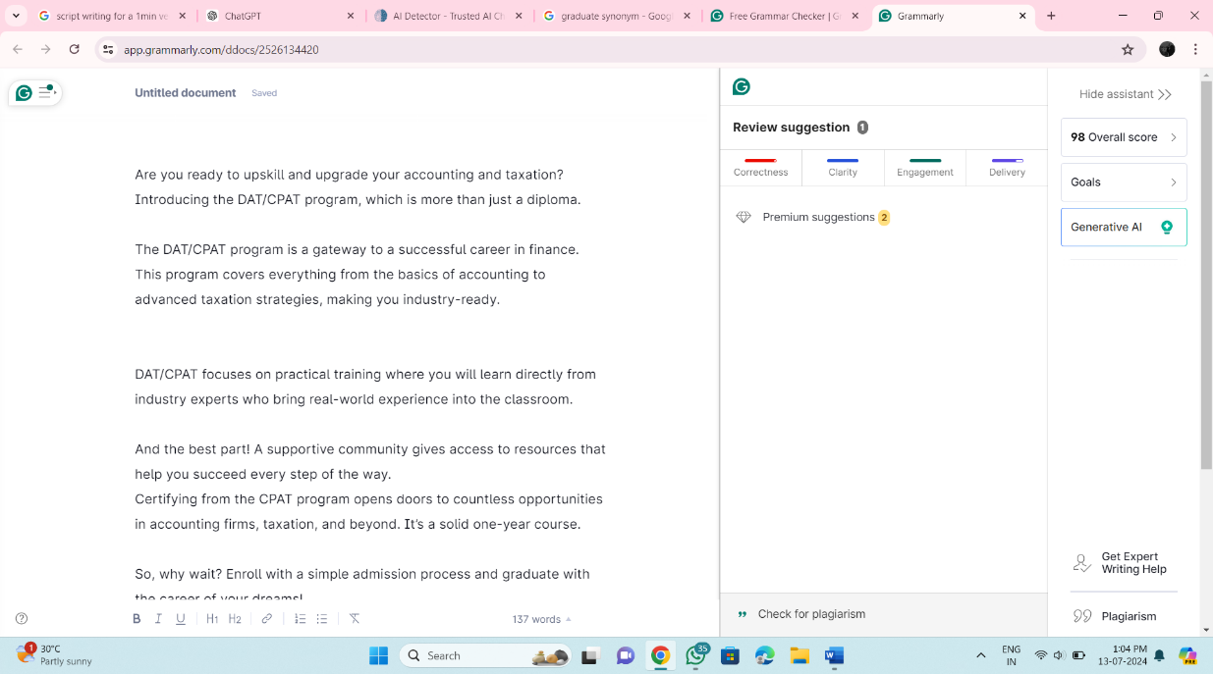

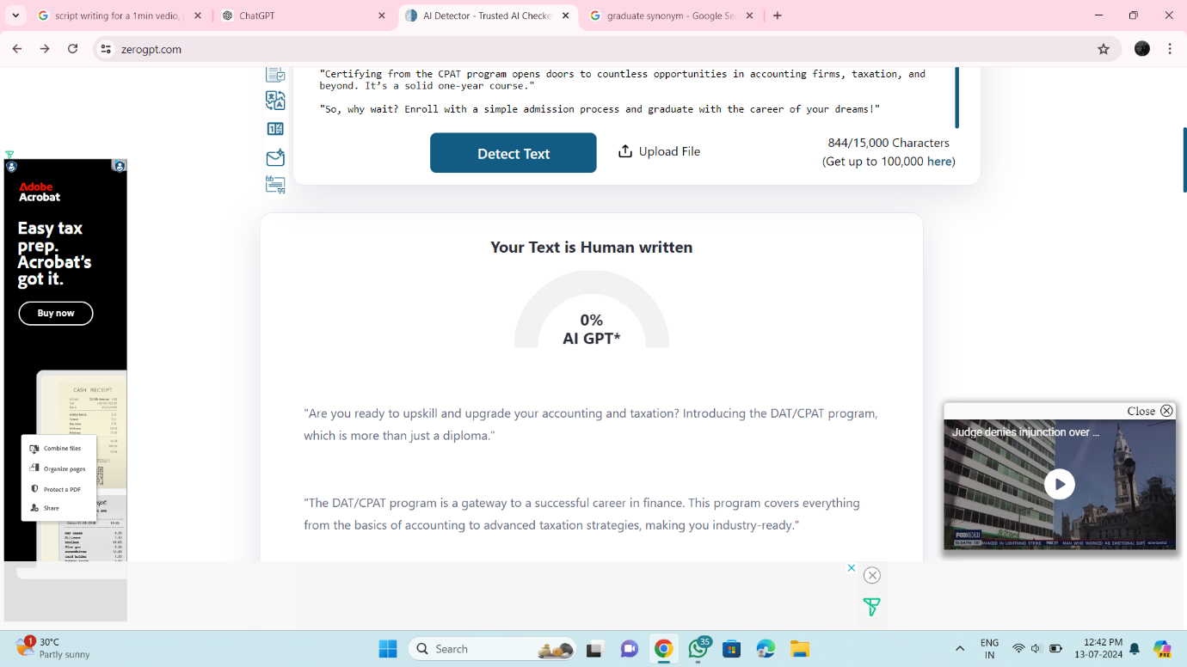

**Script 2- Parent’s Perspective**

1. "Hum maa baap apne bacchon ke liye best chahte hain. We all want them to grow better with their education. Aapke bacchon ke liye hum laye hain DAT/CPAT 1-year program."
2. "DAT/CPAT program students ko upskill karta hai jisse wo accounting aur advanced taxation seekhein, aur tayyar rahein industry mein pehle din se."
3. "Is program ki khaas baat kya hai? Yahi ki students practical training par focus kar sakein. DAT/CPAT program bachon ko industry experts se padhata hai."
4. "Aur saath hi, yeh program students ko tayyar karta hai, unki kamiyabi ke har kadam par."
5. "Accounts aur tax field mein yeh students ko countless job opportunities deta hai unke future ke liye, taake wo safalta ki unchaiyan chhoo saken."
6. "Toh der kis baat ki? Aaj hi apne bacchon ka admission karaiye, aur unhe success ki udaan bharte dekhiye."
7. [contact details]
8. "The most reliable and concrete way to grow your professional career."

