**A CEO’s Guide To Balancing Risks and Opportunities Through Right Decision-Making**

After spending a fairly long time in the industry, I think it’s pretty safe to say that I might have learned a thing or two about what matters the most for an organization to succeed.

I learned the greatest business lessons, the day I realized that my duties go beyond being a leader. And here I am, to share with you what no prestigious degree would teach.

So, let’s start. Shall we?

Hear me out - “Strategic decision-making is the way to go!”. Yes, my dear readers. Nothing helps more than making the right decisions at the right time. It is your one-way ticket to achieving that perfect balance between risks and opportunities.

Let us now dive into the micros of this very topic.

* **Develop a Risk-Aware Team**

This is called starting from the base. The more you train your team to understand risks, the better the outcome. Start by having open conversations and gradually move towards professional training. Trust me, works like magic!

* **Focus on Data Trends**

Knowing what your target audience wants is the key to making important decisions. And what better way to identify their needs other than data-driven insights? Use the available data analytics to interpret purchase patterns, ongoing trends, and much more.

* **Foresee Risks and Opportunities**

While this might not seem possible, you can go a long way by studying the market properly. Equip yourself and your team with the right skills to understand the forthcoming risks and opportunities. Build your strategy based on this very understanding to create the best outcome.

* **Ace Your Impact Effort Matrix**

Get a detailed understanding of the following 4 points:

1. Quick Wins
2. Big Bets
3. Money Pits
4. Fill-Ins

Once you understand these 4 in detail, you will be able to create the right balance in the organization. It helps align both short and long-term organizational objectives paving the way to sustainable growth.

* **Be Appropriately Flexible**

Gone are the days when companies where companies were run on rigid and immovable strategies. In the current world, being agile is crucial. Be open and leave space for modifications in the plan along the way. It ensures inclusivity and long-term benefits. Additionally, it helps you expand your target market as well!

* **Consistent Learning**

The world is moving faster than ever. And when the world moves, you move. Every day there is some innovation and something new to learn. Make sure to never miss out on any learning as you never know what might lead you to the best decision ever.

* **Collaborate, Brainstorm, Decide!**

Last but not least, do not ignore the team. Make space for the team to have a say in the decision-making process of the company. A team that speaks, is a team that works. Their opinions need to be considered, evaluated, and included depending on the objectives of the company.

That brings me to the conclusion of my blog. These few points have been my driving forces for years and the results are pretty evident. Use the comment box to share your thoughts on these. Eagerly waiting for your views to have a healthy discussion.

**AI Detector Report**

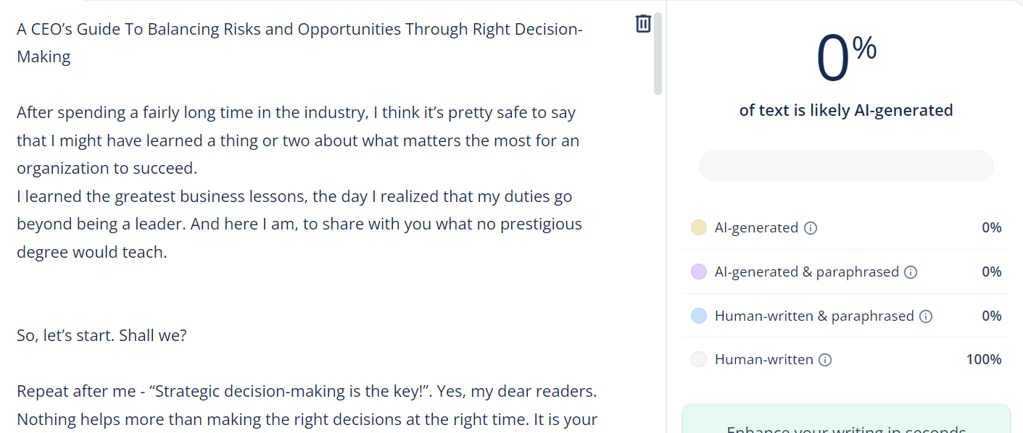

**Plagiarism Report**

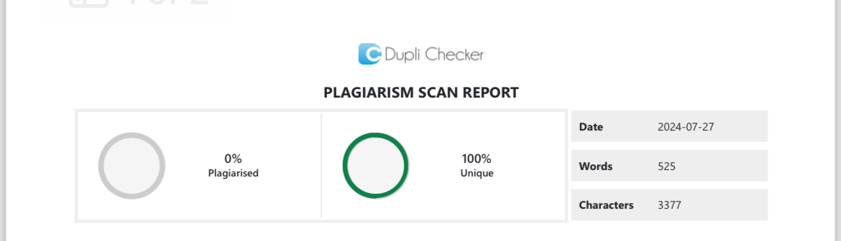

**Grammarly Report**

