1. **How Virtual Staffing Can Provide Cost-Effective and Flexible Solutions for Growing Businesses**

Are you someone who believes in remote work, and virtual staffing or do you belong to the Dinosaur era?😐

Don’t get us wrong. You can obviously have your view and strategies to grow your business. But, the #growth would be missing in 2024. Let us tell you why.

As a growing business, managing costs and maintaining flexibility are absolute mandates for success. Most importantly, why will you bother yourself with a costly, time-consuming recruitment process?

And, don’t even make us start on the fact of the costly office space, high electric bill and travel burden. 😤If only one thing we were happy about being positive in the #COVID-era was this new-norm office trend. Now we have a solution that can help to achieve greater business success. We guess, you already know this.

VIRTUAL STAFFING.🎉🎉🎉

Yes, obviously you know it as a #remote setting. But, what’s the harm of being fancy? By embracing this model, you can actually hundreds of employees and guide them at the corner of your home. Being a manager, you won’t have to walk down to the single desk of your employees to check if they are working. You will connect them with a project management tool. And Viola!.

Anyway, the best part about virtual staffing is cost-effectiveness. When you hire a virtual assistant, you only pay for the specific services you require. So, say bye-bye to eliminating the office space rent, and repairment charge for broken AC and coffee machine

What does it mean? It means now for your business you have a lot more #budget. Additionally, virtual staffing offers flexibility and scalability. Can we please take a moment to acknowledge how hard you are working for your business? If this is so, don’t live in 1999 anymore!

We don’t want to bluff. But we are trendy. That is why we started virtual staffing with @Allshore Technology Pvt Ltd a long time ago. The relief and satisfaction we got is incomparable. So, when your company will start virtual staffing?

1. **Remote Work Trends in 2024**

Here is a bummer for people who believe that on-site work is the only possibility in the near future.

* 32.6 billion U.S. citizens will move to fully-remote work
* 1 out of 2 people wants to work remotely at their work tenure.

As we step into 2024, the opportunities for remote work continue to evolve. At @Allshore Technology, we believe that growth comes with changes. If #Gen-Z is our future and this is what they need, we are willing to give that.

Of course, it is not always possible for companies to arrange complete remote settings for their employees. But along with remote, the hybrid work model is becoming the preferred choice for many organizations. Many employees desire a balance between in-office and remote work.

The best part of working in a remote setting is prioritizing the #mentalhealth and well-being of their employees. Because it is not about providing gym membership or reimbursement charges for therapy sessions. It is also creating a safe and trusted place for working. Flexible working hours and wellness programs are now standard practices.

And, tell us why we will not go for something more convenient. Advanced remote access software tools are there to track productivity and progress. Even, many organizations with full-time onsite roles use this software to keep track.

As we embrace these trends, it’s clear that flexibility is no longer just a perk. So # HR can stop quoting this at their JD. It’s a necessity. Organizations that adapt to these changes will not only attract top talent but also foster a culture of engagement and productivity.

At Allshore Technology, we're committed to helping businesses navigate this evolving landscape. By spreading our wings at virtual staffing and technology solutions, we are ready to thrive in the remote work era.

Let’s embrace the future of work together!

1. **Predictions and insights into how IT outsourcing is evolving and the role Allshore plays in this landscape.**

You say, ‘Trendy’

We say, “Allshore”.😝

Sounds a little cliché? Nyahh, we can never be!

Why? Well, let this blog answer it for you. Because, when you will know about the evolving trends in 2024 and our role in that, we promise we can make you wow!

The numbers you are going to see are massive. So, tighten your seatbelts.

* The global IT outsourcing market is projected to reach approximately $512.6 billion in 2024.
* By 2028, it will grow by $777.8 billion.
* Approximately 65% of companies in the U.S. are already outsourcing services to other countries, with a compound annual growth rate (CAGR) of 8.0% expected from 2023 to 2030.
* 93% of organizations are expected to prioritize cybersecurity measures in their outsourcing strategies.

Now, you will be saying, Ok, understood. These are some BIGGGGG numbers. But so what?

Let us tell them what this number signifies:

1. This number signifies that your next potential client could be from the U.S. and they are expecting you to grow in the same business.
2. Your next business should stretch to evolve in IT Outsourcing, as this will be the future.
3. People are investing in cybersecurity, which means, those stats, my friend, are real.

Did we already convince you how trendy are about our data analytics? No?? Don’t worry. Here is something, which will do that for you.

At Allshore Technology, we are smartly positioned to navigate these trends. To build rapport, we support businesses in their outsourcing journeys. Our commitment is simple. Quality, quality and quality.

And, we can’t enough thank our #dataengieers and the entire #team for their dedication towards our precious clients.

As the IT outsourcing landscape continues to evolve, Allshore Technology remains dedicated to providing innovative, cost-effective, and flexible solutions that drive growth and success.

Are you impressed? ‘Cause we are!😍

Comment us below what’s your take on the above numbers?

1. **Tips and strategies for getting the most out of a remote team**

Are you tired of managing your remote team?

Or you are someone who is not sure to start the remote culture because it can all go down?

Well, let us assure you there are actually some ways to make you worry-free. Wanna know that?

We are going to share some “realities tips and tricks” for managing a remote team and getting 110% results back.

And #employees, we can assure you, we are not promoting #micromanagement or #toxic work culture.

A pinky promise from @ Allshore Technology Pvt. Ltd.

* **No hush-hush, please**

Do you think it would be best if you smartly hide the newly signed contract news

or a bad client review? Because it can break the workflow. Well, we don’t want to make a face. But this is not going to work.

Along with project goals, deadlines, and individual responsibilities, you also need to come up with transparency. Because being a manager or #teamleader you are fearing of not giving 100%. They fear that they are missing out on important details.

* **Call or Chat, just do it!**

No one can beat an effective communication. And, no. A skill-training program won’t work if you deliberately don’t establish over the team. Aim for a mix of formal and informal communication to foster relationships. It doesn’t have to be a 1-hour long meeting.

Maybe just a 15-minute brainstorming session? Also, be consistent in scheduling team meetings and one-on-one sessions. It can boost connectivity and collaboration.

* **Results>>>Hours**

Are you wondering if your remote employees are tagging the ACTUAL 9 hours or not? Well, we beg you to stop doing that. Tell me one thing, if you are not paying them hourly, then why are you even worried about working hours?

You need to start appraising an employee if they can do work within 5 hours instead of 7. ‘Cause at the end of the day., you want results and you are paying them for that.

Lastly, we want to tell you, that there are no magic tips that will help you in managing YOUR team. You can!

Tell us, what’s your superpower in managing your team? Comment below and share your story.

1. **Navigating cultural differences in a global workforce**

Okay, Connections, in this blog please don’t rush, it won’t be that long!) we want you to ask something. Please be honest.

*How is global culture celebrated in your organisation?*

Sounds difficult?

Pause then!

Let us give you a little context behind our question.

Since It-firms around the world dive into bigger collaboration and remote work structure. It is highly important to celebrate and acknowledge cultural differences in a global workplace. Stereotypical jokes about culture are no longer a joke! It is an offence. We repeat it.

For instance, a recent survey indicated that 89% of white-collar workers engage in global virtual teams. It highlights the importance of effective cross-cultural collaboration in 2024.

Here is a listicle of whys:

* Different cultures emphasize collectivism and may prefer collaborative decision-making, while others may favour a more hierarchical approach.
* Work-life balance expectations can differ significantly across cultures. Some cultures prioritize long working hours, while others value personal time.
* Research shows that teams with higher contextual diversity. Because this diversity is related to perspectives and experiences. And it directly tends to produce more creative and innovative solutions.

(Gee! Have you seen @META’s advertisement?)

* Recognizing and celebrating cultural differences can enhance team cohesion. Different employees have various cultural traditions, food, and practices.
* Since different employees work in different time zones and from different countries, it is important to celebrate cultural festivals and observances that your team members might find important. This can involve giving workers time off for significant religious or cultural holidays.

So, now you hopefully can figure out the importance of navigating cultural differences.

Handling cultural variations in a worldwide workforce is obviously challenging. But it also gives a chance for development and creativity. Accepting cultural diversity helps businesses succeed in a linked global economy. The browny points are improving employee satisfaction. At Allshore Technology, we're dedicated to creating a welcoming environment. So, tell us now,

*How is global culture celebrated in your organisation?*

**Grammarly (non-premium) report:**

1. 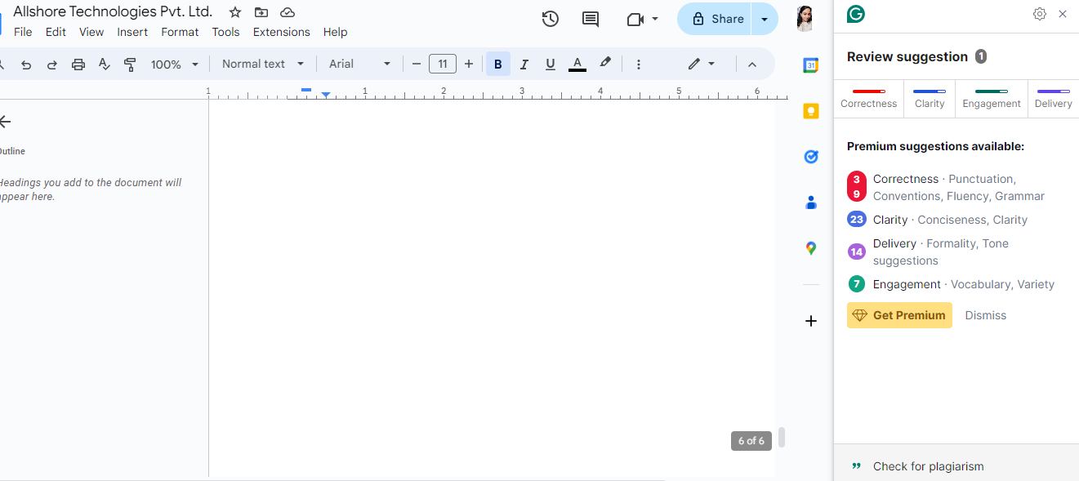

**AI report:**

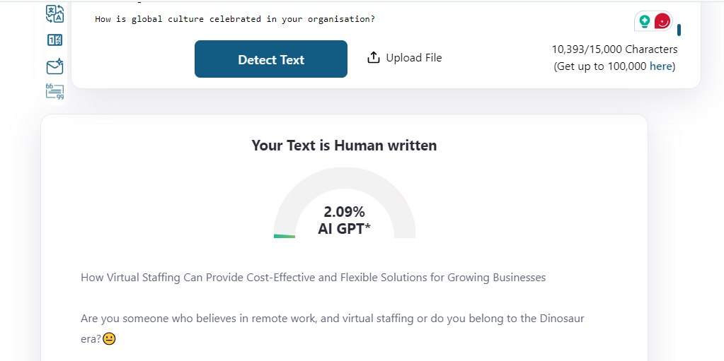

**Plagiarism report:**

