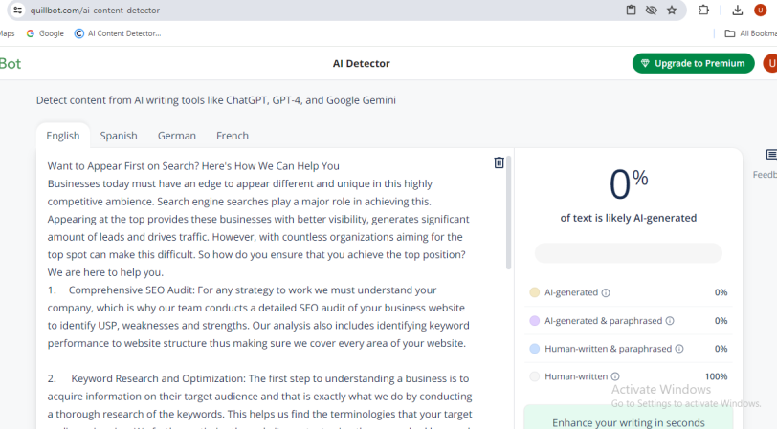

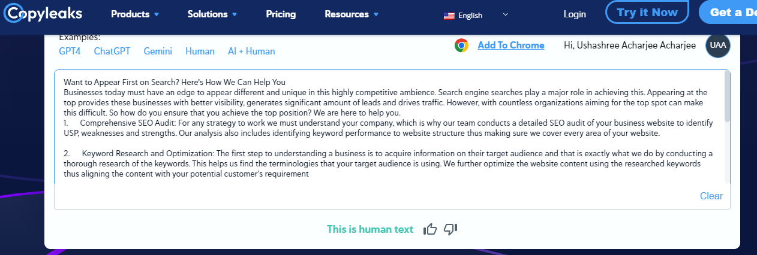

**Want to Appear First on Search? Here's How We Can Help You**

Businesses today must have an edge to appear different and unique in this highly competitive ambience. Search engine searches play a major role in achieving this. Appearing at the top provides these businesses with better visibility, generates significant amount of leads and drives traffic. However, with countless organizations aiming for the top spot can make this difficult. So how do you ensure that you achieve the top position? We are here to help you.

1. **Comprehensive SEO Audit:** For any strategy to work we must understand your company, which is why our team conducts a detailed SEO audit of your business website to identify USP, weaknesses and strengths. Our analysis also includes identifying keyword performance to website structure thus making sure we cover every area of your website.
2. **Keyword Research and Optimization:** The first step to understanding a business is to acquire information on their target audience and that is exactly what we do by conducting a thorough research of the keywords. This helps us find the terminologies that your target audience is using. We further optimize the website content using the researched keywords thus aligning the content with your potential customer’s requirement
3. **Top Quality Content Creation**: In the world of SEO content prioritizing content is the best strategy for a business. We help organizations by producing high-quality, relevant, keyword rich, and engaging content with the help of our team of expert writers. This not only appeals to your audience but also caters to the search engine algorithms.
4. **On-Page and Technical SEO:** Achieve the top position on search engines consist of a number of factors. Therefore, in addition to all the areas of the website we also optimize site speed, meta tags and other on-page elements. Technical SEO improvements provided by us ensure the site is indexable and crawlable.
5. **Link Building:** For SEO to work optimally it is crucial to have high-quality backlinks. We help you by implementing them with strategic campaigning of link-building. This enhances the site’s trustworthiness and authority which drastically improves the ranking of the site.

With all the above strategies in place, you can be sure that your website and business goals are met seamlessly. Get in touch with us today and get to know the tailored SEO assistance that we can offer based on your website.

#SEO #DigitalMarketing #SearchEngineOptimization #OnlineVisibility #ContentMarketing #LinkBuilding