

WELCOME TO YOUR PATH OF SUCCESS

**Guiding you towards the path of success**

Projects are tracked, measured, assessed and issues are communicated and analyzed and critical issues are populated.

Contact Us > Get Started >

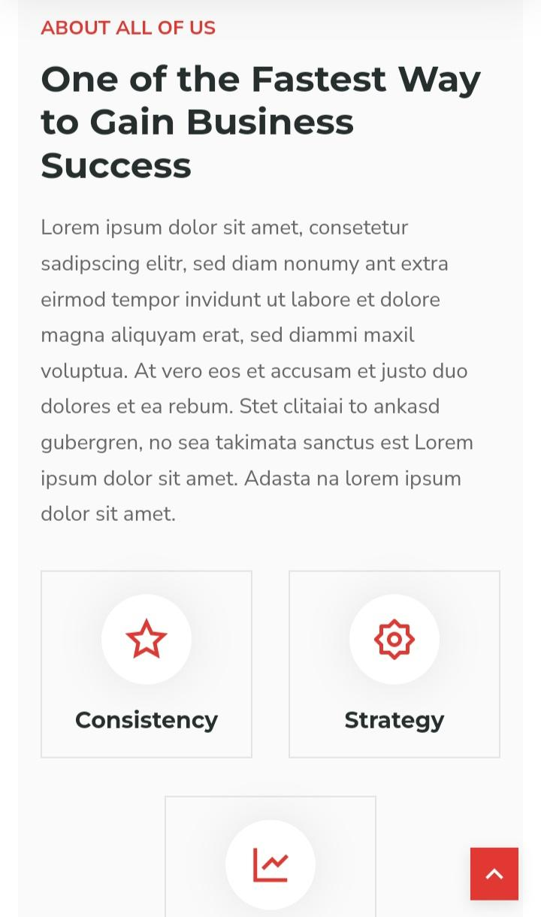

About Us

**Investment Consulting Made Easy**

"Build strategies and encourage success" is our motto. If these words resonate with you and you're visiting this site, you've arrived at the right place. We provide wealth and asset management services specifically to assist people and portfolios with fund assets, wealth assets, industry and capital allocation, advisories, analytics and monitoring, strategic investment, and various other tracks of consulting.

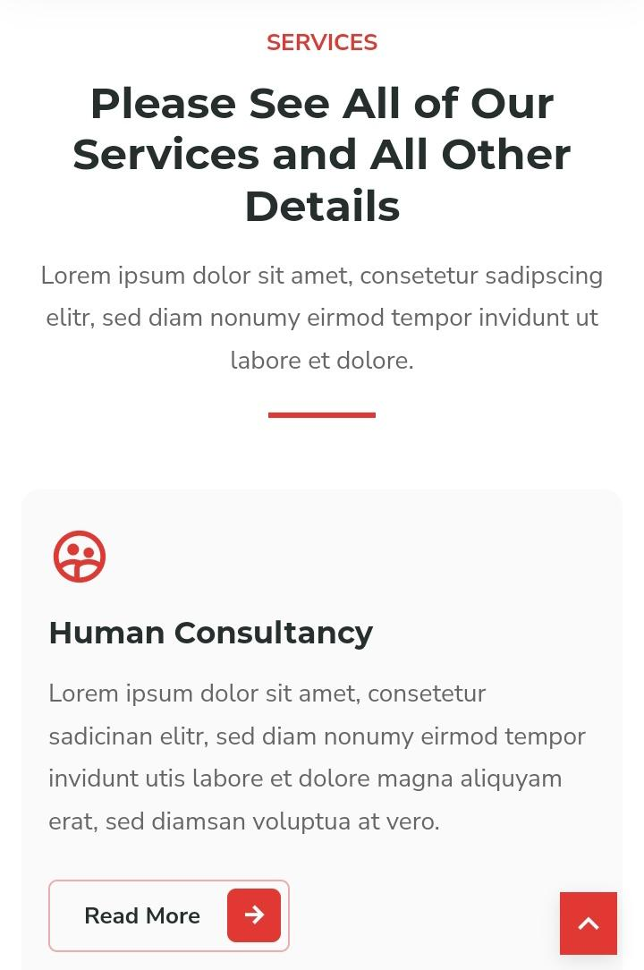

OUR SERVICES

**Exceptional Advisory Solutions**

Watch the journey of promise and success, as your dreams are supplemented with our support.

**Private Client Investment Management**

A team of experts providing investment management regarding personalized investment advisory and wealth management services to individuals or families.

**Institutional Investment Consulting**

A team of experts providing advice to institutional investors, foundations, insurance companies, and businesses to help make the right decisions, build strategies, and manage significant pools of wealth.

**Retirement Plan Consulting**

This plan helps individuals to help them manage, design, and implement the effect of retirement benefit programs to meet the financial needs of the client.



TEAM

**Meet Our Exclusive Anandam Team Members For Your Journey**



JOYFUL INSIGHT

**Connect with these tantalizing tidbits: let’s get to know us better.**



TESTIMONIALS

**Find Out What Ananda's Clients Have To Say**

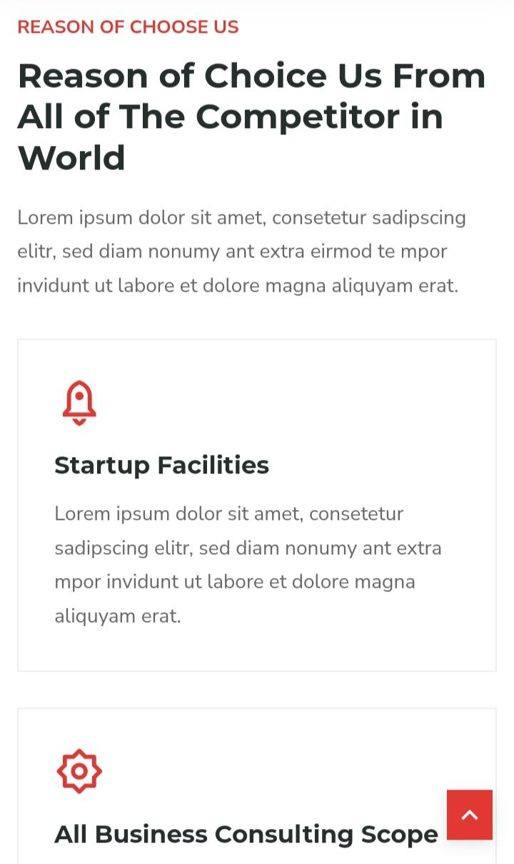

WHY CHOOSE US

**Reasons Why You Should Choose Anandam Over Global Competitors**

At Anandam, find a peace and joy that is unrivaled. We are relentlessly dedicated to providing an oasis of comfort and happiness.

**Extensive Knowledge**

Experience and expert knowledge allow us to know everything.

**Team Approach**

We approach your long-term goals as a team.

**Risk Management**

Risks are a part of your life, but we’re a little smarter about how to do it for you.

**Advanced Tech**

New integrations and faster ways make your experience easier.

**Customized Advice**

A tailored experience for your unique plans and resources.

**Time Savings**

Faster, quicker, and better services.

**Technology & Life Sciences**

An Intersection of Technology and Life Sciences to make the world a better place to live in by the advancements of technology in medicine, Biochemical, and biotechnological research.

**Banking & Financial**

The lifeline of a country’s economy plays a pivotal role in the flow of money, capital, and funds. Finance is a matter that includes the allocation of money and major public finance dealings circulate throughout the monetary plan.

**Commercial Real Estate**

Investment advise to rental properties, commercial complexes, housing finance, and plans to all beneficiaries about different schemes regarding multi-rental home finance.

**Manufacturing**

It is a dynamic and evolving sector that is in a state of constant change. It affects manufacturer investments, loans, and advice to lay out long-term strategies for plans.



OUR BLOGS

**Connect with Our Anandam Insights**



