**Dipesh Pokharel**

**STD ID: 4539161**

**CLASS WORK**

**Inheritance**

**package** week6;

//Inheritance Example

**class** employee{ //parent class

**int** salary= 50000;

}

**public** **class** Week6 **extends** employee { //subclass

**public** **static** **void** main(String[] args) {

Week6 z= **new** Week6();

System.***out***.println("The employye slary is: "+ z.salary);

}

}

**INHERITANCE EXAMPLE**

**package** week6;

**class** sportvehicle{

String manufacturer;

}

**class** SUV **extends** sportvehicle{

**int** passengercapacity;

}

**class** sedan **extends** sportvehicle{

String model;

}

**public** **class** vehicle {

//NAme: Dipesh Pokharel

//STD ID: 4539161

// INstructor: SUMITHRA

//Inheritance Example

**public** **static** **void** main(String[] args) {

SUV z= **new** SUV();

z.manufacturer = "Toyota";

z.passengercapacity= 6; //it can accesss both class cause of extend keyword

System.***out***.println("<SUV DETAILS>");

System.***out***.println("--------------");

System.***out***.println("manufacturer informartion: " +z.manufacturer);

System.***out***.println("Capacity= "+ z.passengercapacity);

sedan a= **new** sedan();

a.model= "BMW 7";

a.manufacturer="BMW";

z.passengercapacity=5;

System.***out***.println("<Sedan DETAILS>");

System.***out***.println("--------------");

System.***out***.println("model informartion: " +a.model);

System.***out***.println("Manufacturer= "+ a.manufacturer);

System.***out***.println("Capacity= "+ z.passengercapacity);

}

}

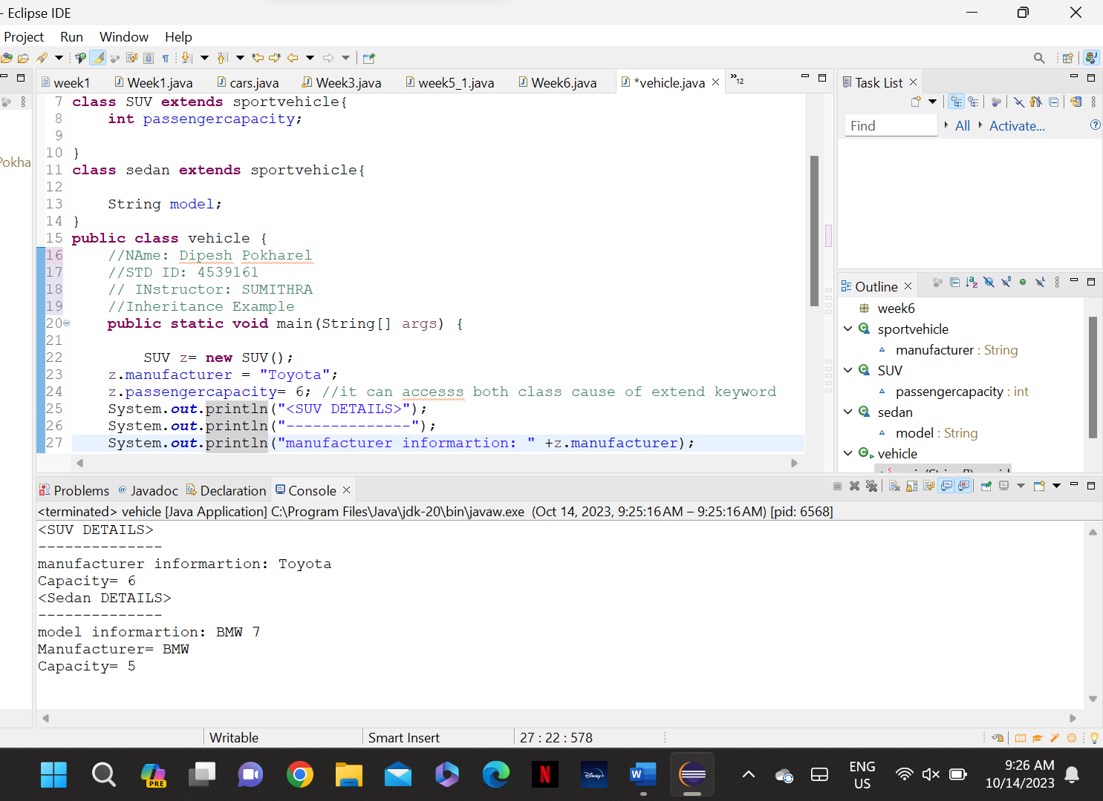

**CONSTRUCTOR**

**package** week6;

//NAme: Dipesh Pokharel

//STD ID: 4539161

// INstructor: SUMITHRA

//Inheritance Example

**public** **class** Constrictor {

Constrictor()

{

System.***out***.println("Example for Constructor (not constrictor).");

}

**public** **static** **void** main(String[] args) {

Constrictor z = **new** Constrictor();

}

}

**package** week6;

//NAme: Dipesh Pokharel

//STD ID: 4539161

// INstructor: SUMITHRA

//Inheritance Example

**public** **class** Constrictor {

Constrictor()

{

System.***out***.println("Example for Constructor (not constrictor).");

}

Constrictor(**int** a, String b)

{

System.***out***.println("Age is: "+a);

System.***out***.println("Name is: "+b);

}

**public** **static** **void** main(String[] args) {

Constrictor z = **new** Constrictor();

Constrictor r = **new** Constrictor(20, "dipesh");

}

}

**Diff ways of assigning**

**package** week6;

//NAme: Dipesh Pokharel

//STD ID: 4539161

// INstructor: SUMITHRA

//Inheritance Example

**public** **class** Constrictor {

String Subject;

**int** fee;

Constrictor()

{

System.***out***.println("Example for Constructor (not constrictor).");

}

Constrictor(**int** a, String b)

{

System.***out***.println("Age is: "+a);

System.***out***.println("Name is: "+b);

}

Constrictor(String Course)

{

Subject=Course;

}

Constrictor(**int** cost)

{

**this**.fee=cost; //we can also assign directly

}

**public** **static** **void** main(String[] args) {

Constrictor z = **new** Constrictor();

Constrictor r = **new** Constrictor(20, "dipesh");

Constrictor s= **new** Constrictor("JAVA");

System.***out***.println("Subject is : "+s.Subject);

Constrictor p= **new** Constrictor(2333);

System.***out***.println("fee is : "+p.fee);

}

}

