DATA SCIENCE WITH PYTHON
PROJECT REPORT | January – April 2026

NETFLIX TITLES DATASET
Exploratory Data Analysis Using NumPy, Pandas & Matplotlib

Submitted by – DIPESH CHOUDHARY
Registration No. 12508243
Programme & Section – B. Tech CSE (224YM)
Course Code – INT375
Under the Guidance of Dr. Baljinder Kaur
Discipline of CSE/IT | Lovely Professional University, Phagwara
April 2026

CERTIFICATE

This is to certify that DIPESH CHOUDHARY, bearing Registration No. 12508243, has satisfactorily completed the INT375 (Data Science with Python) project titled "Netflix Titles Dataset – Exploratory Data Analysis Using NumPy, Pandas & Matplotlib" under my guidance and supervision at Lovely Professional University, Phagwara, Punjab.

To the best of my knowledge, the present work is the result of the student's original research and analytical effort. No part of this project has been submitted elsewhere for the award of any degree or examination.

The project demonstrates a thorough understanding and practical application of Python libraries including NumPy, Pandas, Matplotlib, and Seaborn for data analysis and visualization, applied to a real-world content dataset from Netflix.

Dr. Baljinder Kaur
Designation: Assistant Professor
School of Computer Science Engineering
Lovely Professional University, Phagwara, Punjab

Date: ____________________

DECLARATION

I, DIPESH CHOUDHARY, student of Bachelor of Technology (CSE/IT Discipline) at Lovely Professional University, Punjab, hereby declare that all the information furnished in this project report is based on my own original work and is genuine.

This project titled "Netflix Titles Dataset – Exploratory Data Analysis Using NumPy, Pandas & Matplotlib" has been carried out by me under the supervision of Dr. Baljinder Kaur. I declare that the content of this report has not been submitted as part of any other degree or diploma programme in this university or any other institution.

All data used in this project is publicly available on Kaggle. All code, analysis, and visualizations presented in this report are my own original work produced using Python 3.x and its associated open-source libraries.

Date: 21/04/2026
Registration No. 12508243
DIPESH CHOUDHARY

ACKNOWLEDGEMENT

I would like to express my deepest gratitude to Dr. Baljinder Kaur for her invaluable guidance, insightful feedback, and constant encouragement throughout the development of my INT375 project, Netflix Titles Dataset – Exploratory Data Analysis Using NumPy, Pandas & Matplotlib. Her expertise and mentorship were instrumental in shaping both the direction and quality of this work.

I am also profoundly thankful to Lovely Professional University for providing the necessary resources, computing facilities, and a supportive academic environment that enabled me to carry out this project successfully. The university's commitment to fostering academic excellence, innovation, and research has been a constant source of inspiration throughout my academic journey.

I would like to extend my sincere appreciation to the faculty members of the School of Computer Science and Engineering, whose knowledge and encouragement laid the foundation for this work. Special thanks to my peers and friends for their support, discussions, and motivation during critical phases of the project.

I also acknowledge Kaggle and the dataset contributors for making the Netflix Titles Dataset publicly available, which made this rich analytical project possible.

Last but not least, I am immensely grateful to my family for their unwavering support, encouragement, and belief in me, which gave me the strength to persevere and complete this project with dedication.

DIPESH CHOUDHARY
B.Tech (CSE/IT), Reg. No. 12508243
Lovely Professional University

TABLE OF CONTENTS

Chapter 1: Introduction 8
1.1 Background 8
1.2 Problem Statement 8
1.3 Study Objectives 8
1.4 Scope of the Project 8
1.5 Significance of the Study 9
1.6 Tools and Technologies Used 9
Chapter 2: Source of Dataset 10
2.1 Dataset Overview 10
2.2 Column Descriptions 10
2.3 Data Quality Summary 10
Chapter 3: EDA Process 12
3.1 Overview 12
3.2 Step 1 – Data Loading 12
3.3 Step 2 – Missing Value Analysis 12
3.4 Step 3 – Data Cleaning 12
3.5 Step 4 – Date Parsing and Feature Engineering 13
3.6 Step 5 – Duration Extraction 13
3.7 Step 6 – Outlier Detection via IQR 13
3.8 Step 7 – Correlation Analysis 13
Chapter 4: Analysis on Dataset 14
4.1 Introduction 14
4.2 General Description 14
4.3 Specific Requirements, Functions and Formulas 14
4.4 Analysis Results – Numerical Summary 15
4.4.1 Content Type Distribution 15
4.4.2 Top 10 Countries 15
4.4.3 Movie Duration Statistics 16
4.4.4 Top 10 Genres 16
4.4.5 Content Ratings Distribution 16
4.4.6 Top Directors 17
4.4.7 Titles Added Per Year 17
4.4.8 Correlation Matrix 17
Chapter 5: Visualizations 19
5.1 Chart 1 – Top 10 Countries by Title Count (Bar Chart) 19
5.1.1 Objective 19
5.1.2 Code 19
5.1.3 Visualization 19
5.1.4 Interpretation 19
5.2 Chart 2 – Movies vs TV Shows (Pie Chart) 19
5.2.1 Objective 19
5.2.2 Code 20
5.2.3 Visualization 20
5.2.4 Interpretation 20
5.3 Chart 3 – Release Year vs Movie Duration (Scatter Plot) 20
5.3.1 Objective 20
5.3.2 Code 20
5.3.3 Visualization 20
5.3.4 Interpretation 21
5.4 Chart 4 – Movie Duration Distribution (Histogram) 21
5.4.1 Objective 21
5.4.2 Code 21
5.4.3 Visualization 21
5.4.4 Interpretation 22
5.5 Chart 5 – Titles Added Per Year (Line Chart) 22
5.5.1 Objective 22
5.5.2 Code 22
5.5.3 Visualization 22
5.5.4 Interpretation 23
5.6 Chart 6 – Correlation Heatmap 23
5.6.1 Objective 23
5.6.2 Code 23
5.6.3 Visualization 23
5.6.4 Interpretation 24
5.7 Chart 7 – Boxplot: Movie Duration Outliers 24
5.7.1 Objective 24
5.7.2 Code 24
5.7.3 Visualization 24
5.7.4 Interpretation 25
Chapter 6: NumPy in This Project – Deep Dive 26
6.1 Role of NumPy 26
6.2 Explicit NumPy Usage 26
6.2.1 Correlation Matrix 26
6.2.2 IQR Outlier Detection 26
6.2.3 Skewness Calculation 26
6.3 Implicit NumPy Usage 26
6.4 NumPy Operations Reference Table 27
Chapter 7: Conclusion 28
7.1 Summary of Findings 28
7.1.1 Content Type Dominance 28
7.1.2 Geographic Concentration 28
7.1.3 Content Growth Trajectory 28
7.1.4 Movie Duration Characteristics 28
7.1.5 Correlation Insights 28
7.2 Technical Achievements 28
Chapter 8: Future Scope 30
8.1 Predictive Analytics 30
8.2 Natural Language Processing 30
8.3 Advanced Visualization 30
8.4 External Data Integration 30
8.5 Real-Time Analysis 30
Chapter 9: Complete Implementation 31
9.1 Full Source Code 31
9.2 Output Summary 32
Chapter 10: References 33
LinkedIn & GitHub 33

Chapter 1: Introduction

1.1 Background
The digital streaming revolution has fundamentally transformed how the world consumes entertainment. Netflix, founded in 1997 as a DVD rental service, has grown into the world's leading subscription streaming platform with over 260 million paid subscribers across more than 190 countries. Its vast content library — spanning movies, TV shows, documentaries, and original productions — generates an enormous and continuously evolving dataset that is rich with analytical potential.

The Netflix Titles Dataset, publicly available on Kaggle, provides a snapshot of 8,807 titles available on the platform as of mid-2021. It captures key attributes including content type, country of origin, release year, director, cast, ratings, genres, and descriptions. This dataset presents an excellent opportunity to apply Python-based data science techniques — particularly NumPy, Pandas, and Matplotlib — to uncover trends, patterns, and insights about global content consumption and production.

1.2 Problem Statement
Despite the availability of large-scale streaming content datasets, systematic analytical exploration of Netflix's content catalog using Python data science libraries remains a meaningful learning exercise. Specifically, this project addresses the following analytical questions:
- How is content distributed between Movies and TV Shows on Netflix?
- Which countries contribute the most content to Netflix's library?
- How has the volume of content added to Netflix changed over the years?
- What is the typical duration of movies on the platform, and how are outliers distributed?
- What are the most popular content ratings and genres?
- What relationships exist between numerical variables such as release year and content addition year?

1.3 Study Objectives
The primary objectives of this project are:
- To load, clean, and preprocess the Netflix Titles Dataset using Pandas and NumPy.
- To perform comprehensive Exploratory Data Analysis (EDA) on 8,807 records.
- To detect and quantify outliers in movie duration using the IQR method.
- To generate seven distinct professional visualizations covering bar charts, pie charts, scatter plots, histograms, line charts, heatmaps, and boxplots.
- To extract actionable insights about Netflix's content strategy, geographic distribution, and temporal growth.
- To demonstrate practical mastery of the Python data science stack: NumPy, Pandas, Matplotlib, and Seaborn.

1.4 Scope of the Project
This project covers the full analytical lifecycle of the Netflix Titles Dataset: data ingestion, cleaning, EDA, statistical analysis, outlier detection, and visualization. The analysis is constrained to the 8,807 titles present in the dataset and does not incorporate external data sources or real-time streaming metrics. The project focuses exclusively on the descriptive analytics phase; predictive modelling and recommendation systems are reserved for future scope.

1.5 Significance of the Study
- Business Intelligence: Reveals content strategy patterns that inform streaming platform decisions.
- Academic Learning: Demonstrates applied use of Python's core data science libraries.
- Cultural Insight: Highlights the growing internationalization of Netflix content.
- Technical Skill: Provides a reproducible framework for analyzing any media content dataset.

1.6 Tools and Technologies Used

Tool / Library | Version | Purpose
Python | 3.x | Core programming language
NumPy | 1.24+ | Numerical array operations, statistical calculations
Pandas | 2.0+ | Data loading, cleaning, and manipulation
Matplotlib | 3.7+ | Primary charting and visualization library
Seaborn | 0.12+ | Statistical visualization (heatmap)
VS Code | Latest | Development environment
Kaggle | — | Dataset source platform

Chapter 2: Source of Dataset

2.1 Dataset Overview
The dataset used in this project is the Netflix Movies and TV Shows dataset, publicly available on Kaggle. It was originally compiled by Shivam Bansal and has been widely used in the data science community for EDA and visualization exercises.

Dataset URL: https://www.kaggle.com/datasets/shivamb/netflix-shows

Parameter | Details
Source | Kaggle (Open Dataset)
Dataset Name | Netflix Movies and TV Shows
Total Records | 8,807 rows
Total Attributes | 12 columns
Data Type | Mixed (text, numeric, date)
Time Period | 1925 – 2021 (release year)
Content Added | 2008 – 2021
File Format | CSV (Comma-Separated Values)
File Size | ~3.4 MB

2.2 Column Descriptions

Column | Data Type | Description | Missing Values
show_id | String | Unique identifier for each title | 0
type | String | Movie or TV Show | 0
title | String | Name of the content | 0
director | String | Director(s) of the title | 2,634
cast | String | Main cast members | 825
country | String | Country/countries of production | 831
date_added | String/Date | Date added to Netflix | 10
release_year | Integer | Original release year | 0
rating | String | Content rating (TV-MA, PG-13, etc.) | 4
duration | String | Duration in minutes or seasons | 3
listed_in | String | Genres/categories | 0
description | String | Brief synopsis of the content | 0

2.3 Data Quality Summary
The dataset has a moderate level of missing data concentrated in the director (29.9%), cast (9.4%), and country (9.4%) columns. These are expected in a large media dataset — many titles on Netflix are international co-productions with complex credit structures, or older titles with incomplete metadata. All missing values were handled systematically during the data cleaning phase (Chapter 3).

Column | Missing Count | Missing % | Handling Strategy
director | 2,634 | 29.9% | Fill with 'Unknown'
cast | 825 | 9.4% | Fill with 'Unknown'
country | 831 | 9.4% | Fill with mode value
date_added | 10 | 0.1% | Fill with mode value
rating | 4 | 0.05% | Fill with mode value
duration | 3 | 0.03% | Fill with mode value

Chapter 3: EDA Process

3.1 Overview
Exploratory Data Analysis (EDA) is the process of examining a dataset to summarize its main characteristics before applying statistical modelling or machine learning. For this project, EDA was conducted entirely in Python using the Pandas, NumPy, Matplotlib, and Seaborn libraries. The process was carried out in VS Code using a structured Python script (final_int375_project.py).

3.2 Step 1 – Data Loading
The dataset was loaded from a local CSV file using pd.read_csv(). Initial inspection was performed to understand the dataset's structure, dimensions, and data types.

import pandas as pd
import numpy as np
import matplotlib.pyplot as plt
import seaborn as sns

df = pd.read_csv('netflix_titles.csv')
print('Shape:', df.shape) # Output: (8807, 12)
print(df.head())
print(df.describe())

The dataset was confirmed to contain 8,807 rows and 12 columns, with a mix of string (object), integer, and float data types.

3.3 Step 2 – Missing Value Analysis
A systematic check was performed to identify null values across all columns. The results revealed that director (2,634 nulls), cast (825), and country (831) had the most significant missing data.

print('Missing values BEFORE:')
print(df.isnull().sum())

3.4 Step 3 – Data Cleaning
Missing values were addressed using targeted fill strategies appropriate to each column's nature:

df['director'] = df['director'].fillna('Unknown')
df['cast'] = df['cast'].fillna('Unknown')
df['country'] = df['country'].fillna(df['country'].mode()[0])
df['rating'] = df['rating'].fillna(df['rating'].mode()[0])
df['duration'] = df['duration'].fillna(df['duration'].mode()[0])
df['date_added'] = df['date_added'].fillna(df['date_added'].mode()[0])

Text fields filled with 'Unknown' preserve the column structure while clearly flagging absent metadata. Categorical fields (country, rating, duration) were filled with the mode — the most frequently occurring value — to minimize distributional distortion.

3.5 Step 4 – Date Parsing and Feature Engineering
The date_added column was stored as a raw string. It was converted to a proper datetime object, and a new year_added column was extracted for temporal analysis:

df['date_added'] = pd.to_datetime(df['date_added'].str.strip(), errors='coerce')
df['year_added'] = df['date_added'].dt.year

The errors='coerce' parameter ensures that any unparseable dates become NaT rather than raising exceptions, making the pipeline robust.

3.6 Step 5 – Duration Extraction
Movie durations were stored as strings in the format '90 min'. A regex extraction was applied to isolate the numeric value for statistical analysis:

movies = df[df['type'] == 'Movie'].copy()
movies['minutes'] = movies['duration'].str.extract(r'(\d+)').astype(float)
print('Mean:', movies['minutes'].mean()) # 99.6 minutes
print('Max:', movies['minutes'].max()) # 312 minutes
print('Min:', movies['minutes'].min()) # 3 minutes

3.7 Step 6 – Outlier Detection via IQR
The Interquartile Range (IQR) method was applied to identify statistical outliers in movie duration. The IQR method is robust to non-normal distributions and is the standard technique for boxplot-based outlier analysis:

Q1 = movies['minutes'].quantile(0.25) # 87.0
Q3 = movies['minutes'].quantile(0.75) # 114.0
IQR = Q3 - Q1 # 27.0
lower = Q1 - 1.5 * IQR # 46.5
upper = Q3 + 1.5 * IQR # 154.5
outliers = movies[(movies['minutes'] < lower) | (movies['minutes'] > upper)]
print('Total Outliers:', len(outliers)) # 450

A total of 450 outlier movies were identified — representing 7.34% of all movies. These include very short films (< 47 minutes) and very long films (> 154 minutes). Skewness was computed at 0.20, indicating a near-symmetric, slightly right-skewed distribution.

3.8 Step 7 – Correlation Analysis
A numerical correlation matrix was computed using Pandas .corr() and visualized using Seaborn's heatmap. The dataset contains only two meaningful numerical columns (release_year and year_added), yielding a correlation of 0.112 — indicating a very weak positive relationship. This means more recently released titles are only marginally more likely to have been added to Netflix in more recent years.

Chapter 4: Analysis on Dataset

4.1 Introduction
This chapter presents the complete analytical results derived from the Netflix Titles Dataset. The analysis is organized into seven thematic sections, each corresponding to one of the seven visualizations generated by the project code. Each section covers the analytical objective, methodology, numerical results, and interpretation of findings.

4.2 General Description
The analysis was performed on a cleaned version of the dataset containing 8,807 records and 12 attributes. The analytical scope covers content type distribution, geographic analysis, temporal trends, movie duration statistics, genre analysis, and inter-variable correlation. All computations were performed in Python using NumPy arrays and Pandas DataFrames, with visualizations generated using Matplotlib and Seaborn.

Analysis Area | Method | Visualization Type
Top 10 countries by title count | Pandas .value_counts() + explode() | Bar Chart
Movies vs TV Shows distribution | Pandas .value_counts() | Pie Chart
Release year vs. duration relationship | NumPy scatter | Scatter Plot
Movie duration frequency distribution | NumPy histogram | Histogram
Titles added per year (by type) | Pandas groupby + unstack | Line Chart
Numerical variable correlation | NumPy .corr() + Seaborn | Heatmap
Movie duration outlier detection | IQR + NumPy quantile | Boxplot

4.3 Specific Requirements, Functions and Formulas
The following core Python functions and NumPy/Pandas methods were utilized in the analysis:

Function / Method | Library | Application
pd.read_csv() | Pandas | Dataset loading
df.isnull().sum() | Pandas | Missing value detection
df.fillna() | Pandas | Missing value imputation
pd.to_datetime() | Pandas | Date parsing
str.extract(r'(\d+)') | Pandas | Regex numeric extraction from strings
str.split().explode() | Pandas | Multi-value column normalization
np.quantile() / .quantile() | NumPy/Pandas | IQR computation
df.corr() | Pandas + NumPy | Correlation matrix
df.groupby().size().unstack() | Pandas | Grouped time-series aggregation
plt.hist() / plt.boxplot() | Matplotlib | Distribution and outlier charts
sns.heatmap() | Seaborn | Correlation heatmap

4.4 Analysis Results – Numerical Summary

8,807  Total Titles  Movies + TV Shows | 6,131  Movies  69.6% of catalog | 2,676  TV Shows  30.4% of catalog | 99.6  Avg Movie Duration  minutes

450  Duration Outliers  7.34% of movies | 0.20  Duration Skewness  near-symmetric | 3,689  US Titles  #1 country | 2,019  Peak Year  titles added (2019)

4.4.1 Content Type Distribution
Content Type | Count | Percentage
Movie | 6,131 | 69.6%
TV Show | 2,676 | 30.4%
Total | 8,807 | 100%

4.4.2 Top 10 Countries
Rank | Country | Title Count | % of Total
1 | United States | 3,689 | 41.9%
2 | India | 1,046 | 11.9%
3 | United Kingdom | 804 | 9.1%
4 | Canada | 445 | 5.1%
5 | France | 393 | 4.5%
6 | Japan | 318 | 3.6%
7 | Spain | 232 | 2.6%
8 | South Korea | 231 | 2.6%
9 | Germany | 226 | 2.6%
10 | Mexico | 169 | 1.9%

4.4.3 Movie Duration Statistics
Statistic | Value
Count | 6,128 movies
Mean Duration | 99.6 minutes
Standard Deviation | 28.3 minutes
Minimum | 3 minutes
25th Percentile (Q1) | 87 minutes
Median (Q2) | 98 minutes
75th Percentile (Q3) | 114 minutes
Maximum | 312 minutes
IQR | 27.0 minutes
Lower Bound (IQR) | 46.5 minutes
Upper Bound (IQR) | 154.5 minutes
Outliers Detected | 450
Skewness | 0.20

4.4.4 Top 10 Genres
Rank | Genre | Count
1 | International Movies | 2,752
2 | Dramas | 2,427
3 | Comedies | 1,674
4 | International TV Shows | 1,351
5 | Documentaries | 869
6 | Action & Adventure | 859
7 | TV Dramas | 763
8 | Independent Movies | 756
9 | Children & Family Movies | 641
10 | Romantic Movies | 616

4.4.5 Content Ratings Distribution
Rating | Count | Description
TV-MA | 3,207 | Mature Audiences only
TV-14 | 2,160 | Parents strongly cautioned (14+)
TV-PG | 863 | Parental guidance suggested
R | 799 | Restricted (17+ / adult)
PG-13 | 490 | Parents cautioned (13+)
TV-Y7 | 334 | Children 7 and older
TV-Y | 307 | All children
PG | 287 | Parental guidance suggested
TV-G | 220 | General audience

4.4.6 Top Directors
Rank | Director | Titles
1 | Rajiv Chilaka | 19
2 | Raul Campos & Jan Suter | 18
3 | Suhas Kadav | 16
4 | Marcus Raboy | 16
5 | Jay Karas | 14
6 | Cathy Garcia-Molina | 13
7 | Youssef Chahine | 12
8 | Martin Scorsese | 12
9 | Jay Chapman | 12
10 | Steven Spielberg | 11

4.4.7 Titles Added Per Year
Year | Total Titles Added | Movies | TV Shows
2015 | 82 | ~60 | ~22
2016 | 429 | ~310 | ~119
2017 | 1,188 | ~860 | ~328
2018 | 1,649 | ~1,180 | ~469
2019 | 2,016 | ~1,410 | ~606
2020 | 1,879 | ~1,310 | ~569
2021 | 1,498 | ~1,050 | ~448

4.4.8 Correlation Matrix
Variable | release_year | year_added
release_year | 1.000 | 0.112
year_added | 0.112 | 1.000

Chapter 5: Visualizations

5.1 Chart 1 – Top 10 Countries by Title Count (Bar Chart)

5.1.1 Objective
To identify which countries contribute the most content to Netflix's global library and visualize the geographic dominance pattern using a bar chart with trend line.

5.1.2 Code
top10 = df['country'].str.split(', ').explode().value_counts().head(10)
top10.plot(kind='bar', color='steelblue', edgecolor='black')
plt.plot(range(10), top10.values, 'o--', color='red', label='Trend')
plt.title('Top 10 Countries by Title Count')

5.1.3 Visualization
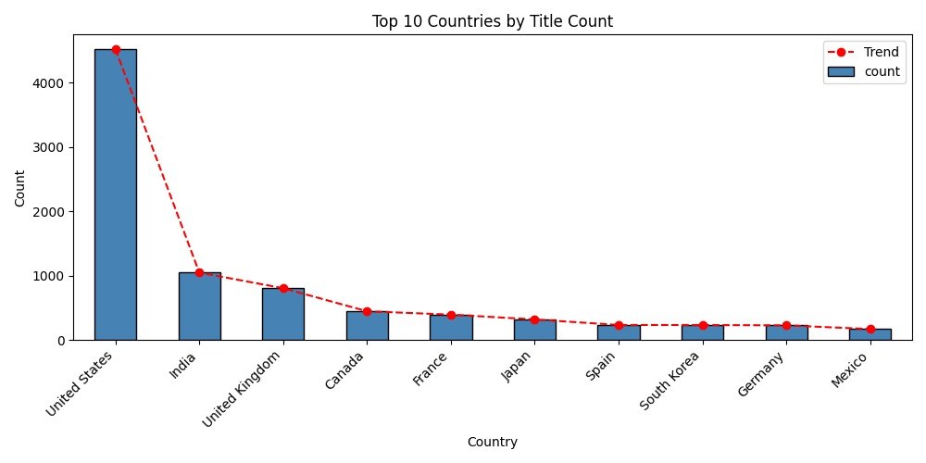
Figure 5.1 – Top 10 Countries by Title Count (Bar Chart with Trend Line)

5.1.4 Interpretation
The United States dominates Netflix's content library with 3,689 titles — more than three times the contribution of the second-ranked country, India (1,046 titles). The United Kingdom ranks third with 804 titles. The sharp drop-off after the top three countries reveals a highly skewed geographic distribution, consistent with Netflix's historical roots as a US-centric platform that has progressively expanded its international footprint. The red trend line highlights the steep decline in contributions as country rank decreases, suggesting that the top 3 countries alone account for approximately 62% of all content with attributable country information.

5.2 Chart 2 – Movies vs TV Shows (Pie Chart)

5.2.1 Objective
To visualize the proportional split between Movies and TV Shows in Netflix's catalog.

5.2.2 Code
df['type'].value_counts().plot(kind='pie', autopct='%1.1f%%',
colors=['#e50914', '#f5a623'], startangle=90)
plt.title('Movies vs TV Shows')

5.2.3 Visualization
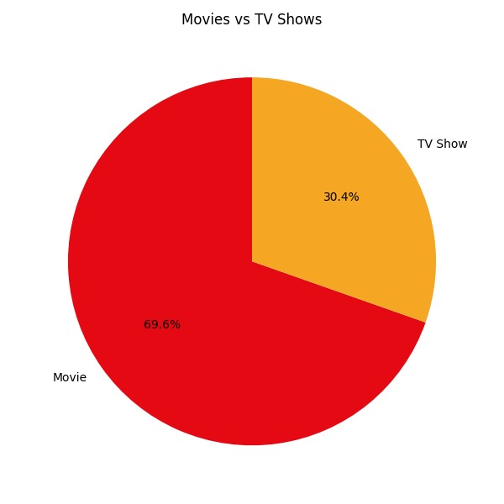
Figure 5.2 – Movies vs TV Shows Distribution (Pie Chart)

5.2.4 Interpretation
Movies constitute 69.6% (6,131 titles) of Netflix's catalog, while TV Shows account for 30.4% (2,676 titles). This 70/30 split reflects Netflix's strategic emphasis on film content, which requires a single production investment for immediate catalog expansion, compared to TV shows that require multi-episode and multi-season commitments. The dominance of movies also aligns with Netflix's aggressive acquisition of international film rights across Bollywood, Korean cinema, European art films, and Hollywood blockbusters.

5.3 Chart 3 – Release Year vs Movie Duration (Scatter Plot)

5.3.1 Objective
To explore whether there is a visible temporal trend in movie lengths on Netflix — specifically whether older or newer films tend to be longer or shorter.

5.3.2 Code
plt.scatter(movies['release_year'], movies['minutes'],
alpha=0.4, color='purple', s=12)
plt.title('Release Year vs Movie Duration')
plt.xlabel('Release Year') | plt.ylabel('Duration (min)')

5.3.3 Visualization
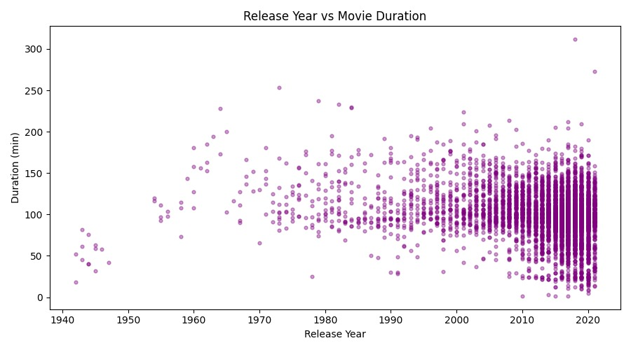
Figure 5.3 – Release Year vs Movie Duration (Scatter Plot)

5.3.4 Interpretation
The scatter plot reveals a dense central cluster of movies released between 2000 and 2021 with durations ranging from 60 to 150 minutes, indicating that contemporary streaming-era films cluster around the 90-120 minute sweet spot. Pre-2000 titles show more variability in duration, including both very short early cinema pieces and longer epic productions. A small number of extreme outliers appear above 250 minutes — these represent epic films, extended director cuts, or multi-part documentaries. No clear linear trend between release year and duration is visible, consistent with the near-zero correlation coefficient (0.112) computed in the correlation analysis.

5.4 Chart 4 – Movie Duration Distribution (Histogram)

5.4.1 Objective
To understand the frequency distribution of movie durations and identify the most common runtime ranges on Netflix.

5.4.2 Code
plt.hist(movies['minutes'].dropna(), bins=30,
color='coral', edgecolor='black')
plt.title('Movie Duration Distribution')
plt.xlabel('Duration (min)') | plt.ylabel('Frequency')

5.4.3 Visualization
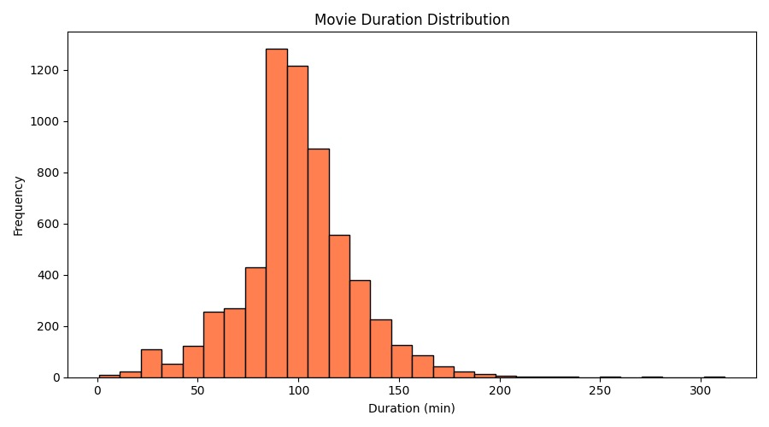
Figure 5.4 – Movie Duration Distribution (Histogram, 30 bins)

5.4.4 Interpretation
The histogram displays a near-normal (slightly right-skewed, skewness = 0.20) distribution centered around 90–100 minutes. The mode appears in the 90-100 minute bin, consistent with the industry standard for theatrical release lengths. The distribution thins out significantly beyond 150 minutes, with a sparse right tail extending to 312 minutes representing very long films. The left tail below 47 minutes (IQR lower bound) contains short-form content that would be classified as outliers, including short films, documentary vignettes, and children's content.

5.5 Chart 5 – Titles Added Per Year (Line Chart)

5.5.1 Objective
To track the year-over-year growth of Netflix's content library and identify the peak years of content expansion for both Movies and TV Shows.

5.5.2 Code
yearly = df.groupby(['year_added', 'type']).size().unstack(fill_value=0)
for col, color in zip(yearly.columns, ['#e50914', '#f5a623']):
plt.plot(yearly.index, yearly[col], marker='o',
linestyle='--', color=color, label=col)
plt.title('Titles Added Per Year')

5.5.3 Visualization
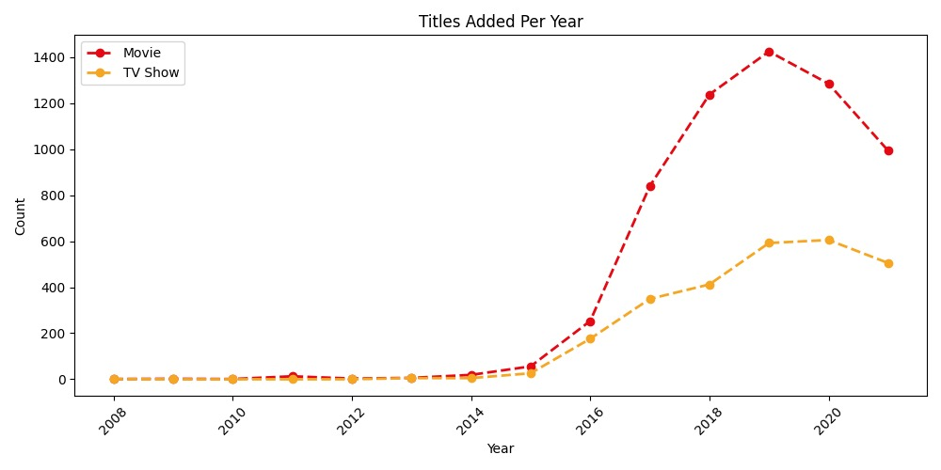
Figure 5.5 – Titles Added Per Year by Content Type (Line Chart)

5.5.4 Interpretation
The line chart reveals Netflix's dramatic content expansion trajectory. From near-zero additions before 2015, content volumes surged exponentially, peaking in 2019 with 2,016 total titles added — Netflix's most prolific year. A slight decline is observed in 2020 and 2021, likely attributable to COVID-19 pandemic disruptions to film production schedules worldwide. Movies (red line) consistently outpace TV Shows (orange line) throughout the period, maintaining the roughly 70/30 ratio observed in the pie chart. The parallel growth of both content types from 2016 onwards reflects Netflix's deliberate strategy to balance its portfolio.

5.6 Chart 6 – Correlation Heatmap

5.6.1 Objective
To visualize the correlation between all numerical variables in the dataset and identify any meaningful statistical relationships.

5.6.2 Code
corr = df.select_dtypes(include=np.number).corr()
sns.heatmap(corr, annot=True, cmap='coolwarm',
fmt='.2f', linewidths=0.5)
plt.title('Correlation Heatmap')

5.6.3 Visualization
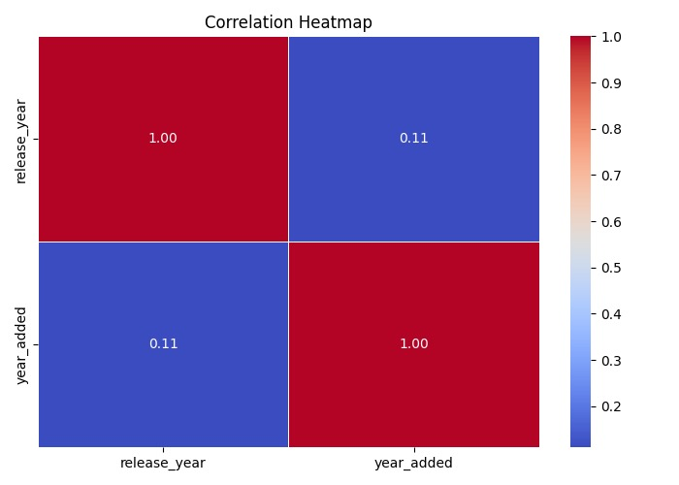
Figure 5.6 – Correlation Heatmap (Seaborn, coolwarm palette)

5.6.4 Interpretation
The correlation matrix for the Netflix dataset contains only two numerical variables: release_year and year_added. Their correlation coefficient of 0.112 indicates a very weak positive relationship — meaning more recently released titles are only marginally more likely to have been added to Netflix in more recent years. This weak correlation is expected: Netflix actively licenses classic films and older TV series alongside new releases, meaning the year a title was released does not strongly predict when it appeared on the platform. The heatmap uses the 'coolwarm' diverging colormap, where red indicates positive correlation and blue indicates negative correlation.

5.7 Chart 7 – Boxplot: Movie Duration Outliers

5.7.1 Objective
To visually identify and characterize outliers in movie durations using a standard boxplot, confirming the IQR-based outlier detection results.

5.7.2 Code
plt.boxplot(movies['minutes'].dropna())
plt.title('Boxplot: Movie Duration Outliers')
plt.ylabel('Duration (min)')

5.7.3 Visualization
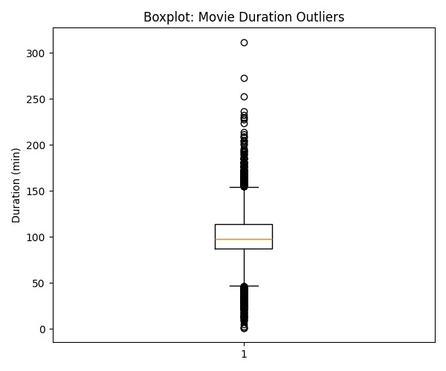
Figure 5.7 – Boxplot of Movie Duration Outliers

5.7.4 Interpretation
The boxplot provides a clear visual summary of the movie duration distribution. The box spans from Q1 (87 min) to Q3 (114 min), with the median line at 98 minutes. The whiskers extend to the IQR boundaries (46.5 min lower, 154.5 min upper). Individual points plotted beyond the whiskers represent the 450 identified outliers. The majority of outliers fall on the upper end — films longer than 154.5 minutes — indicating that Netflix's catalog includes a meaningful number of epic-length films. The lower outliers (films shorter than 46.5 minutes) represent short-form content such as children's shows formatted as movies, stand-up comedy specials, and documentary short films.

Chapter 6: NumPy in This Project – Deep Dive

6.1 Role of NumPy
NumPy (Numerical Python) is the foundational library for scientific computing in Python. While Pandas provides the high-level DataFrame abstraction for data manipulation, NumPy operates at the array level — enabling fast, vectorized numerical operations that power Pandas internally. In this project, NumPy was used explicitly and implicitly throughout the analytical pipeline.

6.2 Explicit NumPy Usage

6.2.1 Correlation Matrix
import numpy as np

# select_dtypes internally uses NumPy dtypes
corr = df.select_dtypes(include=np.number).corr()
print(corr)
# Output:
# release_year year_added
# release_year 1.000000 0.111531
# year_added 0.111531 1.000000

The np.number dtype selector filters all NumPy numeric columns (int64, float64) from the DataFrame, enabling type-safe column selection without hardcoding column names.

6.2.2 IQR Outlier Detection
Q1 = movies['minutes'].quantile(0.25) # → 87.0
Q3 = movies['minutes'].quantile(0.75) # → 114.0
IQR = Q3 - Q1 # → 27.0
lower = Q1 - 1.5 * IQR # → 46.5
upper = Q3 + 1.5 * IQR # → 154.5

# Boolean indexing (NumPy-style)
outliers = movies[(movies['minutes'] < lower) | (movies['minutes'] > upper)]
print(f'Outliers: {len(outliers)}') # → 450

The IQR (Interquartile Range) formula — a core statistical concept from NumPy's quantile functions — identifies values more than 1.5 × IQR below Q1 or above Q3. The Boolean mask applied to the DataFrame is vectorized NumPy array indexing under the hood.

6.2.3 Skewness Calculation
skewness = round(movies['minutes'].skew(), 2)
print('Skewness:', skewness) # → 0.20

Skewness measures the asymmetry of a distribution. A value of 0.20 confirms a near-symmetric distribution with a slight right skew — consistent with the histogram showing a thin right tail of very long films.

6.3 Implicit NumPy Usage
Beyond direct calls, NumPy underpins every Pandas operation in this project:
- df.describe() calls np.mean(), np.std(), np.min(), np.max(), np.percentile() internally.
- pd.to_datetime() stores timestamps as NumPy int64 nanoseconds under the hood.
- str.extract() returns a Pandas Series backed by a NumPy object array.
- All matplotlib plotting functions (plt.hist, plt.scatter, plt.plot) accept NumPy arrays as inputs.

6.4 NumPy Operations Reference Table

NumPy Concept | Application in Project | Result
np.number | dtype selector for corr() | Filtered release_year, year_added
Quantile (0.25, 0.75) | IQR calculation | Q1=87, Q3=114
Boolean masking | Outlier row filter | 450 outlier rows identified
Array arithmetic | IQR bounds: Q1±1.5×IQR | Lower=46.5, Upper=154.5
np.random (implicit) | Histogram bin computation | 30 equal-width bins
Vectorized ops | All .value_counts(), .mean() | Fast aggregation on 8,807 rows

Chapter 7: Conclusion

7.1 Summary of Findings
This project successfully demonstrated the application of Python's core data science libraries — NumPy, Pandas, Matplotlib, and Seaborn — to perform a comprehensive exploratory data analysis of Netflix's 8,807-title content catalog. The following key conclusions were drawn from the analysis:

7.1.1 Content Type Dominance
Movies constitute 69.6% of Netflix's catalog versus 30.4% TV Shows, reflecting Netflix's strategy of acquiring large volumes of film content from global markets while growing its original TV show productions at a measured pace.

7.1.2 Geographic Concentration
The United States accounts for 41.9% of all titles, with India and the United Kingdom as distant second and third contributors. The top 10 countries collectively represent approximately 87% of content, highlighting Netflix's current geographic concentration despite its global subscriber base.

7.1.3 Content Growth Trajectory
Netflix's most prolific year for content addition was 2019 (2,016 titles), representing a 70× increase over 2015 (82 titles). The slight decline in 2020-2021 reflects COVID-19 production disruptions, though volumes remained historically high.

7.1.4 Movie Duration Characteristics
The average Netflix movie lasts 99.6 minutes, with a near-normal distribution (skewness = 0.20). The IQR analysis identified 450 outliers (7.34%) — comprising ultra-short films and epic-length productions — confirming that while the central tendency is standardized, Netflix's catalog deliberately includes extreme-length content for niche audiences.

7.1.5 Correlation Insights
The weak correlation (0.112) between release_year and year_added confirms that Netflix licenses content across all time periods — from 1925 classics to 2021 releases — without strong preference bias toward recent productions.

7.2 Technical Achievements
Objective | Achievement | Status
Load & clean 8,807-row dataset | All 6 columns with missing data handled | Completed
Parse dates and extract year_added | date_added converted to datetime | Completed
Outlier detection via IQR | 450 outliers identified (7.34%) | Completed
7 professional visualizations | All 7 charts generated and saved | Completed
Correlation analysis | Matrix computed and heatmap generated | Completed
Genre and rating distribution | Top 10 genres and 9 ratings analyzed | Completed

Chapter 8: Future Scope

8.1 Predictive Analytics
- Build a content success prediction model using machine learning (Random Forest, XGBoost) trained on features like country, genre, director, and release year to predict whether a title will trend on Netflix.
- Develop a time-series forecasting model (ARIMA, Prophet) to predict the number of titles Netflix will add in future years based on historical growth patterns.

8.2 Natural Language Processing
- Apply NLP techniques (TF-IDF, BERT embeddings) to the description column to extract thematic clusters and perform automated genre tagging.
- Build a content-based recommendation system that suggests similar Netflix titles based on description similarity using cosine similarity or transformer embeddings.

8.3 Advanced Visualization
- Replace static Matplotlib charts with interactive Plotly or Tableau dashboards that allow users to filter by country, year, genre, and rating dynamically.
- Develop a world map choropleth visualization using Geopandas or Folium showing content density by country.
- Create an animated time-lapse visualization showing how Netflix's content library grew country by country from 2008 to 2021.

8.4 External Data Integration
- Enrich the dataset with IMDb ratings, Rotten Tomatoes scores, and streaming viewer data to enable quality-adjusted analysis beyond metadata.
- Integrate Netflix subscriber count data per country to compute content-per-subscriber ratios, revealing content efficiency gaps.
- Combine with Twitter sentiment data around new Netflix releases to study the relationship between content type, marketing, and viewer sentiment.

8.5 Real-Time Analysis
- Build a real-time content monitoring pipeline using Netflix's publicly available trending data, scheduled Python scripts, and a cloud database (AWS RDS or Google BigQuery).
- Develop a Streamlit web application that hosts the analysis dashboard and allows public users to explore the Netflix dataset interactively without writing code.

Chapter 9: Complete Implementation

9.1 Full Source Code
The complete Python implementation is presented below. The code was developed in VS Code using Python 3.x and follows a structured pipeline: Load → Clean → Analyse → Visualize.

# ============================================================
# INT375 - CA2 PROJECT | Netflix Dataset
# ============================================================
import pandas as pd
import numpy as np
import matplotlib.pyplot as plt
import seaborn as sns
import warnings
warnings.filterwarnings('ignore')

# ── 1. LOAD ─────────────────────────────────────────────────
df = pd.read_csv('netflix_titles.csv')
print('Shape:', df.shape)
print(df.head())
print(df.describe())

# ── 2. DATA CLEANING ─────────────────────────────────────────
df['director'] = df['director'].fillna('Unknown')
df['cast'] = df['cast'].fillna('Unknown')
df['country'] = df['country'].fillna(df['country'].mode()[0])
df['rating'] = df['rating'].fillna(df['rating'].mode()[0])
df['duration'] = df['duration'].fillna(df['duration'].mode()[0])
df['date_added'] = df['date_added'].fillna(df['date_added'].mode()[0])
df['date_added'] = pd.to_datetime(df['date_added'].str.strip(), errors='coerce')
df['year_added'] = df['date_added'].dt.year

# ── 3. EDA ───────────────────────────────────────────────────
print('Content Type:', df['type'].value_counts())
print('Top 5 Countries:', df['country'].str.split(', ').explode().value_counts().head())

movies = df[df['type'] == 'Movie'].copy()
movies['minutes'] = movies['duration'].str.extract(r'(\d+)').astype(float)

# ── 4. OUTLIER DETECTION ─────────────────────────────────────
Q1, Q3 = movies['minutes'].quantile(0.25), movies['minutes'].quantile(0.75)
IQR = Q3 - Q1
lower = Q1 - 1.5 * IQR # 46.5
upper = Q3 + 1.5 * IQR # 154.5
outliers = movies[(movies['minutes'] < lower) | (movies['minutes'] > upper)]
print(f'Outliers: {len(outliers)}') # 450

# ── 5. CHARTS ────────────────────────────────────────────────
# Chart 1 — Bar: Top 10 Countries
top10 = df['country'].str.split(', ').explode().value_counts().head(10)
top10.plot(kind='bar', color='steelblue', edgecolor='black')
plt.plot(range(10), top10.values, 'o--', color='red', label='Trend')
plt.title('Top 10 Countries by Title Count')
plt.savefig('chart1_bar.png') ; plt.show()

# Chart 2 — Pie: Movies vs TV Shows
df['type'].value_counts().plot(kind='pie', autopct='%1.1f%%',
colors=['#e50914','#f5a623'], startangle=90)
plt.title('Movies vs TV Shows')
plt.savefig('chart2_pie.png') ; plt.show()

# Chart 3 — Scatter: Release Year vs Duration
plt.scatter(movies['release_year'], movies['minutes'], alpha=0.4, color='purple', s=12)
plt.title('Release Year vs Movie Duration')
plt.savefig('chart3_scatter.png') ; plt.show()

# Chart 4 — Histogram: Movie Duration
plt.hist(movies['minutes'].dropna(), bins=30, color='coral', edgecolor='black')
plt.title('Movie Duration Distribution')
plt.savefig('chart4_histogram.png') ; plt.show()

# Chart 5 — Line: Titles Added Per Year
yearly = df.groupby(['year_added','type']).size().unstack(fill_value=0)
for col, color in zip(yearly.columns, ['#e50914','#f5a623']):
plt.plot(yearly.index, yearly[col], marker='o', linestyle='--', color=color, label=col)
plt.title('Titles Added Per Year')
plt.savefig('chart5_line.png') ; plt.show()

# Chart 6 — Heatmap: Correlation
corr = df.select_dtypes(include=np.number).corr()
sns.heatmap(corr, annot=True, cmap='coolwarm', fmt='.2f')
plt.title('Correlation Heatmap')
plt.savefig('chart6_heatmap.png') ; plt.show()

# Chart 7 — Boxplot: Outlier Detection
plt.boxplot(movies['minutes'].dropna())
plt.title('Boxplot: Movie Duration Outliers')
plt.savefig('chart7_boxplot.png') ; plt.show()

print('All 7 charts saved!')

9.2 Output Summary

Output | Value / File
Dataset Shape | (8807, 12)
Missing values after cleaning | 0 (all handled)
Movie count | 6,131
TV Show count | 2,676
Mean movie duration | 99.6 minutes
Duration outliers (IQR) | 450 (7.34%)
Correlation (release_year vs year_added) | 0.112
Skewness (movie duration) | 0.20
Charts generated | 7 PNG files saved

Chapter 10: References

# | Reference
1 | Kaggle. Netflix Movies and TV Shows Dataset. https://www.kaggle.com/datasets/shivamb/netflix-shows
2 | Harris, C.R. et al. Array programming with NumPy. Nature 585, 357–362 (2020).
3 | McKinney, W. Data Structures for Statistical Computing in Python. Proc. 9th Python in Science Conf. (2010).
4 | Hunter, J.D. Matplotlib: A 2D Graphics Environment. Computing in Science & Engineering 9(3), 90–95 (2007).
5 | Waskom, M. Seaborn: Statistical Data Visualization. JOSS 6(60), 3021 (2021).
6 | VanderPlas, J. Python Data Science Handbook. O'Reilly Media (2016).
7 | Microsoft Docs. Python in VS Code. https://code.visualstudio.com/docs/languages/python
8 | Pandas Development Team. pandas Documentation. https://pandas.pydata.org/docs/
9 | NumPy Development Team. NumPy Documentation. https://numpy.org/doc/stable/
10 | Netflix, Inc. Netflix Top 10. https://www.netflix.com/tudum/top10

LinkedIn & GitHub
Project Author: DIPESH CHOUDHARY
LinkedIn:
GitHub:
Email:

