Core PHP Assessment Test

* **Write a program to demonstrate the Library management system.**
* **Prepare demonstration of console based Application with crud operations with Library management system under software development principles**
* **First start with Password if you enter same password then start showing all menu.**



* **Execution of the code following menu must be displayed.**

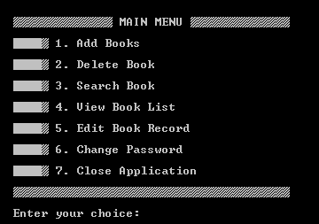

* **Make sure each business logic is denoted with appropriate comments and make your code interactive and represent clean and clear output on your console screen**
* **when user select option 1 then it will display following menu**

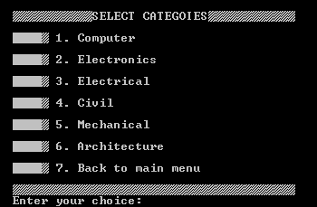

* **If you select add book then it will display all categories then you select any option to add book with fill up the all details so all data store into array list.**

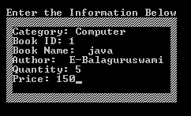

* **If you select 2nd option from the main menu then delete the book from the array list**



* **If you select 3rd option then you search the book with several option with display by using built-in function**

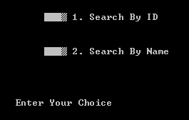 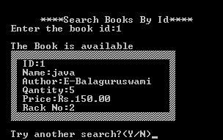

* **When you select the 4th option then you view the whole books which you added and display with all details if no any books found then you pass message for no book found**



* 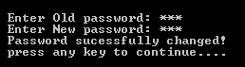**If you want to change the password the you pass enter first old password then you enter new password what you want to changed**