**TOPIC – SQL**

Task – 1

**TABLE: - Employee**

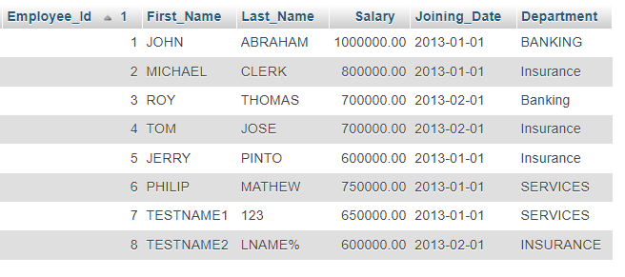

**TABLE :- Incentives**

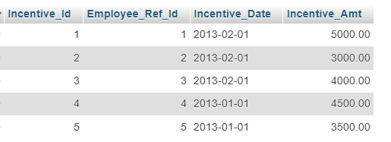

* **Questions & Answers**

a) Get First Name from employee table using alias name “Employee Name”.

=> [SELECT](http://localhost/phpmyadmin/url.php?url=https://dev.mysql.com/doc/refman/8.0/en/select.html) `First_Name`as 'Employee Name' FROM `employee`;

b) Get FIRST_NAME, joining year, Joining Month and Joining Date from employee table.

=>[Select](http://localhost/phpmyadmin/url.php?url=https://dev.mysql.com/doc/refman/8.0/en/select.html) First_Name, year(Joining_Date) JoinYear , month(Joining_Date), day(Joining_Date) from employee;

c) Get all employee details from the employee table order by First Name Ascending And Salary descending?

=> SELECT * FROM ‘employee’ ORDER BY ‘First Name’ ASC, ‘Salary’ DESC;

d) Get employee details from employee table whose first name contains „o‟.

=> [SELECT](http://localhost/phpmyadmin/url.php?url=https://dev.mysql.com/doc/refman/8.0/en/select.html) * FROM employee WHERE First Name [LIKE](http://localhost/phpmyadmin/url.php?url=https://dev.mysql.com/doc/refman/8.0/en/string-comparison-functions.html%23operator_like) 'O';

e) Get employee details from employee table whose joining month is “January”.

=>[SELECT](http://localhost/phpmyadmin/url.php?url=https://dev.mysql.com/doc/refman/8.0/en/select.html) * FROM employee WHERE Joining Date [LIKE](http://localhost/phpmyadmin/url.php?url=https://dev.mysql.com/doc/refman/8.0/en/string-comparison-functions.html%23operator_like) 'January';

f) Get department, total salary with respect to a department from employee table Order By total salary descending.

=> [SELECT](http://localhost/phpmyadmin/url.php?url=https://dev.mysql.com/doc/refman/8.0/en/select.html) Department, [SUM](http://localhost/phpmyadmin/url.php?url=https://dev.mysql.com/doc/refman/8.0/en/aggregate-functions.html%23function_sum)(Salary) AS TotalSalary FROM employee GROUP BY Department ORDER BY Salary DESC;

g) Get department wise maximum salary from employee table order by salary ascending?

=>[SELECT](http://localhost/phpmyadmin/url.php?url=https://dev.mysql.com/doc/refman/8.0/en/select.html) Department, [MAX](http://localhost/phpmyadmin/url.php?url=https://dev.mysql.com/doc/refman/8.0/en/aggregate-functions.html%23function_max)(Salary) AS MaxSalary FROM Employee GROUP BY Department ORDER BY MaxSalary ASC;

h) Select first name, incentive amount from employee and incentives table for those Employees who have incentives and incentive amount greater than 3000

=>[SELECT](http://localhost/phpmyadmin/url.php?url=https://dev.mysql.com/doc/refman/8.0/en/select.html) First_Name,Incentive_Amt FROM employee emp INNER JOIN Incentives INC ON emp.Employee_Id = Inc.Employee_Ref_Id [AND](http://localhost/phpmyadmin/url.php?url=https://dev.mysql.com/doc/refman/8.0/en/logical-operators.html%23operator_and) Incentive_Amt> 3000;

i) Select 2nd Highest salary from employee table.

=>[Select](http://localhost/phpmyadmin/url.php?url=https://dev.mysql.com/doc/refman/8.0/en/select.html) [Max](http://localhost/phpmyadmin/url.php?url=https://dev.mysql.com/doc/refman/8.0/en/aggregate-functions.html%23function_max)(Salary) as Salary from employee where Salary <([select](http://localhost/phpmyadmin/url.php?url=https://dev.mysql.com/doc/refman/8.0/en/select.html) [MAX](http://localhost/phpmyadmin/url.php?url=https://dev.mysql.com/doc/refman/8.0/en/aggregate-functions.html%23function_max)(Salary) from employee);

j) Select first name, incentive amount from employee and incentives table for all Employees who got incentives using left join.

=>[SELECT](http://localhost/phpmyadmin/url.php?url=https://dev.mysql.com/doc/refman/8.0/en/select.html) First_Name,NVL(Incentive_Amt,0) FROM employee A [RIGHT](http://localhost/phpmyadmin/url.php?url=https://dev.mysql.com/doc/refman/8.0/en/string-functions.html%23function_right) JOIN Incentives B ON A.Employee_Id=B.Employee_Ref_Id;

k) Create View OF Employee table in which store first name, last name and salary only.

=>[CREATE](http://localhost/phpmyadmin/url.php?url=https://dev.mysql.com/doc/refman/8.0/en/create-view.html) [VIEW](http://localhost/phpmyadmin/url.php?url=https://dev.mysql.com/doc/refman/8.0/en/create-view.html) Employee_View AS [SELECT](http://localhost/phpmyadmin/url.php?url=https://dev.mysql.com/doc/refman/8.0/en/select.html) Employee_Id, First_Name, Last_Name , Salary FROM Employee;

l) Create Procedure to find out department wise highest salary.

=> CREATE PROCEDURE Find_Department_Highest_Salary()

BEGIN

DECLARE done INT DEFAULT FALSE;

DECLARE Department_id INT;

DECLARE Max_Salary DECIMAL(10, 2);

m) Create after Insert trigger on Employee table which insert records in view table.

=> CREATE TRIGGER AfterEmployeeInsert

AFTER INSERT ON Employee

FOR EACH ROW

BEGIN

-- Inserting into the EmployeeView table

INSERT INTO EmployeeView (Employee_ID, First_Name, Last_Name, Department)

VALUES (NEW.EmployeeID, NEW.FirstName, NEW.LastName, NEW.Department);

END;

Task – 2

**TABLE :- Sales Person**

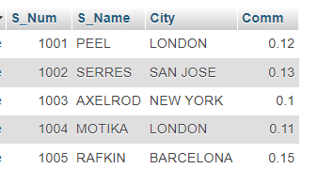

**TABLE :- Customer**

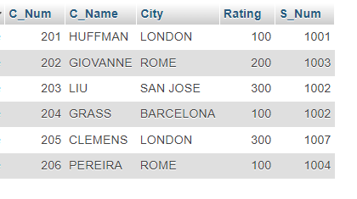

**TABLE: - Order**

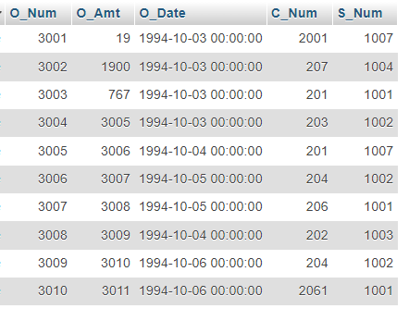

a) All orders for more than $1000.

=> [SELECT](http://localhost/phpmyadmin/url.php?url=https://dev.mysql.com/doc/refman/8.0/en/select.html) * FROM `order` WHERE O_Amt>1000;

b) Names and cities of all salespeople in London with commission above 0.10.

=>[SELECT](http://localhost/phpmyadmin/url.php?url=https://dev.mysql.com/doc/refman/8.0/en/select.html) S_Name , City FROM `sales_person` WHERE Comm > 0.10 [AND](http://localhost/phpmyadmin/url.php?url=https://dev.mysql.com/doc/refman/8.0/en/logical-operators.html%23operator_and) City ='LONDON';

c) All salespeople either in Barcelona or in London.

=>[SELECT](http://localhost/phpmyadmin/url.php?url=https://dev.mysql.com/doc/refman/8.0/en/select.html) S_Name , City FROM `sales_person` WHERE City [IN](http://localhost/phpmyadmin/url.php?url=https://dev.mysql.com/doc/refman/8.0/en/comparison-operators.html%23function_in) ('BARCELONA','LONDON');

d) All salespeople with commission between 0.10 and 0.12. (Boundary values should be excluded).

=>[SELECT](http://localhost/phpmyadmin/url.php?url=https://dev.mysql.com/doc/refman/8.0/en/select.html) S_Name , Comm FROM `sales_person` WHERE Comm > 0.10 [AND](http://localhost/phpmyadmin/url.php?url=https://dev.mysql.com/doc/refman/8.0/en/logical-operators.html%23operator_and) Comm < 0.12;

e) All customers with NULL values in city column.

=> [SELECT](http://localhost/phpmyadmin/url.php?url=https://dev.mysql.com/doc/refman/8.0/en/select.html) C_Name FROM `customer` WHERE City [IS](http://localhost/phpmyadmin/url.php?url=https://dev.mysql.com/doc/refman/8.0/en/comparison-operators.html%23operator_is) NULL;

f) All orders taken on Oct 3Rd and Oct 4th 1994.

=> [SELECT](http://localhost/phpmyadmin/url.php?url=https://dev.mysql.com/doc/refman/8.0/en/select.html) * FROM `order` WHERE O_Date [IN](http://localhost/phpmyadmin/url.php?url=https://dev.mysql.com/doc/refman/8.0/en/comparison-operators.html%23function_in) ('03-10-1994','04-10-1994');

g) All customers serviced by peel or Motika.

=> [SELECT](http://localhost/phpmyadmin/url.php?url=https://dev.mysql.com/doc/refman/8.0/en/select.html) * FROM customer WHERE S_Num = 1001 [OR](http://localhost/phpmyadmin/url.php?url=https://dev.mysql.com/doc/refman/8.0/en/logical-operators.html%23operator_or) S_Num = 1004;

h) All customers whose names begin with a letter from A to B

=>[SELECT](http://localhost/phpmyadmin/url.php?url=https://dev.mysql.com/doc/refman/8.0/en/select.html) C_Name FROM `customer` WHERE C_Name [LIKE](http://localhost/phpmyadmin/url.php?url=https://dev.mysql.com/doc/refman/8.0/en/string-comparison-functions.html%23operator_like) 'A%' [OR](http://localhost/phpmyadmin/url.php?url=https://dev.mysql.com/doc/refman/8.0/en/logical-operators.html%23operator_or) C_Name [LIKE](http://localhost/phpmyadmin/url.php?url=https://dev.mysql.com/doc/refman/8.0/en/string-comparison-functions.html%23operator_like) 'B%';

i) All customers excluding those with rating <= 100 unless they are located in Rome.

=> [SELECT](http://localhost/phpmyadmin/url.php?url=https://dev.mysql.com/doc/refman/8.0/en/select.html) C_Name FROM `customer` WHERE Rating <= 100 [OR](http://localhost/phpmyadmin/url.php?url=https://dev.mysql.com/doc/refman/8.0/en/logical-operators.html%23operator_or) City = 'ROME';

j) All orders except those with 0 or NULL value in amt field.

=> [SELECT](http://localhost/phpmyadmin/url.php?url=https://dev.mysql.com/doc/refman/8.0/en/select.html) O_Num FROM `order` WHERE O_Amt != 0 [OR](http://localhost/phpmyadmin/url.php?url=https://dev.mysql.com/doc/refman/8.0/en/logical-operators.html%23operator_or) O_Amt [IS](http://localhost/phpmyadmin/url.php?url=https://dev.mysql.com/doc/refman/8.0/en/comparison-operators.html%23operator_is) [NOT](http://localhost/phpmyadmin/url.php?url=https://dev.mysql.com/doc/refman/8.0/en/logical-operators.html%23operator_not) NULL;

k) Count the number of salespeople currently listing orders in the order table.

=> SELECT COUNT(DISTINCT S_Num) AS num_active_sales_person

FROM `order`

WHERE order_status = 'Active';