# 

**STUDY OF THE STATUS OF HYDROELECTRICITY IN NEPAL**

A PROJECT WORK SUBMITTED FOR THE PARTIAL FULFILLMENT OF

THE REQUIREMENT FOR THE GRADE 12 SCIENCE IN PHYSICS



By

DEEPIKA DEVKOTA

Grade XII

2080

ID NO:27797

Trinity International SS/ College

National Education Board (NEB)

Dillibazar, Kathmandu, Nepal

Date:2080

# DECLARATION

I, “DEEPIKA DEVKOTA” hereby declare that the project work entitled “STUDY OF THE STATUS OF HYDROELECTRICITY IN NEPAL” under the supervision of“Krishna Raj Baral and Roshan Hona” Trinity International SS/College, Nepal, presented herein is genuine work done originally by me and has not been published or submitted elsewhere for the requirement of any degree program. Any literature, data or works done by others and cited in this project work has been given due acknowledgement and listed in the reference section.

….………………………….

Name**:** DEEPIKA DEVKOTA

Grade**:** 12

Registration No. :803270070431

Trinity International SS/College

i

# CERTIFICATE OF APPROVAL

The project work entitled “STUDY OF THE STATUS OF HYDROELECTRICITY IN NEPAL” by Ms. Deepika Devkota id no: 27797 under the supervisor Mr. Krishna Raj Baral and Mr. Roshan Hona, Trinity International SS/College Nepal is hereby submitted for the partial fulfillment of requirement of Physics in Grade 12. This project work has not been submitted in any other school or institution previously for the award of Grade 12.

Mr. Krishna Raj Baral Mr. Roshan Hona

Supervisor Supervisor

Department of physics Department of physics

Trinity International College Trinity International College

Jivan Panta

Head of Department

Department of Physics

Trinity International College

ii

# ACKNOWLEDEMENT

I would like to express my deep appreciation and gratitude to my subject teacher Mr. Krishna Raj Baral and Mr. Roshan Hona for their coinstantaneous help, advice, information and encouragement in this project. I feel immense pleasure to present my project after a long work. Beside my effort, the help and guideline given by my team hasn’t been unnoticed. I express my gratitude to all those countless people who supported me in this doing this project. I express my thanks to Trinity International SS/College for this opportunity and the immeasurable support, valuable information, resources and the guidance given to me to do this project. I am also grateful and in debt of my beloved friends for their immense help, support and encouragement from the beginning to the end of this project without whom this project would not have a reality.

**Abstract**

Nepal possesses immense potential for hydro-power generation, boasting an estimated capacity of 40,000 megawatts. However, only a fraction (around 5%) has been harnessed, with the current installed capacity reaching 2,191 MW. Despite significant growth in 2023, adding nearly 500 MW to the national grid, substantial development is needed. While progress is evident with independent power producers contributing and the government aiming for further expansion, challenges persist. These include seasonal variations in river flow impacting year-round electricity availability, alongside financial, technical, and environmental considerations. Addressing these hurdles is crucial to fully capitalizing on Nepal's abundant hydro-power potential and achieving energy security

Table of Content

DECLARATION ……………………………………………………………………………….i

CERTIFICATEOF APPROVAL…………………………………………………………………………..i1

ACKNOWLEDGMENT..................................................................................................................................iii ABSTRACT................................................................................................................................................iv

1.INTRODUCTION…………………………………………………………………………………………………………………………..1-3

1.1 THEORETICAL BACKGROUND…………………………………………………………………………………………..2

1.2 PRODUCTION OF HYDROELECTRICITY………………………………………………………………………3

2. OBJECTIVES……………………………………………………………………………………………………………………………………4

3. LIMITATIONS……………………………………………………………………………………………………………………..5

4. THEORY………………………………………………………………………………………………………………………….6-13

4.1 HYDROPOWER IN NEPAL ………………………………………………………………………………………..6-8

4.2 TRANSMISSION…………………………………………………………………………………………………………….9

4.3 DISTRIBUTION OF ELECTRICITY………………………………………………………………………………..10

4.4 IMPORTANCE OF HYDROELECTRICITY…………………………………………………………………11

4.5 PROBLEMS RELATED WITH PRODUCTIONS………………………………………………………..12

4.6 SOLUTIONS OF HYDROPOWER PRODUCTION…………………………………………..…………….13

5. RESEARCH METHODOLOGIES……………………………………………………………………………………...14

5.1. DATA SOURCES…………………………………………………………………………………………………………..14

6.ANALYSIS…………………………………………………………………………………………………………………………..15

7. POLICIES RELATED TO HYDROPOWER PRODUCTIONS…………………………………………..16

8. FINDINGS…………………………………………………………………………………………………………………………..17

9.CHALLENGES…………………………………………………………………………………………………………………….18

10.CONCLUSION…………………………………………………………………………………………………………………..19

11.BIBILOGRAPHY……………………………………………………………………………………………………………….20

1. **INTRODUCTION**

HYDROPOWER:

**Hydropower, or hydroelectric power, is a renewable source of energy that generates power by using a dam or diversion structure to alter the natural flow of a river or other body of water. Hydropower relies on the endless, constantly recharging system of the water cycle to produce electricity, using a fuel-water-that is not reduced or eliminated in the process. There are many types of hydropower facilities, though they are all powered by the kinetic energy of flowing water as it moves downstream. Hydropower utilizes turbines and generators to convert that kinetic energy into electricity, which is then fed into the electrical grid to power homes, businesses, and industriesThere are several types of hydroelectric facilities; they are all powered by the kinetic energy of flowing water as it moves downstream. Turbines and generators convert the energy into electricity, which is then fed into the electrical grid to be used in homes, businesses, and by industry.**

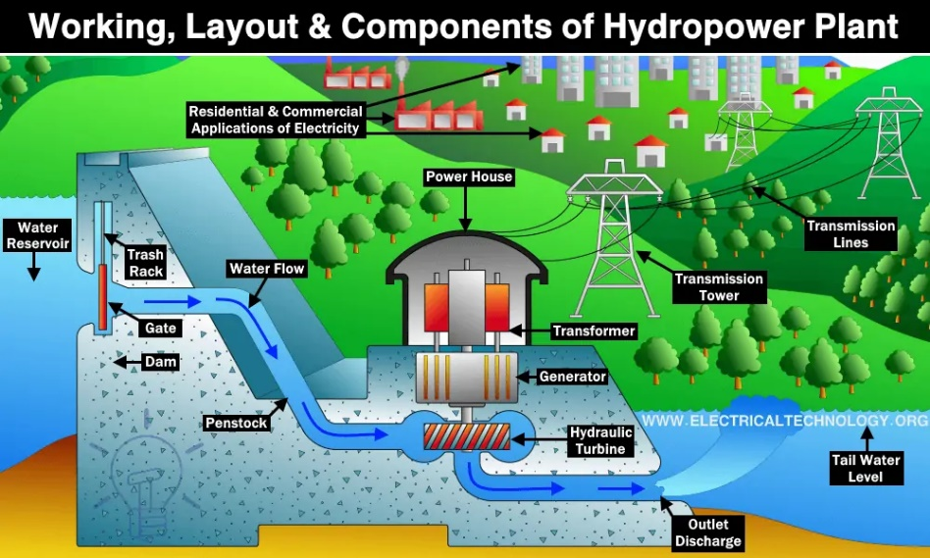

### **STUDY OF THE STATUS OF HYDROELECTRICITY IN NEPAL**

**1.1 THEORETICAL BACKGROUND**

Hydroelectric energy, also called hydroelectric power or hydroelectricity, is a form of energy that harnesses the power of water in motion such as water flowing over a waterfall to generate electricity. People have used this force for millennia. Over two thousand years ago, people in Greece used flowing water to turn the wheel of their mill to ground wheat into flour. Hydropower has been used since ancient times to grind flour and perform other tasks. In the late 18th century hydraulic power provided the energy source needed for the start of the Industrial Revolution. At the beginning of the 20th century, many small hydroelectric power stations were being constructed by commercial companies in mountains near metropolitan areas. Grenoble, France held the International Exhibition of Hydropower and Tourism, with over one million visitors. By 1920, when 40% of the power produced in the United States was hydroelectric, the Federal Power Act was enacted into law. The Act created the Federal Power Commission to regulate hydroelectric power stations on federal land and water. The history of hydropower development in Nepal began on May 22, 1911 (9 Jestha 1968 BS) by installing 500 kW electricity at Pharping named as Chandra Jyoti. After 25 years, long duration, Prime Minister Dev Shamsher initiated 640 kW, Sundarijal Hydropower plant with a capacity of 900 kW in 1936. Sundarijal, hydroelectricity development in Nepal was once again stalled for decades. Some years later, Morang Hydropower Company established in 1939and completed construction of third Letang hydropower plant with an installed capacity of 1800 kW in AD 1943 under public-private partnership Hydropower has been recognised as aaustainable source of energy with almost zero input cost. Its benefits are that it is non-polluting in the sense that it releases no heat or noxious gases, it has low operating and maintenance cost, its technology offers reliable and flexible operation, and hydropower stations have increased efficiencies along with long life. Nepal's huge potential in hydropower is still untapped. Though Nepal has not yet been able to tap even one percent of its potential electricity capacity and 60 percent of Nepal's population is still deprived of electricity, it is fascinating to note that Nepal's start in 1911 in the hydropower generation almost dates back to a century. As a cheap, renewable source of energy with negligible environmental impacts, small hydropower has an important role to play in Nepal's future energy supply.

**1.2 PRODUCTION OF HYDROELECTRICITY:**

**In the generation of hydroelectric power, water is collected or stored at a higher elevation and led downward through large pipes or tunnels (penstocks) to a lower elevation; the difference in these two elevations is known as the head. At the end of its passage down the pipes, the falling water causes turbines to rotate. The turbines in turn drive generators, which convert the turbines' mechanical energy into electricity. Transformers are then used to convert the alternating voltage suitable for the generators to a higher voltage suitable for long-distance transmission. The structure that houses the turbines and generators, and into which the pipes or penstocks feed, is called the powerhouse. Hydroelectric power plants are usually located in dams that impound rivers, thereby raising the level of the water behind the dam and creating as high a head as is feasible. The potential power that can be derived from a volume of water is directly proportional to the working head, so that a high-head installation requires a smaller volume of water than a low-head installation to produce an equal amount of power. In some dams, the powerhouse is constructed on one flank of the dam, part of the dam being used as a spillway over which excess water is discharged in times of flood. Where the river flows in a narrow steep gorge, the powerhouse may be located within the dam itself.**

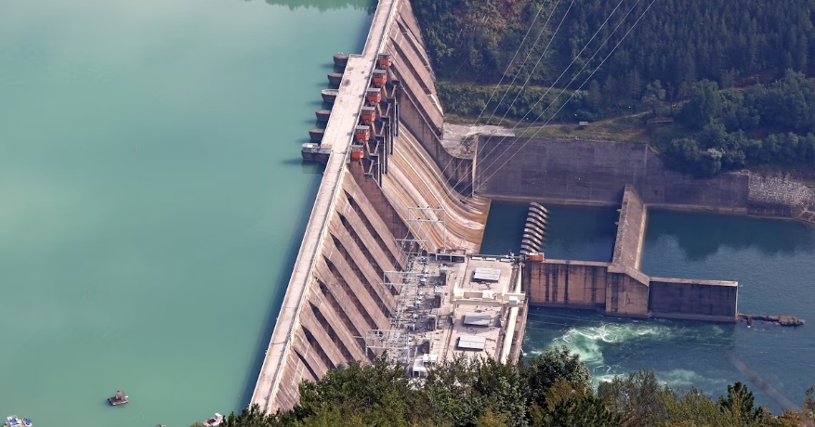

1. **OBJECTIVES OF STUDY:**

1. **To make us familiar about hydropower.**

**2. To know how electricity is transmitted to our households.**

**3. To know on what basis electricity is distributed to each of us.**

**4. To know the basics of how energy transmissions take place.**

**5. To find the problems regarding the production and distribution of hydroelectricity in Nepal.**

**6. To learn the current situation of the hydroelectricity in Nepal.**

## ****LIMITATIONS OF THE STUDY:****

## **1**.** Data used in this study is not recent and is not taken from the official sites.**

## **2. Due to the limitation of the time period, the proper research on the topic was unable to be conducted.**

## **3. Improper methods/ techniques used to collect the data.**

## **4. Along with that the study is unable to provide the information about the total available alternative sources of energy in Nepal and their uses**.****

### **4.1 HYDROPOWER IN NEPAl**

Nepal's river has a storage capacity of 202,000 million cubic meter, which includes about 74% amount from three major rivers, Koshi, Gandaki, and Karnali. Geographically, perennial nature of rivers estimated an annual runoff accounting up to 170 billion m3 that flows from steep gradient and rugged topography and estimated 45.610 MW, feasible for hydropower generation which is equivalent to 50% of the total theoretical potential of 83, 290 MW. The hydropower system is dominated by run-of-river schemes in Nepal while storage schemes have been benefited to control flood, provide irrigation facility, drinking water supply, navigation, recreation, tourism, aquaculture, and generate revenue The source of energy shares from a conventional source in Nepal is 87% as a significant share of electricity and renewable energy with 56.1% households have access of electricity Hydropower is the main source of energy in Nepal, nearly 90% installed capacity and 90% generation of electricity. Nepal Electricity Authority (NEA) has a total installed capacity of about 746 MW and 26 MW operating from mini and micro hydropower plants in the hills and mountains of Nepal. There is a significant energy deficit due to the poor economic and instable government to continue the electricity supply. However, the country has three strategic considerations for exploring large-scale hydropower like storage types of projects, to fulfill country's required demands through installation of medium sized projects and finally small hydropower projects targeting to fulfill demand of the local communities. The hydropower potential of Nepal's river systems is about 83,000 MW. Hydropower utilization is currently less than one per cent of the proven potential. The total installed hydroelectric generation capacity is around 650 MW. This power has been made available to 2,053,259 consumers through 1980 km of transmission and distribution lines (2011 data). The national grid represents the overall hydroelectric industry of Nepal as it accounts for almost 98 per cent of the capacity and 99 per cent of the energy supplied. Apart from national grid, both the public and private sectors and independent power producers manage isolated supply systems. At present there are 11 major hydroelectric plants, 16 grid connected small hydroelectric plants, 23 isolated small hydroelectric plants, 22 Private Sector Hydro Projects known as Independent Power producers (IPPs) connected to Integrated Nepal Power System (INPS) in operation in the country. During 2010/11 Nepal Electricity Authority (NEA) signed Power Purchase Agreements (PPAs) worth 714.77 MW, which was almost double the total capacity of power purchase agreement signed in the past.Total capacity of power purchaseagreement signed by NEA so far has reached 1,118.35 MW. There are 4 major hydro power projects under construction and 8 small scale hydropower projects under 10MW being developed by IPPs. Electricity prices in Nepal had been kept too low and below cost-recovery levels in the past in absence of adequately independent regulatory regime. However, NEA was able to generate an operating profit in 2018 due to actions taken in the recent past including bringing an end to load-shedding, controlling operational expenses, and implementing financial reform measures. Low average price of imported electricity also contributed to the profitability. Yet, NEA still has about NRs10 billion in cumulative losses. Nepal's water resources endowments are extraordinary. It endows approximately 6,000 rivers with a total length of 45,000 kilometers (km). Average water runoff from these rivers is about 220 billion cubic meters annually. Based on the water resources availability, it Nepal's technical potential for hydropower has been estimated to be 83 gigawatts (GW). Usually all the technically potential water resources will not be developed due to other constraints. About 42 GW is considered economically viable. The major river basins are SaptaKoshi, Karnali, Sapta Gandaki, Mahakali, and the Southern rivers (Gurungand Oh 2011); their respective generation capacities are presented in Table.

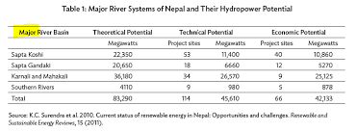

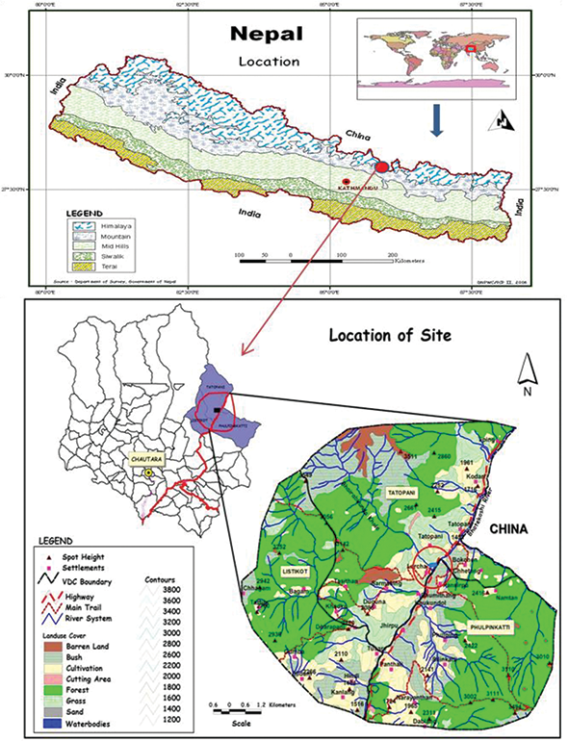

**4.2 TRANSMISSION:**

The NEA transmission system consists of 1,563 km of 132 kV lines, 350 km of 66 kV lines, and 2,500 km of 33 kV lines. A 132 kV transmission ring around the Nepal Electricity Transmission Expansion and Supply improvement Project (NEP RRP 41155) 3 Kathmandu valley is being completed by the NEA. The completion of this series of projects will cater io the demand growth in the Kathmandu valley, will reduce losses, and improve supply quality and reliability. Timely commissioning of transmission lines is critical for evacuation of much-needed new hydropower generation. Several IPs have been constrained in undertaking new power development initiatives because of the difficulties in power evacuation. The NEA completed its most recent comprehensive transmission planning study in July 2006. However, the study did not directly address increased transmission connectivity with India, an issue that has far-reaching implications for Nepal's power sector and the development of large-scale export-focused hydropower plants in Nepal. Construction of 175 km of high-voltage transmission line and 377 megavolt- amperes (MVA) of transmission substation capacity wasprogrammed for the Interim Plan period.

**4.3 DISTRIBUTION OF ELECTRICITY:**

The NEA presently serves near to 2 million customers across all 75 districts of the country. It sold 2,204 gigawatt-hours (GWh) of electricity in FY2007, an increase of 10% over the previous year. Domestic and industrial consumers represent almost 80% of sales. Only 40% of the population has access to electricity services, with 33% having access to the grid and the NEA off-grid tacilities, with the remaining 7% served by micro-hydro plants developed by local entrepreneurs, and other alternate sources. The Interim Plan expressed the need to connect an additional 450.000 rural households to the national electricity grid and has identified 651 km of 33 kV lines, 3,163 km of 11 kV lines, 5,978 km of low-voltage lines, and 113 MVA of 33/11 kV substation capacity to be added during the plan period.

**4.4 IMPORTANCE OF HYDROELECTRICITY**

1. Clean fuel source, since hydropower is fueled by water. Therefore, it won't pollute air.

2. Domestic source of energy, so each state or province can produce their own energy without relying on international fuel sources.

3. Renewable power source, which is more reliable and affordable than fossil fuels.

4. Hydropower plants can provide power to the grid immediately, and provide back- power during major electricity outages.

5. Hydroelectricity increases the stability and reliability of electricity systems.

6. It is a reliable source of energy.

7. It is one of the safest sources of energy.

8. It is a one-time investment as once built it can be used for a long time.

**4.5 PROBLEMS RELATED TO HYDROPOWER IN NEPAL**

Though Nepal is rich in water resources there are very few hydropower plants in operation it is because of the following reasons:

1. Lack of political will and unstable political condition.

2. Lack of capital for investment.

3. Lack of specialized and highly skilled manpower for its operation and maintenance.

4. Problems caused due to landslides, earthquakes and other natural calamities.

5. Inadequate transmission lines and its insufficient capacity.

6. Lack of public-private partnership.

7. Lack of needed resources for operation and maintenance.

**4.6 POSSIBLE SOLUTION MEASURES:**

1.Stable political environment should be created and people with higher power should support such projects.

2. Foreign capital investment should be promoted.

3. Skilled manpower should be produced for thus sectors.

4. Transmission lines should be upgraded and should reach each households.

1. **RESEARCH METHODOLOGY**

**5.1 DATA SOURCES:**

For the project I used both primary and secondary sources. For primary data collection 1 read many documents written on this topic as well as consulted with my subject teacher and an engineer of a hydropower project I knew and I also took few surveys to find out my conclusions. For secondary data collection I read many unpublished articles on this topic, read books from the library and some journals.

**6. ANALYSIS**

Nepal has an estimated 42.000 MW hydropower potential, 100 MW of micro hydropower, 2100 MW of solar power for the grid, and 3000 MW of wind power renewable energy commercially exploitable. Nepal's ninth plan addressed to generate 22,000 MW electricity by 2017 and other studies estimated 10,000 MW within 10 years and 17,000 MW by 2030. They policy of government for small hydropower generation from 1 to25 MW has focused on providing incentives to local institutions/organizations and promoting the development of medium hydropower from >25 to 100 MW for national private sectors and seek support for large hydropower projects. The electricity generation in FY 2013/2014 was 746 MW, which increased by 4.98% (782.45 MW) in 8 months of the year and 1987.36 km transmission line has been extended. The electricity consumers have been increased 2,789,678 in the number and 116,090-km-extended line of electricity distribution. The total demand of the electricity 1291.1 MW has limited to just 782.45 MW by the end of the year.

The hydropower development started from 1911 generating 1.1 MW electricity, before first five year plan and consequent development in the thirteenth plan which targeted to 668 MW hydropower generation in 2018. The growing energy demand has estimated at 11,500 MW by 2030 for moderate GDP growth (5.6%) and higher demand for GDP growth of >8%. Thus, the existing policy and legal arrangement need to be put in a place, considering the present situation for the sustainable development of hydropower for the overall development of the country. As per the WECS energy strategy 2012, clean energy technology (CET) scenario, in which the fossil fuels should be decreased by 20% by 2020 and 30% by 2030.

1. **POLICY AND LEGAL INSTRUMENTS IN HYDROPOWER SECTOR:**

Nepal's liberal foreign investment policy attracted donor's assistance in hydropower sector since the 1980s. Among the areas of investment in industry manufacturing, services, touris construction, agriculture, minerals, and energy, hydropower sector has a widespread investment opportunity due to liberal policy and environmental friendly enacted legal instruments. The government has prioritized the hydropower sector for foreign and domestic investment.

Nepal's Climate Change Policy (2011) has envisaged protection of environment and sustainable human development by promoting the use of clean energy, reducing GHG emissions, enhancing the climate adaptation, and resilience capacity of local communities. The emissions of carbon threaten basic elements of society like water, food production, health, and the environment imposing a huge social cost as anywhere from $8 per ton to a high as $100 per ton of CO2. Fossil fuel combustion for transportation and electricity generation are the main source of CO2 generation, contributing more than 50% of the emissions, and generation of electricity with thermal power plants contributes 66% the world's electric generation capacity.

1. **FINDINGS:**

Hydropower was one of the first sources of energy used for electricity generation, and until 2019, hydropower was the largest source of total annual Nepal's renewable electricity generation. The amount of precipitation that drains into rivers and streams in a geographic area determines the amount of water available for producing hydropower. Seasonal variations in precipitation and long-term changes in precipitation patterns, such as droughts, can have large impact on production of hydroelectricity. Because the source of hydroelectric power is water, hydroelectric power plants are usually located on or near a water source. Nepal has purposed many hydropower project for the commercial growth of the electricity. Nepal is aiming for the production of more electricity so that it can be sold to other countries and increase the economy of the country

Currently over 12 hydropower projects are under construction in Nepal. Some major under-construction projects are shown in Table. Several projects are supposed to be completed in 2016.2017. Due to recent severe earthquake, most hydro projects have been delayed. The government of Nepal has developed a plan "2016-2026 National Energy Crisis Reduction and Electricity Development Decade in February 2016. This plan aims to end the current power shortages within three years and to generate surplus power for export. Some prospective (future) power plants are shown in Table. However, no detailed feasibility study has been undertaken or reported about these hydro projects. It may be noted that most Nepalese power plants are "Run-of-River" type. Hence they generate power well during the monsoon season and less power during the dry season.

1. **CHALLENGES AND OPPORTUNITIES:**

The major thrust for hydropower development in Nepal is the financial investment and risk of natural catastrophe. On the other hand, the environmental and social impacts are linked to the development of hydropower projects which obey misrepresented and this delays the process, or in some cases stops the development of hydropower project.

Landslide dam outburst floods (LDOFs) is one of the major challenges for hydropower development in Nepal due to its rugged topography, susceptible to landslides, very high relief, and intense precipitation during the monsoon period, for example, UBHEP event of July 2016 learnt more about it. As the glacier melt, water volume initially increases with an increase of temperature and hydropower potential generally increases accordingly, as it largely depends on the lean season flows. Nepal's hydropower generation generally follows the pattern of dry season flows.

The flooding events like GLOFS, LDOFs, and flash floods increase sediment or debris flow on the reservoir that may loss production capacity. In July 1993, Kulekhani project had turn out such event causing high sediment and debris inflow to the reservoir because of flood. Similarly, in 2014, landslide occurred during monsoon which badly hit United Modi Project 10 MW, and damaged the concrete cover slab of hundreds of meters of the headrace tunnel and canal covered by debris.

Nepal's energy market is dependent on hydropower generation. The power demand for Nepal was 470 MW in 2002-2003 with available 2261 GWh, out of which 2107 GWh energy system within NEA was met by hydropower generation (93%). Despite having a potential to generate 43,000 MW of electricity, Nepal's installed hydropower capacity is just 787 MW, which is less than half of the demand. Even at a high growth scenario of about 12% per annum, peak power demand will reach only 3400 MW and energy requirement 16,000 GWI in 2020. Thus, even in the foreseeable future Nepal's electricity needs will still be a small percentage of its realizable hydropower potential. Thus, in order for Nepal to exploit its hydropower potential in a substantive way, it has to look for an export market where there is a demand for such power (Nepal's Electricity Act, 1992, provides for export of electricity generated by a developer to foreign country by entering into an agreement with the government.

1. **CONCLUSION:**

Having a theoretical potential of nearly 90,000 MW hydropower at least 42,000 MW is technically and economically feasible. Unfortunately, Nepal is utilizing only 2% of it (i.e., 98% remains unutilized). On the other hand, over 60% population do not have access to gr connected power in Nepal. Moreover, the annual growth of power demand (grid connected is over 10%. During the lean season, the power shortage becomes so acute that NEA needs ration the power up to 12 hours each day. Nepal's prosperity is certainly dependent on the utilization of its hydro resources. Nepal can be one of the major green power exporters in region. The revenue from power export will help to achieve economic prosperity and generate funds for education, healthcare, housing, agriculture and infrastructures. During hydropower developments in Nepal, some extra care is required to be undertaken. Hence. hydropower plants with dam must be well planned and designed to mitigate the environmental impact. Most Himalayan Rivers contain huge quantities of sediment with ha abrasive particles.

1. **BIBLIOGRAPHY:**

➤ https://www.intechopen.com/chapters/53350

➤ https://www.enbridge.com/energy-matters/energy-school/hydro-generation

➤ https://pdf.sciencedirectassets.com/

➤ https://en.wikipedia.org/wiki/List_of power stations in Nepal

➤ https://en.wikipedia.org/wiki/Hydropower

➤ https://www.nea.org.np/

➤ Physics Practical book - Garuda Publication