MADAN BHANDARI MEMORIAL ACADEMY NEPAL
COLLEGE OF ENGINEERING
JOINT CONSTITUENT OF POKHARA UNIVERSITY
URLABARI-03, MORANG


A Major Project Proposal On
“Smart City Information Portal”
A project report submitted for the partial fulfilment of requirements for the degree of Bachelor of Engineering in Computer

Submitted By:
BUNU KHATIWADA [22070012]
DIPESH KUMAR MAHATO [22070014]
KAJJAL CHAMLAGAIN [22070020]
RAJA KUMAR SHAH [22070037]

Submitted To:
Department Of Computer Engineering
Madan Bhandari Memorial Academy Nepal and Pokhara University
Supervised By: Er. Basant Prasad Yadav
TABLE OF CONTENTS
LIST OF FIGURES i
CHAPTER 1: INTRODUCTION 1
1.1 Background 1
1.2 Problem Statement 2
1.3 Objectives 3
1.4 Applications 3
CHAPTER 2: LITERATURE REVIEW 5
2.1 Smart City and Digital Governance 5
2.2 Existing City Information and E-Governance Systems 5
2.3 Role of Modern Web Technologies in Smart Cities 6
2.4 Research Gap and Proposed System 6
CHAPTER 3: METHODOLOGY 7
3.1 Agile Methodology 7
3.2 Tools and Technology 8
3.3 Procedure 10
3.4 System Architecture 11
3.5 Er Diagram 12
CHAPTER 4: EPILOGUE 13
4.1 Expected Outcomes 13
4.2. Gantt Chart 14
REFERENCES

LIST OF FIGURES
Figure 1: Agile Methodology 8
Figure 2: System Architecture 11
Figure 3: Er Diagram 12
Figure 4: Gantt Chart 14

CHAPTER 1: INTRODUCTION

1.1 Background
Traditionally, city information and public services are managed through manual processes, physical offices, notice boards, paper documents and separate departmental systems. For example, citizens often have to visit the municipal offices several times to obtain information about public services, announcements, permits, event or to file complaints. This approach is time-consuming, inefficient and can lead to communication gaps, delays in service delivery, lack of transparency and difficulty in accessing updated information. With the growth of cities and the increase in population, it becomes more difficult for both citizens and local authorities to deal with information manually.
The Smart City Information Portal is a digital platform that integrates and presents city information and services in a single online portal. The Internet provides citizens the ability to access announcements, emergency contacts, public service information, event updates, and complaint submission facilities from anywhere and at anytime. They can communicate with the city authorities and get information through a user-friendly portal without having to visit several offices. This enhances communication, cuts down on paperwork, boosts transparency, speeds up service delivery and increases citizen participation in the city governance. Hence, the portal helps in the development of a more efficient, accessible and citizen-oriented urban environment.
Project Features:
- User Registration and Login System: This feature allows citizens and administrators to create accounts and securely log in to the portal. Authentication is implemented using JWT to ensure data security and controlled access.
- City Announcements and Notifications.: Administrators can post important announcements such as public notices, road closures, holidays, and emergency alerts. Citizens can view these updates in real time.
- Public Service Information System: The portal provides information about various municipal services, including office locations, operating hours, required documents, and service procedures.
- Emergency Services Directory: The system provides contact information for emergency services such as police, ambulance, and fire departments.

1.2 Problem Statement
The rapid growth of urban populations and the escalating demands for efficient public services present cities with formidable challenges in managing and disseminating information effectively. Many municipalities still handle city information (public announcements, emergency contacts, government services, community events etc.) manually or across different departments and platforms. This disjointed approach makes it hard for the citizens to get correct and timely information, which causes inconvenience and less public involvement. Also, the traditional ways of submitting complaints and service requests are predominantly paper-based, resulting in delays, lack of transparency and poor tracking of issues.
The lack of a centralized digital system also results in communication gaps between citizens and local authorities, impeding effective governance and decision-making. Citizens are often required to visit several offices to get information or submit requests, which is time-consuming and resource-consuming. As cities are rapidly moving towards digital transformation, an integrated platform to deliver city services, improve transparency and increase citizen engagement is needed. The proposed Smart City Information Portal aims to overcome these challenges by offering a unified, user-friendly, and accessible platform to centralize city information and services, thus supporting efficient urban management and fostering the development of smart and sustainable cities.

1.3 Objectives
1. To develop a centralized Smart City Information Portal that provides citizens with easy access to city information, public services, and announcements.
2. To improve communication, transparency, and citizen engagement through digital services such as complaint management and real-time updates.

1.4 Applications
1. Public Information Dissemination
- Provides citizens with real-time access to city announcements and notices.
2. Complaint Management System
- Enables citizens to submit and track complaints online
3. Emergency Service Access
- Offers quick access to emergency contacts such as police, ambulance, and fire services.
4. Location-Based Services
- Uses maps to help citizens locate public facilities and services.

1.5 Scope and Significance
- Provides a centralized platform for accessing city information and public services.
- Enables citizens to view announcements, notifications, and event updates in real time.
- Allows users to submit complaints and feedback online, reducing manual paperwork.
- Offers quick access to emergency service contacts such as police, ambulance, and fire departments.
- Facilitates efficient management of city data through an admin dashboard.
- Improves communication and transparency between citizens and local authorities.
- Enhances citizen engagement and participation in urban governance.
- Contributes to efficient service delivery and better urban management.

CHAPTER 2: LITERATURE REVIEW

2.1 Smart City and Digital Governance
Smart cities concept has emerged as a response to rapid urbanization, population growth and need for efficient public services. Smart cities use information and communication technologies (ICT) to enhance urban infrastructure, governance and sustainable development. As defined by Caragliu et al., smart cities are targeted at integrating human capital, social capital and ICT infrastructure to increase the quality of life and urban efficiency [1]. Similarly, Nam and Pardo point out that smart cities integrate technology, people and institutions to improve governance and citizen engagement [2]. These studies show that digital platforms are important in the current urban development.

2.2 Existing City Information and E-Governance Systems
E-governance systems have been widely adopted to improve the delivery of public services and reduce dependency on manual processes. According to Anthopoulos, e-governance applications help governments provide transparent, efficient, and citizen-friendly services through digital platforms [3]. Many municipalities have implemented web-based systems for announcements, complaint registration, and service requests. However, most of these systems are fragmented and do not provide a unified platform for all city services. This limitation reduces usability and efficiency for citizens.

2.3 Role of Modern Web Technologies in Smart Cities
Modern web technologies such as React.js, Node.js, and MongoDB have significantly improved the development of scalable and responsive applications. According to recent studies, JavaScript-based full-stack development enables faster development cycles and better performance in real-time systems. Integration of APIs like Google Maps improves location-based services, while Cloudinary supports efficient media storage and management. Socket.io enables real-time communication between users and systems, which is essential for notifications and live updates in smart city platforms [4]. These technologies collectively support the development of efficient and user-friendly municipal systems.

2.4 Research Gap and Proposed System
Despite advancements in smart city technologies, there is still a gap in developing a fully integrated, user-friendly, and scalable platform that combines all essential city services. Most existing systems do not provide unified access to announcements, complaints, emergency services, and citizen engagement tools in a single platform. To address this gap, the proposed Smart City Information Portal is designed to integrate all major municipal services into one system using modern web technologies. This system aims to improve communication between citizens and authorities, enhance transparency, and support efficient urban management through a centralized digital platform [6].

CHAPTER 3: METHODOLOGY

3.1 Agile Methodology
The Agile model is a flexible and iterative approach to software development that focuses on breaking the project into smaller parts called sprints, allowing teams to build, test, and improve the product continuously. In the context of Smart city information portal the system consists of multiple interconnected modules such as user authentication, city announcements, complaint management, emergency services, and admin dashboards. Instead of developing the entire system at once, Agile divides the project into small development cycles called sprints, where each sprint focuses on designing, developing, testing, and improving specific features. This allows the development team to continuously refine the system based on feedback from supervisors and users, ensuring that errors are identified and corrected early. Agile also improves collaboration among team members, enhances adaptability to changing requirements, and ensures steady progress throughout the project lifecycle. As a result, it helps deliver a more reliable, user-friendly, and efficient Smart City Information Portal that effectively meets the needs of both citizens and city administrators.

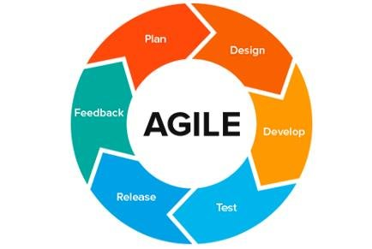
Figure 1: Agile Methodology

3.2 Tools and Technology

3.2.1 Frontend Tools
- React.js: Frontend library used to build interactive user interfaces.
- Tailwind CSS: Utility-first CSS framework used for fast and responsive UI design.

3.2.2 Backend Tools
- Node.js: Runs JavaScript on the server side.
- Express.js: Backend framework used to create APIs and handle server-side logic.
- JWT: Used for secure user authentication and authorization.

3.2.3 Database
- MongoDB: NoSQL database used to store user data, complaints, and announcements.
- Cloudinary: Cloud service used for storing and managing images and files.

3.2.4 Real Time Authentication
- Socket.io: Enables real-time communication and instant notifications between users and server.

3.2.5 Development Tools
- Visual Studio Code: Code editor used for frontend and backend development with extensions like Live Server and MongoDB tools.
- GitHub: Hosts the project, tracks version history, and supports team collaboration.

3.3 Procedure
The development of the Smart City Information Portal will follow the Agile methodology, which allows the project to be developed incrementally through multiple iterations or sprints. Initially, the project requirements will be gathered by studying the needs of citizens and local authorities to identify the necessary features and functionalities. Based on these requirements, system models such as use case diagrams, ER diagrams, and system architecture will be designed. The development environment will be set up using Visual Studio Code (VS Code) as the primary code editor for writing, debugging, and managing the project source code. The frontend of the application will be developed using React.js and Tailwind CSS to create an interactive and responsive user interface, while the backend will be implemented using Node.js and Express.js to handle server-side logic and APIs. MongoDB will be used as the database to store user information, complaints, announcements, and other city-related data. Secure user authentication and authorization will be implemented using JWT (JSON Web Token)
For efficient version control and team collaboration, Git and GitHub will be used to manage source code, track changes, and maintain project backups. Additional services such as Cloudinary for image storage, Google Maps API for displaying locations of public facilities, and Socket.io for real-time notifications will be integrated to enhance system functionality. The project will be developed and tested module by module, including user management, complaint handling, announcements, and emergency services. Continuous testing and feedback will be incorporated throughout the development process to ensure software quality and reliability. Finally, the completed system will be deployed on cloud platforms such as Vercel or Render, and comprehensive documentation will be prepared to support future maintenance and scalability.

3.4 System Architecture
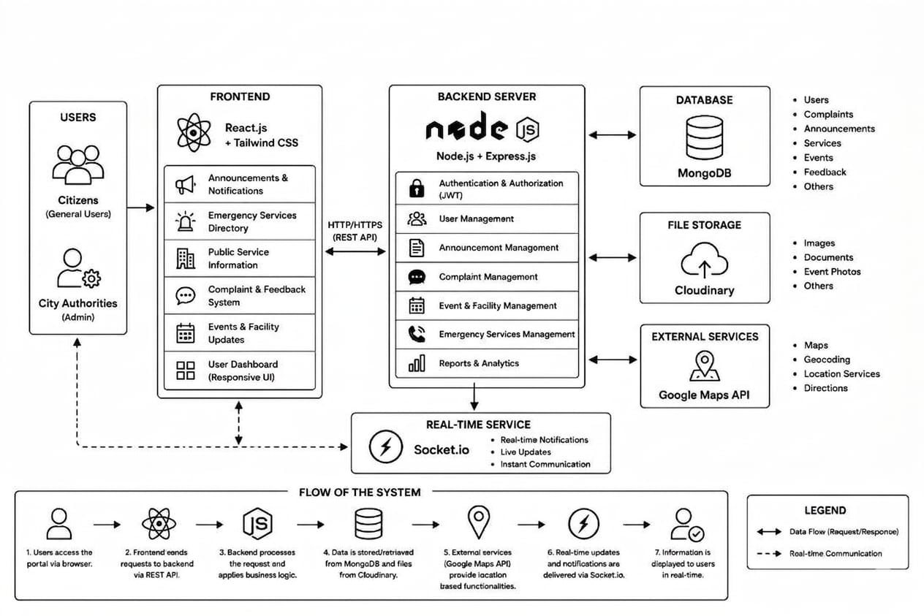
Figure 2: System Architecture

3.5 Er Diagram

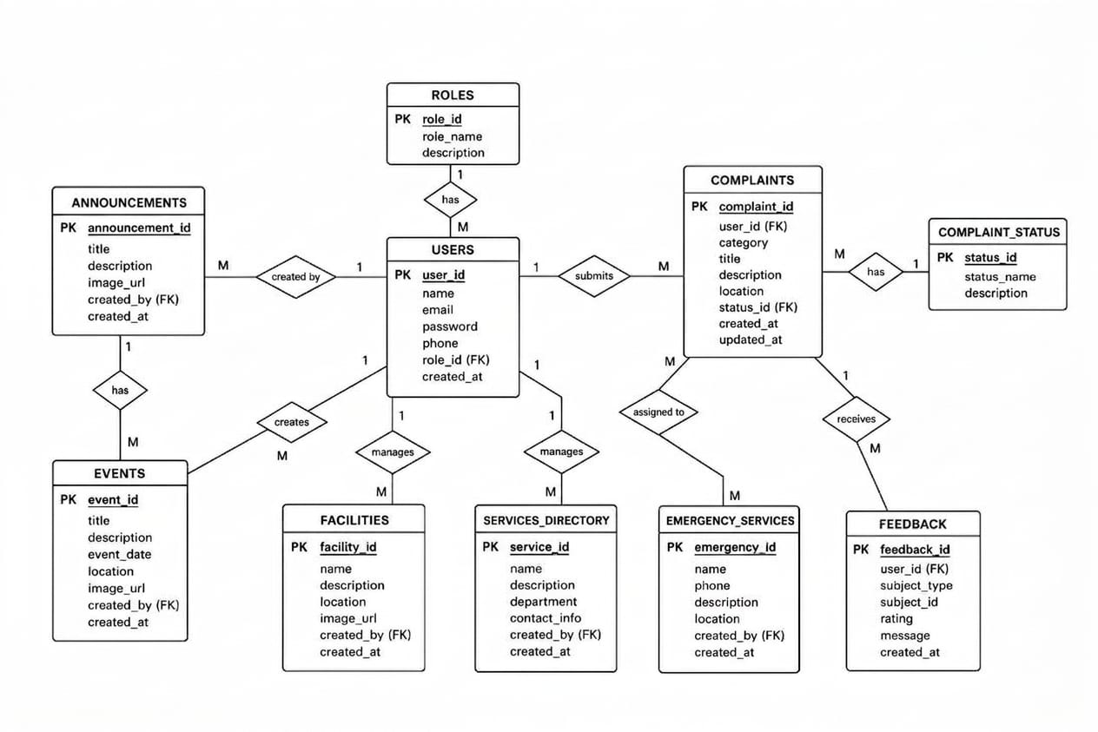
Figure 3: Er Diagram

CHAPTER 4: EPILOGUE

4.1 Expected Outcomes
- Centralized Information System: Provides a single platform where citizens can access city-related information and services conveniently
- Improved Communication: Enhances interaction between citizens and local authorities through announcements, notifications, and feedback mechanisms.
- Efficient Complaint Management: Enables users to submit and track complaints online, leading to faster issue resolution.
- Real-Time Access to Information: Allows citizens to receive up-to-date information on city events, emergencies, and public services.
- User-Friendly Platform: Offers an intuitive and accessible interface for both citizens and administrators.
- Responsive Design: The platform will be fully responsive, ensuring a smooth user experience on mobile devices, tablets, and desktops.
- Sustainable City Development: Supports the creation of more connected, efficient, and sustainable urban environments.

4.2. Gantt Chart

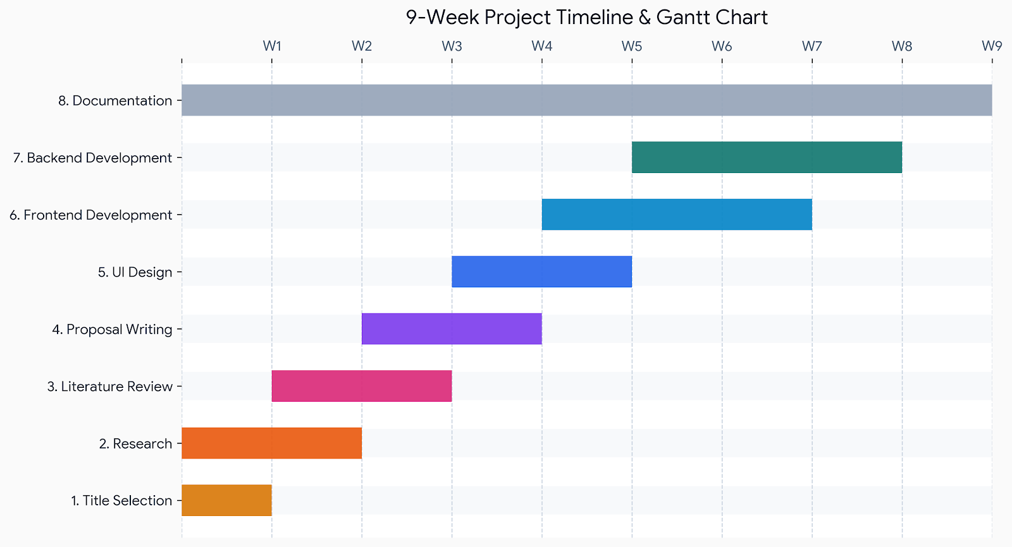
Figure 4: Gantt Chart

REFERENCES
[1] A. Caragliu, C. Del Bo, and P. Nijkamp, “Smart Cities in Europe”, Journal of Urban Technology, vol. 18, no. 2, pp.65-82, 2011.
[2] T. Nam and T. A. Pardo, “Conceptualizing Smart City with Dimensions of Technology, People, and Institutions,” Proceedings of the 12th Annual International Conference on Digital Government Research
[3] L. Antopoulos, Smart City Emergence: Cases from Around the World, Elsevier, 2017.
[4] M. Batty et al., “Smart Cities of the Future,” The European Physical Journal Special Topics, vol. 214, pp. 481-518, 2012.
[5] H. Zhang and J. Liu, “Challenges in E-Governance Systems and Smart City Implementation,”International Journal of Computer Applications, vol. 182, no.45, 2019.
[6] S. Alawadhi et al., “Building Understanding of Smart City Initiatives,”
Proceedings of the IEEE International Confernce on Smart Cities, 2012.

