Dipesh

Paudel

# Career Objective

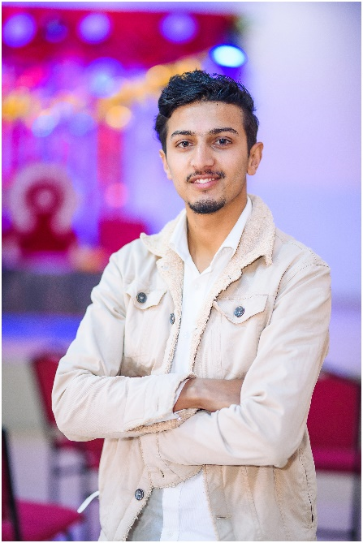I'm a passionate learner, motivated and curious person who is currently pursuing the Bachelor in Technology in Computer Science Engineering and seeking for opportunity to utilize and sharpen my skills in reputed company where I can enhance my working skills, strengthen work ethics and gain experience.

# Skills

|  |  |
| --- | --- |
| * JavaScript * CSS * HTML | * Creative Design * Computer Skills * Communication Skill |

Project

Contact

**Address:**

Pokhara 19, Nepal

**Phone:**

+977 9806615687

**Email:**

[dipeshpaudel1999@gmail.com](mailto:dipeshpaudel1999@gmail.com)

**Github:**

www.github.com/DipeshPaudel1999

**LinkedIn:**

[https://www.linkedin.com/in/dipesh-paudel-37b926246/](https://www.linkedin.com/in/dipesh-paudel-37b926246/ww.linkedin.com/in/dipesh-%20paudel-37b926246)

Language

* English
* Nepali
* Hindi
* Punjabi

Hobbies

* Football
* Guitar
* Book Reading
* Design
* Vlogging

## Web Development

## Startup Business Website

https://dipeshpaudel1999.github.io/Startup_Website/

* **Professional Profile Website**

<https://dipeshpaudel1999.github.io/Multiplayer-Dice-Game/>

# Education

2019-Present **B.Tech Computer Science Engineering**

Amritsar Group of Colleges **- 75.14%**

2017-2018 Higher Secondary Level / 12th

Bharati Bhawan Hr. Sec. School - 68.14%

2015-2016 School Leaving Certificate (SLC) / 10th

Life Angel Sec. English School - 88.%

# Achievements

* **Rotract Club of Annapurna**
  + Fundraising and rehabilitate casualties of Earthquake
  + Afforestation on bare hills of Pokhara valley.
* Winner of AGC Football Tournament as a team captain.
* Initiated and organized Freshers Party and Prayash-Talent Hunt event as a member of Pallas Athena Cultural Society (PACS)