Assignment 1 (Unit 4)

1. Get this graph in R/R Studio using the codes provided in the class slide of session 18:

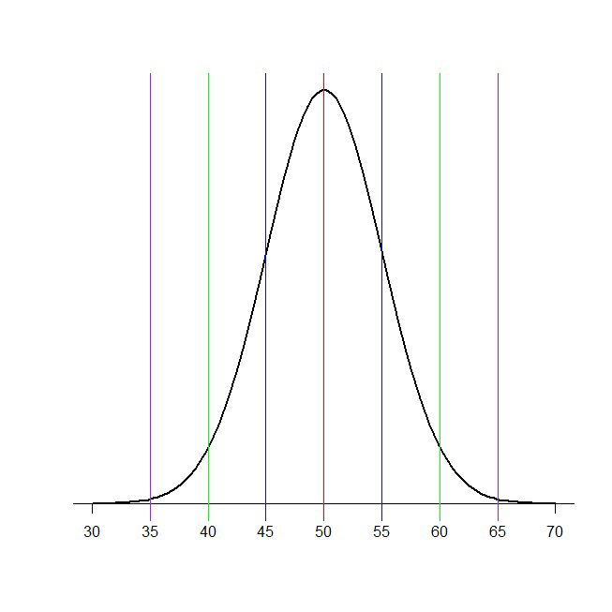

*#Define mean and SD*  
pop_mean<-50  
 pop_sd<-5  
 *#Define lower and upper limits*  
LL <-pop_mean-pop_sd  
 UL <-pop_mean+ pop_sd  
 *#Create a sequence of 100 x values based on pop mean and sd*  
x <-seq(-4,4, length=100)*pop_sd+pop_mean  
 y <-dnorm(x, pop_mean, pop_sd)  
 plot(x,y, type="l", lwd=2, axes=F, xlab="", ylab="")  
 sd_axis_bounds= 5  
 axis_bounds<-seq(-sd_axis_bounds*pop_sd + pop_mean, sd_axis_bounds*pop_sd+ pop_mean, by=pop_sd)  
 axis(side=1, at=axis_bounds, pos=0)  
 abline(v=50)  
 abline(v=50+pop_sd)  
 abline(v=50-pop_sd)  
 abline(v=50+2*pop_sd)  
 abline(v=50-2*pop_sd)  
 abline(v=50+3*pop_sd)  
 abline(v=50-3*pop_sd)

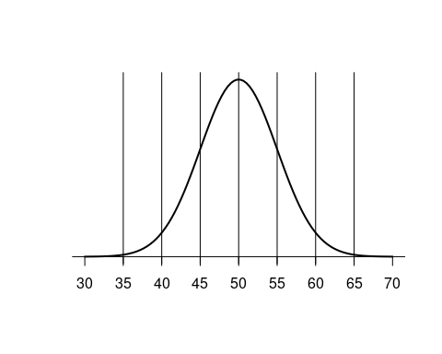

1. Add annotation in this graph as follows:

45-55: mean ± 1SD = 67% data with double edge arrow

40-60: mean ± 2SD = 95% data with double edge arrow

35-65: mean ± 3SD = 99% data with double edge arrow

**Note: You can use the “ggplot2” package if you want!**

library(ggplot2)  
 ggplot(data=as.data.frame(x,y),aes(x=x,y=y))+geom_line()+scale_x_continuous(breaks = axis_bounds)+geom_vline(xintercept = seq(30,70,by=pop_sd))+annotate(geom = "text",x = 50,y=mean(y)+0.01, label = "67% data")+annotate(geom = "segment",x = 45,y=mean(y)+0.012,xend = 55,yend = mean(y)+0.012)+annotate(geom = "text",x = 50,y=mean(y)+0.02, label = "95% data")+annotate(geom = "segment",x = 40,y=mean(y)+0.025,xend = 60,yend = mean(y)+0.025)+annotate(geom = "text",x = 50,y=mean(y)+0.03, label = "99% data")+annotate(geom = "segment",x = 35,y=mean(y)+0.035,xend = 65,yend = mean(y)+0.035)

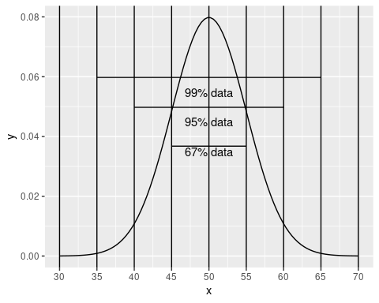

Assignment 2 (Unit 4):

1. Get stem-leaf plot, histogram and normal q-q plot of mpg variable of the built-in “mtcars” data of R.

cars_data<-mtcars  
 ggplot(data=cars_data,aes(x=mpg))+geom_histogram(binwidth = 5)

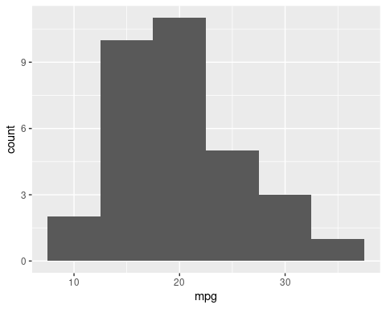

ggplot(data = cars_data,aes(mpg))+geom_histogram(binwidth = 5)+coord_flip()

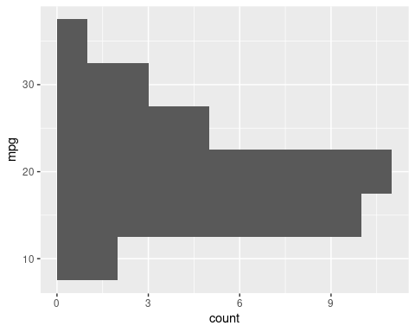

cars_data<-mtcars  
 qqnorm(cars_data$mpg, pch = 1, frame = FALSE)  
 qqline(cars_data$mpg, col = "steelblue", lwd = 2)

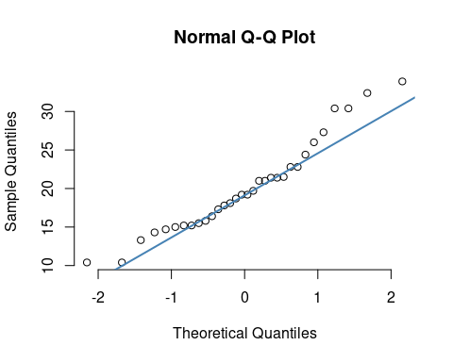

1. Test the normality of mpg variable of mtcars data using Shapiro-Wilk test of normality and take decision based on the p-value of this test for null and alternative hypothesis you wrote for this test. Explain why this test of normality must be used here!

shapiro.test(cars_data$mpg)

##   
## Shapiro-Wilk normality test  
 ##   
## data: cars_data$mpg  
 ## W = 0.94756, p-value = 0.1229

Null Hypothesis(H0): The data follows normal distribution Alternative Hypothesis(H1): The data does not follow normal distribution Since the p-value obtained from the test is not less than 0.05 we can say that the data comes from normal distribution i.e Null Hypothesis is accepted.

Since the number of samples (32)<50 we cannot use Kolmogorov-Smirnov. Thus, we have to use Shapiro-Wilk normality test.