Project 3

Dipesh Poudel

12/2/2021

# Project 3 - Data Visualization in R

## Part 1: Data visualization with Base R graphics packages

Use the built-in CO2 data and do as follows:

# Loading the CO2 data  
co2_data<-CO2  
str(co2_data)

## Classes 'nfnGroupedData', 'nfGroupedData', 'groupedData' and 'data.frame': 84 obs. of 5 variables:  
## $ Plant : Ord.factor w/ 12 levels "Qn1"<"Qn2"<"Qn3"<..: 1 1 1 1 1 1 1 2 2 2 ...  
## $ Type : Factor w/ 2 levels "Quebec","Mississippi": 1 1 1 1 1 1 1 1 1 1 ...  
## $ Treatment: Factor w/ 2 levels "nonchilled","chilled": 1 1 1 1 1 1 1 1 1 1 ...  
## $ conc : num 95 175 250 350 500 675 1000 95 175 250 ...  
## $ uptake : num 16 30.4 34.8 37.2 35.3 39.2 39.7 13.6 27.3 37.1 ...  
## - attr(*, "formula")=Class 'formula' language uptake ~ conc | Plant  
## .. ..- attr(*, ".Environment")=<environment: R_EmptyEnv>   
## - attr(*, "outer")=Class 'formula' language ~Treatment * Type  
## .. ..- attr(*, ".Environment")=<environment: R_EmptyEnv>   
## - attr(*, "labels")=List of 2  
## ..$ x: chr "Ambient carbon dioxide concentration"  
## ..$ y: chr "CO2 uptake rate"  
## - attr(*, "units")=List of 2  
## ..$ x: chr "(uL/L)"  
## ..$ y: chr "(umol/m^2 s)"

1. Create bar graph of plant, type and treatment variables

variables<-c('Plant','Type','Treatment')  
for (var in variables){  
barplot(table(co2_data[var]),main = paste("Bar Graph of ",var),  
 xlab = var, ylab = "Frequency")   
}

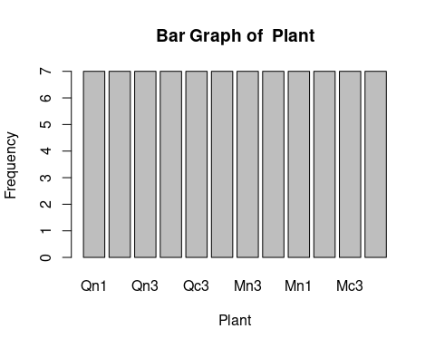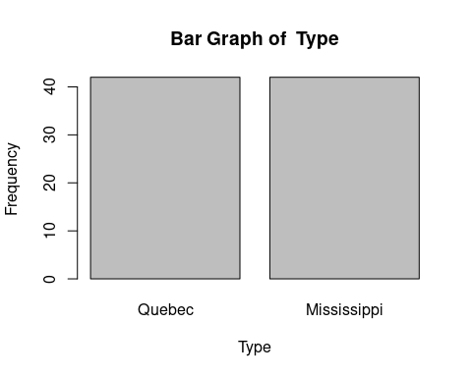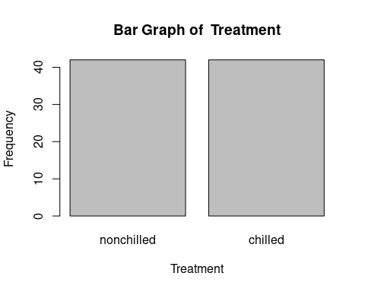 2. Create histogram of conc and uptake variables Histogram of conc variable

# Histogram of conc variable  
hist(co2_data$conc,main = "Histogram of conc",xlab = "conc",ylab = "Frequency")

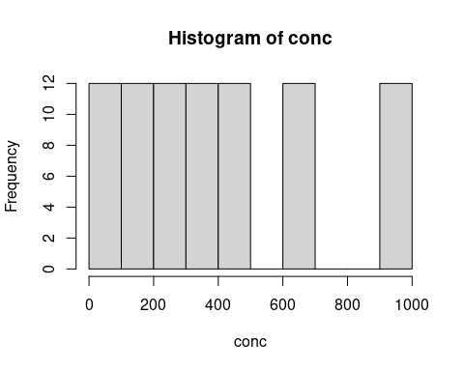 Histogram of uptake variable

# Histogram of uptake variable  
hist(co2_data$uptake,main = "Histogram of uptake",xlab = "conc",ylab = "Frequency")

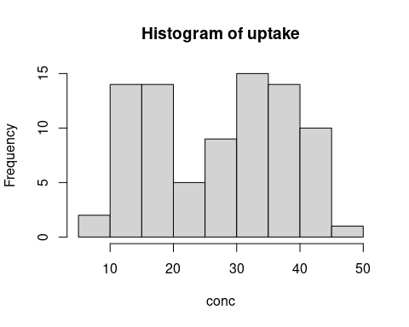

1. Create scatterplot of conc and uptake variables

plot(co2_data$conc,co2_data$uptake,main = "Scatter Plot of conc and uptake",  
 xlab = "conc",ylab = "uptake")

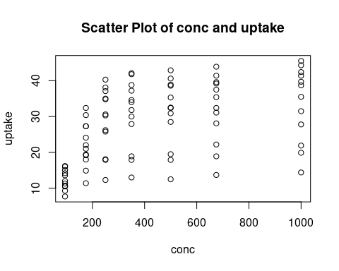 4. Which measure of association is suitable for conc and uptake variables Since the relationship is not linear we have to use spearman correlation for association 5. Compute the best correlation coefficient for conc and uptake variables and interpret the result carefully.

cor(co2_data$conc,co2_data$uptake,method = c("spearman"))

## [1] 0.5800041

Since the correlation coefficient is positive and greater than 0 we can say that the as the conc increases the uptake tends to increase but not in linear way.

## Part 2: Data visualization with ggplot2 package

Use the built-in CO2 data and do as follows:

library(ggplot2)

1. Create bar graph of plant, type and treatment variables

variables<-c('Plant','Type','Treatment')  
ggplot(data = co2_data) + geom_bar(mapping = aes(x = Plant))+ggtitle("Bar Graph of Plant")

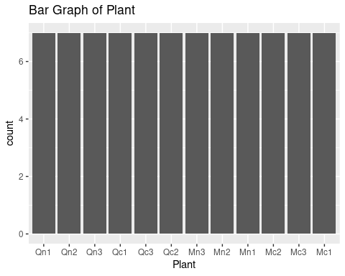

ggplot(data = co2_data) + geom_bar(mapping = aes(x = Type))+ggtitle("Bar Graph of Type")

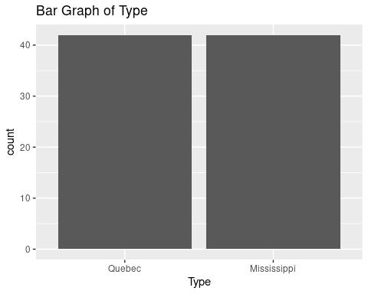

ggplot(data = co2_data) + geom_bar(mapping = aes(x = Treatment))+ggtitle("Bar Graph of Treatment")

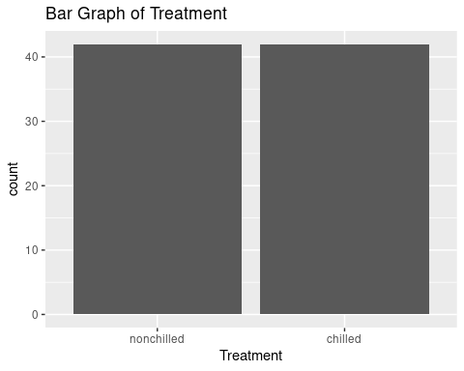 2. Create histogram of conc and uptake variables

ggplot(data = co2_data)+geom_histogram(mapping = aes(x=conc))+ggtitle("Histogram of conc")

## `stat_bin()` using `bins = 30`. Pick better value with `binwidth`.

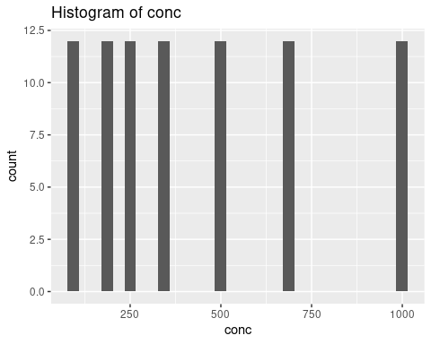

ggplot(data = co2_data)+geom_histogram(mapping = aes(x=uptake))+ggtitle("Histogram of uptake")

## `stat_bin()` using `bins = 30`. Pick better value with `binwidth`.

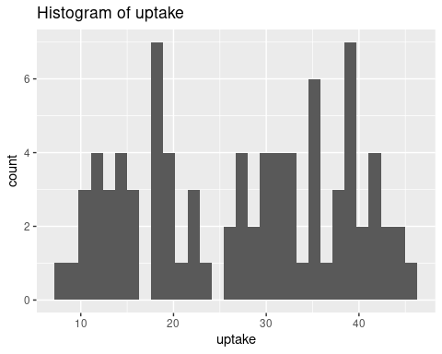

1. Create scatterplot of conc and uptake variables

ggplot(data=co2_data)+geom_point(mapping = aes(x=conc,y=uptake))+ggtitle('Scatter Plot of conc and uptake')

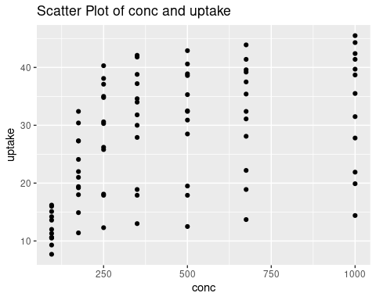

## Part 4: Text analysis with base/ggplot and Social Network Analysis with igraph package

Use/load the attached “termDocMatrix.rdata” file in R studio and do as follows:

file_path = 'data/termDocMatrix.rdata'  
term_matrix_data<-load(file = file_path)

1. Covert this data as matrix

library(tm)

## Loading required package: NLP

##   
## Attaching package: 'NLP'

## The following object is masked from 'package:ggplot2':  
##   
## annotate

term_matrix_data<-as.DocumentTermMatrix(termDocMatrix,weighting=weightBin)  
term_matrix_data<-as.matrix(term_matrix_data)

1. Get the term frequencies

freq <- sort(rowSums(term_matrix_data), decreasing=T)  
freq

## r data mining analysis package users   
## 70 53 47 23 21 18   
## examples network slides tutorial research social   
## 17 17 16 16 12 12   
## positions postdoctoral computing introduction applications code   
## 11 11 10 10 9 9   
## parallel series time   
## 8 8 8

1. Create the histogram of the term frequencies

barplot(freq,main = "Frequency of Each Term",xlab = "Term",ylab = "Frequency")

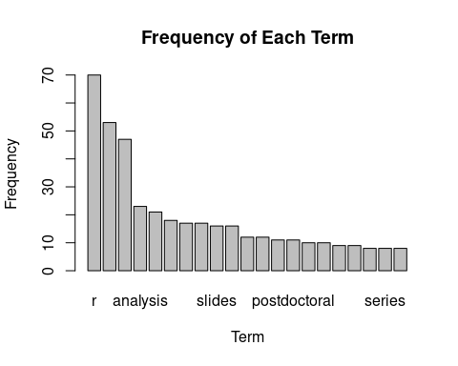

hist(freq,main = "Histogram of Frequency",xlab = "Term Frequency")

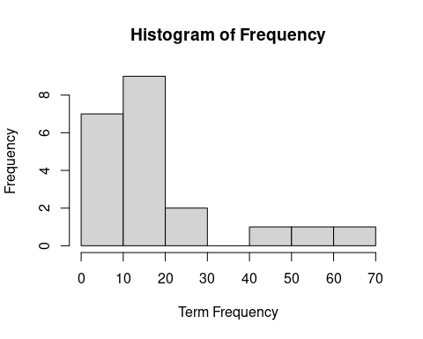 4. Create the histogram of the terms with frequencies of 5 and more

freq_1<-subset(freq,freq>=5)  
barplot(freq_1,main = "Frequency of Each Term with Freq>=5",xlab = "Term",ylab = "Frequency")

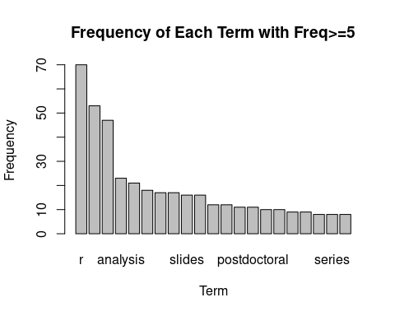

hist(freq-1,main = "Histogram of Frequency",xlab = "Term Frequency")

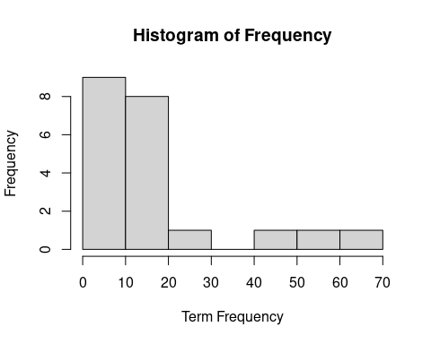 5. Create word cloud of the term frequencies

library(wordcloud)

## Loading required package: RColorBrewer

freq <- sort(rowSums(term_matrix_data), decreasing=T)  
wordcloud(words=names(freq), freq=freq, min.freq=5,  
random.order=F)

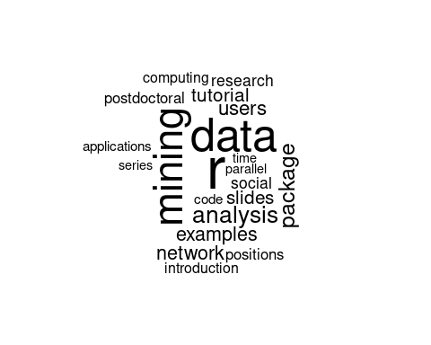 6. Perform social network analysis of the termDocumentMatrix data and interpret it carefully

library(igraph)

##   
## Attaching package: 'igraph'

## The following objects are masked from 'package:stats':  
##   
## decompose, spectrum

## The following object is masked from 'package:base':  
##   
## union

#Transform Data into an Adjacency Matrix  
termDocMatrix[termDocMatrix>=1] <- 1  
# Transformation into term-term adjacency matrix  
termMatrix <- termDocMatrix %*% t(termDocMatrix)  
# Checking few terms in the adjacency matrix  
termMatrix[1:5,1:5]

## Terms  
## Terms analysis applications code computing data  
## analysis 23 0 1 0 4  
## applications 0 9 0 0 7  
## code 1 0 9 0 1  
## computing 0 0 0 10 1  
## data 4 7 1 1 53

# Creating a undirected graph  
g <- graph.adjacency(termMatrix, weighted=T, mode = "undirected")  
# Removing the loop in same term   
g<-simplify(g)  
plot(g)

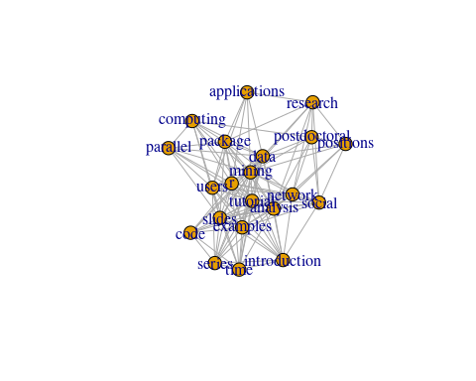

In the graph above, we can see that the terms like ‘r’, ‘mining’, ‘data’ are at center and are frequently with other words. We can also see that ‘time’,‘series’,‘introduction’ have a cluster. We can also see the cluster of words ‘research’, ‘postdoctoral’,‘positions’ from cluster. It makes sense for these words to come together.