Lab Sheet: 2

Objective:
• To understand and implement SQL transactions using COMMIT, SAVEPOINT, and ROLLBACK, retrieve records using SELECT queries, and perform INSERT, UPDATE, and ALTER operations on tables.

Instructions:
- Open your preferred Database Management System (DBMS) tool.
- Create the required tables: CLASS, EMPLOYEES, and Client_master.
- Insert the given/suitable records into each table.
- Execute the SQL scripts and queries step by step.
- Observe the output carefully after each operation, especially after ROLLBACK and UPDATE commands.

Table Structures:

CLASS
D (NUMBER) and Name (VARCHAR).
The initial records in the table are (1, 'Bravo'), (2, 'Alex'), and (4, 'Cheng').

EMPLOYEES
Employee_Id (NUMBER), First_Name (VARCHAR), Last_Name (VARCHAR), Email (VARCHAR), Phone_Number (VARCHAR), Hire_Date (DATE), Job_Id (VARCHAR), Salary (NUMBER), Commission_Pct (NUMBER), Manager_Id (NUMBER), and Department_Id (NUMBER).

DDL Questions (Data Definition Language):

- How do you create a table named CLASS with appropriate data types?
- How do you create a table named EMPLOYEES with the specified attributes?
- How do you create a table named Client_master with the specified attributes?
- What SQL statement would you use to rename the table Client_master to Client12?
- How do you display the bal_due column heading as “BALANCE”?

DML Questions (Data Manipulation Language):

Part A: Transactions and Savepoints (CLASS Table)
Give the output of the following SQL script:
  - INSERT INTO class VALUES (5,’Rahul’);
  - COMMIT;
  - UPDATE class SET name = ‘Abhijeet’ WHERE id=’5’;
  - SAVEPOINT A;
  - INSERT INTO class VALUES (6,’Chris’);
  - SAVEPOINT B;
  - INSERT INTO class VALUES (7,’Bravo’);
  - SAVEPOINT C;
  - SELECT * FROM class;
  - ROLLBACK TO B;
  - SELECT * FROM class;
  - ROLLBACK TO A;

Part B: Retrieving Records (EMPLOYEES Table)

- Find out the employee id, names, and salaries of all the employees.
- List out the employees who work under manager 100.
- Find the names of the employees who have a salary greater than or equal to 4800.
- List out the employees whose last name is ‘AUSTIN’.
- Find the names of the employees who work in departments 60, 70, and 80.
- Display the unique Manager_Id.

Part C: Updating Records (Client_master Table)
- Insert five records into the Client_master table.
- Find the names of clients whose bal_due > 5000.
- Change the bal_due of ClientNO "C123" to Rs. 5100.

ANSWERS
DDL QUESTIONS:

Q1. How do you create a table named CLASS with appropriate data types?
CREATE TABLE CLASS (
Id NUMBER PRIMARY KEY,
Name VARCHAR2(50)
);

Insert initial records:
INSERT INTO CLASS VALUES (1,'Bravo');
INSERT INTO CLASS VALUES (2,'Alex');
INSERT INTO CLASS VALUES (4,'Cheng');
COMMIT;

Q2. How do you create a table named EMPLOYEES with the specified attributes?
CREATE TABLE EMPLOYEES (
Employee_Id NUMBER PRIMARY KEY,
First_Name VARCHAR2(50),
Last_Name VARCHAR2(50),
Email VARCHAR2(100),
Phone_Number VARCHAR2(20),
Hire_Date DATE,
Job_Id VARCHAR2(20),
Salary NUMBER(10,2),
Commission_Pct NUMBER(5,2),
Manager_Id NUMBER,
Department_Id NUMBER
);

Q3. How do you create a table named Client_master with the specified attributes?
CREATE TABLE Client_master (
ClientNo VARCHAR2(10) PRIMARY KEY,
Name VARCHAR2(50),
City VARCHAR2(50),
Pincode NUMBER,
State VARCHAR2(50),
Bal_due NUMBER(10,2)
);

Q4. What SQL statement would you use to rename the table Client_master to Client12?
RENAME Client_master TO Client12;

Q5. How do you display the bal_due column heading as “BALANCE”?
SELECT Bal_due AS "BALANCE"
FROM Client_master;

DML QUESTIONS:

PART A: Transactions and Savepoints (CLASS Table)
CREATE DATABASE IF NOT EXISTS DBMS_Lab2_PartA;
USE DBMS_Lab2_PartA;

DROP TABLE IF EXISTS CLASS;
CREATE TABLE CLASS (
Id INT PRIMARY KEY,
Name VARCHAR(50)
);

INSERT INTO CLASS VALUES (1,'Bravo');
INSERT INTO CLASS VALUES (2,'Alex');
INSERT INTO CLASS VALUES (4,'Cheng');
COMMIT;

SET autocommit = 0;

INSERT INTO CLASS VALUES (5,'Rahul');
COMMIT;

UPDATE CLASS SET Name='Abhijeet' WHERE Id=5;
SAVEPOINT A;

INSERT INTO CLASS VALUES (6,'Chris');
SAVEPOINT B;

INSERT INTO CLASS VALUES (7,'Bravo');
SAVEPOINT C;

SELECT 'After All Inserts (C)' AS Stage, Id, Name FROM CLASS;

ROLLBACK TO B;
SELECT 'After ROLLBACK TO B' AS Stage, Id, Name FROM CLASS;

ROLLBACK TO A;
SELECT 'After ROLLBACK TO A' AS Stage, Id, Name FROM CLASS;

COMMIT;
Output:

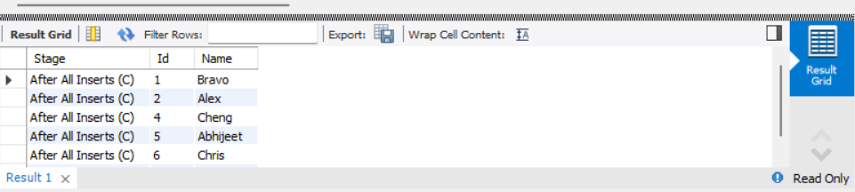

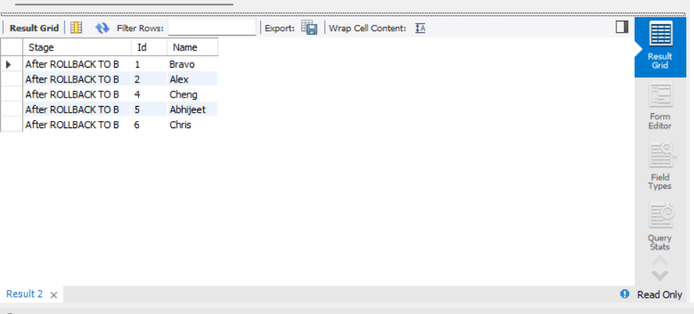

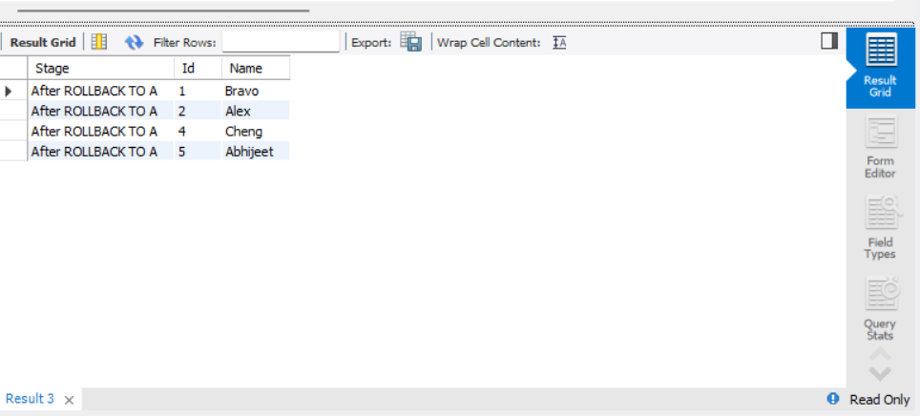

PART B – RETRIEVING RECORDS (EMPLOYEES Table)
CREATE DATABASE IF NOT EXISTS DBMS_Lab2_PartB;
USE DBMS_Lab2_PartB;

DROP TABLE IF EXISTS EMPLOYEES;

CREATE TABLE EMPLOYEES (
Employee_Id INT PRIMARY KEY,
First_Name VARCHAR(50),
Last_Name VARCHAR(50),
Email VARCHAR(100),
Phone_Number VARCHAR(20),
Hire_Date DATE,
Job_Id VARCHAR(20),
Salary DECIMAL(10,2),
Commission_Pct DECIMAL(5,2),
Manager_Id INT,
Department_Id INT
);

INSERT INTO EMPLOYEES VALUES
(101,'John','Austin','john@gmail.com','9999999999','2020-01-10','IT_PROG',5000,NULL,100,60),
(102,'Neha','Sharma','neha@gmail.com','8888888888','2021-02-15','HR_REP',4500,NULL,100,70),
(103,'Rahul','Verma','rahul@gmail.com','7777777777','2019-03-20','IT_PROG',6000,NULL,101,80),
(104,'Anjali','AUSTIN','anjali@gmail.com','6666666666','2022-04-12','SA_REP',4800,NULL,100,60);

COMMIT;

1. Find out the employee id, names, and salaries of all the employees.
SELECT Employee_Id, First_Name, Last_Name, Salary FROM EMPLOYEES;
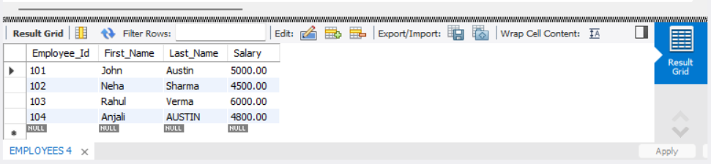

2. List out the employees who work under manager 100.
SELECT First_Name, Last_Name FROM EMPLOYEES WHERE Manager_Id = 100;
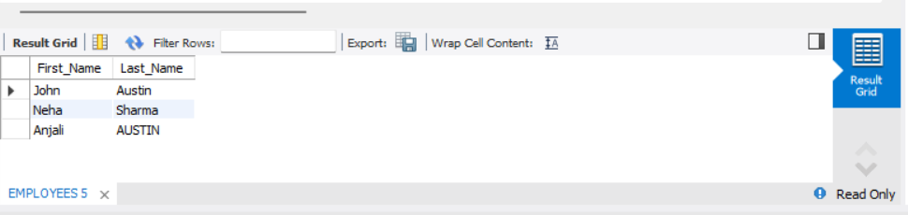

3. Find the names of the employees who have a salary greater than or equal to 4800.
SELECT First_Name, Last_Name FROM EMPLOYEES WHERE Salary >= 4800;
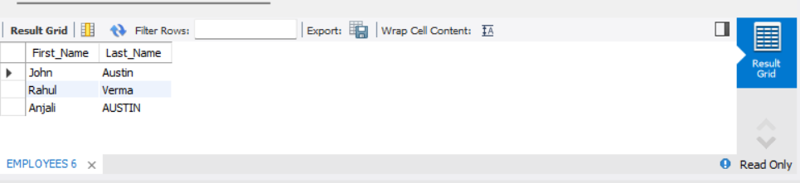

- List out the employees whose last name is ‘AUSTIN’.
- SELECT First_Name, Last_Name FROM EMPLOYEES WHERE Last_Name = 'AUSTIN';

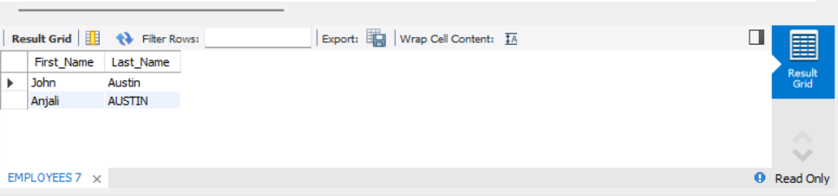

5. Find the names of the employees who work in departments 60, 70, and 80.

SELECT First_Name, Last_Name FROM EMPLOYEES WHERE Department_Id IN (60,70,80);
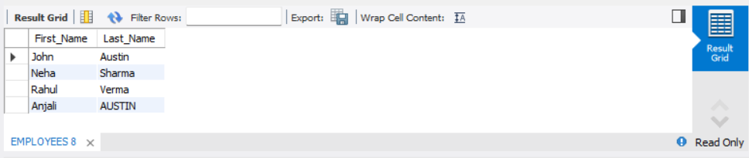

- Display the unique Manager_Id. give for part b answers.
- SELECT DISTINCT Manager_Id FROM EMPLOYEES;
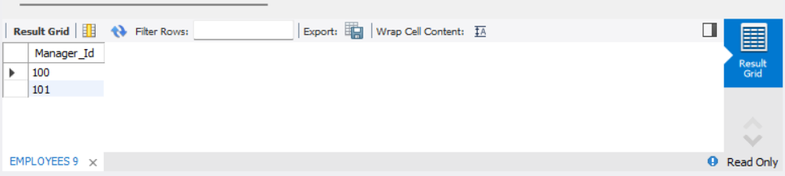

PART C – CLIENT_MASTER TABLE

CREATE DATABASE IF NOT EXISTS DBMS_Lab2_PartC;
USE DBMS_Lab2_PartC;

DROP TABLE IF EXISTS Client_master;

CREATE TABLE Client_master (
ClientNo VARCHAR(10) PRIMARY KEY,
Name VARCHAR(50),
City VARCHAR(50),
Pincode INT,
State VARCHAR(50),
Bal_due DECIMAL(10,2)
);

1. Insert five records into the Client_master table.

INSERT INTO Client_master VALUES
('C123','Amit','Delhi',110001,'Delhi',5000),
('C124','Neha','Mumbai',400001,'Maharashtra',8000),
('C125','Rahul','Chennai',600001,'Tamil Nadu',3000),
('C126','Sneha','Kolkata',700001,'West Bengal',9000),
('C127','Kiran','Bangalore',560001,'Karnataka',2000);

COMMIT;

2. Find the names of clients whose bal_due > 5000.
SELECT Name, Bal_due FROM Client_master WHERE Bal_due > 5000;
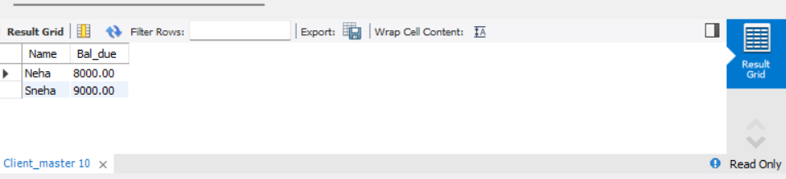

3. Change the bal_due of ClientNO "C123" to Rs. 5100. gave answers for part c.
UPDATE Client_master SET Bal_due = 5100 WHERE ClientNo = 'C123';
COMMIT;

SELECT * FROM Client_master;
