LAB ASSIGNMENT 5: (Exercise on retrieving records from the table)

Table: EMPLOYEES (Employee_Id, First_Name, Last_Name, Email, Phone_Number, Hire_Date, Job_Id, Salary, Commission_Act, Manager_Id, Department_Id)

(a) Find out the employee id, names, salaries of all the employees
(b) List out the employees who works under manager 100
(c) Find the names of the employees who have a salary greater than or equal to 4800
(d) List out the employees whose last name is ‘AUSTIN’
(e) Find the names of the employees who works in departments 60,70 and 80
(f) Display the unique Manager_Id.
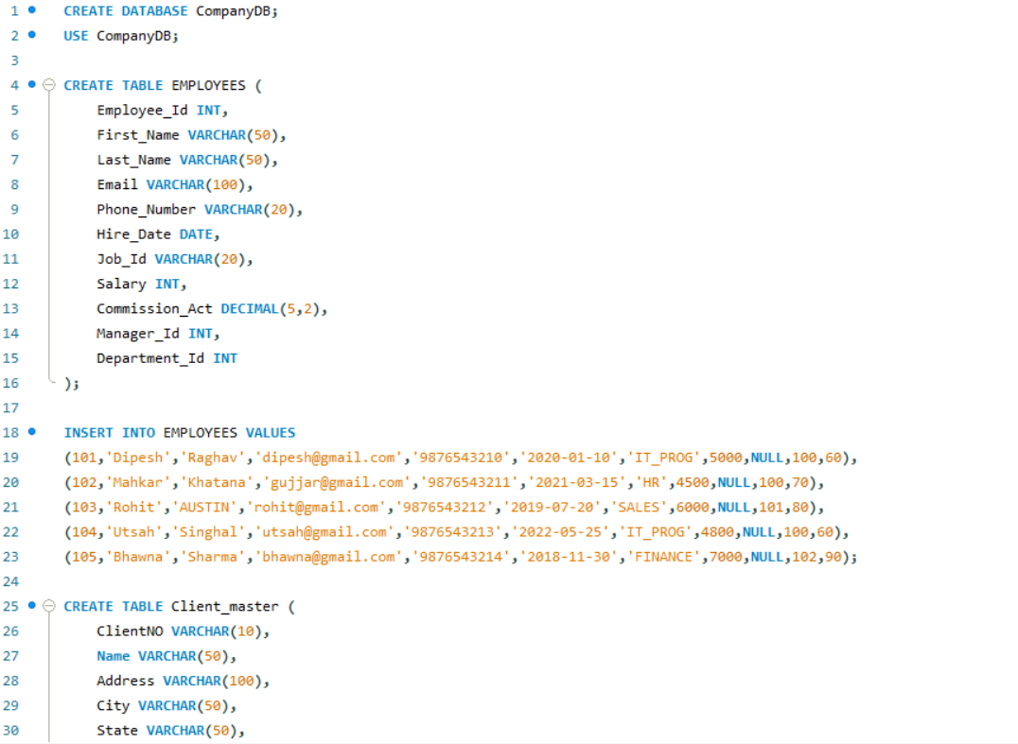
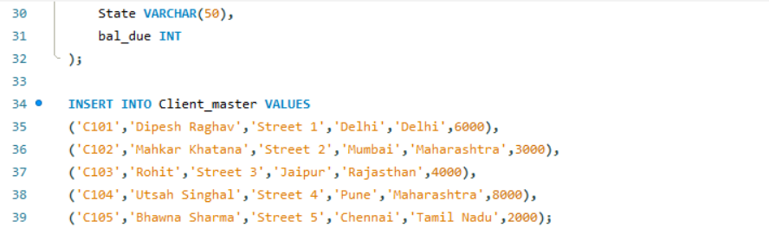

- Find out the employee id, names, salaries of all the employees.
Code:

Output:
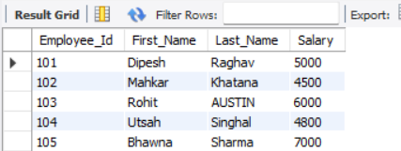
- List out the employees who works under manager 100

Code:
Output:

- Find the names of the employees who have a salary greater than or equal to 4800.
Code:
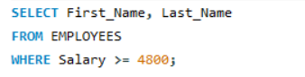

Output:
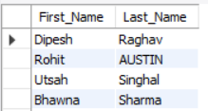

- List out the employees whose last name is ‘AUSTIN’.
Code:
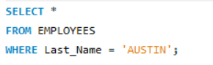
Output:

- Find the names of the employees who works in departments 60, 70 and 80.
Code:
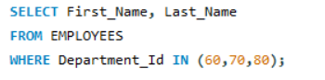
Output:
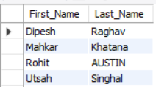
- Display the unique Manager_Id.
Code:

Output:
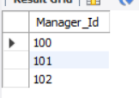

Lab Assignment 6: (Exercise on updating records in table)

Create Client_master with the following fields (ClientNO, Name, Address, City, State, bal_due)

(a) Insert five records.
Code:
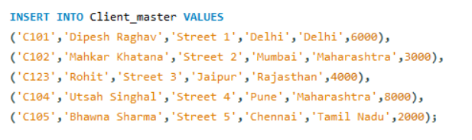
(b) Find the names of clients whose bal_due> 5000 .
Code:
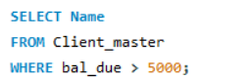
Output:
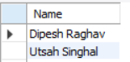
(c) Change the bal_due of ClientNO “ C123” to Rs. 5100.
Code:
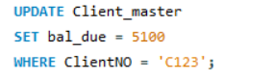

(d) Change the name of Client_master to Client12.
Code:

(e) Display the bal_due heading as “BALANCE”.
Code:

Output:
