Lab Experiment 10

Objective: Using the tables “DEPARTMENTS” and “EMPLOYEES” from Lab 9 perform the following queries:
- Display the employee details, departments that the departments are same in both the emp and dept.
- Display the employee name and Department name by implementing a left outer join.
- Display the employee name and Department name by implementing a right outer join.
- Display the details of those who draw the salary greater than the average salary.
SOLUTION CODE: (By Dipesh Raghav – 2401010223)
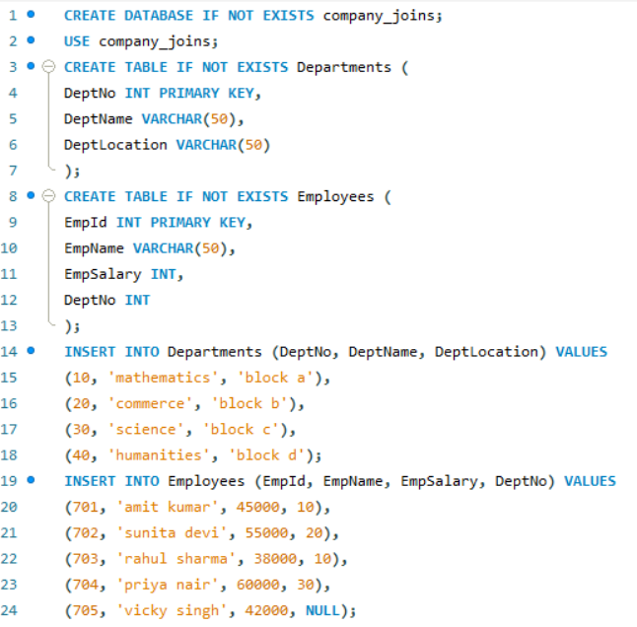
- Display the employee details, departments that the departments are same in both the emp and dept.
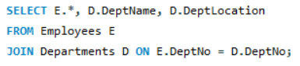
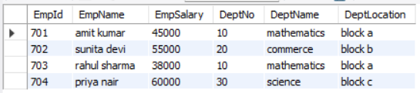

- Display the employee name and Department name by implementing a left outer join.
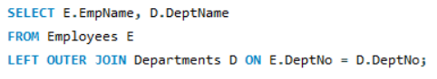
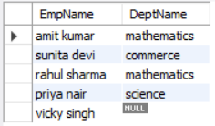

- Display the employee name and Department name by implementing a right outer join.
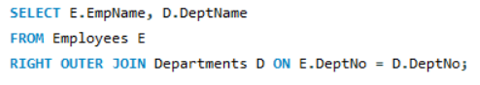
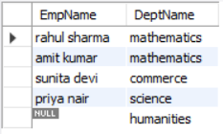

- Display the details of those who draw the salary greater than the average salary.

