Lab Experiment 7

Objective: Rollback and Commit commands Create Teacher table with the following fields (Name, DeptNo, Date of joining, DeptName, Location, Salary)
a) Insert five records.
b) Give Increment of 25% salary for Mathematics Department.
c) Perform Rollback command.
d) Give increment of 15% salary for Commerce Department.
e) Perform Commit command.

SOLUTION CODE: (By Dipesh Raghav – 2401010223)
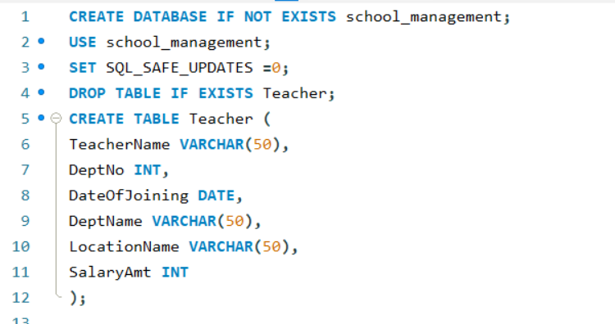

- Insert five records.

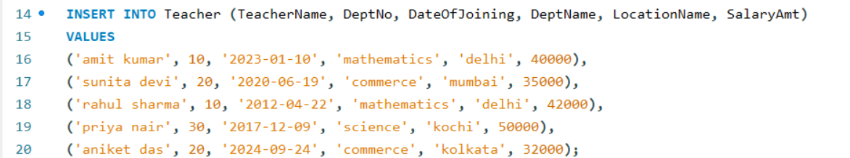

- Give Increment of 25% salary for Mathematics Department.

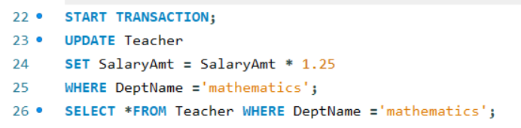
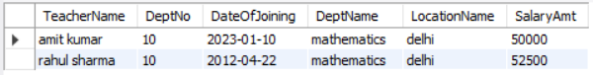

- Perform Rollback command.

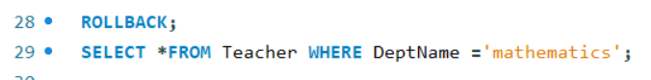
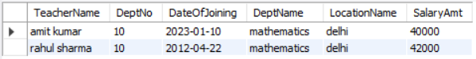

- Give increment of 15% salary for Commerce Department.

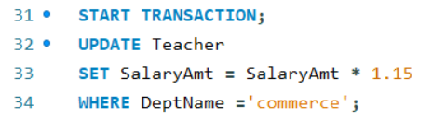

- Perform Commit command.

