Lab Experiment 8

Objective: Create Sales table with the following fields (Sales No, Salesname, Branch, Salesamount, DOB)
- Insert five records.
- Calculate total salesamount in each branch.
- Calculate average salesamount in each branch.
- Display all the salesmen, DOB who are born in the month of December as day in character format i.e. 21-Dec-09.
- Display the name and DOB of salesman in alphabetical order of the month.
SOLUTION CODE: (By Dipesh Raghav – 2401010223)
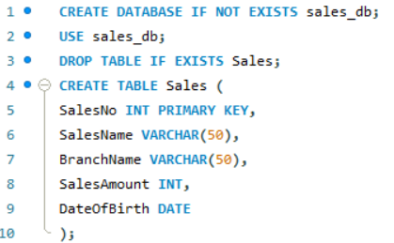
- Insert five records.
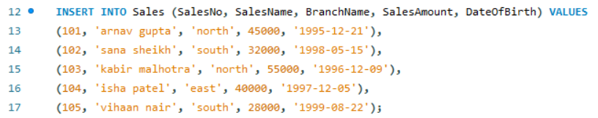

- Calculate total salesamount in each branch.
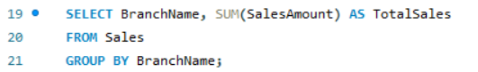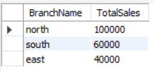

- Calculate average salesamount in each branch.
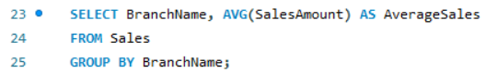
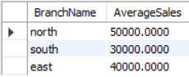

- Display all the salesmen, DOB who are born in the month of December as day in character format i.e. 21-Dec-09.

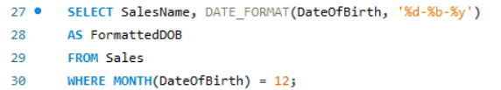

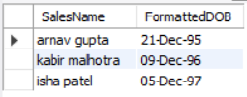

- Display the name and DOB of salesman in alphabetical order of the month.

