Lab Experiment 9

Objective: Consider the following tables namely “DEPARTMENTS” and “EMPLOYEES”
Their schemas are as follows:
Departments ( dept no , dept name , dept_location );
Employees ( emp_id , emp_name , emp_salary,dept_no);
- Develop a query to grant all privileges of employees table into departments table.
- Develop a query to grant some privileges of employees table into departments table.
- Develop a query to revoke all privileges of employees table from departments table.
- Develop query to revoke some privileges of employees table from departments table.
- Write a query to implement the save point.
SOLUTION CODE: (By Dipesh Raghav – 2401010223)
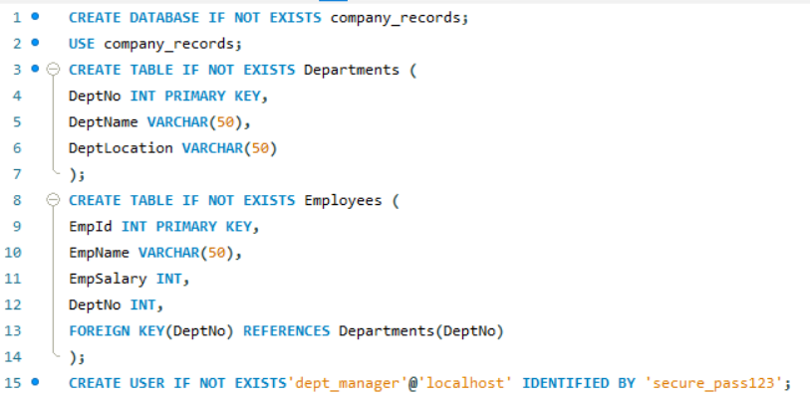

- Develop a query to grant all privileges of employees table into departments table.

- Develop a query to grant some privileges of employees table into departments table.

- Develop a query to revoke all privileges of employees table from departments table.

- Develop query to revoke some privileges of employees table from departments table.

- Write a query to implement the save point.

