DATABASE MANAGEMENT LAB
LAB Report
Submitted in partial fulfilment of the requirement of the degree of BACHELORS OF TECHNOLOGY
to
K.R Mangalam University, Gurugram- 122001, India

Submitted by: Submitted to:
Dipesh Raghav Ms. Mansi Kajal
2401010223
BTech CSE (Core) Sec A
Semester 4

Department of Computer Science and Engineering
School of Engineering and Technology
K.R Mangalam University, Gurugram- 122001, India
Batch– 2024-2028

Lab Experiment 1
Objective:
- To design ER diagrams and convert entities and relationships into relational tables using proper schema notation.
Instructions:
- Open your preferred Database Management System (DBMS) tool.
- Create a new database named DBMS_YourName.
- Draw ER diagrams for the given scenarios.
- Convert entities and relationships into relational schemas.
- Create tables using the derived schemas.

Relational Schema

PART A – COLLEGE DATABASE
STUDENT ( USN, SName, Address, Phone, Gender )
SEMSEC ( SSID, Sem, Sec )
CLASS ( USN, SSID )
SUBJECT ( Subcode, Title, Sem, Credits )
IAMARKS ( USN, Subcode, SSID, Test1, Test2, Test3, FinalIA )

PART B – COMPANY DATABASE

EMPLOYEE ( SSN, Name, Address, Sex, Salary, Superssn, Dno )
DEPARTMENT ( Dno, Dname, Mgrssn, Mgrstartdate )
DLOCATION ( Dno, Dloc )
PROJECT ( PNo, PName, PLocation, DNo )
WORKS_ON ( SSN, PNo, Hours )

PART C – CUSTOMER SALE SCHEMA

  - Database Schema for a customer-sale scenario
  - Customer(Cust id : integer, cust_name: string)
  - Item(item_id: integer, item_name:string, price: integer) Sale(bill_no:integer,bill_data:date,cust_id: integer, item_id: integer, qty_sold: integer)

DDL Questions (Data Definition Language):

- Write SQL statements to create all the above relations with appropriate PRIMARY KEY and FOREIGN KEY constraints.
- Add a new column Email to the STUDENT relation.
- Apply NOT NULL constraints to Salary and Price attributes.
- Rename attribute SName to StudentName in STUDENT relation.
- Drop the DLOCATION relation.

DML Questions (Data Manipulation Language):

- Insert at least 10 tuples into CUSTOMER, ITEM, and SALE relations.
- List all bills of the current date with customer names and item names.
- Display total bill amount using quantity and price.
- List customers who purchased products priced above 200.
- Count the number of products purchased by each customer.
- List products purchased by customer having Cust_id = 5.
- Create a VIEW showing bill_no, bill_date, cust_id, item_id, price, qty,sold, amount.
- Create a VIEW showing daily sales date-wise for the last one week.

ER DIAGRAM:
PART A – COLLEGE DATABASE
Entities and Attributes:
- STUDENT: USN (PK), SName, Address, Phone, Gender
- SEMSEC: SSID (PK), Sem, Sec
- CLASS: USN (FK → STUDENT), SSID (FK → SEMSEC)
- SUBJECT: Subcode (PK), Title, Sem, Credits
- IAMARKS: USN (FK → STUDENT), Subcode (FK → SUBJECT), SSID (FK → SEMSEC), Test1, Test2, Test3, FinalIA
Relationships:
- CLASS → maps STUDENT to SEMSEC
- IAMARKS → maps STUDENT, SUBJECT, SEMSEC with marks
ER Diagram (Text Representation)

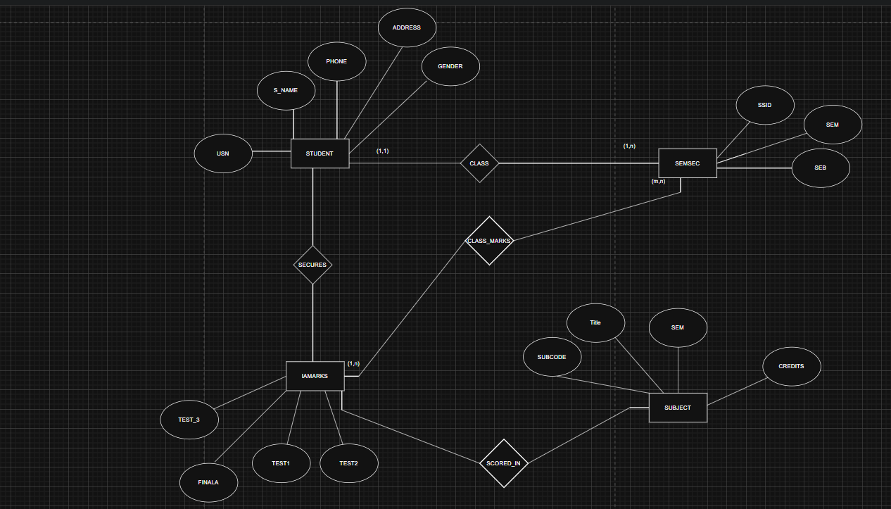

PART B – COMPANY DATABASE
Entities and Attributes:
- EMPLOYEE: SSN (PK), Name, Address, Sex, Salary, Superssn (FK → EMPLOYEE), Dno (FK → DEPARTMENT)
- DEPARTMENT: Dno (PK), Dname, Mgrssn (FK → EMPLOYEE), Mgrstartdate
- DLOCATION: Dno (FK → DEPARTMENT), Dloc
- PROJECT: PNo (PK), PName, PLocation, DNo (FK → DEPARTMENT)
- WORKS_ON: SSN (FK → EMPLOYEE), PNo (FK → PROJECT), Hours
Relationships:
- EMPLOYEE works in DEPARTMENT
- DEPARTMENT manages PROJECT
- EMPLOYEE works_on PROJECT
- DEPARTMENT has DLOCATION
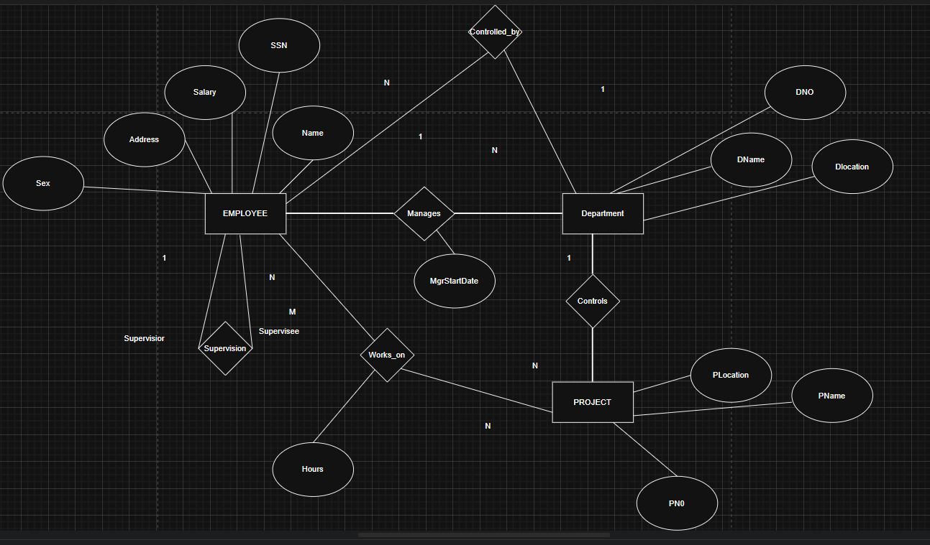
PART C – CUSTOMER SALE SCHEMA:
Entities and Attributes:
- CUSTOMER(Cust_id PK, cust_name)
- ITEM(Item_id PK, item_name, price)
- SALE(Bill_no PK, Bill_date, Cust_id → CUSTOMER, Item_id → ITEM, qty_sold)
Relational Schema:
- CUSTOMER(Cust_id, cust_name)
- ITEM(Item_id, item_name, price)
- SALE(Bill_no, Bill_date, Cust_id, Item_id, qty_sold)

DDL Questions (Data Definition Language)
Q1. Write SQL statements to create all the above relations with PRIMARY KEY and FOREIGN KEY constraints.
Code:
CREATE DATABASE DBMS_DipeshRaghav;
USE DBMS_DipeshRaghav;

CREATE TABLE STUDENT(
USN VARCHAR(10) PRIMARY KEY,
SName VARCHAR(50),
Address VARCHAR(100),
Phone VARCHAR(15),
Gender CHAR(1)
);

CREATE TABLE SEMSEC(
SSID INT PRIMARY KEY,
Sem INT,
Sec CHAR(1)
);

CREATE TABLE CLASS(
USN VARCHAR(10),
SSID INT,
PRIMARY KEY(USN, SSID),
FOREIGN KEY (USN) REFERENCES STUDENT(USN),
FOREIGN KEY (SSID) REFERENCES SEMSEC(SSID)
);

CREATE TABLE SUBJECT(
Subcode VARCHAR(10) PRIMARY KEY,
Title VARCHAR(50),
Sem INT,
Credits INT
);

CREATE TABLE IAMARKS(
USN VARCHAR(10),
Subcode VARCHAR(10),
SSID INT,
Test1 INT,
Test2 INT,
Test3 INT,
FinalIA INT,
PRIMARY KEY(USN, Subcode, SSID),
FOREIGN KEY (USN) REFERENCES STUDENT(USN),
FOREIGN KEY (Subcode) REFERENCES SUBJECT(Subcode),
FOREIGN KEY (SSID) REFERENCES SEMSEC(SSID)
);

CREATE TABLE DEPARTMENT(
Dno INT PRIMARY KEY,
Dname VARCHAR(50),
Mgrssn CHAR(9),
Mgrstartdate DATE
);

CREATE TABLE EMPLOYEE(
SSN CHAR(9) PRIMARY KEY,
Name VARCHAR(50),
Address VARCHAR(100),
Sex CHAR(1),
Salary DECIMAL(10,2) NOT NULL,
Superssn CHAR(9),
Dno INT,
FOREIGN KEY(Superssn) REFERENCES EMPLOYEE(SSN),
FOREIGN KEY(Dno) REFERENCES DEPARTMENT(Dno)
);

ALTER TABLE DEPARTMENT
ADD CONSTRAINT fk_mgr
FOREIGN KEY(Mgrssn) REFERENCES EMPLOYEE(SSN);

CREATE TABLE PROJECT(
PNo INT PRIMARY KEY,
PName VARCHAR(50),
PLocation VARCHAR(50),
DNo INT,
FOREIGN KEY(DNo) REFERENCES DEPARTMENT(Dno)
);

CREATE TABLE WORKS_ON(
SSN CHAR(9),
PNo INT,
Hours DECIMAL(5,2),
PRIMARY KEY(SSN, PNo),
FOREIGN KEY(SSN) REFERENCES EMPLOYEE(SSN),
FOREIGN KEY(PNo) REFERENCES PROJECT(PNo)
);

CREATE TABLE CUSTOMER(
Cust_id INT PRIMARY KEY,
Cust_name VARCHAR(50)
);

CREATE TABLE ITEM(
Item_id INT PRIMARY KEY,
Item_name VARCHAR(50),
Price INT NOT NULL
);

CREATE TABLE SALE(
Bill_no INT PRIMARY KEY,
Bill_date DATE,
Cust_id INT,
Item_id INT,
Qty_sold INT,
FOREIGN KEY(Cust_id) REFERENCES CUSTOMER(Cust_id),
FOREIGN KEY(Item_id) REFERENCES ITEM(Item_id)
);
Q2. Add a new column Email to STUDENT.
ALTER TABLE STUDENT ADD Email VARCHAR(50);
Q3: Apply NOT NULL constraints to Salary and Price attributes.
ALTER TABLE EMPLOYEE
MODIFY Salary DECIMAL(10,2) NOT NULL;

ALTER TABLE ITEM
MODIFY Price INT NOT NULL;
Q4. Rename attribute SName to StudentName in STUDENT relation.
ALTER TABLE STUDENT
CHANGE SName StudentName VARCHAR(50);
Q5. Drop the DLOCATION relation.
DROP TABLE DLOCATION;

DML QUESTIONS (CUSTOMER–SALE SCHEMA)
Q1. Insert at least 10 tuples into CUSTOMER, ITEM, and SALE relations.
INSERT INTO CUSTOMER VALUES
(1,'Aakash'),
(2,'Vivek'),
(3,'Rahul'),
(4,'Mayank'),
(5,'Karan'),
(6,'Ravi'),
(7,'Amit'),
(8,'Vikas'),
(9,'Rohit'),
(10,'Arjun');

INSERT INTO ITEM VALUES
(101,'Pen',10),
(102,'Book',250),
(103,'Bag',800),
(104,'Pencil',5),
(105,'Notebook',120),
(106,'Shoes',1500),
(107,'Bottle',200),
(108,'Scale',15),
(109,'Laptop',50000),
(110,'Mouse',600);

INSERT INTO SALE VALUES
(1,CURDATE(),1,101,5),
(2,CURDATE(),2,102,2),
(3,CURDATE(),3,103,1),
(4,CURDATE(),4,105,3),
(5,CURDATE(),5,106,1),
(6,CURDATE(),6,110,2),
(7,CURDATE(),7,107,4),
(8,CURDATE(),8,102,1),
(9,CURDATE(),9,103,2),
(10,CURDATE(),10,109,1);
Q2. List all bills of the current date with customer names and item names.
SELECT s.Bill_no, c.Cust_name, i.Item_name
FROM SALE s
JOIN CUSTOMER c ON s.Cust_id = c.Cust_id
JOIN ITEM i ON s.Item_id = i.Item_id
WHERE s.Bill_date = CURDATE();

Q3. Display total bill amount using quantity and price.
SELECT s.Bill_no,
SUM(s.Qty_sold * i.Price) AS Total_Amount
FROM SALE s
JOIN ITEM i ON s.Item_id = i.Item_id
GROUP BY s.Bill_no;
Q4. List customers who purchased products priced above 200.
SELECT DISTINCT c.Cust_name
FROM CUSTOMER c
JOIN SALE s ON c.Cust_id = s.Cust_id
JOIN ITEM i ON s.Item_id = i.Item_id
WHERE i.Price > 200;
Q5. Count the number of products purchased by each customer.
SELECT c.Cust_name,
SUM(s.Qty_sold) AS Total_Products
FROM CUSTOMER c
JOIN SALE s ON c.Cust_id = s.Cust_id
GROUP BY c.Cust_name;
Q6. List products purchased by customer having Cust_id = 5.
SELECT i.Item_name
FROM SALE s
JOIN ITEM i ON s.Item_id = i.Item_id
WHERE s.Cust_id = 5;
Q7. Create a VIEW showing bill_no, bill_date, cust_id, item_id, price, qty_sold, amount.
CREATE VIEW BILL_DETAILS AS
SELECT s.Bill_no,
s.Bill_date,
s.Cust_id,
s.Item_id,
i.Price,
s.Qty_sold,
(s.Qty_sold * i.Price) AS Amount
FROM SALE s
JOIN ITEM i ON s.Item_id = i.Item_id;
Q8. Create a VIEW showing daily sales date-wise for the last one week.
CREATE VIEW WEEKLY_SALES AS
SELECT s.Bill_date,
SUM(s.Qty_sold * i.Price) AS Daily_Total
FROM SALE s
JOIN ITEM i ON s.Item_id = i.Item_id
WHERE s.Bill_date >= CURDATE() - INTERVAL 7 DAY
GROUP BY s.Bill_date;
Lab Experiment 2

Objective:
• To understand and implement SQL transactions using COMMIT, SAVEPOINT, and ROLLBACK, retrieve records using SELECT queries, and perform INSERT, UPDATE, and ALTER operations on tables.

Instructions:
- Open your preferred Database Management System (DBMS) tool.
- Create the required tables: CLASS, EMPLOYEES, and Client_master.
- Insert the given/suitable records into each table.
- Execute the SQL scripts and queries step by step.
- Observe the output carefully after each operation, especially after ROLLBACK and UPDATE commands.

Table Structures:

CLASS
D (NUMBER) and Name (VARCHAR).
The initial records in the table are (1, 'Bravo'), (2, 'Alex'), and (4, 'Cheng').

EMPLOYEES
Employee_Id (NUMBER), First_Name (VARCHAR), Last_Name (VARCHAR), Email (VARCHAR), Phone_Number (VARCHAR), Hire_Date (DATE), Job_Id (VARCHAR), Salary (NUMBER), Commission_Pct (NUMBER), Manager_Id (NUMBER), and Department_Id (NUMBER).

DDL Questions (Data Definition Language):

- How do you create a table named CLASS with appropriate data types?
- How do you create a table named EMPLOYEES with the specified attributes?
- How do you create a table named Client_master with the specified attributes?
- What SQL statement would you use to rename the table Client_master to Client12?
- How do you display the bal_due column heading as “BALANCE”?

DML Questions (Data Manipulation Language):

Part A: Transactions and Savepoints (CLASS Table)
Give the output of the following SQL script:
  - INSERT INTO class VALUES (5,’Rahul’);
  - COMMIT;
  - UPDATE class SET name = ‘Abhijeet’ WHERE id=’5’;
  - SAVEPOINT A;
  - INSERT INTO class VALUES (6,’Chris’);
  - SAVEPOINT B;
  - INSERT INTO class VALUES (7,’Bravo’);
  - SAVEPOINT C;
  - SELECT * FROM class;
  - ROLLBACK TO B;
  - SELECT * FROM class;
  - ROLLBACK TO A;

Part B: Retrieving Records (EMPLOYEES Table)

- Find out the employee id, names, and salaries of all the employees.
- List out the employees who work under manager 100.
- Find the names of the employees who have a salary greater than or equal to 4800.
- List out the employees whose last name is ‘AUSTIN’.
- Find the names of the employees who work in departments 60, 70, and 80.
- Display the unique Manager_Id.

Part C: Updating Records (Client_master Table)
- Insert five records into the Client_master table.
- Find the names of clients whose bal_due > 5000.
- Change the bal_due of ClientNO "C123" to Rs. 5100.

ANSWERS
DDL QUESTIONS:

Q1. How do you create a table named CLASS with appropriate data types?
CREATE TABLE CLASS (
Id NUMBER PRIMARY KEY,
Name VARCHAR2(50)
);

Insert initial records:
INSERT INTO CLASS VALUES (1,'Bravo');
INSERT INTO CLASS VALUES (2,'Alex');
INSERT INTO CLASS VALUES (4,'Cheng');
COMMIT;

Q2. How do you create a table named EMPLOYEES with the specified attributes?
CREATE TABLE EMPLOYEES (
Employee_Id NUMBER PRIMARY KEY,
First_Name VARCHAR2(50),
Last_Name VARCHAR2(50),
Email VARCHAR2(100),
Phone_Number VARCHAR2(20),
Hire_Date DATE,
Job_Id VARCHAR2(20),
Salary NUMBER(10,2),
Commission_Pct NUMBER(5,2),
Manager_Id NUMBER,
Department_Id NUMBER
);

Q3. How do you create a table named Client_master with the specified attributes?
CREATE TABLE Client_master (
ClientNo VARCHAR2(10) PRIMARY KEY,
Name VARCHAR2(50),
City VARCHAR2(50),
Pincode NUMBER,
State VARCHAR2(50),
Bal_due NUMBER(10,2)
);

Q4. What SQL statement would you use to rename the table Client_master to Client12?
RENAME Client_master TO Client12;

Q5. How do you display the bal_due column heading as “BALANCE”?
SELECT Bal_due AS "BALANCE"
FROM Client_master;

DML QUESTIONS:

PART A: Transactions and Savepoints (CLASS Table)
CREATE DATABASE IF NOT EXISTS DBMS_Lab2_PartA;
USE DBMS_Lab2_PartA;

DROP TABLE IF EXISTS CLASS;
CREATE TABLE CLASS (
Id INT PRIMARY KEY,
Name VARCHAR(50)
);

INSERT INTO CLASS VALUES (1,'Bravo');
INSERT INTO CLASS VALUES (2,'Alex');
INSERT INTO CLASS VALUES (4,'Cheng');
COMMIT;

SET autocommit = 0;

INSERT INTO CLASS VALUES (5,'Rahul');
COMMIT;

UPDATE CLASS SET Name='Abhijeet' WHERE Id=5;
SAVEPOINT A;

INSERT INTO CLASS VALUES (6,'Chris');
SAVEPOINT B;

INSERT INTO CLASS VALUES (7,'Bravo');
SAVEPOINT C;

SELECT 'After All Inserts (C)' AS Stage, Id, Name FROM CLASS;

ROLLBACK TO B;
SELECT 'After ROLLBACK TO B' AS Stage, Id, Name FROM CLASS;

ROLLBACK TO A;
SELECT 'After ROLLBACK TO A' AS Stage, Id, Name FROM CLASS;

COMMIT;
Output:

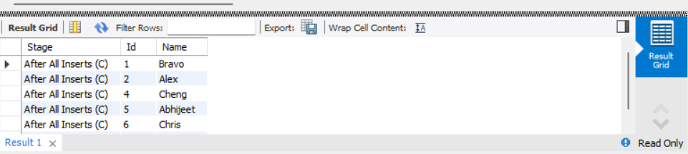

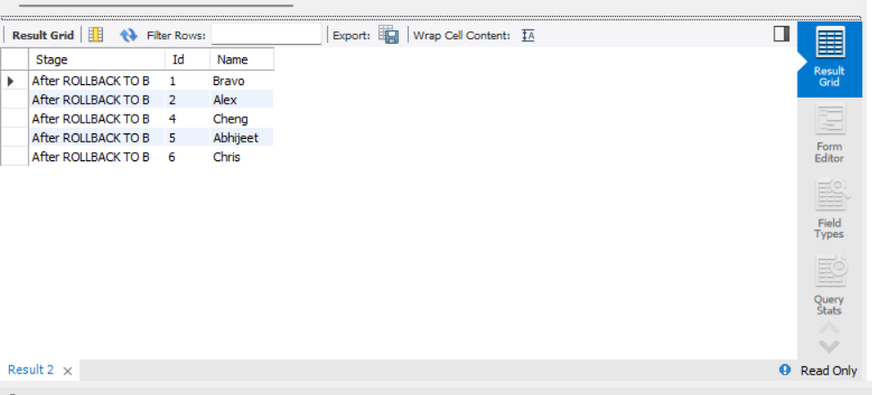

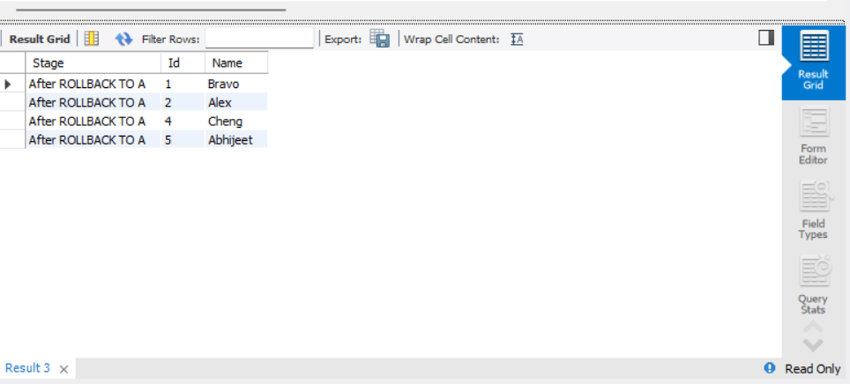

PART B – RETRIEVING RECORDS (EMPLOYEES Table)
CREATE DATABASE IF NOT EXISTS DBMS_Lab2_PartB;
USE DBMS_Lab2_PartB;

DROP TABLE IF EXISTS EMPLOYEES;

CREATE TABLE EMPLOYEES (
Employee_Id INT PRIMARY KEY,
First_Name VARCHAR(50),
Last_Name VARCHAR(50),
Email VARCHAR(100),
Phone_Number VARCHAR(20),
Hire_Date DATE,
Job_Id VARCHAR(20),
Salary DECIMAL(10,2),
Commission_Pct DECIMAL(5,2),
Manager_Id INT,
Department_Id INT
);

INSERT INTO EMPLOYEES VALUES
(101,'John','Austin','john@gmail.com','9999999999','2020-01-10','IT_PROG',5000,NULL,100,60),
(102,'Neha','Sharma','neha@gmail.com','8888888888','2021-02-15','HR_REP',4500,NULL,100,70),
(103,'Rahul','Verma','rahul@gmail.com','7777777777','2019-03-20','IT_PROG',6000,NULL,101,80),
(104,'Anjali','AUSTIN','anjali@gmail.com','6666666666','2022-04-12','SA_REP',4800,NULL,100,60);

COMMIT;

1. Find out the employee id, names, and salaries of all the employees.
SELECT Employee_Id, First_Name, Last_Name, Salary FROM EMPLOYEES;
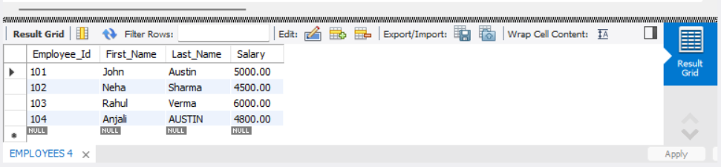

2. List out the employees who work under manager 100.
SELECT First_Name, Last_Name FROM EMPLOYEES WHERE Manager_Id = 100;
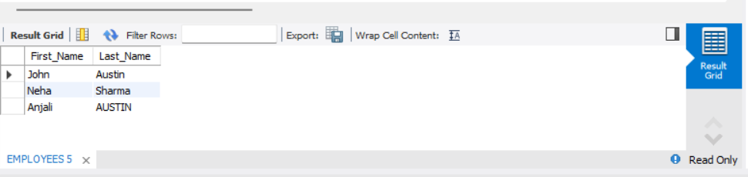

3. Find the names of the employees who have a salary greater than or equal to 4800.
SELECT First_Name, Last_Name FROM EMPLOYEES WHERE Salary >= 4800;
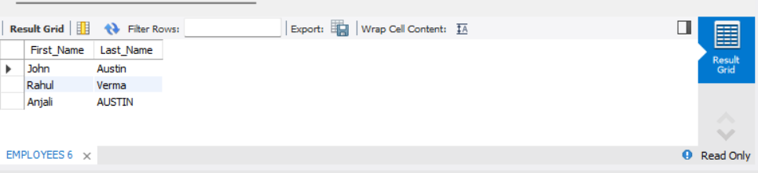

- List out the employees whose last name is ‘AUSTIN’.
- SELECT First_Name, Last_Name FROM EMPLOYEES WHERE Last_Name = 'AUSTIN';

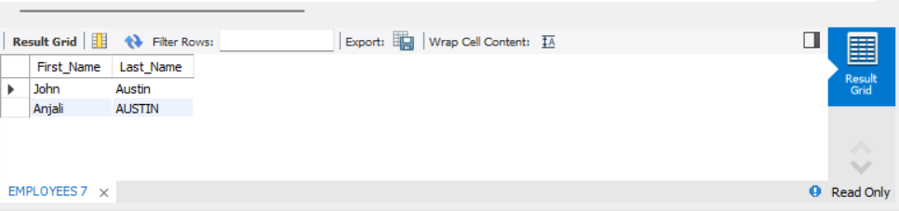

5. Find the names of the employees who work in departments 60, 70, and 80.

SELECT First_Name, Last_Name FROM EMPLOYEES WHERE Department_Id IN (60,70,80);
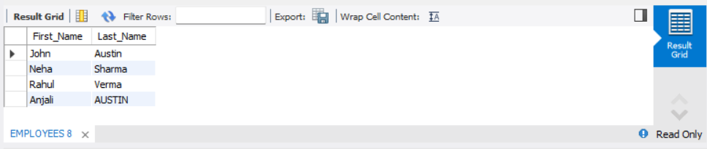

- Display the unique Manager_Id. give for part b answers.
- SELECT DISTINCT Manager_Id FROM EMPLOYEES;
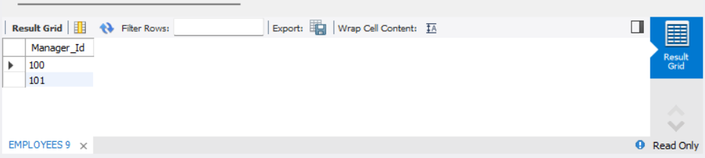

PART C – CLIENT_MASTER TABLE

CREATE DATABASE IF NOT EXISTS DBMS_Lab2_PartC;
USE DBMS_Lab2_PartC;

DROP TABLE IF EXISTS Client_master;

CREATE TABLE Client_master (
ClientNo VARCHAR(10) PRIMARY KEY,
Name VARCHAR(50),
City VARCHAR(50),
Pincode INT,
State VARCHAR(50),
Bal_due DECIMAL(10,2)
);

1. Insert five records into the Client_master table.

INSERT INTO Client_master VALUES
('C123','Amit','Delhi',110001,'Delhi',5000),
('C124','Neha','Mumbai',400001,'Maharashtra',8000),
('C125','Rahul','Chennai',600001,'Tamil Nadu',3000),
('C126','Sneha','Kolkata',700001,'West Bengal',9000),
('C127','Kiran','Bangalore',560001,'Karnataka',2000);

COMMIT;

2. Find the names of clients whose bal_due > 5000.
SELECT Name, Bal_due FROM Client_master WHERE Bal_due > 5000;
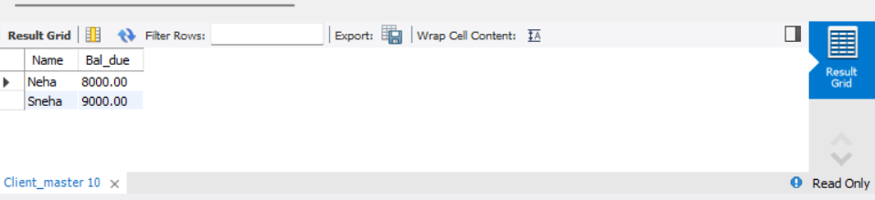

3. Change the bal_due of ClientNO "C123" to Rs. 5100. gave answers for part c.
UPDATE Client_master SET Bal_due = 5100 WHERE ClientNo = 'C123';
COMMIT;

SELECT * FROM Client_master;
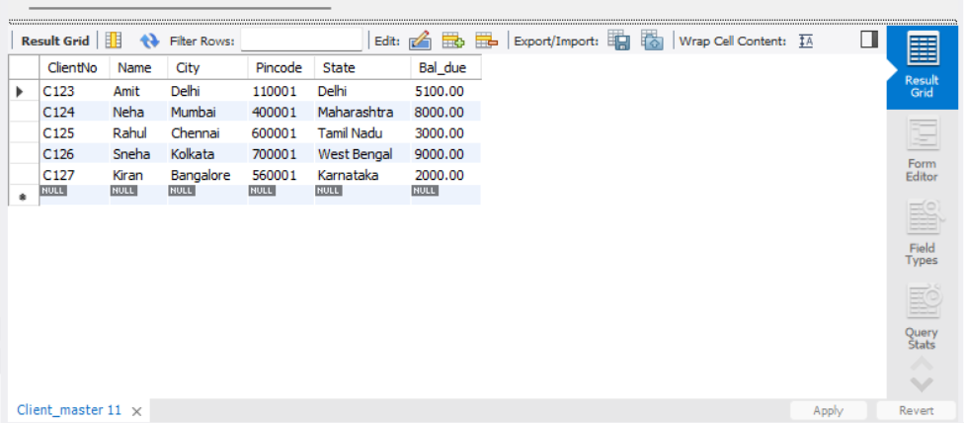

Lab Sheet: 3

Objectives

- To understand the use of COMMIT and ROLLBACK commands in transaction control.
- To use ORDER BY and GROUP BY clauses in SQL queries.
- To understand DCL commands (GRANT, REVOKE) and the use of SAVEPOINT.
- To understand and implement JOIN operations in SQL.

Instructions

Open your preferred Database Management System (DBMS) tool.

- Create the required tables: TEACHER, SALES, DEPARTMENTS, and EMPLOYEES.
- Insert suitable records into each table.
- Execute the SQL commands for transaction control, privilege control, grouping, sorting, and joins.
- Observe the output after each operation such as ROLLBACK, COMMIT, SAVEPOINT, GRANT, and REVOKE.

DDL Questions (Data Definition Language)

- Create the TEACHER table with the following attributes:
(Name, DeptNo, Date_of_Joining, DeptName, Location, Salary).
- Create the SALES table with the following attributes:
(Sales_No, Salesname, Branch, Salesamount, DOB).
- Create the DEPARTMENTS table with the following attributes:
(dept_no, dept_name, dept_location).
- Create the EMPLOYEES table with the following attributes:
(emp_id, emp_name, emp_salary, dept_no).

DML Questions (Data Manipulation Language)

From TEACHER Table

- Insert five records into the TEACHER table.
- Give an increment of 25% salary to teachers working in the Mathematics department.
- Give an increment of 15% salary to teachers working in the Commerce department.

From SALES Table

- Insert five records into the SALES table.
- Calculate the total sales amount in each branch.
- Calculate the average sales amount in each branch.
- Display the Salesname and DOB of salesmen born in the month of December with date format like 21-Dec-09.
- Display the Salesname and DOB of salesmen in alphabetical order of the month.

From JOIN Operations

- Display employee details and department details where the department numbers are the same in both tables.
- Display the employee name and department name using a LEFT OUTER JOIN.
- Display the employee name and department name using a RIGHT OUTER JOIN.
- Display the details of employees who draw a salary greater than the average salary.

TCL Questions (Transaction Control Language)

- Perform the ROLLBACK command on the TEACHER table.
- Perform the COMMIT command on the TEACHER table.
- Write a query to implement a SAVEPOINT.

DCL Questions (Data Control Language)

- Write a query to grant all privileges on the EMPLOYEES table to DEPARTMENTS.
- Write a query to grant selected privileges on the EMPLOYEES table to DEPARTMENTS.
- Write a query to revoke all privileges on the EMPLOYEES table from DEPARTMENTS.
- Write a query to revoke selected privileges on the EMPLOYEES table from DEPARTMENTS.
ANSWERS
DDL Questions (Data Definition Language)

1. Create the TEACHER table with the following attributes: (Name, DeptNo, Date_of_Joining, DeptName, Location, Salary).
CREATE DATABASE IF NOT EXISTS DBMS_Lab3;
USE DBMS_Lab3;

DROP TABLE IF EXISTS TEACHER;
CREATE TABLE TEACHER (
Name VARCHAR(50),
DeptNo INT,
Date_of_Joining DATE,
DeptName VARCHAR(50),
Location VARCHAR(50),
Salary DECIMAL(10,2)
);

2. Create the SALES table with the following attributes: (Sales_No, Salesname, Branch, Salesamount, DOB).
DROP TABLE IF EXISTS SALES;
CREATE TABLE SALES (
Sales_No INT PRIMARY KEY,
Salesname VARCHAR(50),
Branch VARCHAR(50),
Salesamount DECIMAL(10,2),
DOB DATE
);

3. Create the DEPARTMENTS table with the following attributes: (dept_no, dept_name, dept_location).
DROP TABLE IF EXISTS DEPARTMENTS;
CREATE TABLE DEPARTMENTS (
dept_no INT PRIMARY KEY,
dept_name VARCHAR(50),
dept_location VARCHAR(50)
);

4. Create the EMPLOYEES table with the following attributes: (emp_id, emp_name, emp_salary, dept_no).
DROP TABLE IF EXISTS EMPLOYEES;
CREATE TABLE EMPLOYEES (
emp_id INT PRIMARY KEY,
emp_name VARCHAR(50),
emp_salary DECIMAL(10,2),
dept_no INT
);
DML – TEACHER Table Operations

From TEACHER Table
1. Insert five records into the TEACHER table.
INSERT INTO TEACHER (Name, DeptNo, Date_of_Joining, DeptName, Location, Salary) VALUES
('Aakash', 101, '2015-06-10', 'Mathematics', 'Delhi', 50000),
('Rohit', 102, '2016-07-12', 'Commerce', 'Mumbai', 45000),
('Vivek', 103, '2017-08-15', 'Science', 'Chennai', 40000),
('Mayank', 101, '2018-09-20', 'Mathematics', 'Bangalore', 55000),
('Rahul', 102, '2019-10-25', 'Commerce', 'Kolkata', 48000);
2. Give an increment of 25% salary to teachers working in the Mathematics department.
UPDATE TEACHER
SET Salary = Salary * 1.25
WHERE DeptName = 'Mathematics';

3. Give an increment of 15% salary to teachers working in the Commerce department.
UPDATE TEACHER
SET Salary = Salary * 1.15
WHERE DeptName = 'Commerce';

SELECT * FROM TEACHER;

From SALES Table
Q1. Insert five records into the SALES table.
INSERT INTO SALES (Sales_No, Salesname, Branch, Salesamount, DOB) VALUES
(1, 'Aakash', 'Delhi', 15000, '1985-12-21'),
(2, 'Rohit', 'Mumbai', 20000, '1990-11-15'),
(3, 'Vivek', 'Delhi', 18000, '1988-12-05'),
(4, 'Mayank', 'Chennai', 22000, '1992-07-10'),
(5, 'Rahul', 'Mumbai', 25000, '1987-12-30');

Q2. Calculate the total sales amount in each branch.
SELECT Branch, SUM(Salesamount) AS Total_Sales
FROM SALES
GROUP BY Branch;

Q3. Calculate the average sales amount in each branch.
SELECT Branch, AVG(Salesamount) AS Avg_Sales
FROM SALES
GROUP BY Branch;

Q4. Display the Salesname and DOB of salesmen born in December (format: 21-Dec-09).
SELECT Salesname, DATE_FORMAT(DOB,'%d-%b-%y') AS DOB
FROM SALES
WHERE MONTH(DOB) = 12;
Q5. Display the Salesname and DOB of salesmen in alphabetical order of the month.
SELECT Salesname, DATE_FORMAT(DOB,'%d-%b-%y') AS DOB
FROM SALES
ORDER BY MONTH(DOB), DAY(DOB);

From JOIN Operations

Q1. Display employee details and department details where the department numbers are the same.
SELECT e.emp_id, e.emp_name, e.emp_salary, d.dept_name, d.dept_location
FROM EMPLOYEES e
JOIN DEPARTMENTS d
ON e.dept_no = d.dept_no;

Q2. Display employee name and department name using LEFT OUTER JOIN.
SELECT e.emp_name, d.dept_name
FROM EMPLOYEES e
LEFT JOIN DEPARTMENTS d
ON e.dept_no = d.dept_no;

Q3. Display employee name and department name using RIGHT OUTER JOIN.
SELECT e.emp_name, d.dept_name
FROM EMPLOYEES e
RIGHT JOIN DEPARTMENTS d
ON e.dept_no = d.dept_no;

Q4. Display details of employees who draw a salary greater than the average salary.
SELECT *
FROM EMPLOYEES
WHERE emp_salary > (SELECT AVG(emp_salary) FROM EMPLOYEES);

TCL Questions (Transaction Control Language)

Q1. Perform the ROLLBACK command on the TEACHER table.
SET autocommit = 0;

INSERT INTO TEACHER VALUES('TestUser', 105, '2023-01-01', 'Arts', 'Pune', 40000);

ROLLBACK;

Q2. Perform the COMMIT command on the TEACHER table.
SET autocommit = 0;

INSERT INTO TEACHER VALUES('TestUser2', 106, '2023-02-01', 'Science', 'Mumbai', 45000);

COMMIT;

Q3. Write a query to implement a SAVEPOINT.
SET autocommit = 0;

INSERT INTO TEACHER VALUES('TempUser', 107, '2023-03-01', 'Commerce', 'Delhi', 42000);

SAVEPOINT SP1;

ROLLBACK TO SP1;
COMMIT;

DCL Questions (Data Control Language)

Q1. Grant all privileges on EMPLOYEES table to DEPARTMENTS.
GRANT ALL PRIVILEGES ON DBMS_Lab3.EMPLOYEES TO 'departments_user'@'localhost';

Q2. Grant selected privileges (SELECT, INSERT) on EMPLOYEES table to DEPARTMENTS.
GRANT SELECT, INSERT ON DBMS_Lab3.EMPLOYEES TO 'departments_user'@'localhost';

Q3. Revoke all privileges on EMPLOYEES table from DEPARTMENTS.
REVOKE ALL PRIVILEGES ON DBMS_Lab3.EMPLOYEES FROM 'departments_user'@'localhost';

Q4. Revoke selected privileges (INSERT) on EMPLOYEES table from DEPARTMENTS.
REVOKE INSERT ON DBMS_Lab3.EMPLOYEES FROM 'departments_user'@'localhost';

DBMS LAB EXPERIMENT 4:

Consider the following table: Table: CLASS
ID Name
1 Bravo
2 Alex
4 Cheng
Give the output of the following SQL script:
• INSERT INTO class VALUES (5,’Rahul’);
• COMMIT;
• UPDATE class SET name = ‘Abhijeet’ WHERE id= ‘5’;
• SAVEPOINT A;
• INSERT INTO class VALUES (6, ‘Chris’);
• SAVEPOINT B;
• INSERT INTO class VALUES (7, ‘Bravo’);
• SAVEPOINT C
• SELECT * FROM class;
• ROLLBACK TO B;
• SELECT * FROM class;
• ROLLBACK TO A;

Code:
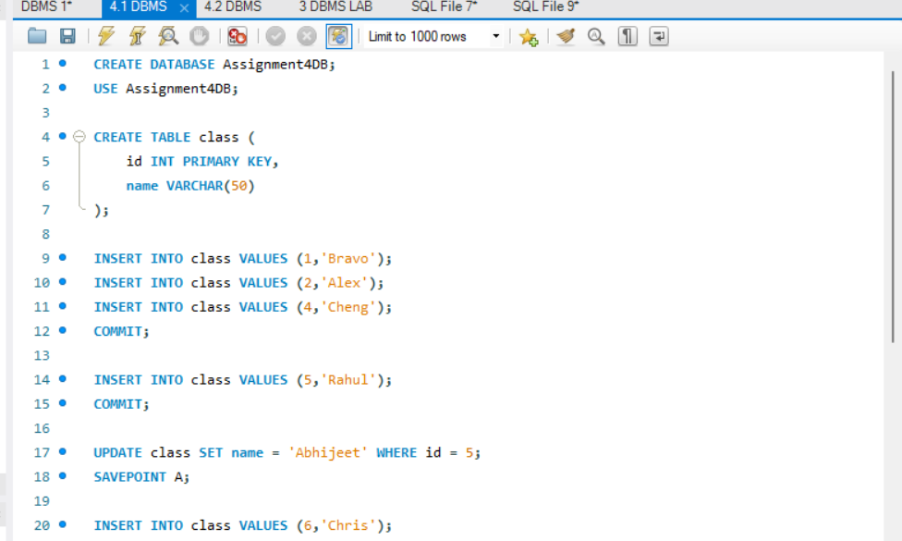
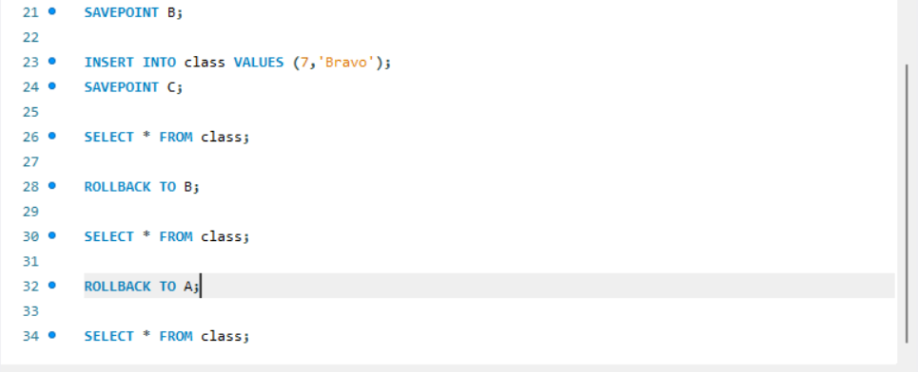

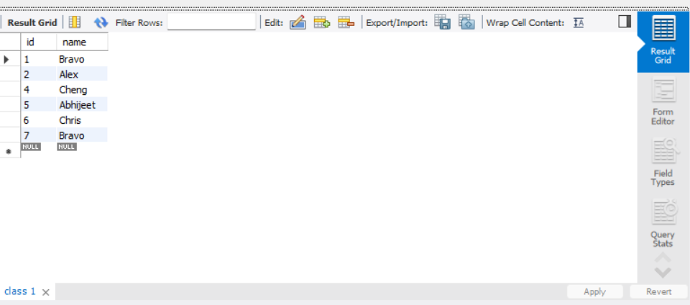
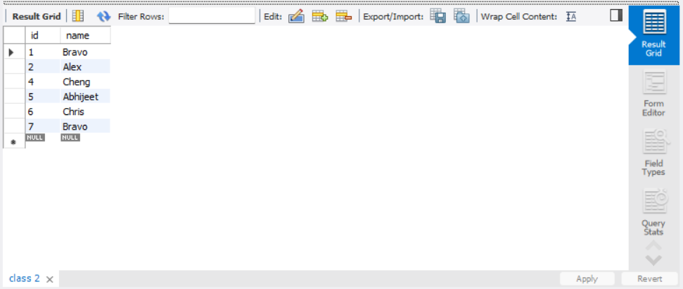
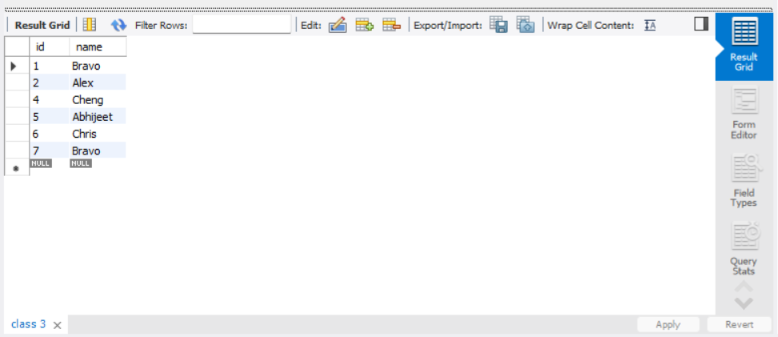

DBMS LAB ASSIGNMENT 4.2:
Consider the following table: Table: ACCOUNT_TXN
Acc_ID Holder_Name Balance
101 Aman 5000
102 Bhavna 7000
103 Chirag 6000

Perform the following TCL-based SQL script and write the output after each SELECT statement:
INSERT INTO ACCOUNT_TXN VALUES (104, 'Diya', 4000);
SAVEPOINT S1;
UPDATE ACCOUNT_TXN SET Balance = Balance + 1500 WHERE Acc_ID = 101;
UPDATE ACCOUNT_TXN SET Balance = Balance - 1000 WHERE Acc_ID = 102;
SAVEPOINT S2;
DELETE FROM ACCOUNT_TXN WHERE Acc_ID = 103;
INSERT INTO ACCOUNT_TXN VALUES (105, 'Eshan', 3000);
SAVEPOINT S3;
UPDATE ACCOUNT_TXN SET Holder_Name = 'Bhavna Sharma' WHERE Acc_ID = 102;
SELECT * FROM ACCOUNT_TXN;
ROLLBACK TO S2;
SELECT * FROM ACCOUNT_TXN;
INSERT INTO ACCOUNT_TXN VALUES (106, 'Farah', 4500);
SAVEPOINT S4;
UPDATE ACCOUNT_TXN SET Balance = Balance + 500 WHERE Acc_ID IN (101,104);
SELECT * FROM ACCOUNT_TXN;
ROLLBACK TO S4;
SELECT * FROM ACCOUNT_TXN;
COMMIT;

Student Tasks
- Write the output of all 4 SELECT statements in tabular format.
- Identify which rows are permanently saved after COMMIT.
- Mention which operations were undone by:
  - ROLLBACK TO S2
  - ROLLBACK TO S4
- Write the final state of the table after COMMIT.

Answer the following:
What is the difference between ROLLBACK and ROLLBACK TO SAVEPOINT?
Can we rollback to S3 after ROLLBACK TO S2? Why/Why not?
What happens if COMMIT is executed before creating any savepoint?

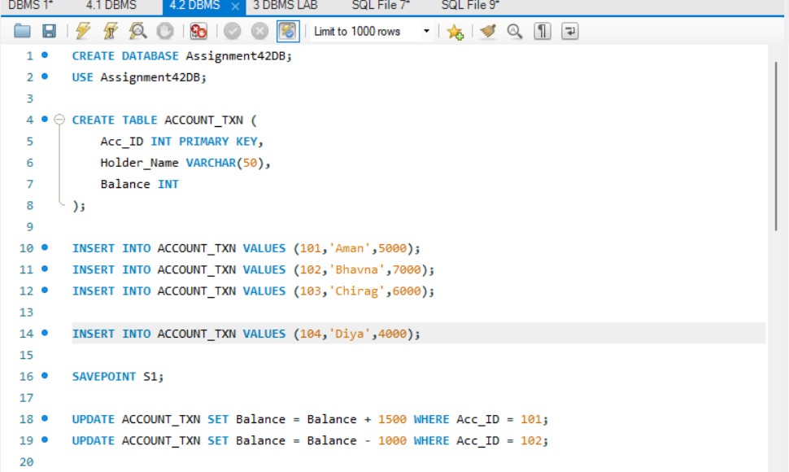
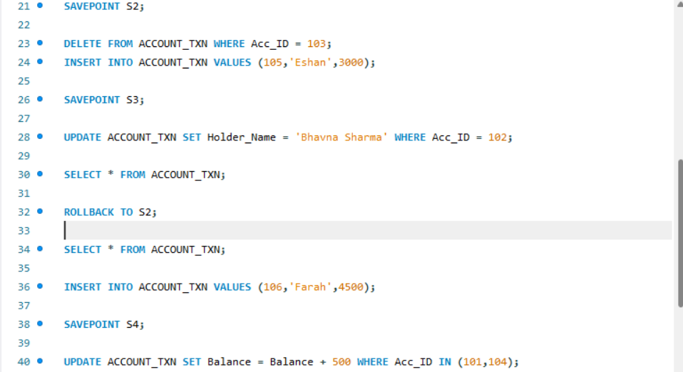
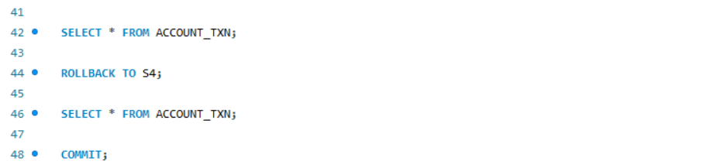

OUTPUT:
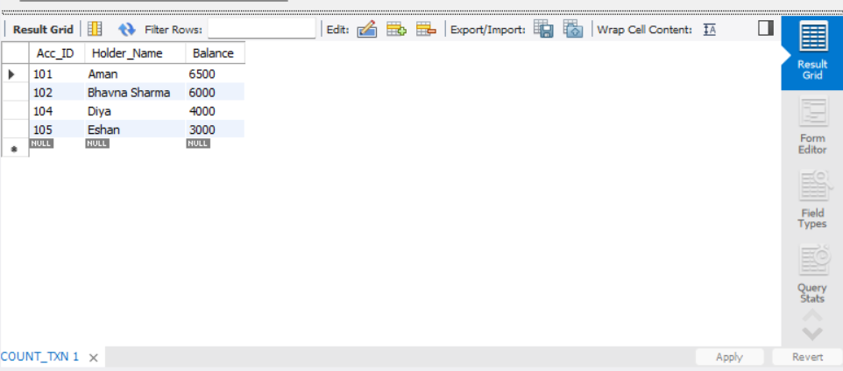
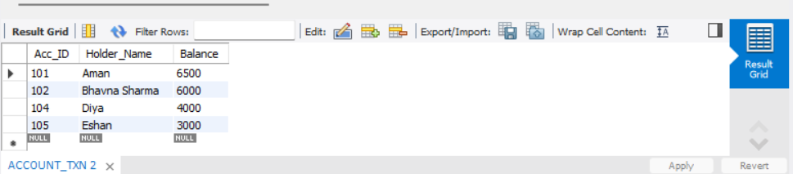
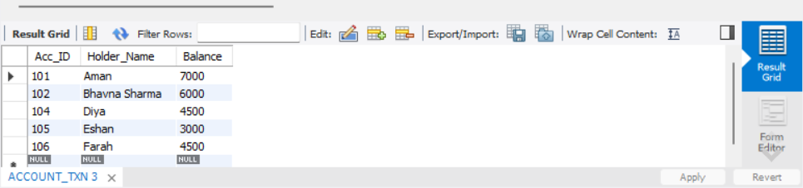
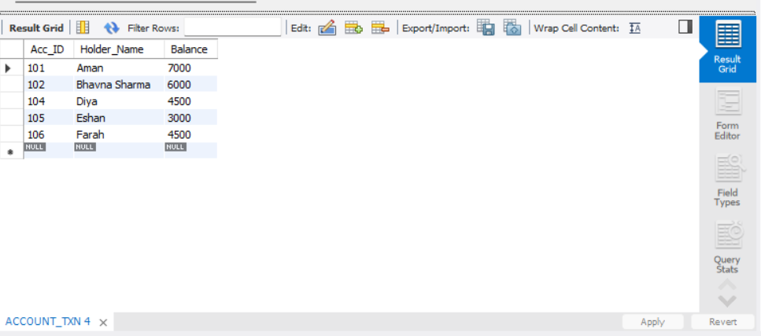

LAB ASSIGNMENT 5: (Exercise on retrieving records from the table)

Table: EMPLOYEES (Employee_Id, First_Name, Last_Name, Email, Phone_Number, Hire_Date, Job_Id, Salary, Commission_Act, Manager_Id, Department_Id)

(a) Find out the employee id, names, salaries of all the employees
(b) List out the employees who works under manager 100
(c) Find the names of the employees who have a salary greater than or equal to 4800
(d) List out the employees whose last name is ‘AUSTIN’
(e) Find the names of the employees who works in departments 60,70 and 80
(f) Display the unique Manager_Id.
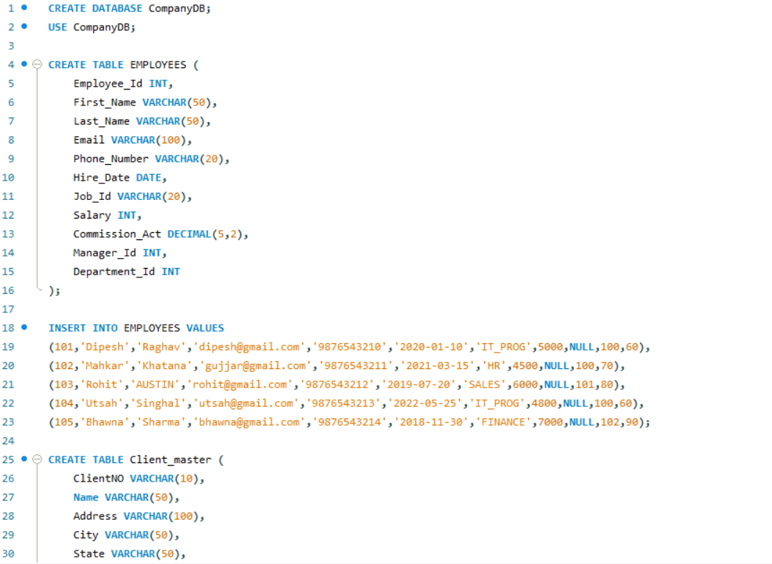
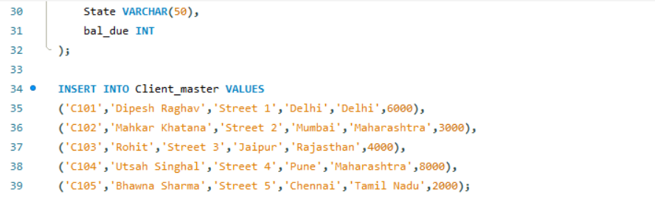

- Find out the employee id, names, salaries of all the employees.
Code:
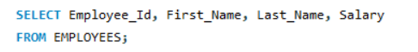
Output:
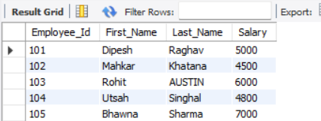
- List out the employees who works under manager 100
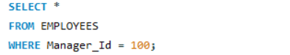
Code:
Output:

- Find the names of the employees who have a salary greater than or equal to 4800.
Code:
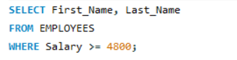

Output:
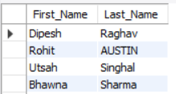

- List out the employees whose last name is ‘AUSTIN’.
Code:
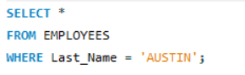
Output:

- Find the names of the employees who works in departments 60, 70 and 80.
Code:
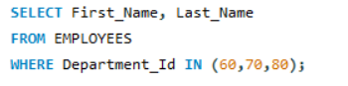
Output:
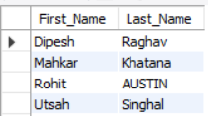
- Display the unique Manager_Id.
Code:
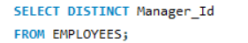
Output:
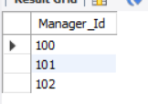

Lab Assignment 6: (Exercise on updating records in table)

Create Client_master with the following fields (ClientNO, Name, Address, City, State, bal_due)

(a) Insert five records.
Code:
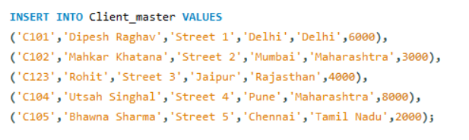
(b) Find the names of clients whose bal_due> 5000 .
Code:
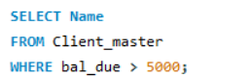
Output:
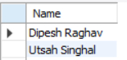
(c) Change the bal_due of ClientNO “ C123” to Rs. 5100.
Code:
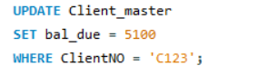

(d) Change the name of Client_master to Client12.
Code:

(e) Display the bal_due heading as “BALANCE”.
Code:
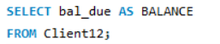
Output:
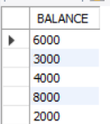

Lab Experiment 7

Objective: Rollback and Commit commands Create Teacher table with the following fields (Name, DeptNo, Date of joining, DeptName, Location, Salary)
a) Insert five records.
b) Give Increment of 25% salary for Mathematics Department.
c) Perform Rollback command.
d) Give increment of 15% salary for Commerce Department.
e) Perform Commit command.

SOLUTION CODE: (By Dipesh Raghav – 2401010223)
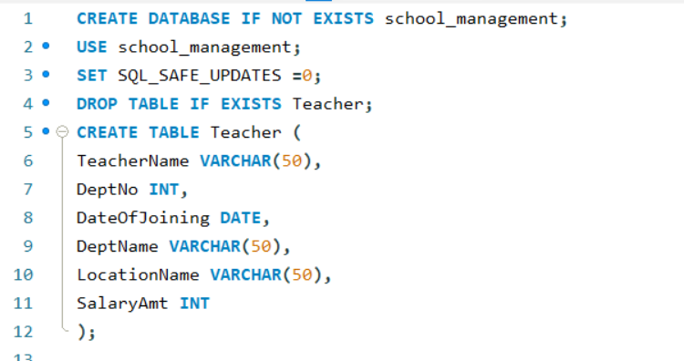

- Insert five records.

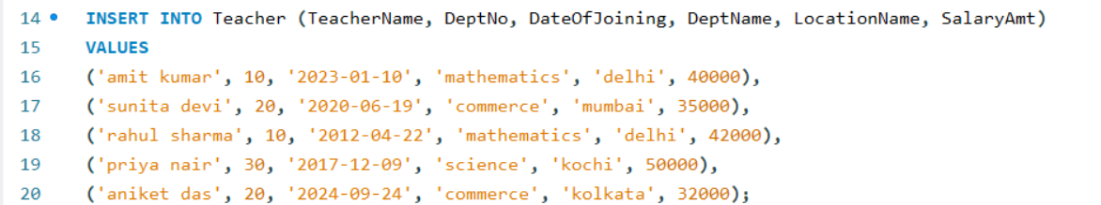

- Give Increment of 25% salary for Mathematics Department.

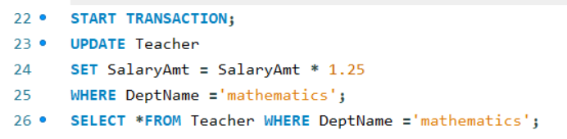
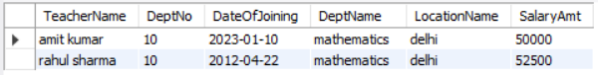

- Perform Rollback command.

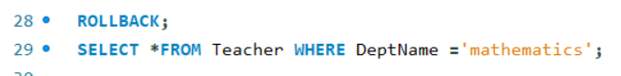
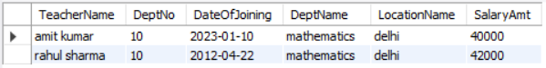

- Give increment of 15% salary for Commerce Department.

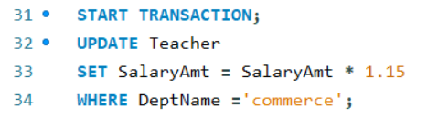

- Perform Commit command.

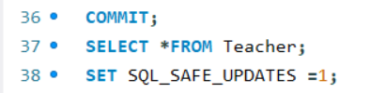
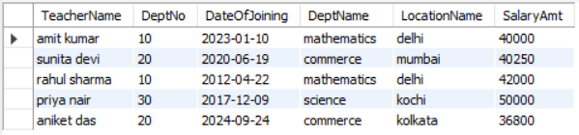

Lab Experiment 8

Objective: Create Sales table with the following fields (Sales No, Salesname, Branch, Salesamount, DOB)
- Insert five records.
- Calculate total salesamount in each branch.
- Calculate average salesamount in each branch.
- Display all the salesmen, DOB who are born in the month of December as day in character format i.e. 21-Dec-09.
- Display the name and DOB of salesman in alphabetical order of the month.
SOLUTION CODE: (By Dipesh Raghav – 2401010223)
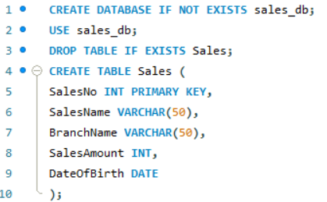
- Insert five records.
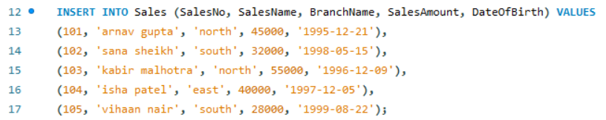

- Calculate total salesamount in each branch.
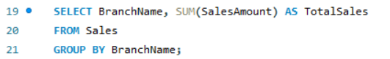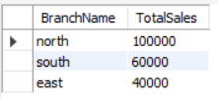

- Calculate average salesamount in each branch.
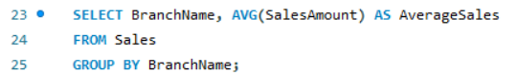
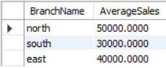

- Display all the salesmen, DOB who are born in the month of December as day in character format i.e. 21-Dec-09.

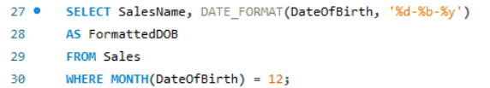

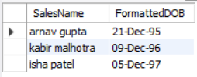

- Display the name and DOB of salesman in alphabetical order of the month.

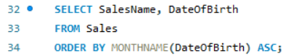

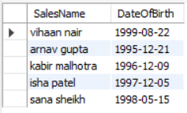

Lab Experiment 9

Objective: Consider the following tables namely “DEPARTMENTS” and “EMPLOYEES”
Their schemas are as follows:
Departments ( dept no , dept name , dept_location );
Employees ( emp_id , emp_name , emp_salary,dept_no);
- Develop a query to grant all privileges of employees table into departments table.
- Develop a query to grant some privileges of employees table into departments table.
- Develop a query to revoke all privileges of employees table from departments table.
- Develop query to revoke some privileges of employees table from departments table.
- Write a query to implement the save point.
SOLUTION CODE: (By Dipesh Raghav – 2401010223)
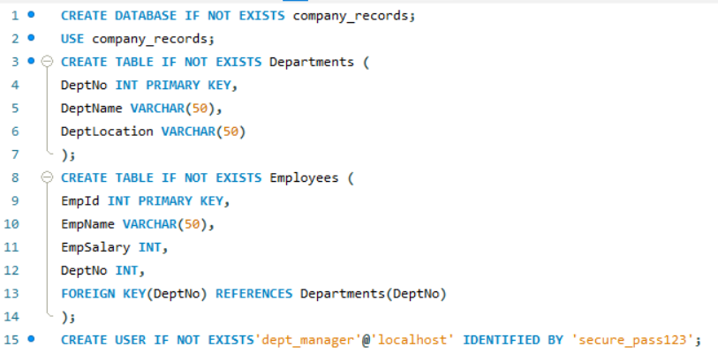

- Develop a query to grant all privileges of employees table into departments table.

- Develop a query to grant some privileges of employees table into departments table.

- Develop a query to revoke all privileges of employees table from departments table.

- Develop query to revoke some privileges of employees table from departments table.

- Write a query to implement the save point.

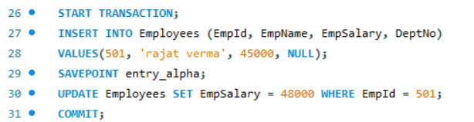

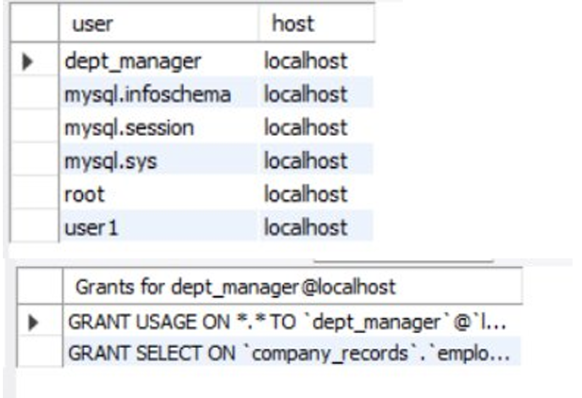

Lab Experiment 10

Objective: Using the tables “DEPARTMENTS” and “EMPLOYEES” from Lab 9 perform the following queries:
- Display the employee details, departments that the departments are same in both the emp and dept.
- Display the employee name and Department name by implementing a left outer join.
- Display the employee name and Department name by implementing a right outer join.
- Display the details of those who draw the salary greater than the average salary.
SOLUTION CODE: (By Dipesh Raghav – 2401010223)
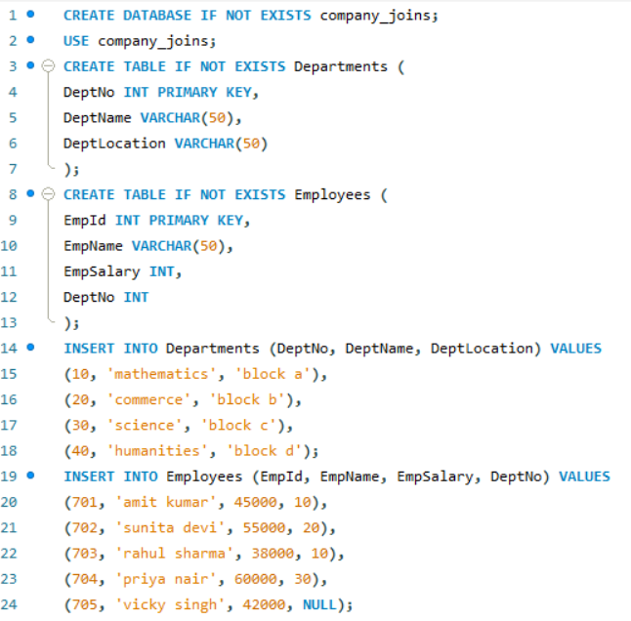
- Display the employee details, departments that the departments are same in both the emp and dept.
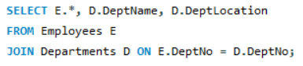
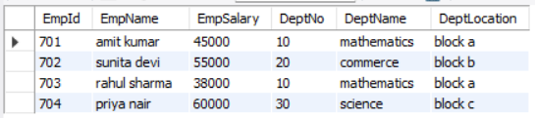

- Display the employee name and Department name by implementing a left outer join.
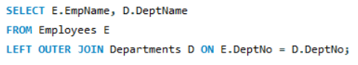
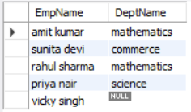

- Display the employee name and Department name by implementing a right outer join.
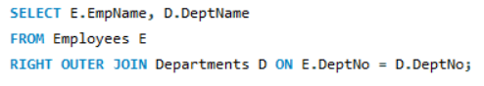
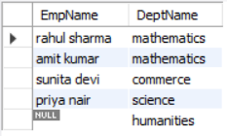

- Display the details of those who draw the salary greater than the average salary.

