

Programme Name: ________BCs.IT_______________________________________

Course Code: __CSC 1403________

Course Name: ________Database concept______________________________

Assignment / Lab Sheet / Project / Case Study No. _2___

Date of Submission: ______5/01/2020_____________

**Submitted By: Submitted To:**

Student Name**: Dipesh Tha Shrestha** Faculty Name**: Amar Subedi**

IUKL ID: Department**: PO**

Semester**: Second Semester**

Intake**: September 2019**

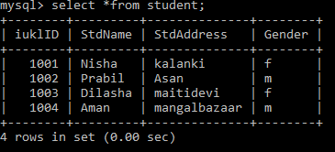

1. Add single column in existing table

Define: to create a single column into the existing table student

Output:

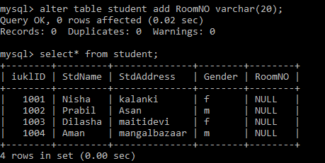

1. Add multiple columns in existing table

Define: to add multiple columns in the existing table student;

Output:

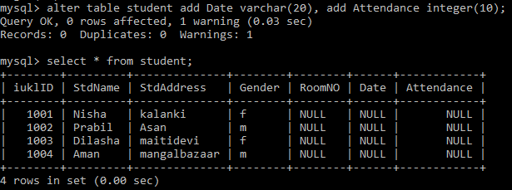

1. Insert single value into existing table

Define: to add a value in the table where the value is missing

Output:

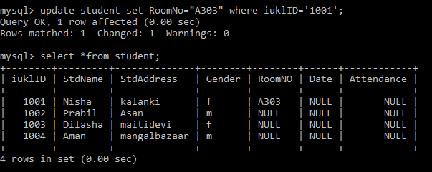

1. Add multiple values in the existing table

Define: to add different values in the table where the values are missing

Output:

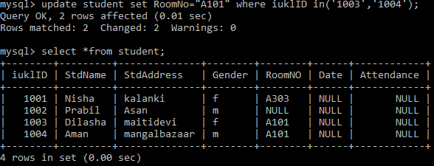

1. Update single value into existing table

Define: to replace a value by another value in the existing table

Output:

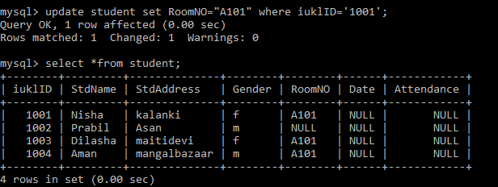

1. Add date column in the existing table

