

Programme Name: **________BCs.IT_______________________________________**

Course Code: **__CSC 1403________**

Course Name: **________Database concept______________________________**

Assignment / Lab Sheet / Project / Case Study No. **_1___**

Date of Submission: **______4/28/2020_____________**

**Submitted By: Submitted To:**

Student Name: **Dipesh Tha Shrestha** Faculty Name: **Amar Subedi**

IUKL ID: Department: **PO**

Semester**: Second Semester**

Intake: **September 2019**

1. Show databases;

Define: to show /display the existing database

Output:

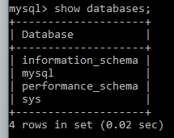

1. Create database Sunway;

Define: to create a new database named Sunway

Output:



1. Show databases;

Define: to show/display the existing database

Output:

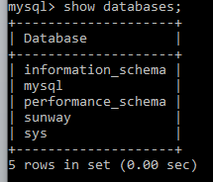

1. Use sunway;

Define: to enter into/use a specific database

Output:



1. create table student(

  iuklID integer(10) Not Null,  
    StdName varchar(20),  
    StdAddress varchar(20),  
    Gender char(1),  
    primary key(iuklID));

Define: to create a table named student inside the database sunway

Output:

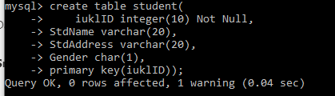

1. desc student;

Define: to describe the table student

Output:

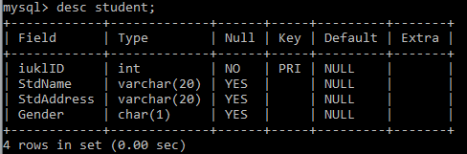

1. drop database sunway;

Define: to delete the database sunway

Output:



