

Programme Name: ________**BCS HONS**_______________________________________

Course Code: __**CSC 1403**________

Course Name: ________**Database concept**______________________________

**Assignment** / Lab Sheet / Project / Case Study No. _**2**___

Date of Submission: ______**5/28/2020**_____________

**Submitted By: Submitted To:**

Student Name**: Dipesh Tha Shrestha** Faculty Name**: Amar Subedi**

IUKL ID: Department**: PO**

Semester**: Second Semester**

Intake**: September 2019**

**1. Write the SQL statements for :-**

**a) List details of patient from Bangi and display the output.**

**→** Command and output :

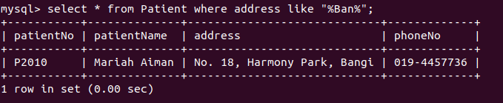

**b) List all treatments that cost less than RM1500 and display the output.**

→Command and output :

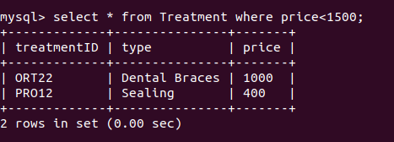

**c) List details of patient who have made appointment with Dr Harith Danial.**

→ Command :



→ Output :

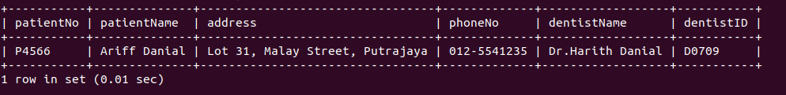

**d)** **List patient’s name, appointment date and time for Dental Braces treatment.**

→ Command :

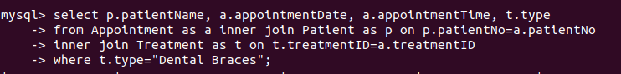

→ Output :

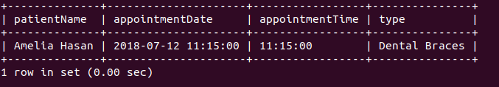

**e) Find total number of patient who have made appointment on 12/07/18.**

→ Command and output :

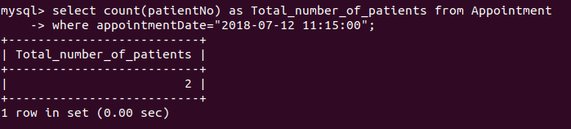

**Tables Concerned :**

