

Programme Name: ________**BCS HONS**_______________________________________

Course Code: __**CSC 1403**________

Course Name: ________**Database concept**______________________________

**Assignment** / Lab Sheet / Project / Case Study No. _**3**___

Date of Submission: ______**6/5/2020**_____________

**Submitted By: Submitted To:**

Student Name**: Dipesh Tha Shrestha** Faculty Name**: Amar Subedi**

IUKL ID: Department**: PO**

Semester**: Second Semester**

Intake**: September 2019**

1. **List all customers that live in Putrajaya and display the output.**

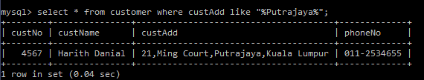

1. **List all bookings made by customer named Iman Maisarah**

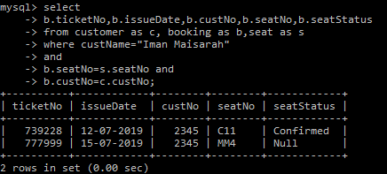

1. **List details of seat reserved for Disabled customer and the area is at the balcony.**

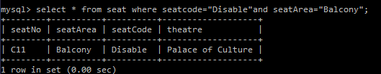

1. **Find the total number of tickets for seats that already confirmed by the customer.**

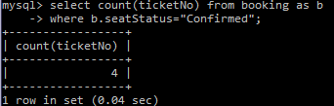

1. **List the customer’s name and seat’s number for ticket issues on 12-07-2019 and display the output.**

