

Programme Name: ________**BCS HONS**_______________________________________

Course Code: __**CSC 1403**________

Course Name: ________**Database concept**______________________________

**Assignment** / Lab Sheet / Project / Case Study No. _**4**___

Date of Submission: ______**6/5/2020**_____________

**Submitted By: Submitted To:**

Student Name**: Dipesh Tha Shrestha** Faculty Name**: Amar Subedi**

IUKL ID: **041902900028** Department**: LMS**

Semester**: Second Semester**

Intake**: September 2019**

1. **List the details of staff who works as a Senior Lecturer.**

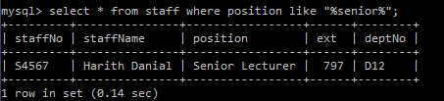

1. **List the staff’s name and leave type for leave applied on 15-8-18.**

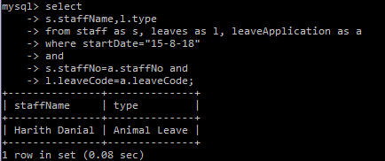

1. **List the details of staff whose leave is still pending.**

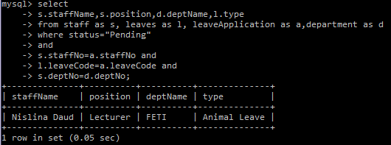

1. **List th staff’s name and department’s name for staff with leave balance less than 9.**

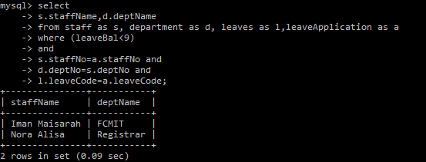

1. **Change the department number for HOD number to D10.**

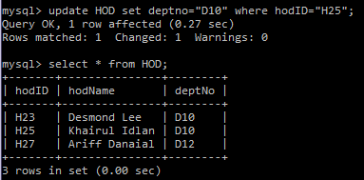

1. **Find the total number of leave approved by HOD number H27.**

