

Programme Name: ______________**BCS(Hons.)**________________________________________

Course Code: **_CSC 1403**_________

Course Name: ____**Database concept**____________________________________________

Assignment / **Lab Sheet** / Project / Case Study No. __**3**__

**Submitted By: Submitted To:**

Student Name: **Dipesh Tha Shrestha** Faculty Name: **Amar Subedi**

IUKL ID:

Department: **LMS**

Semester**: 2nd sem**

Intake: **September 2019**

# 1. Table section creation:

**Syntax:** CREATE TABLE *table_name*(*column1 datatype*, *column2 datatype*);

create table ***section***(***sectionID integer(10)*, *sectionName varchar(25****)*);

**Define:** used for creating table.

# Output:

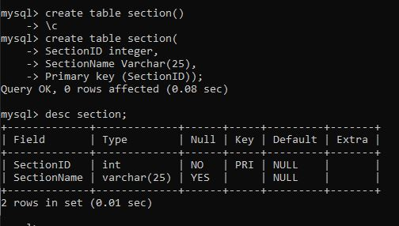

**2. Drop specific column:**

**Syntax:** ALTER TABLE *table_name* DROP Column *column_name*; alter table ***student*** drop column ***section***;

**Define:** used for deleting the particular column from the table.

# Output:

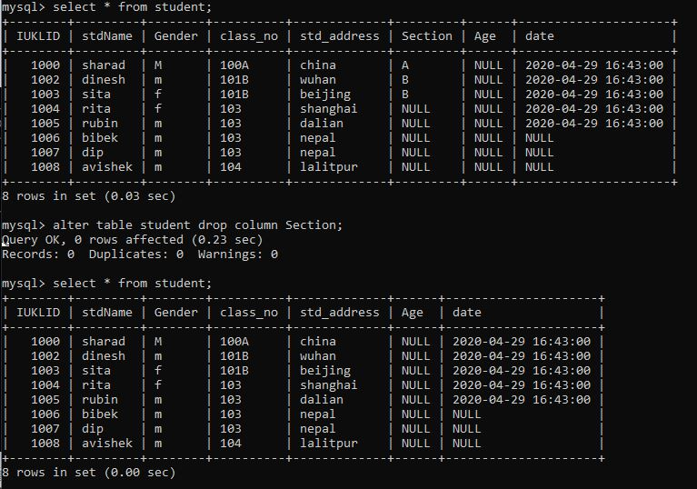

**3. Identify maximum, minimum, average, a. count: Maximum:**

**Syntax:** SELECT max(*column_name*) FROM *table_name*; select **max**(**iuklID**) from **class**;

**Define:** used for finding the maximum value from the column in the table.

# Output:

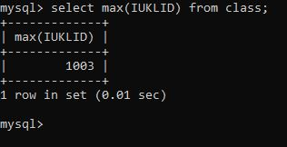

**b. Minimum:**

**Syntax:** SELECT min(*column_name*) FROM *table_name*; select **min**(**iuklID**) from **class**;

**Define:** usedfor finding the minimum value from the column in the table.

# Output:

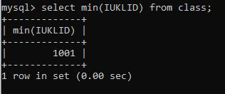

**c. Average:**

**Syntax:** SELECT avg(*column_name*) FROM *table_name*; select **avg**(**iuklID**) from **class**;

**Define:** used for finding the average value from the column in the table.

# Output:

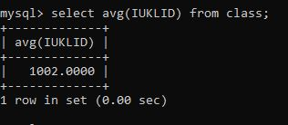

**d. Count:**

**Syntax:** SELECT count(*column_name*) FROM *table_name*; select **count**(**iuklID**) from **class**;

**Define:** used for counting the number of data in the column in the table.

# Output:

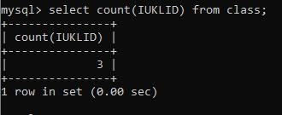

**4: As**

**Syntax:** SELECT s.StdName as StudentName,

s.StdAddress as StudentAddress,

c.className as StudentClassName from student as s, class as c where s.iuklID=c.iuklID;

**Define:** used for renaming column name temporary.

# Output:

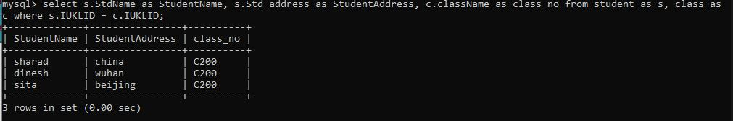

**5. Join table student and class with their iuklID and StdAddress**

**Syntax:** SELECT temporary_*table_name1* . *column_name1* as *temporary_column_name1*,

temporary_*table_name1* . *column_name2* as *temporary_column_name2*, temporary_*table_name2* . *column_name1* as *temporary_column_name1*

FROM *table_name1* as *temporary_table_name1*, *table_name2* as *temporary_table_name1*

WHERE

*table_name1* . *column_name1* = *table_name2* . *column_name1* AND *table_name1* . *column_name1*

= ‘value1’;

select ***s***.***StdName*** as ***StudentName***, ***s***.***StdAddress*** as ***StudentAddress***, ***c***.***className*** as ***StudentClassName*** from ***student*** as ***s***, ***class*** as ***c***

where ***s***.***iuklID***=***c***.***iuklID*** and ***StdAddress***=***‘Butwal’***;

# Output:

